CANON Experiment Plans
May – June 2012

Science theme: time-space relationships in upwelling ecosystems
The upwelling filament—shadow complex of Monterey Bay provides a natural laboratory for the study of ecosystem processes in upwelling ecosystems (Figure 1). Coastal topography strongly modifies coastal upwelling processes in eastern boundaries; coastline irregularities such as capes and bays produce variations in coastal wind, alongshore currents, chemistry and biology. Strong upwelling and horizontal advection occur at wind-exposed capes while in their lee, often in bays behind headlands, winds, upwelling and horizontal advection are weaker. As a result of the slower physical dynamics and increased stratification, biological processes proceed without being advected or mixed offshore and dense phytoplankton blooms often develop in these ‘‘upwelling shadows”. Strong gradients or ‘‘fronts” form between the freshly upwelled waters off a cape and the protected shadow waters behind the cape. These convergent fronts are typically sites of intense biological activity, attracting a diverse community of predators. For Monterey Bay the region of strong upwelling is located to the north (Figure 1) where recently upwelled is found at the surface, loaded with nutrients (and often sediments) but with relatively low plankton abundance. At the other end of the spectrum “old” waters, aged as they are transported and reside in the northern bay upwelling shadow, contain more mature plankton communities that are relatively impoverished of nutrients. What at first appears as a simple temporal development of phytoplankton communities in an optimum nutrient and light environment is soon “complicated” by varying circulation in, below and around the upwelling plume, and mixing processes at the frontal area between the new and old waters. Climatological patterns from satellite data illustrate biological enrichment of the frontal boundary zone between the upwelling shadow and upwelling filaments (Figure 1).

The filament—shadow complex provides the opportunity to study a diverse set of fundamental ecosystem physical / chemical structure and processes associated with eastern boundary upwelling ecosystems, including:
- Supply of nutrients, including ventilation of the subsurface ammonium maximum, which has its maximum intensity in Monterey Bay (relative to Line 67)
- Transport of sediments from the shelf and bottom boundary layer into the pelagic system
- Formation of regional water types
- Plankton aggregation

Motivation
The experiment has a number of motivations:
- to conduct effective basic research by applying traditional and emergent methods
- to build upon and advance the science and technology of previous CANON efforts while preparing for the more extensive effort planned for September
- to advance CANON’s synergistic collaborations
- others…?

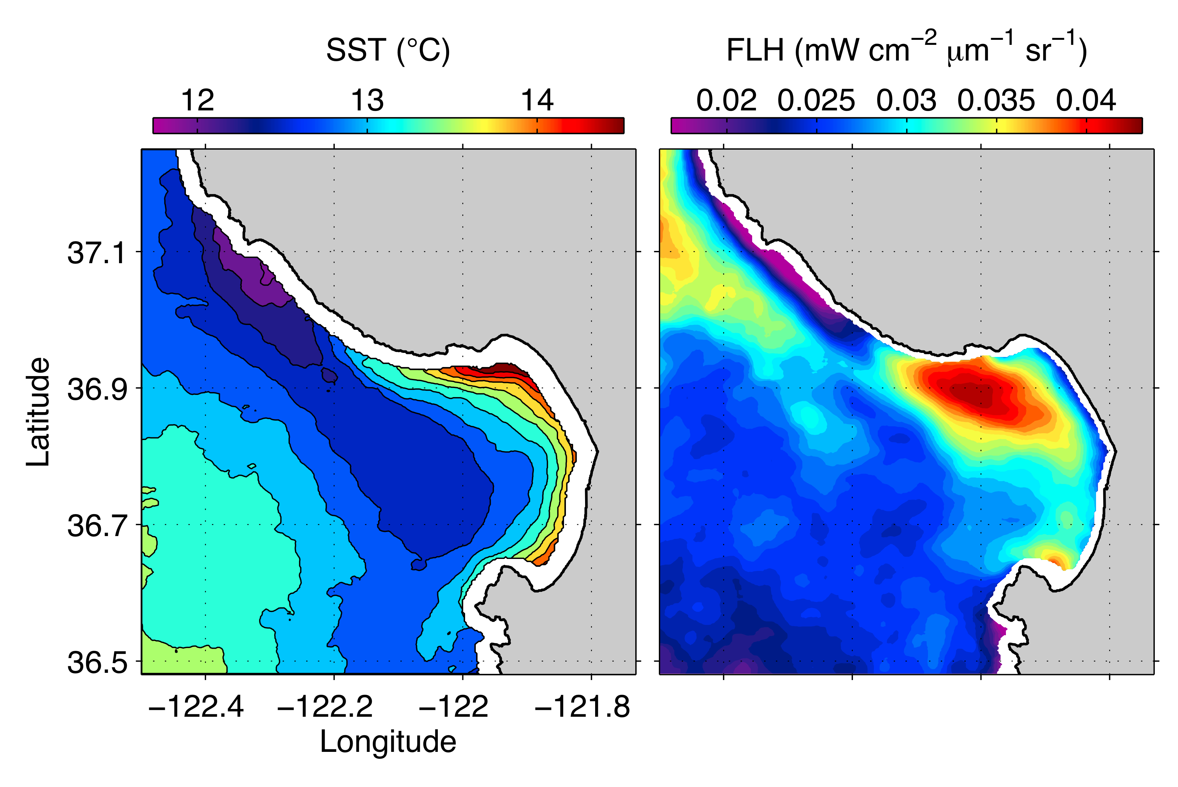

Figure 1. Organization of pelagic ecology by the upwelling filament—shadow complex of the Monterey Bay region. Sea surface temperature (SST) and chlorophyll fluorescence line height (FLH) are averages of summer (May – July).

Questions
The fundamental dynamics of this system - wind forcing and upwelling response - are thought to be reasonably well understood and predictable, however, we have only rudimentary quantitative understanding of many key processes:
- fluxes of new and recycled nutrients and sediments within upwelling filaments
- lateral and vertical fluxes of upwelled nutrients from filaments via mixing / transport within, beneath, and across stratified frontal boundaries
- responses of the phytoplankton community to influx of new and recycled nutrients
- responses of the zooplankton community to phytoplankton blooms of variable community composition
- activity (rates) of conversion from new nutrients, through trophic levels into recycled nutrients, and back to biomass (there and back again, a nutrient’s tale)
- temporally and spatially dependent transitions in the balance between new and recycled nutrients in supporting primary production, and dynamics of the recycled nutrient pool as modulated by the activity of phytoplankton, zooplankton, bacteria and viruses

The intense variability and rapid changes of this system motivate carefully targeted questions matched with effective methods to answer them. Questions will be selected based on motivations from previous studies, goals for this and future studies, collaborative research interests and goals, and critical evaluation of potential questions in light of our anticipated ability to answer them using available methods and resources. Drafted as questions, these can be translated into hypotheses after we refine them. Add / modify questions and hypotheses as you are motivated.

Question cluster #1:
Do zooplankton consistently aggregate in upwelling fronts? Do zooplankton aggregations in fronts exhibit consistent patterns of community composition; are certain species preferentially aggregated? What are the ecological and biogeochemical consequences of zooplankton aggregation in fronts?

Oceanic fronts shape marine ecology across a great range of habitat and life-form scales (see literature summaries in Ryan et al., 2010 and Harvey et al., 2012). One of the frequently observed ecological influences of fronts is plankton aggregation. Early applications of the Gulper sampling system on the Dorado AUV captured signal of this type of aggregation in the fronts of an upwelling filament in Monterey Bay (Figure 2).

Motivated by these results, which were captured somewhat by chance in a 2009 AUV survey using only prescribed geographic sampling, CANON researchers advanced related methods of frontal detection and targeted sampling. We have well-tested methods for fully autonomous onboard detection of water types and fronts, and allocation of AUV samplers to each targeted category (Zhang et al., 2011a, b, 2012 in press, 2012 in review), as well as methods for analyzing AUV data on shore for frontal classification and initiative from humans in the loop (Rajan et al., in review; Gottlieb et al., 2012).

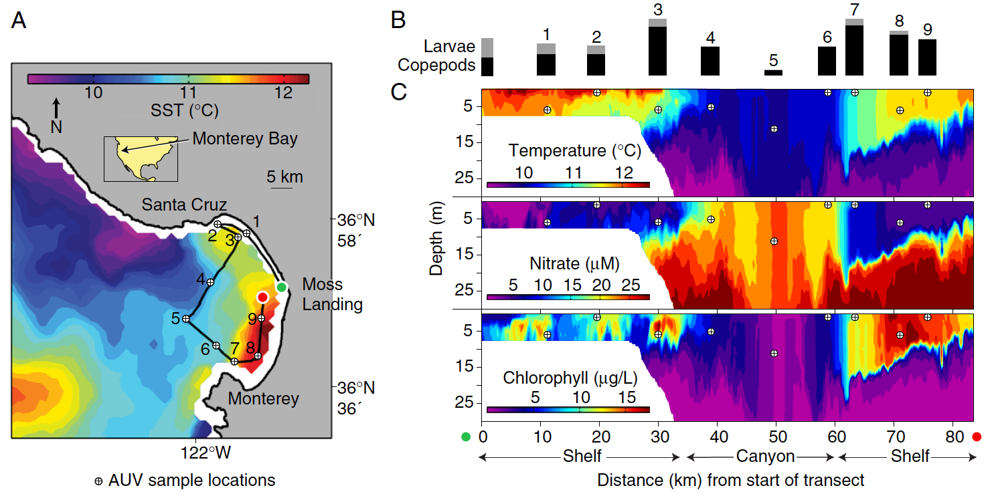

Figure 2. (From Harvey et al., 2012). Aggregation of copepods in the frontal zones of an upwelling filament, indicated by results from molecular analysis of AUV Gulper samples.

Question cluster #2:
What is the source of high ammonium in upwelling filaments transported from the Ano Nuevo upwelling center? Does ventilation of the subsurface ammonium maximum by the upwelling process occur primarily by upwelling circulation itself, or is turbulent vertical mixing in unstratified filaments (beneath strong winds) also a key process acting over a larger scale than the upwelling center? Does ventilation of deeper ammonium-rich waters also introduce bacterial populations that are important to the transformation of ammonium in upwelling filaments and subsequent transitional water types? Does high ammonia in upwelling plumes inhibit diatom growth? (Does the literature suggest that concentrations found in upwelling filaments could inhibit diatom growth?)

This question cluster is motivated by data illustrating the ammonium maximum, which showed high levels of ammonium in recently upwelled waters, relatively homogeneous throughout the upper water column, adjacent to ammonium-depleted waters of the upwelling shadow (Figure 3). During this brief time-series, the ammonium maximum was evidently displaced, mixed away, or subducted by seaward extension of the upwelling shadow, which was closely monitored by Tethys . (The ship / AUV / satellite data set from this period is a good one to examine further for experiment preparation. It contains indications of cross-frontal mixing processes.)

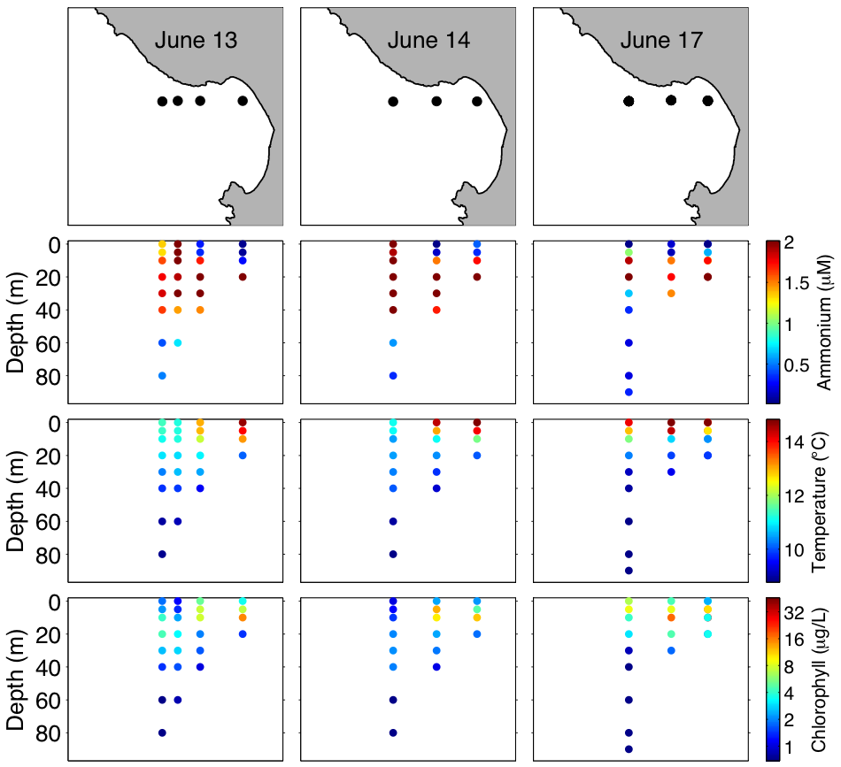

Figure 3. Distributions of ammonium, temperature and chlorophyll across the filament—shadow complex acquired during the June 2011 CANON experiment (ammonium data from J. Smith, Stanford).

Question cluster #3:
How do physical and biological processes determine the spatial patterns and rates of biological assimilation of ammonium and nitrate from upwelling filaments? What is the relative importance of different physical processes in the transport of nutrients from upwelling filaments into the upwelling shadow (subduction in convergent frontal circulation, turbulent vertical mixing, lateral mixing and stirring)? How do these physical processes interact, and how do they influence biological populations that are involved in nutrient utilization and transformation?

This question cluster is motivated by the fact that (a) we really don’t know much about these fundamental processes, and (2) we may have an effective suite of capabilities to apply toward answering them. For example, with Tethys, the LRAUV team provided autonomous frontal tracking (April 2011) and high-resolution mapping of fronts (April and June 2011). Multi-vehicle coordination allowed intelligent direction of the Dorado AUV to localize augmented sensing and sampling capabilities. In these data we see indications of the lateral stirring processes, rapid local changes in the distributions of water types and their front, physical and biological patterns relatable to remote sensing and other data. With the addition of turbulence sensing on LRAUV Daphne, we may have the opportunity for the first time to approach quantitative evaluation of turbulent vertical mixing within the spectrum of physical processes.

Question cluster #4:
Can we measure diel changes in ammonium at the edges of the upwelling plume? Can we measure diel changes in nitrogen uptake by phytoplankton and nitrification by bacteria at the edges of the upwelling plume?

Does effective investigation of diel variability require consistent methods applied in Lagrangian tracking of populations? If so, we need to evaluate whether or not we can and will try to do this in May.

Question cluster #5+:
Genomics-based questions, large zooplankton questions…

Pre-experiment analysis
What data is available, where is it, how do we access it, how do we process, analyze, visualize? Thom and John

Pre-experiment data analysis by the DAC has thus far been focused on developing a clear description of the ammonium maximum off central California and its relationship to other environmental variables and indicators of processes and biological populations that influence it, potential proxies for reconnaissance, etc. Available data sets that any of the CANON researchers and collaborators can access and analyze (links will be filled in) include:
- Ammonium data and ancillary measurements from Line 67 cruises and CANON experiments in Monterey Bay have been made available through the BOG database. Older data from previous experiments will be made available similarly.
- All Dorado AUV data, at full and reduced resolution and in multiple formats (matlab, netcdf, ODV) are available on the MBARI SSDS storage system, which one can access by URL inside or outside, or mounted disks in-house
- All Tethys data are all available online at reduced resolution; full resolution data are accessible within the LRAUV project storage archive
- Satellite sea surface temperature images are available on the NOAA CoastWatch web site, with products resulting from no cloud/fog removal and aggressive cloud/fog removal. The best SST data set, involving custom processing for each image, begins as a CoastWatch product, is processed by the UCSC remote sensing lab, and is fed to MBARI for the final screening of useful images that are posted to ODSS.
- Etc., etc.

Note that we have as a planning resource, data at a range of scales indicating the significant role that lateral stirring plays in nutrient fluxes across the upwelling filament-shadow complex.

Pre-experiment planning

What are the assets, how do we deploy them, how do we know how long it takes for transects, how do we know where they are, what measurements do we make on water samples, do we have locations to store the data, do we have tools to extract, analyze the data, do we have tools to visualize the data?

Asset list
Spray, Wave and Webb gliders
LRAUV (Daphne with turbulence, Tethys with CTD package)
Dorado with LIST and LIST Holo, CTD package and gulpers
Small ship support with CTD and underway measurements
Drifters, moorings, satellites, HF radar, COAMPS, etc.

Preliminary plan (Francisco and John)

Deploy Spray, Wave and Webb gliders on May 21 for reconnaissance phase (see figure below for repeat transects), recover on June 7 or 8
Deploy LRAUV Daphne May 29 (Tuesday) with Turbulence Sensor for transect along 36.9N. Recover LRAUV Daphne May 31 (Thursday). Deploy LRAUV Tethys May 31 (Thursday). Recover LRAUV Tethys no later than June 8th (Friday).
Deploy Dorado May, 29, 30, 31, June 1 (three evenings) with LIST and LIST Holo, make transect offshore along 36.9, collect water on the return transect in upwelling plume, front and shadow. Repeat June 5, 6,7, and maybe 8.
Deploy small ship May 30, 31, June 1 deploy drifters along 36.9 and collect water on the return transect in upwelling plume, front and shadow. Repeat June 6,7, and maybe 8. Drifters recovered daily unless clear that they will not exit region rapidly.

Multiple science goals define the same requirement: we must effectively target sampling across three water types: upwelling filament, upwelling shadow, and the front between them. Recognizing the scientific value of being able to track dynamic fronts, and to accurately target sampling within fronts and the contrasting water types that create them, the CANON team has developed multiple related capabilities. These include:
- human-in-the-loop “mixed initiative” frontal detection and tracking (Rajan et al., in review)
- fully autonomous onboard detection of water types and fronts, and allocation of AUV samplers to each targeted category (Zhang et al., 2011a, b, 2012 in press, 2012 in review)
- extension of environmental signal extraction from (2) with momentum-based methods of frontal classification (Gottlieb et al., 2012)

Additionally, CANON has developed abilities to autonomously target AUV sampling of phytoplankton layers and patches, identifiable by chlorophyll fluorescence (Zhang et al., 2010). This algorithm consistently provided biologically-targeted sampling in CANON experiments of 2011, and it is highly relevant to effective sampling in this experiment. Thus, we have multiple onboard and onshore methods to exercise in optimizing sampling in the May 2012 experiment.

Dorado
The Zhang et al. algorithm that was tested successfully last year will be our primary tool onboard Dorado. We want to apply this algorithm where the signal is greatest, which is the far northern bay, where the most recently upwelled waters meet the most mature upwelling shadow waters. The same 36.9N line that we used last year remains the best choice for this purpose. The existing code has been modified for depth-dependence of sampling in the upwelling filament to be more consistent with sampling of the other water types. Last year, we ran the 36.9N section from onshore to offshore, and the mission duration permitted the full transit westward and partial return transit eastward, nearly back to Santa Cruz before recovery. This year, we want to reverse the direction. The motivation for this is that we will then acquire the frontal samples toward the upwelling shadow side of the front, and therefore better get the biological signals we are after (Figure 2). So, we may deploy approximately mid-way along the 36.9 N line heading westward with a partial vertical section and no Gulper firing, followed by the full eastward leg in which all Gulper firings are allocated to upwelled, frontal, and shadow waters. Other parameters (depth of yoyo, etc.) are tbd.

LISST-HOLO, tested during the April 2011 CANON experiment, is planned to be operational during this experiment. This will permit exploration of the plankton community, in complement to molecular and microscopic analyses on samples returned to shore by AUV and ship.

Tethys
Can we apply the more advanced algorithms and sensors on Tethys:
- Frontal high-resolution mapping and turbulence sensing (ventilation of ammonium maximum, mixing in frontal zones, etc.)
- Drifting to define Lagrangian pathways

R/V Martin
Complementary to the Dorado mapping / sampling plan…

Water sample analysis/other collections
Alex Worden/Jon Zehr, other genomics folks please fill in
Biogeochemistry (Tim, Jason, Marguerite et al.) – Euphotic integrated rates of primary production (C14 and C-13), ammonia and nitrate uptake. Nitrification rates. Triple isotope samples. Chlorophyll, bacteria, flow cell cytometry ?, microscopy, etc.
Zooplankton – Steve H.

Water sample analysis (Vrijenhoek/Zehr)

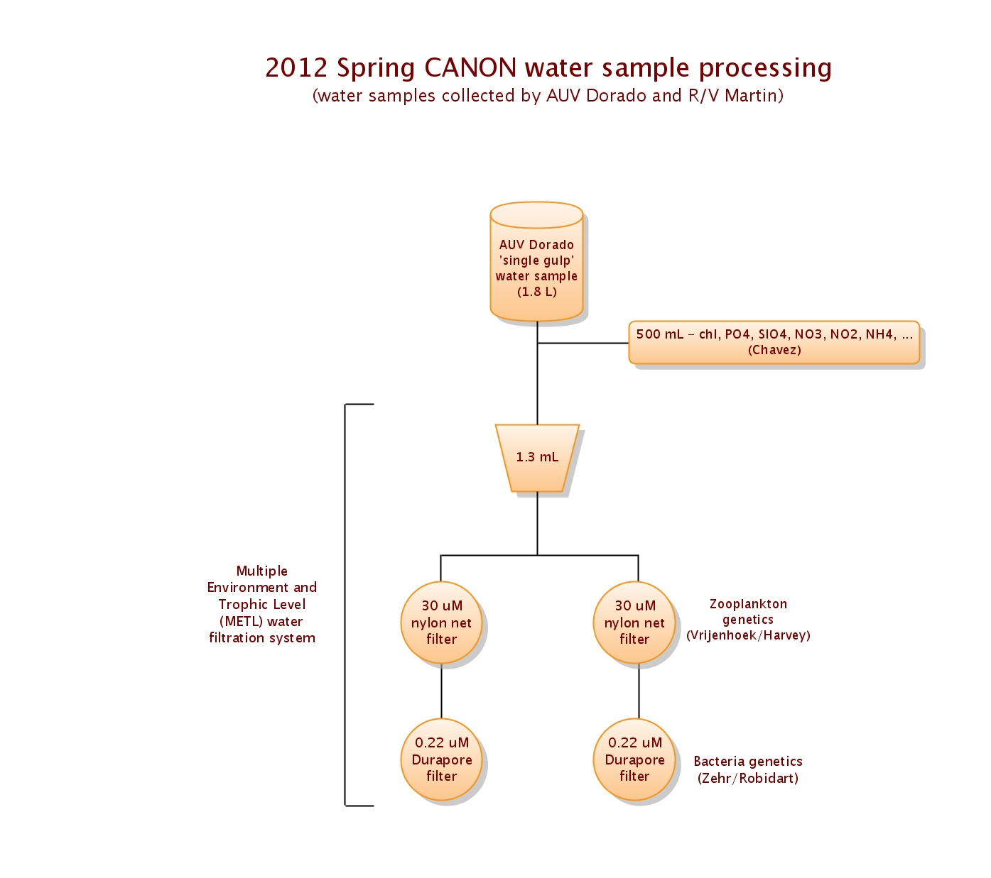

Also see: https://oceana.mbari.org/confluence/display/CDATA/ODSS%20Water%20Management

Water sample processing depicted above will be identical for water samples collected by Niskin bottle from the R/V Martin.

Zooplankton genetics (Vrijenhoek)

Water samples will be filtered for both zooplankton (30 uM nylon net filters) and bacteria (0.22 uM Durapore filters) using the Multiple Environment and Trophic Level (METL) water filtration system, in collaboration with Zehr/Robidart (see above water filtration diagram).

Regarding zooplankton, we plan to use the sandwich hybridization assay (SHA) to detect invertebrate larvae and copepods from whole water samples, consistent with previous studies, to build on our existing data set and enable testing of specific hypotheses regarding the aggregation of zooplankton in upwelling fronts. The relationship (presence/absence and abundance data) of these same organisms to subsurface ammonium maxima, via comparison to hydrographic data, will also be simultaneously assessed. Additionally, we will obtain COI sequence data from water samples in order to assess genetic differences among copepod populations across temporal and spatial scales. Additionally, it may be possible to connect a subset of AUV water samples spatially/temporally with images obtained from LISST-HOLO. We will generate COI and/or ribosomal DNA sequence data from representative individuals present in these samples, to attempt molecular taxonomic identification for some of the holographic images.

The methods will be applied to water collected by AUV Dorado and from R/V Martin (Nisken rosette and vertical plankton net pulls). We will analyze ‘single gulp’ samples from the AUV (1.8 L) and hope to obtain a single Niskin sample (~4 L) from each station where a rosette cast is performed from the Martin. Vertical plankton net pulls will also be performed at each of these stations. Subsequently, it will be possible to evaluate the sampling biases that characterize each of these three methods.

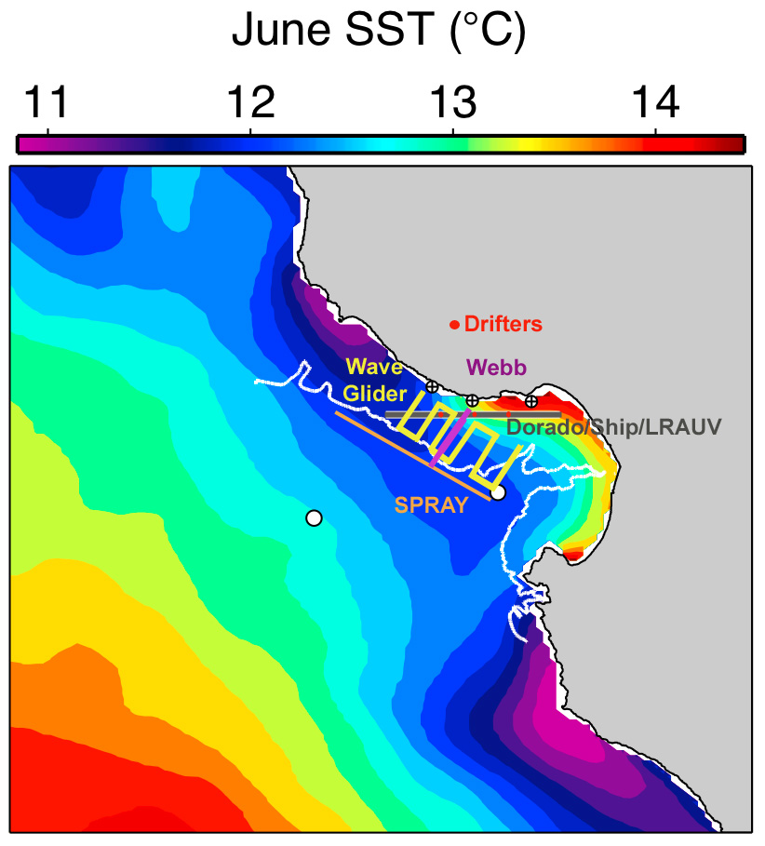

Figure. Preliminary plan for the deployment of assets.

Platform coverage capabilities (inserted by Thom):

Distance travelled over ground = (Speed * SOG Factor * Hours * 3600 sec/hr) / 1000 m / km * DeratingFactor for surfacing and overshoot

Surfacing: 3 to 5 % derating. Overshoot 4 to 6% => 10% derate, factor = 0.90

Platform | Speed  (m/s) | Speed  Range  (m/s) | Pitch Angle  (Degrees) | Speed  Over ground  factor  Cos(pitch * 0.01745) | YoYo  Depth  (TBD by Science)  (m) | Hours per day  (hr) | Derating | Compute  Distance  Traveled  (km)
Dorado | 1.5 | 1.25 to 1.75 | 25 | 0.90 | 120 m ? | 18 | 0.9 | 80
LRAUV | 1.0 | 0 to 1.0 | 20 | 0.94 |  | 24 | 0.9 | 73
Webb Glider | 0.13 | 0.1 to 0.33 | 17 | 0.96 | 200 m ? | 24 | 0.9 | 9
Scripps Glider | 0.13 | 0.1 to 0.33 | 17 | 0.96 | 200 m | 24 | 0.9 | 9
Wave Glider | 0.5 | 0.1 to 1.0 | 0 | 1.0 |  | 24 | 1.0 | 43
Stella Drifter | 0.1 ? | 0 to 1.0? | 0 | 1.0 |  | 24 | 1.0 | 8
LST | 0.1 ? | 0 to 1.0? | 0 | 1.0 |  | 24 | 1.0 | 8

A tool to graphically estimate platform operational area is in the works – first a prototype proof of concept by CSUMB, then an implementation by ODSS engineering after they finish priority features/bug fixes for situational awareness and data archive description (can’t commit to deliver for May just yet)

Reconnaissance phase

How do we access information, process the data, visualize, how do we use the information to make decisions, adapt the preliminary plan, what is the decision process, how do we transmit the information to the operators, etc.?

Experiment phase

How do we access information, process the data, visualize, how do we use the information to make decisions, adapt the preliminary plan, what is the decision process, how do we transmit the information to the operators, etc.?

Post experiment phase

How do we archive information, what kind of products should be produced immediately, what is the plan for data analysis and visualization, what are the lessons learned, etc.

