Method of pre-setting optical distances in air with housing open
First, mechanical distance between target slide, and back side of optical window was measured on the assembly as built, and modeled as stack of parts. This ‘mechanical distance’ is 4.449 inch per model drawing “901027-101Rev1 - Optical Thickness.pdf”
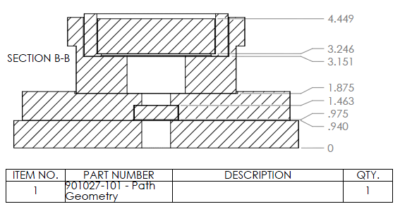

Second, optical thickness was modeled and calculated by scaling mechanical drawing with refractive indexes of respective glass parts, and cavities to be filled with water. This “Optical Distance” is 3.202 inches per model drawing “901027-101Rev1 - Optical Thickness.pdf”
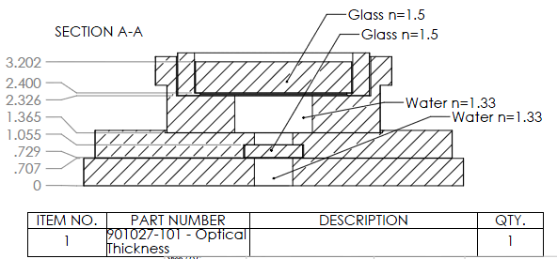

Third, there is additional nominal 0.040 inch between LED ring (foremost interface of camera optics) and optical window (see “901027-AS10 - SES Camera Optical - 2013-02-13.pdf” as illustrated below). Therefore, total “Optical Distance” from LED flange to the target slide is 3.24 inch

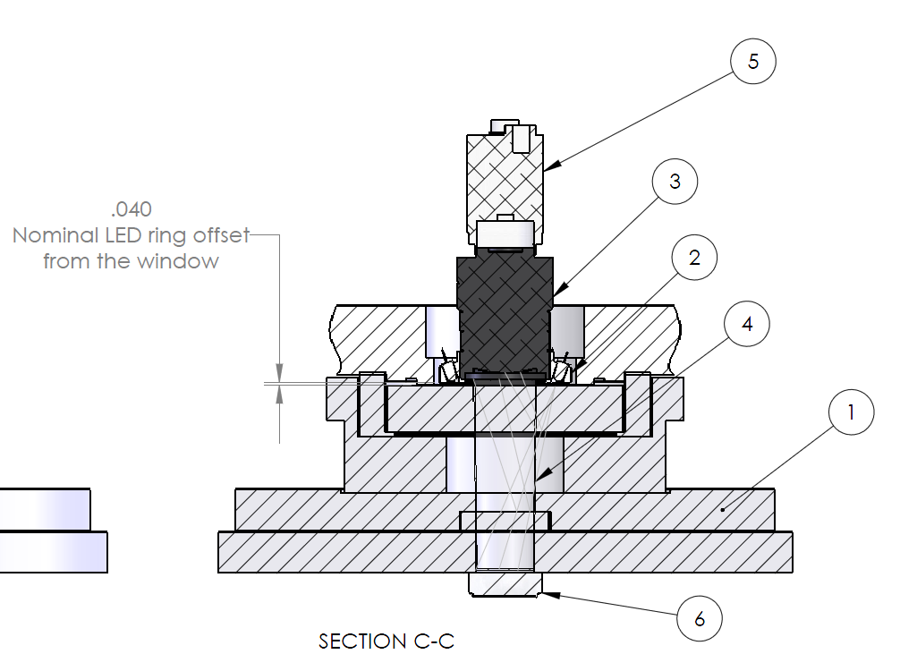

Forth, the settingsof lens focus, iris, and zoom, were ajusted in air with housing open, to the distance and depth of field of 3.22 +1/16 -1/8 inches (81.8 +1.6 – 3.2mm) . Here positive value is to gurantee the surface of the slide is on focus, and negative to camera to be able to image objects raising over slide surface (thick objects). Here is a note from file “SES-Camera-Mounting-Notes-Scan-2013-10-30.pdf” on the left-top
