Sedimentation Event Sensor for collecting time-series images of sinking particulate matter over long period of time

Introduction

Resolving biogeochemical cycling in the ocean is heavily dependent on measuring fluxes of particulate matter. Inverted funnels and cylinders have been used over the past four decades to collect particulate matter sinking through the water column and to estimate fluxes of biogenic and mineral material in all major regions of the world ocean (e.g. Honjo 1980; Knauer et al., 1979). These sediment traps can be either moored at discrete depths through the water column or be autonomous free-drifting devices set to float at pre-determined depths or density surfaces (Buesseler et al., 2007). All these designs require the retrieval of collected samples to estimate particulate fluxes.

To avoid the necessity of sample collection and increase the duration of sampling, an autonomous, vertically profiling float was developed to estimate particulate organic carbon in the upper 1000 m of the water column for durations up to 15 months (Bishop et al., 2002; Bishop and Wood, 2009). This Lagrangian instrument, the carbon explorer (CE), uses a transmissometer to measure suspended particle density that is then used to estimate particulate organic carbon (Bishop, 1999).

Our goal was to develop a moored instrument that could optically image settling particulate matter with high resolution in the water column to abyssal depths at any desired sampling frequency, hours to days, for periods of up to a year. The resulting time-series of high-definition images could then be processed to estimate biological origin, number, size and fluorescent quality without the need to collect or preserve samples. For biogenic material, the organic carbon and nitrogen content could then be estimated from similar material collected in conventional sediment traps.

Materials and Methods

Mechanical Hardware

At the core of the mechanical design is a commercially available sediment trap (McLane Laboratories model Mark78H-21). The sample funnel is constructed of natural polyethylene, 80 centimeters in diameter with a collection area of 0.5 m². The titanium frame of the Parflux Mark 78 offered an excellent platform in size and strength to build upon.

The frame was modified to function as a stand-alone benthic elevator. Mounts were added to the frame to accommodate syntactic foam flotation, as well as two deep-sea acoustic releases (Teledyne Benthos model 865-A). An auxiliary frame extension, (91.5 centimeters in diameter 77.5 in length), was built to accommodate an MBARI-developed titanium pressure sphere, drop weight release mechanism, and drop weight. The auxiliary frame bolts directly to the base of the Parflux frame. The pressure sphere contains the necessary electronics and batteries to power the system. The release mechanism reliably drops the ascent weight should one or both of the Benthos releases fire.

As was the case with the Parflux frame, the existing rotary assembly offered a good starting point for modification. The fiberglass channel that supports the rotary assembly was replaced with a sheet of one-centimeter thick Garolite (G-10) composite, to allow adequate support for the camera and fluorometer housings, (40+ kilograms) as well as the rotary assembly. The existing sample bottle carousel was replaced with a new sample assembly. This assembly allows the sample slide, which sits beneath the funnel during the collection period, to rotate into position beneath the fluorometer or camera for processing. As the rotation continues, a cam-driven mechanism moves the sample slide to a vertical orientation and passes it between a pair of cleaning brushes to remove any collected material before starting the next collection cycle. At the completion of one revolution the sample slide is back in position below the funnel ready for the next time series

Sensors and Electronics

The original McLane sediment trap had a simple controller to advance the sample bottle carousel to the next position at a programmed interval. A much more sophisticated controller is required to interface to the SES’s camera and fluorometer, and so the original controller was replaced. The new controller uses a PC/104 stack comprised of an ARM9-based CPU board, a relay board to switch power to the lights and sensors, Ethernet and RS-232 serial interface boards to connect the sensors to the CPU, and a real-time clock. A separate stepper motor controller board [Allmotion model EZ-17] drives the original McLane carousel motor to move the sample slide between the collection, imaging, and fluorometry stations. A Hall-effect switch senses the position of the carousel to index the stations.

A 5 megapixel, color digital camera [Allied Vision Technologies model GC2450C] captures images of the sediment collected on the slide. The camera is mounted inside of the controller housing and looks down through a flat-plate viewport. Two LED lights illuminate the sample: a ring light surrounds the camera lens inside the housing and illuminates the sample from the front, while an external light in its own pressure housing provides illumination through the back of the translucent sample slide. Each pixel in the image represents a distance of 13.9 µm on the sample slide, which is 72 pixels per mm.

A 5 megapixel, color digital camera (Allied Vision Technologies model GC2450C) captures images of the sediment collected on the slide. Each pixel in the image represents a distance of 13.9 µm on the sample slide, yielding 72 pixels per mm. The camera is mounted inside of the controller housing and looks down through a flat-plate viewport, and flat sample slide viewport with 25 mm clear aperture. The volume between viewports is filled with 50% water/ethanol solution to act as a biocide and optical interface, and pressure compensated by means of a length of soft PVC tubing.

The camera is equipped with 12-36 mm C-mount Computar 11A varifocal video lens, Edmunds part NT57-680; coupled to the camera through a generic 5 mm C-Mount spacer to accommodate for shorter viewing distances. The zoom of the lens is adjusted to match the clear aperture of the sample slide viewport to the field of view of the camera with 5-10% margins per side to allow for mechanical misalignments. The focus and aperture of the lens are adjusted for a sharp image at the surface of the slide, with a depth of focus approximately +1 mm to -3 mm to accommodate for a taller particles accumulated on the sample slide.

The camera lens is not accessible for adjustment inside the sealed controller housing when the SES is water. Therefore the zoom, focus, and aperture of the lens were pre-adjusted on the bench using a test target positioned at the precise distance in air required to simulate the combined optical thickness of the two viewports and an optical liquid interface. This in-air distance was calculated from a CAD model of the assembly based on the thicknesses and refractive indices of the optical elements. The camera lens, adjusted using this procedure, did not need any further readjustments once the SES was in water.

The sample slide is made of translucent white high molecular weight polyethylene to act as a volumetric light diffuser capable of operating underwater. Its thickness is 10 mm, selected as a compromise between light uniformity across camera field of view and efficiency of light transmission. The 31.5 mm diameter of the slide was selected to be slightly larger than the clear viewport aperture to allow for some inaccuracy in the mechanical indexing of the carousel.

Two LED lights illuminate the sample: direct front illumination is provided by an eight-LED ring positioned at the front edge of camera lens inside the pressure housing, and a three-LED external light in its own pressure housing provides diffused illumination through the back of the translucent sample slide. Ring light is made of Black Delrin with eight 4.97 mm holes equally spaced around lens centerline and populated with eight T-1 ¾ Lumex SLX-LX5093UWC/C LEDs, positioned at 20 degrees relative to lens centerline so light beam of each LED is crossing centerline and illuminating opposite corners of the slide for shadow-less illumination.

External light is made of titanium pressure housing with a front quartz window, with 3 pieces of T-1 ¾ Lumex SLX-LX5093UWC/C LEDs, equally spaced around centerline, and positioned such as they touch each other and their light beams are parallel to the centerline. To achieve a compromise between uniformity of illumination and efficiency of light delivery, the LED light position is first adjusted in the air to achieve desired image brightness and uniformity, and then distance is increased by a ratio of water-to-air refractive indexes to correct for underwater illumination, final mechanical position of a light source is about 38 mm under the sample slide.

The fluorescence data is acquired by optical 2-band fluorometer built in house, at 690x10 nm and 590x10 nm optical bands, providing proxy to the concentration of Chlorophyll A and accessory pigments on the sample slide. Fluorometer is installed in a separate pressure housing connected to the main housing with underwater cables for power and control signals.

Excitation is provided by blue LED LXHL-NB98 from Lumileds with built-in optical reflector forming pre-collimated, slightly divergent beam with 20 mm linear aperture, and passed thought 25 mm 480x30 nm bandpass filter to minimize cross-talk between optical channels.

Detector is comprised of two Hamamatsu PMTs, H7155 for 590 nm band, and H7155-01 for 690 nm band, operating in photon counting mode. Each PMT has a set of neutral density filters installed in light tight enclosures along with 590x10 and 690x10 interference filters immediately in front of PMT for overload protection, made of 25% transmission optical film #98 from Roscolux of North Hollywood CA; 590 nm band PMT is equipped with 2 filters totaling 6.2% transmission, and 690 nm band – with 4 for 0.4% transmission; different number of filters are used to equalize sensitivity between optical channels.

Light paths to two detectors and excitation LED are combined using conventional setup with two generic dychroic 25 mm 45 degree filters, first one reflecting blue light < 510 nm from LED at 90 degrees to the sample slide and passing resulting fluorescent signal to the detectors; and second – reflecting yellow 550-620 nm light to 590 nm detector, and transmitting red light to 690nm band detector. In addition, 25mm front surface generic aluminum coated first-surface mirror is used in front on 590nm channel PMT to fold the optical path to reduce a size of fluorometer.

Original fluorometer design included a 25mm x 80 mm EFL lens in the optical path to collimate LED beam on the slide, however during testing it was found that this lens provided too much collimation and up to 4x variation of fluorometer sensitivity across the sample slide, so it was eliminated resulting in more acceptable 2x sensitivity variation across sample slide.

Further testing revealed the problem of stray light inside a fluorometer housing resulting in excessive channel cross talk and signal from reflective target (bead-blades aluminum plate with non-reflective flat texture) compare to a test fluorescent target (4 mm disk cut of a green leaf) reaching up to 25%. Subsequent installation of additional baffles and painting mechanical parts around optical path with generic black paint with flat (non-reflective) texture reduced this ratio to a more acceptable level of about 2.6%

The operation of the fluorometer is controlled from main PC104 board stack in the main housing. LED is powered by a signal with predefined pulse length of about 1 sec, and 20mA current. Photon counting pulses from each PMTs are passed thought 12 bit hardware counters, wired to reduce frequency of the signal pulses as 1:64. Subsequently number of pulses are counted over the LED pulse length and resulting number of pulses are stored in the controller memory as F590 and F690 signals for each sample on the slide.

A large 28 V battery comprised of 240 alkaline D cells powers the SES system. The battery provides about 2500 W-h of energy – enough to process over 1300 sediment samples. The SES spends the vast majority of its time collecting sediment, so it’s critical that all the electronics can be put into a very low-power state while the system is “sleeping.” This is accomplished by a custom power controller board, which has DC-to-DC converters to convert the 28 V battery voltage to the 5 V and 12 V required by the system. The power controller is capable of providing up to 39 W while the system is processing a sample, although the current system uses less than 20 W. Once the sample is processed and the sample slide is back in the collection position, the power controller removes power from the rest of the system and puts itself into a sleeping state, consuming only 330 µW until waking the system for the next sample. This approach allows the use of commercial computer boards and sensors that aren’t particularly optimized for low power consumption, while still keeping the average power consumption of the system low enough for yearlong deployments.

Software

Control code is written in Ruby running under Linux.
Missions are controlled by scripts, which are easily modified. Changes don’t require recompilation of the core code.
A test script exercises all SES functions for testing just prior to deployment.
Extensive log files are recorded to aid in performance diagnostics.

The design of the software system used in the SES was driven primarily by the requirement for unattended operations at depth with service intervals greater than six months. The system required reliable operation of the SES devices and components, mission data management, and the capability to resume the mission after scheduled hibernation periods as well as unscheduled restarts. The resulting system design emphasized simple, robust functionality over cutting-edge techniques with the objectives of predictable mission programming, minimal energy use, and easy servicing in the field.

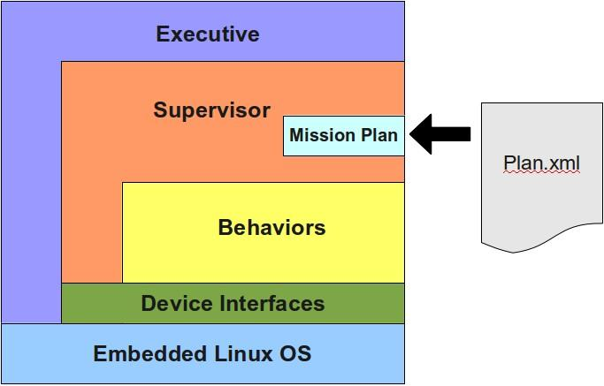

Figure xx is a high-level diagram of the software architecture. Generally requests flow from top to bottom and information is filtered from bottom to the top. Also, higher-level logic is conducted as you move up in the diagram.

At the base is a stable and reliable Debian-based Linux kernel and operating system (OS) tailored for embedded systems. Communication to the devices is handled using the conventional Linux serial and networking protocols, using both C and Ruby programming languages. The SES system design also relies on the simple and proven process management tools available in Linux to both automatically start the control system at boot time, and to restart the system should it fail unexpectedly.

Layered onto the OS are the interfaces to the SES system components. The interfaces are designed to be used during short, focused dialogues as the devices will often be turned off between sessions. Any special handshaking required with a device is handled within the interface, providing a simple interface to higher-level functions. Serial protocols are used to communicate with the carousel motor driver, Wakey board, and fluorometer, while the imaging camera is controlled using the SDK provided by the manufacturer. The relay board used to manage power to the devices is controlled using shared memory on the computer board.

The Behavior layer is where most of the SES control logic resides. Behaviors can best be described as functional units of operation that define what the instrument can be tasked to do. An example of a behavior is MoveCarousel, which, as the name implies, moves the carousel to a given position. In the SES control system, behaviors run one at a time, have complete control of the instrument during execution, and leave the instrument in a neutral state when completed. By leaving the SES in a neutral state, a user is able to combine behaviors in arbitrary ways to produce unique mission plans.

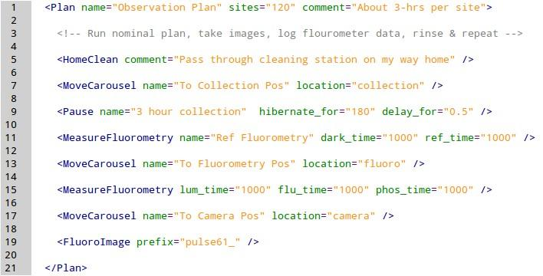

A mission plan is the method by which a user defines the operation of the SES during a deployment. A mission plan consists of a list of behaviors specified sequentially in a text file using a simple XML format. Figure xx+1 is an example of a mission file. The first line contains the Plan element where the user specifies the number iterations of the list using the sites attribute. Inside the Plan element the mission author simply lists the behaviors to execute in the desired sequence. The names of the different behavior types (e.g., HomeClean) hint at the function of each behavior, but each can also be documented using the name and comment attributes. The other behavior attributes relate to the task each type behavior performs, and are unique to each type. For example, the location attribute of the MoveCarousel behavior relates to the position to which the carousel will move.

The Supervisor is responsible for managing the execution of the mission plan. At the start of the process the plan file is loaded and parsed resulting in a behavior list. The Supervisor steps through the list executing each behavior one at a time, repeating the list based on the number of sites specified in the plan file. The Supervisor also manages restarts after hibernation periods during which the instrument draws very little power. When hibernation is requested by a behavior, the Supervisor saves the state of the instrument to a small execution database. The saved state is loaded after the mission plan on restarts and the Supervisor resumes mission execution from where it left off.

At the top of the architecture is the Executive. The Executive is started automatically by the Linux system during the boot process and is responsible for launching the Supervisor and responding to external messages. The Executive launches the Supervisor in such a way that, should the Supervisor process unexpectedly quit due to an unhandled exception, the Executive will receive a signal from the operating system and the Supervisor will be restarted. External messages come from the system console and request system information such as the current behavior and battery voltage, or command an action from the instrument. Commands include stopping the current mission plan, loading a different mission plan, and requesting the system to reboot.

