The design of the software system used in the SES was driven primarily by the requirement for unattended operations at depth with service intervals over 6 months. The system required reliable operation of the SES devices and components, mission data management, and the capability to resume the mission after scheduled hibernation periods as well as unscheduled restarts. The resulting system design emphasized simple, robust functionality over cutting-edge techniques with the objectives of predictable mission programming, minimal energy use, and hassle-free servicing in the field.

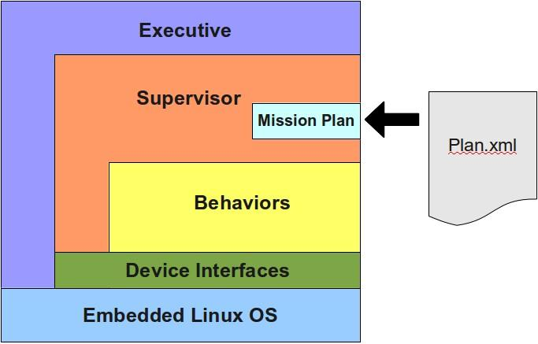

Figure xx is a high-level diagram the software architecture. Generally requests flow from top to bottom and information is filtered from bottom to the top. Also, higher level logic is conducted as you move up in the diagram.

At the base is a stable and reliable Debian-based Linux kernel and operating system (OS) tailored for embedded systems. Communication to the devices is handled using the conventional Linux serial and networking protocols, using both C and Ruby programming languages. The SES system design also relies on the simple and proven process management tools available in Linux to both automatically start the control system at boot time, and to restart the system should it fail unexpectedly.

Layered onto the OS are the interfaces to the SES system components. The interfaces are designed to be used during short, focused dialogues as the devices will often be turned off between sessions. Any special handshaking required with a device is handled within the interface, providing a simple interface to higher-level functions. Serial protocols are used for the carousel motor, wakey board, and fluorometer, while the imaging camera is controlled using the SDK provided by the manufacturer. The relay board used to manage power to the devices is controlled using shared memory on the computer board.

The Behavior layer is where most of the SES control logic resides. Behaviors can best be described as functional units of operation that define what the instrument can be tasked to do. An example of a behavior is MoveCarousel which, as the name implies, moves the carousel to a given position. In the SES control system, behaviors run one at a time, have complete control of the instrument during execution, and leave the instrument in a neutral state when completed. By leaving the SES in a neutral state, a user to combine behaviors in arbitrary ways to produce unique mission plans.

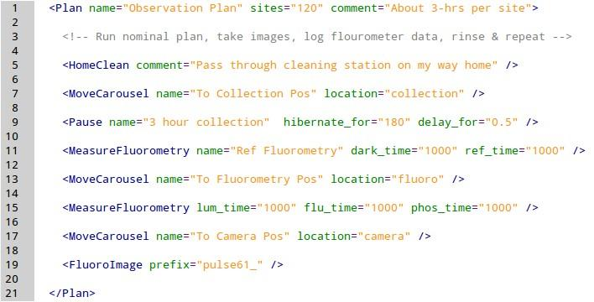

A mission plan is the method by which a user defines the operation of the SES during a deployment. A mission plan consists of a list of behaviors specified sequentially in a ASCII file using a simple XML format . Figure xx+1 is an example of a mission file. The first line contains the Plan element where the user specifies the number iterations of the list using the sites attribute. Inside the Plan element the mission author simply lists the behaviors to execute in the desired sequence. The names of the different behavior types (e.g., HomeClean) hint at the function of each behavior, but each can also be documented using the name and comment attributes. The other behavior attributes relate to the task each type behavior performs, and are unique to each type. For example, the location attribute of the MoveCarousel behavior relates to the position the carousel will move.

The Supervisor is responsible for managing the execution of the mission plan. At the start of the process the plan file is loaded and parsed resulting in a behavior list. The Supervisor steps through the list executing each behavior one at a time, repeating the list based on the number of sites specified in the plan file. The Supervisor also manages restarts after hibernation periods during which the instrument draws very little power. When hibernation is requested by a behavior the Supervisor saves the state of the instrument to a small execution database. The saved state is loaded after the mission plan on restarts and the Supervisor resumes mission execution from where it left off.

At the top of the architecture is the Executive. The Executive is started automatically by the Linux system during the boot process and is responsible for launching the Supervisor and responding to external messages. The Executive launches the Supervisor in such a way that, should the Supervisor process unexpectedly quit due to an unhandled exception, the Executive will receive a signal from the operating system and the Supervisor restarted. External messages come from the system console and request system information such as the current behavior and battery voltage, or command an action from the instrument. Commands include stopping the current mission plan, loading a different mission plan, and requesting the system to reboot.

