  - 3D at Depth
  - Wide Swath LiDAR
  - Factory Acceptance Test
  - Revision: 2.1
March 2025

- Purpose:
The purpose of this document is to capture all the Factory Acceptance Tests to be performed at 3D at Depth’s Longmont site with MBARI personnel. A hard copy of this document with MBARI and 3D at Depth representative sign-offs will be delivered with the system.

- Mechanical
  - Depth Certification of Housing

To date, the housing was certified to a depth of 4,000 MSW and pressured tested to 20% over working depth, 4810 MSW (7000 PSI). See Appendix 1 for details of pressure test.

The specification for this parameter is 6000m which has not been met; 3D at Depth will retest to 6000m within one year.

___________________________ | ___________________________
3D at Depth | MBARI

  - Mounting Calibration Report

Mounts are rigid and will hold calibration.

Validate dimensions with Mechanical ICD. (Mike S.) to review M.E.

___________________________ | ___________________________
3D at Depth | MBARI
  - Tooling, tools, and support equipment (Mike S.)

Provide a list of all tooling, tools and support equipment that would be used to service the system.
- See Mechanical ICD for hardware / fastener requirements for interfacing to the mount plate
- See User’s Manual for laser safety warnings.
___________________________ | ___________________________
3D at Depth | MBARI

The following items will be included with the system:

Qty (5) spare anodes P/N M000249 will be provided with the deliverable. _____

Qty (1) set spare Optical Head Safety Cover screws will be provided with the deliverable.

Qty (1) Optical Head Safety Cover will be provided with the deliverable. _____

The Head safety cover is not complete, missing holes for mounting screws. There are two types of anodes used in this design, and we request 5 spares of each. Please dictate which grease to use in service for any hardware. This must be addressed prior to delivery at MBARI.

___________________________ | ___________________________
3D at Depth | MBARI

- Electrical and Thermal:
24V measurements will be performed with MBARI provided 140W power supply: model VMS-225C-24-CNF. 18V and 36V measurements will be performed with a standard lab power supply.
  - Measure DC in-rush current draw at 18V, 24V, and 36V: (Kevin: on secondary from established 24 volts supply on)
18 VDC: DC Current: __________ Amps
24 VDC: DC Current: __________ Amps
36 VDC: DC Current: __________ Amps
Images (from Kevin) at 24 Volts in Appendix 2:

___________________________ | ___________________________
3D at Depth | MBARI

  - Measure DC current draw at 18V, 24V, 36V while scanning:
18 VDC: DC Current: __________ Amps
24 VDC: DC Current: __________ Amps
36 VDC: DC Current: __________ Amps
The system cannot scan at 36VDC at present, the voltage sensor needs calibration. This will be addressed by 3D at Depth prior to delivery at MBARI.

___________________________ | ___________________________
3D at Depth | MBARI

  - Measure DC current draw at 18V, 24V, 36V while at steady state:
18 VDC: DC Current: __________ Amps
24 VDC: DC Current: __________ Amps
36 VDC: DC Current: __________ Amps
Low Power State (18 VDC): DC Current: __________ Amps
Low Power State (24 VDC): DC Current: __________ Amps
Low Power State (36 VDC): DC Current: __________ Amps
Low power state is not complete or testable, 3D at Depth will complete this feature within one year of the FAT date.

___________________________ | ___________________________
3D at Depth | MBARI

  - Let the system soak in 3ºC salt water (~32 PSU) for approximately 1 hour to reach thermal stability. Then power on system and perform scans to demonstrate normal operation. (in aquarium with cover look at RTV)
The system cannot scan in normal operation when the laser temperature is below normal operating temperature (~12C). 3D at Depth will resolve this issue within 1 year of FAT.
___________________________ | ___________________________
3D at Depth | MBARI

  - Measure time that system can operate out of water in idle condition after Test 3.4 before reaching temperature limits (no more than one hour): _______________________
___________________________ | ___________________________
3D at Depth | MBARI

  - Demonstrate long term operation of the sensor at full power in scanning operation in < 20ºC Water.
The system was seen to overheat when the laser module temperature exceeded 40C during day 2 of FAT. Alarm limits may be increased after consulation with the laser vendor. 3D at Depth will resolve this issue before delivery to MBARI.
___________________________ | ___________________________
3D at Depth | MBARI

  - Pin Isolation

Test system has no faults to case from wet connector contacts.
___________________________ | ___________________________
3D at Depth | MBARI
  - Demonstrate successful isolation of 1PPS/ZDA input.
ZDA input is via Ethernet, therefore is isolated by design.
PPS & PPS ground pins will be validated against housing and all other connector pins.
PPS: ________
ZDA: ________
___________________________ | ___________________________
3D at Depth | MBARI
- Software:
  - Demonstrate successful real time target data collection at maximum acquisition rates.
Show profile and waterfall graphs while moving objects during scan: _________
Show presence of archived data: _________
Process data for 3D Cloud visualization: _________
Show scan rates: _________
In profile visualization, 0 as vertical down, with positive angles to starboard, and ordering angles in a scan from -180 to +180. System cannot collect data continuously at the maximum frequency of the laser pulse. Laser optical output power is below desired levels. A sample data file code sample will be developed. 3D at Depth will resolve this within 1 year of the FAT date.
___________________________ | ___________________________
3D at Depth | MBARI

  - Demonstrate CTD input, PPS/ZDA input functions properly
PPS/ZDA demonstrated with in-house GPS, 3D at Depth test software, and visual inspection of sensor clock synchronized: _________
Demonstrate CTD auto-update across Ethernet with 3D at Depth test SW. Visual inspection of sensor GUI to show updates: _________
Visual inspection of status LEDs on GUI: _________
Instability in the PPS indicators in the GUI exist. When testing on in-house GPS, the 3v3 level of the PPS did not successfully trigger the input on the sensor. CTD messages have been received successfully, but log files are being broken too often, overwrite the same file per day. CTD Socket on the sensor times out and closes the connection at rates ~1Hz. Clarify CTD Indicator behvaviour on the GUI. 3D at Depth with change this prior to delivery at MBARI.
___________________________ | ___________________________
3D at Depth | MBARI

  - Demonstrate that topside software can be installed on new topside machine (in case of field failure of acquisition machine)-install in Eric’s Laptop
Documentation of how to perform this will be provided prior to delivery at MBARI.
___________________________ | ___________________________
3D at Depth | MBARI

  - Demonstrate system functionality through Ethernet
Validate 100 Mbps communications through cable
___________________________ | ___________________________
3D at Depth | MBARI
  - Demonstrate remote control protocol
Turn off, on, low power state, turn off laser, turn on laser
Demonstrate the ability to save and run a script from the sensor
Power and attenuation controls are missing from scripts and CCI interface. 3D at Depth will complete this feature within 1 year of delivery.
___________________________ | ___________________________
3D at Depth | MBARI

  - Step through all GUI Command operations (3D Collect), functions, configurations and safety features
Temperature sensing on Red1 is not working. 3D at Depth will complete this feature withing 1 year of delivery.

___________________________ | ___________________________
3D at Depth | MBARI
  - Ensure the Help button in 3D Collect opens the User Manual
The current User Manual is a draft. The final version will be available, pending approval, prior to delivery at MBARI.
___________________________ | ___________________________
3D at Depth | MBARI

  - Step through all GUI visualization operations (Real Time Viewer), functions, and configurations
Orientation of the polar plot needs to be adjusted, this will be complete before delivery to MBARI
___________________________ | ___________________________
3D at Depth | MBARI

  - Step through Tool Operations (2D Viewer, 3D Cloud Motion, etc.)
___________________________ | ___________________________
3D at Depth | MBARI

- Performance:
  - Qualify swath width of final assembly
Swath should be 360° (minus the upper area covered to reduce scan file size).
Measure distance to wall and measure scan width on wall. Compare to trig calculation.
___________________________ | ___________________________
3D at Depth | MBARI
  - Demonstrate outputs from two red channels
This specification is currently not complete or testable, 3D at Depth will complete this feature within one year of the FAT date
___________________________ | ___________________________
3D at Depth | MBARI
  - Demonstrate output from accelerometer
This specification is currently not complete or testable, 3D at Depth will complete this feature within one year of the FAT date
___________________________ | ___________________________
3D at Depth | MBARI

  - Demonstrate system safety features
Safety light on during scan: _________
Verify emergency stop button in GUI shuts off laser: _________
Verify loss of ethernet laser safety:(if no communication laser will shut of within a specified amount of time) _________
Validate 3DC GUI is password protected: _________
Loss of ethernet does not succeed at this time, leaving laser on with no recovery mechanism. Laser Emission indicator needs to accurately reflect the class rating of the laser. 3D at Depth will complete this feature prior to delivery at MBARI.

___________________________ |  | ___________________________
3D at Depth |  | MBARI
  - Range Performance
System must achieve required range performance and precision.
Range 1-10m:______
Precision 3mm: _______
___________________________ |  | ___________________________
3D at Depth |  | MBARI

- Shipping Manifest:

Optics Pelican Case
ITEM | Quantity
Wide Swath Dual Optical Head Assembly | 1

Support Pelican Case
ITEM | Quantity
MacArtney 13-pin cable 3m (right angle) | 1
13-pin MacArtney dummy plug, female | 1
Black Locking Sleeve, Female (w/ Retaining Ring in Middle Groove) | 1
Laser Safety Documentation | 1
Spare handle screws & washers (4/ea) | 4
Laser Safety Cover | 1
Set of spare safety cover screws | 1
Spare anodes (¼-20) | 5

___________________________ | ___________________________
3D at Depth | MBARI
- Terms of Acceptance

In process of completing this set of Factory Acceptance Tests, items marked in red above represent incomplete features or issues within the sensor that prevent testing as prescribed. For each of these identified items, 3D at Depth agrees to address them in the dictated amount of time under the existing contract. It is acknowledged by both 3D at Depth and MBARI that the sensor is conditionally accepted under these terms, in order to allow for continued testing at MBARI’s test facilities. Failure to resolve the identified items will be considered a violation of the contract.

Appendix 1: Pressure Test Results
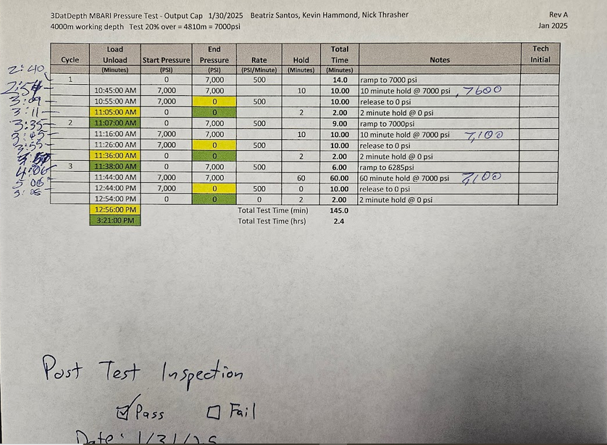

Appendix 2 – Current Testing Pictures

Scale: 10mv equates to 2 Amps (V * 0.2 = Amps)

24VDC – Inrush (7.6 Amps)
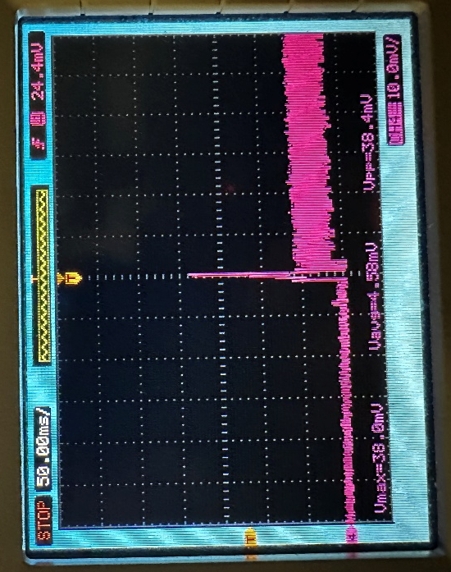

24 VDC – Steady State (2.46 Amps, 59.04 Watts)
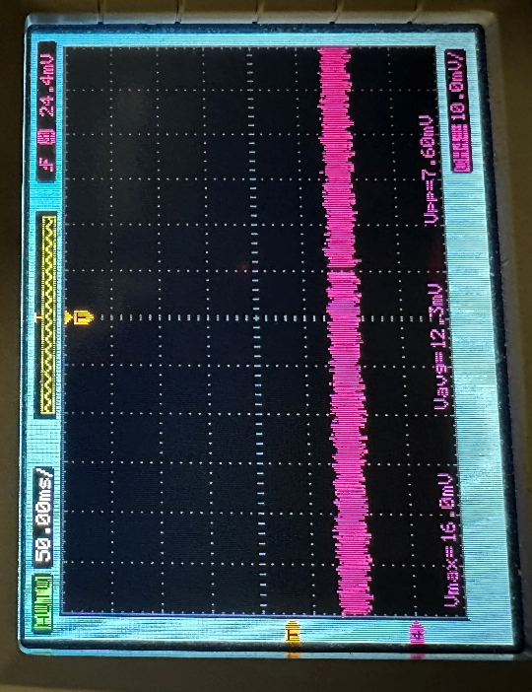

24VDC – Scanning (4 Amps, 96 Watts)
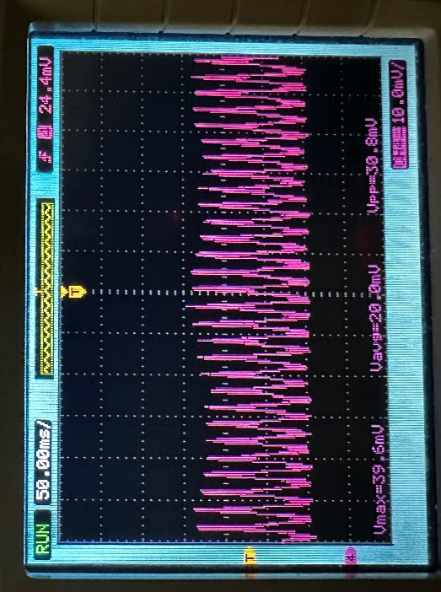

18VDC – Inrush (11.52 Amps)
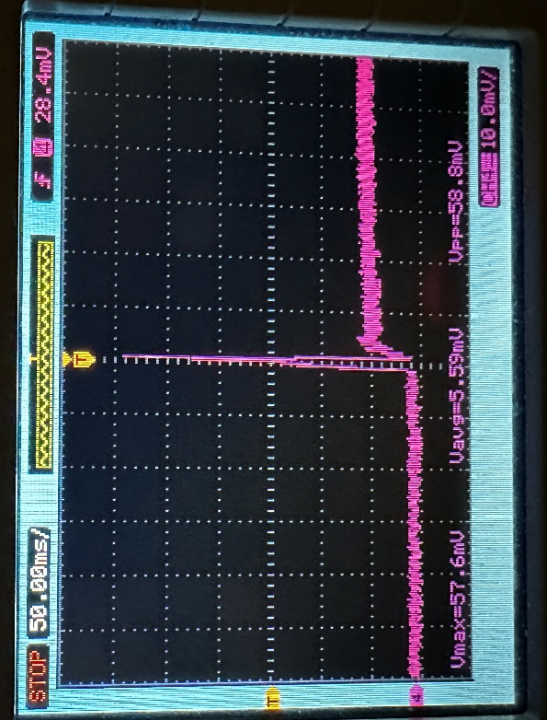

18VDC – Steady State (3.18 Amps, 57.24 Watts)
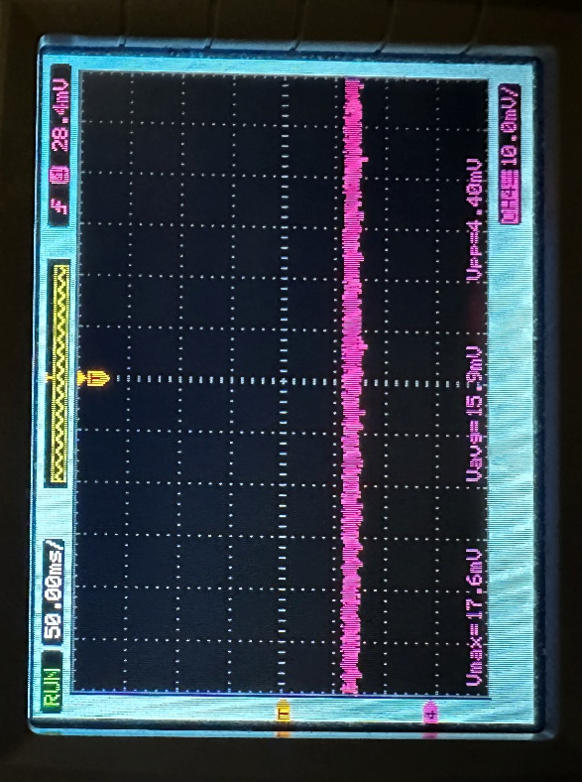

18VDC – Scanning (5.32 Amps, 95.76 Watts)
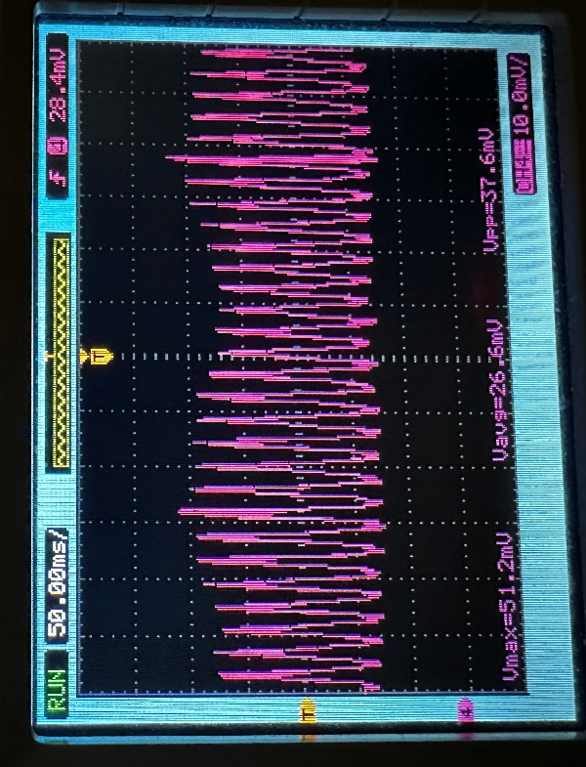

36 VDC – Inrush (6.4 Amps)
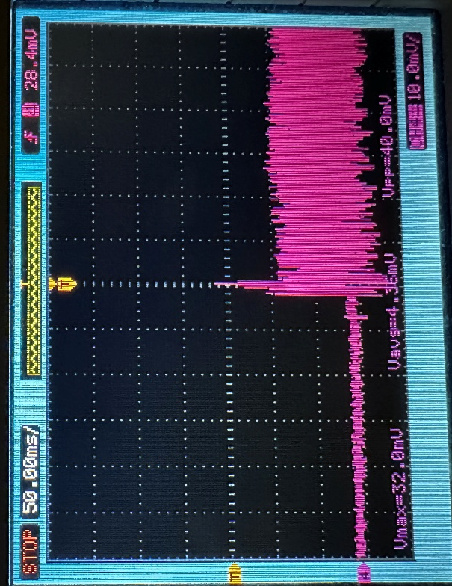

36 VDC – Steady State (1.962 Amps, 70.632 Watts)
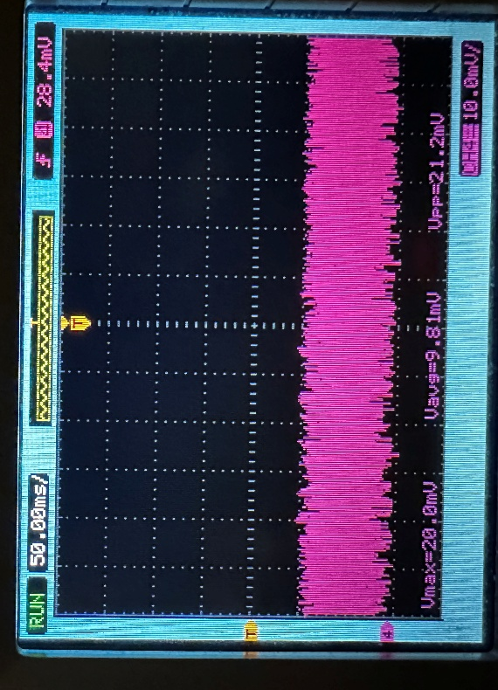

36 VDC – Scanning

Not Measured

