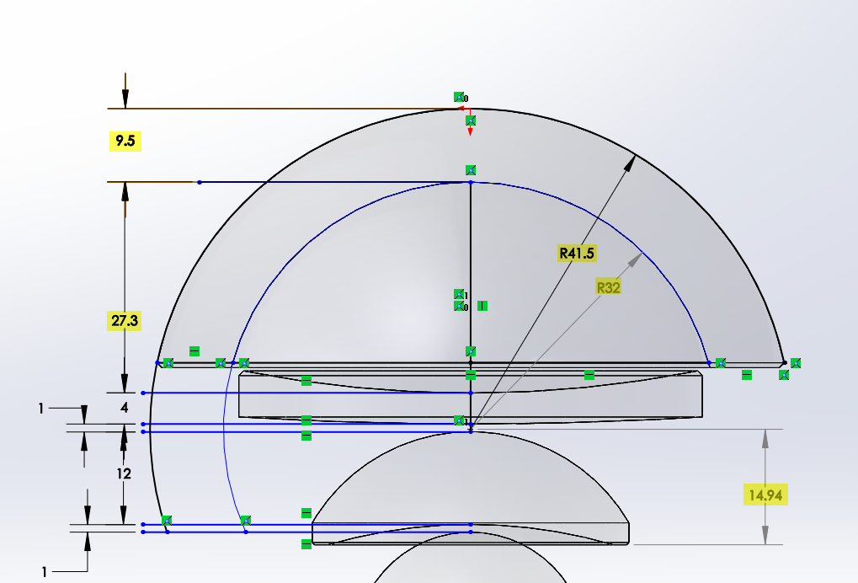
Figure 1: The highlighted dimensions have changed from the previous design. We finally secured an accurate drawing of the hemispherical port, which was significantly different from what we originally measured.

`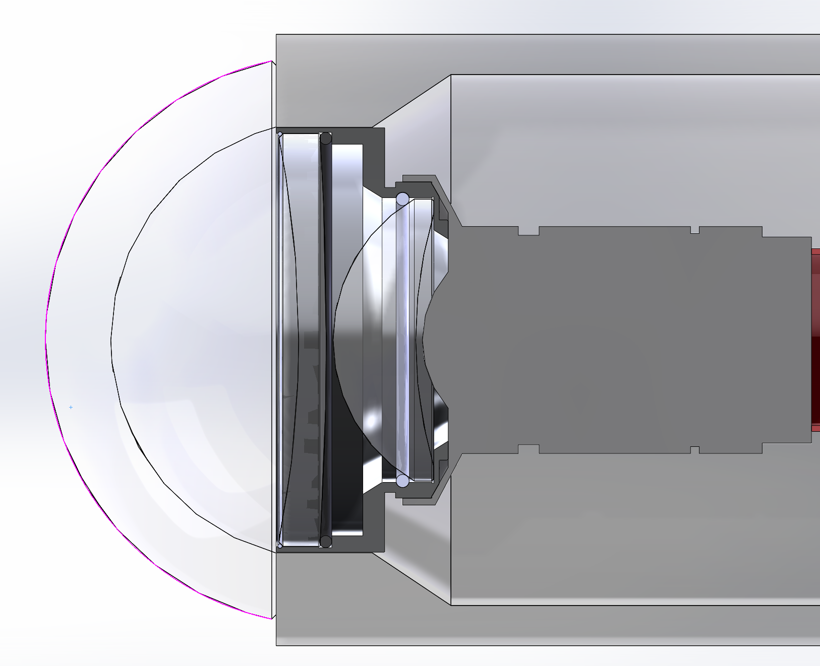
Element A’s convex surface sits on rubber O-ring. Nylon coated stainless steel wire “feed-through” contacting on large (0.06mm) bevel holds lens both axially and radially.
Element B sits on ground base. Upper right corner of cell is relieved and lens is beveled. Lens is retained by 0.075” monofilament “feed-through”

