Email chains regarding the strobe overheating issue discovered during the 2023 R/V Carson cruises.

Jan. 3 2024 11:15AM

Chad,
Digging through old emails and found this nugget of information. 70C is sane, but we could still reach out to eli and see if he wants to look at the unit. I'll ping him in a minute.
Eric
----- Forwarded Message -----
From: "David Caress" <caress@mbari.org>
To: "Hans Thomas" <hthomas@mbari.org>, "Eric Martin" <emartin@mbari.org>
Cc: "David Caress" <caress@mbari.org>
Sent: Tuesday, November 3, 2020 1:20:21 PM
Subject: Re: temperature cutoff in the strobes
Can we add a temperature sensor to the ballast electronics?
Dave
> On Nov 3, 2020, at 12:52 PM, Hans Thomas <hthomas@mbari.org> wrote:
>
> Dave and Eric -
> I was talking with Eli Perrone who builds the strobes. He mentioned that there is a temperature cutoff in the strobe ballasts which monitors the temperature of the charging FET, and trips at 70C. This will prevent the strobe from charging and firing until the temperature drops. This might be the cause of the strobes cutting off in the tank.
>
> Regards
>
> Hans Thomas

Jan. 3 2024 11:37AM

That would make sense with the consistent 11 second interval (cooling down time). But, why are we reaching their cutoff temperature? Maybe that's why Hans derated the power supplies (400W)?
Oh,

Jan. 3 2024 11:43AM

No i think those supplies were just the best he found, but he wasn't always transparent so that could've been a factor.
Why are we reaching it is a good question, but it all fits that the bottle just isn't conducting enough heat out as its working. Titanium is not the most efficient in thermal characteristics, worse than steel and aluminum. I sent the email to Eli, hopefully we get a reply.

----------------------------------------------------------------------------------------------------------------------------------
Jan. 3 2024 11:38AM

Eli,
As you may recall we updated the capacitor banks in our model 3831 titanium housings a few years ago, which are deployed on our Low Altitude Survey System, mounted to our ROVs. Until recently, they have been working well with only the occasional service for new bulbs on the lamps occasionally. There is a new problem I'd like to discuss with you.
On our last expedition one of the two ballasts would seem to stop outputting light at regular intervals after running for 2 hours or so. Approximately every 12-15 minutes, they would turn off for 3-5 minutes. Triggering remained constant at a period of 2.25 seconds. The water was around 7 degrees celsius.
We have seen this issue before in our test tank where the water is closer to 17C, and some past notes I have from Hans Thomas indicates that there a temperature cutoff at 70C in the housings that prevents discharge as a protective mechanism. We haven't seen this problem so reliably in the past in the field, so I'm wondering if perhaps we have damaged electronics that could get us back to our previous level of performance.
What are your thoughts on these observations? We are planning on using this system again, but not for 4 months or more from now, there is ample time to get them sent in for service or repair if those options are available.
Thanks for your time, and happy new year.
Cheers,
Eric

Jan. 4 2024 12:26PM

Eric,
That's interesting. When you say "one of the two ballasts would seem to stop outputting light", do you mean that one flash head would stop firing while the other one kept going? Or do you have both bottles mounted and one of them has this problem? If it's one of the two flash heads connected to one chassis pausing, that points to something else other than thermals.

There is indeed a thermal switch (SW1) mounted to the capacitor charge FET (Q5). I wonder if it's the older system, SN:026. The possible cause might be dried out thermal paste or lose hardware attaching Q5 to the aluminum chassis rail. I'm happy to help troubleshoot, and hopefully fix the issue without the need to ship anything cross country. I doubt the electronics are damaged, so it should be an easy fix.

Thanks,
Eli

Eli Perrone
EP Oceanographic, LLC
5 Spinnaker Lane
Pocasset, MA 02559
(508) 296-0290

Jan. 4 2024 12:52PM

Eli,
Thanks for getting back to me. I can confirm that both heads on one ballast would stop firing while the other pair on their own ballast kept going. We have power relay control to individual housings so we could confirm it was localized to one ballast and that both lamps on that one ballast were not firing. Our notes seem to have been lost, so we're not sure exactly which ballast it was that had this happen subsea. However we have a test tank and can replicate the issue there.
Sounds like the next step is to open the housings and inspect the areas you indicated for signs of trouble. We'll send pictures once we dig into that.
Cheers,
Eric

--------------------------------------------------------------------------------------------------------------

May 20 2024 5:14PM

Eli,
Sorry I never sent any pictures, but the thermal paste did seem dry on that part you mentioned. Do you have a spec for a specific thermal paste you would recommend?
Eric

May 21 2024 11:19AM

Eric,
I use Arctic Alumina, but any compound should work fine. Has the problem persisted?

Thanks,
Eli

Sept 25 2024 3:26PM

Think I found the thermal switch datasheet, the embossed bit looks like the cantherm logo.
The marking makes sense,
- F20B = Normally Open
- E06 = Housing
- 07005 = response temp 70˚C ± 5K tolerance
- 065C = date code and factory.. ?
So 70˚ is closer to what we had on the FLIR.
https://www.cantherm.com/wp-content/uploads/2017/05/cantherm_f20e061.pdf

Sept 25 2024 3:34PM

Ok, cool. Still working as anticipated. Probably not worth the hassle, but now I'm really curious how the port ballast would look under the FLIR.

Sept 25 2024 6:59PM

I share your interest, let's see if Eli comes back with anything, but either the FET is heating up too much or we need better bonding.

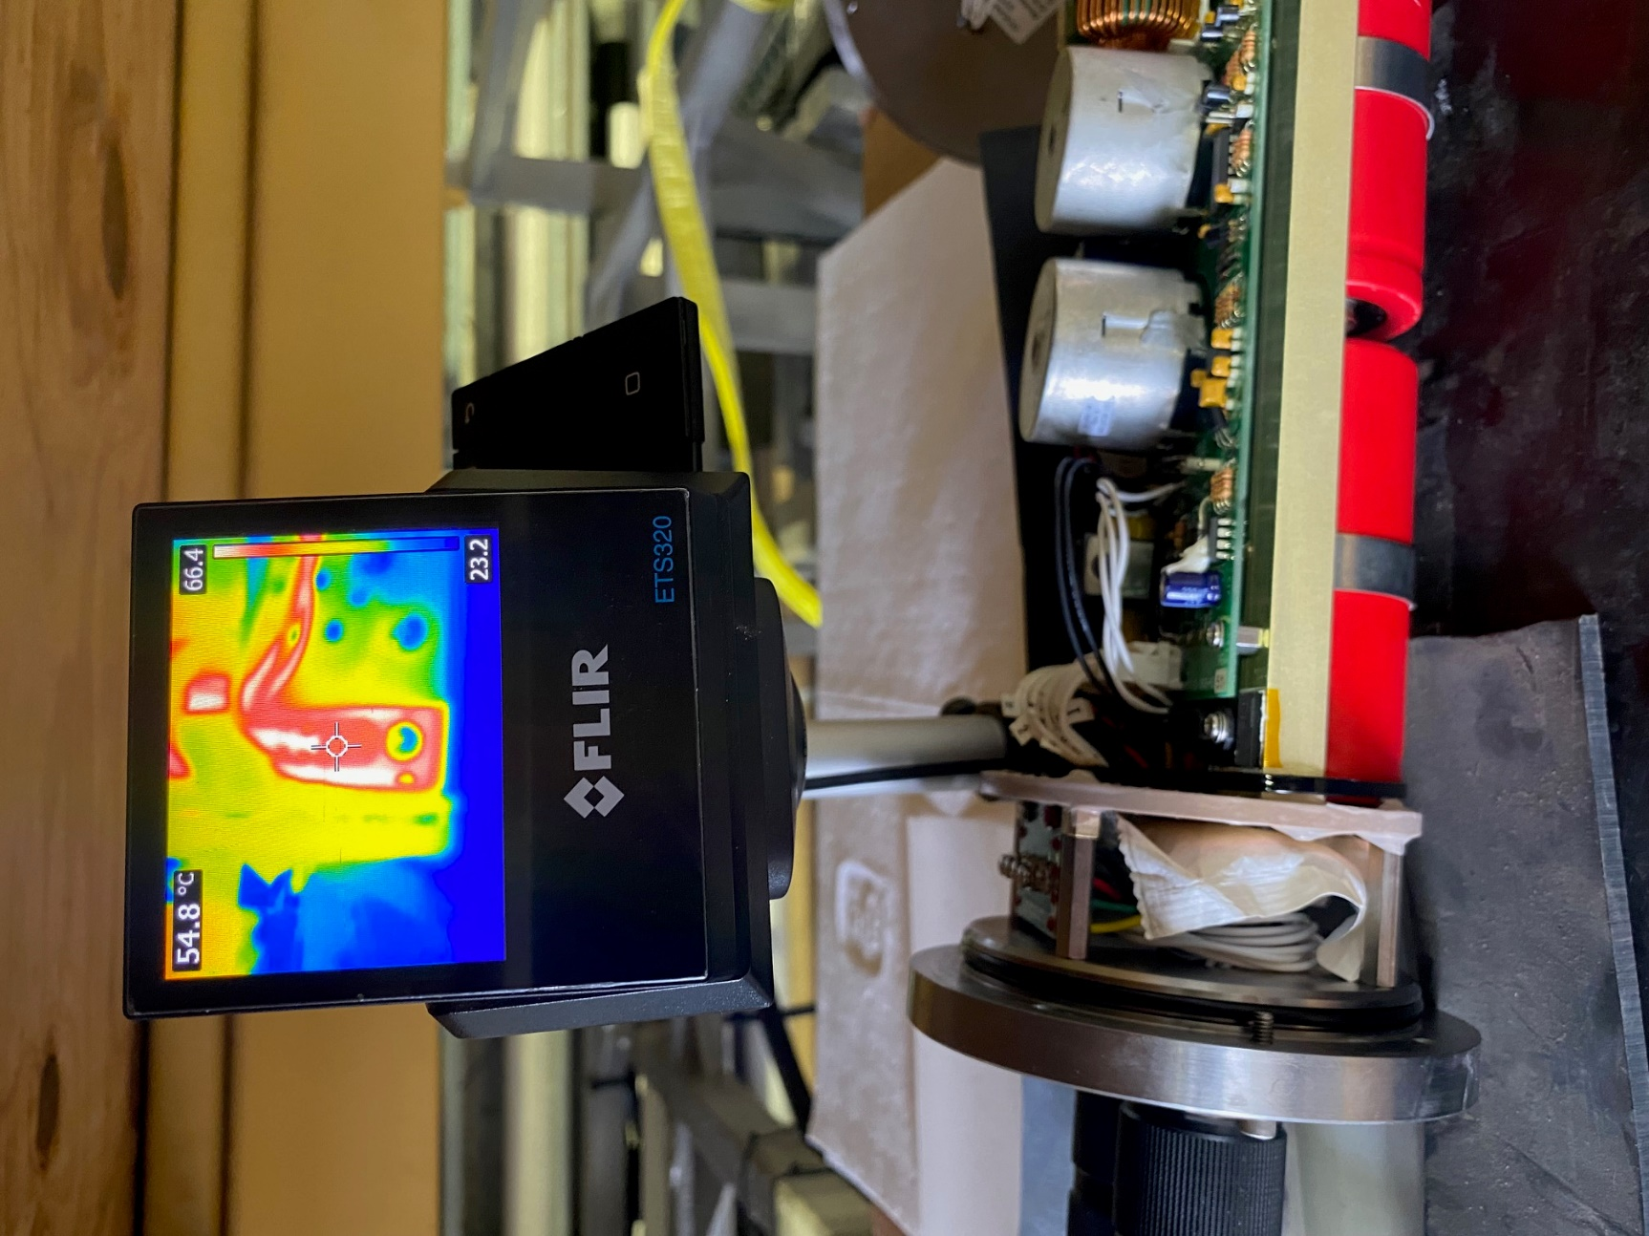

Sept 25 2024 3:42PM

Eli,
We were finally able to get offshore and test out the strobes again, but the problem remains on only one ballast. We replaced the heat sink compound as it was rather dry (pic attached). We used arctic alumina and reassembled (other pic).
The sea trial let us characterize the problem a bit more and today we tested some more in air. We were able to recreate the problem, and still see this cutout happening on serial number 48 only.
We took some precautions and setup to run the electronics outside the housing, using a FLIR camera to watch the temperature switch. Exposed to air, the problem still occurred, but from the attached flir image you will see the temperature switch responded at 69˚C measured on the case. From the marking, I believe that it should cut the charge FET at 70˚C. Please confirm that the unit is working within specification.
If so, seems like the that the heat cannot be conducted out of the ballast housing as well on one unit as the other.
We would appreciate any thoughts you have to improve the performance. We have some time until our next deployment and we could send components back for evaluation as well.
Eric Martin

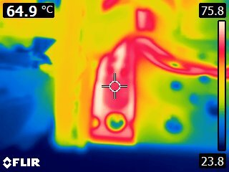

Sept 26 2024 11:06AM

Eric,
Interesting. I bet we can turn down the charge power a little, and remedy the issue. Can you compare the amperage drawn during charge (it'll vary somewhat as the caps charge up) between the 2 chassis? My notes say that the new chassis using PCB #51 drew 8.67A with a continuous 60mA load applied (using a DC electronic load), the spare PCB, #53, drew 8.40A with the same load. Unfortunately, I don't have Bill's notes on your ~2012 PCB, #31, other than the manual saying it could draw up to 8.6A and a photo showing 8.43A. Which PCB numbers are you using (I see #51 is the one overheating, but I'm not sure which one/ones you are comparing against). Also, when running at 2.25 second rep rate, is there a delay between the charge stopping and the flash firing with each PCB? It's also possible that the capacitors have aged a bit, and have changed value. This is pretty common, but it usually doesn't cause problems because people generally don't run these quite as hard as you folks are. You are correct that the temp switch is a 70°C unit, so that's working properly.

I can adjust 2 parameters on the PCBs: the maximum charge voltage and the time that Q5 is on. Both are changed by changing the value of a 10-turn potentiometer on the PCB, and you'd only need access to a scope and volt meter do make adjustments. If you have a capacitance meter that can read high enough, you could also check the capacitance of each capacitor on your chassis, and see if there's a difference, but you MUST discharge the caps fully before testing them. I would run them down to nothing, and then stick a resistor on them overnight to let the residual charge dissipate before measuring them. They're nominally 1600uF each, but they usually read higher than that when they're new. They tend to change over time, usually getting lower, but it's possible that one bank is still higher than the others, which would lead to the PCB having to run longer to achieve the same voltage.

We could also add some thermal compound between the chassis rail and the endplate, but I don't see this making a huge difference. If all else fails, we could install a secondary heatsink between Q5 and the chassis, possibly extending up to the endplate and capturing a couple of those screws. Let's start simple, and work our way to more complicated fixes.

Thanks,
Eli

Nov. 19 2024 9:29AM

Hi Justin - I was wondering if you could help us out with a heat issue we're having with one of our two strobe ballast housing in the LASS system. I've forwarded the email chain between Eric M and Eli (the designer of the housing) for background. Basically, one of the housings is overheating and its thermal switch is killing power to the strobes. We were thinking that an additional metal conduit from the baseplate to the endcap might help dissipate the heat quicker? I have the housing in question down in the lab.

Thanks,
Chad

Nov 19 2024 9:58AM
Hi Chad,

Yes happy to help. I think I understand the problem but I’ll swing by in a bit to talk it over.

-Justin

Dec. 12 2024 10:03AM

Eli,
We've been working on this in the background a little. We did check the capacitors and they seemed to match well. We'd hate to lose light output so I think try to pull out the heat better is perhaps where we'll jump to. I'm including Justin Tucker, our ME whose going to look at adding some bits to the chassis. Mostly he's looking for drawings of the chassis parts if you have any, or a model really is best.
Eric

Dec. 12 2024 10:09AM

Eric,
I was suggesting lowering the charge amperage, not the fully charged voltage, so you wouldn't lose any light output. It would just take the strobe PCB a little longer to charge the capacitors to full voltage. If you're running high rep rates, this might not help, but it would if there was some dead time between the charge and photo.

I have models for the strobe chassis rails and endplates, and I can send those to you soon. I've got to head out today for a funeral down in NJ, and I won't be back until late tomorrow, so it'll have to wait until Monday (if I don't get to it over the weekend).

Justin,
I assume STEP or IGES format would work?

Thanks,
Eli

Dec. 16 2024 6:39AM

Justin,

Please find the 4 parts and the assembly (sans hardware) attached. If there's anything else I can do to assist, please don't hesitate to reach out.

Another option would be to replace the charge FET with one with lower RDSon, or a lower resistance curve/faster turn-on. The one I'm using is the IRFP260N, which isn't the latest and greatest, but has a long history of surviving the abuses of the strobe charge circuit.

Thanks,
Eli

Dec. 17 2024 9:18AM

Hey Eric - After rereading Eli's response and checking the ballast schematic, it is the IRFP260N that is currently used. It is an active, stocked part at Digikey so I ordered some spares. I also found (and ordered) two potential replacements: IRFP90N20D and IRFP4668P. They are very similar but the newer TO247 parts have slightly better thermal resistance (lower). The RDSon of the 4668 is 4-5 times lower than the 260 so that alone should help cut down on excess power being dissipated in the mosfet. I've attached the datasheets of all three parts. The key parameters I was focused on was junction thermal resistance, RDSon, and Turn-on delay times. The turn on delay times are in the 10-100 of nsec, so it is *probably* fine for all three parts. Feel free to review them and give me any thoughts.

I still think we should pursue the mechanical solution too (or both) as the performance of any part degrades as it heats up.

Chad

