WISSL-2G housing Review

  - Drawing communication date: April 17th 2024
  - Reviewer: Justin Tucker
Last update: 4/18/2024

Review Scope:
- Survivability at 6000m
  - Justin (FOS seems low)
    - Consider OD increase
- O-ring design
  - Justin (warning)
    - On the edge for recommended squeeze
    - Extrusion gap at 1500psi is a problem
- Validate we have the correct connector and they are OK with placement
  - Erik (OK’d)
- Do they have any issues with using SS 17-4 PH H1025 material for the optical endcap? We are looking at changing the heat treat from the current product for strength.
  - Justin – Not ideal. do we know why they don’t want to use Ti? Methods exist for using a hardened steel backing plate to reinforce on the inside to support Ti in stiffness for the optic interface.

Survivability

Tube Review
Yield seems fine, buckling FOS seems low.
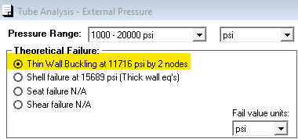
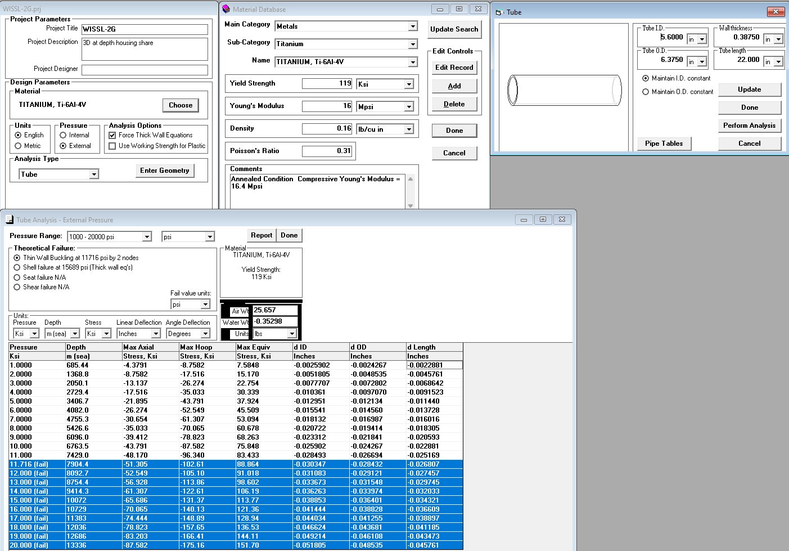

End cap
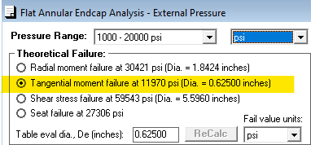
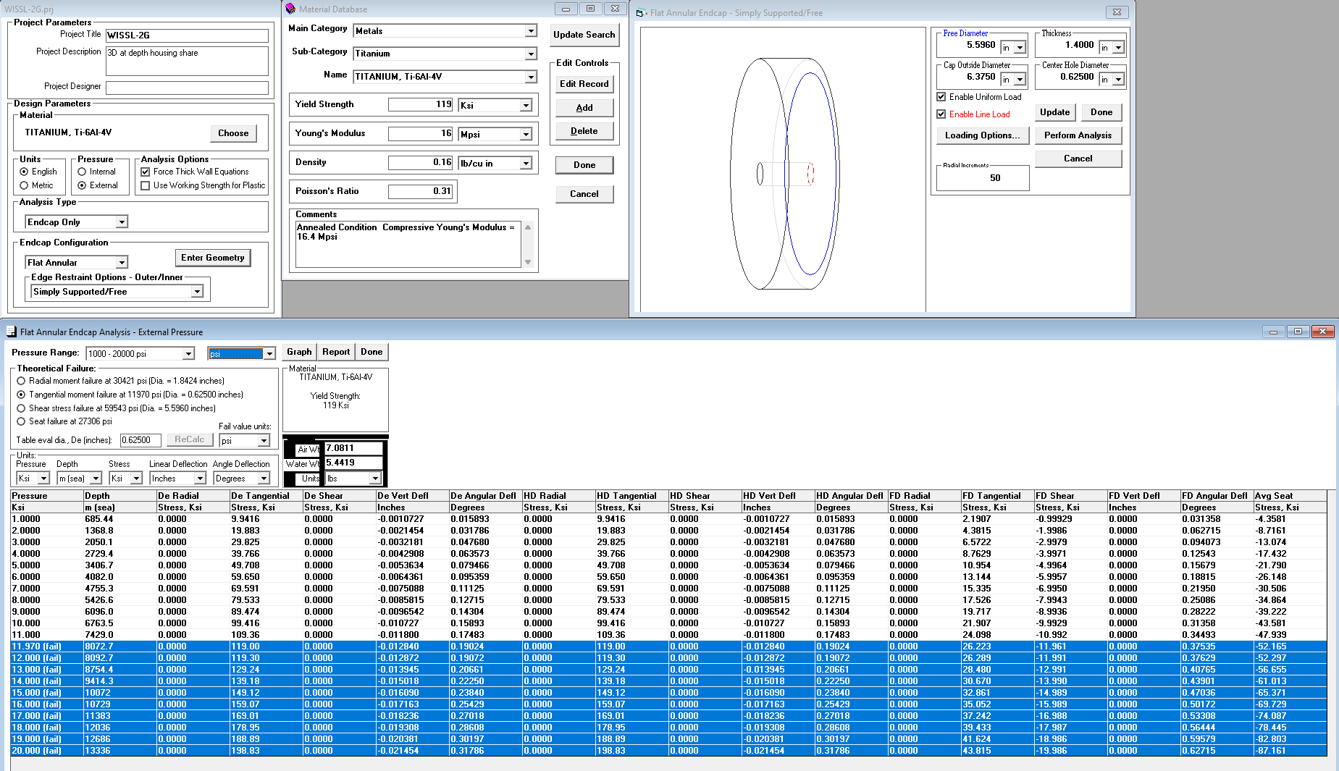

O-ring

Warning
- O-ring extrusion gap exists at 1500psi!
- Min tolerance stack slightly lower squeeze than recommended.

