LASS Seafloor Mapping Triggering Information

Teledyne Tasman DVL
Triggering
Triggering is the most efficient mitigation technique to prevent or minimize interference between the DVL and other external (acoustic) sensors in the vehicle. For example, an external trigger commands the external device and the DVL to alternate their transmissions, and this external synchronization ensures that the two devices will never interfere with each other. There are two methods for triggering the DVL

Sending ASCII Character through Serial Port.
When the system is interfaced to a serial port (e.g., a navigation computer), the system can be setup to wait for an input before each ping. To setup the DVL in this fashion, clear the Auto Ping Cycle bit in the CF command by sending CFx0xxx, where the x’s represent the set-tings of the other parameters. Start the DVL pinging with the CS command. The DVL will output a ‘<’ before each ping and wait for input. Send any valid ASCII character to trigger the ping. The instrument will not enter sleep mode while it is waiting for the trigger. This trigger method has latencies ranging from a few milliseconds to a few hundred milliseconds, which may be excessive for high-precision applications.

Using Low-Latency Triggering.
The DVL has a TRIG_IN line, which accepts Low-Latency Trigger signals. TRDI has specified the input trigger voltage as 3.3VDC to 7VDC. The polarity is defined as the electrical level at the connector referenced to COM_GND (see Cable Wiring Diagrams for the full pinout).

Pin # Signal Name Wire Color
8 | TRIG IN | Green
9 | COM_GND | White

Trigger Pulse Length Limits.
Based on our experience, the following trigger pulse works well:
• Trigger input voltage: 3.3 ~ 7Vdc, polarity referenced to COM_GND
• Trigger pulse length: 500𝝁sec

Our internal testing shows that the minimum trigger pulse length must be at least 105 𝝁𝝁𝝁𝝁 for the trigger to function properly. A trigger pulse length < 105 𝜇𝜇𝜇𝜇 will not be recognized by the DVL (i.e., the DVL will not ping on trigger).

The maximum trigger pulse length depends on the trigger rate. Our internal testing shows that the maximum trigger pulse length is approximately 99% of the trigger period. If the trigger pulse length is > 99% of the trigger period, the DVL may work intermittently. The following table shows some examples of various trigger rates and their corresponding approximate maximum trigger pulse lengths.

Trigger Rate (Hz) Trigger Period (msec) Maximum Trigger PW (msec)
1 | 100 | 990
2 | 500 | 495
5 | 200 | 198
10 | 100 | 99

To configure the DVL for low-latency triggering, set the CX command to enable trigger input.
Format: CX n d t [p]
Where:
n = 0 to 5 (see table below).
d = 0 to 65535 one hundredths of a second delay time.
t = 0 to 65535 one hundredths of a second time-out time. Setting “t” to 65535 disables the time-out.
p = 0 or 1 (optional). Setting “p” to 1 enables ping-once mode after time-out.

For example, set the CX command to CX 1 0 65535 0 to set the system behavior to ping after a low to high transition with no delay and the time-out is disabled. Start the DVL pinging with the CS command. The DVL will then wait for a trigger before each ping. Set the trigger lines to a break state for the recommended trigger pulse length to send the trigger. The DVL will then ping within 1 millisecond of the leading edge of the break pulse.

CX (n) System Behavior
0 | Trigger off
1 | Pings after low to high transition
2 | Pings after high to low transition
3 | Pings after either low to high or high to low transition
4 | Ping while trigger is low
5 | Pings while trigger is high

Note that it is possible through the CX command settings to set a timeout for the DVL to wait for a Trig-ger and then if no Trigger occurs during that time, it will either Self Deploy and never look for Trigger again or Ping once and then go back to waiting for Trigger. See the CX command for details.

Teledyne Reson T51-R

- PPS In and Trigger In
  - Electrical Specifications for PPS In and Trigger In
Table 20: PPS In and Trigger In Signals
Parameter | Min. | Typical | Max. | Unit | Note
Absolute maximum signal voltage | 15 |  |  | V
Absolute maximum reverse signal voltage |  |  | -1 | V
Low voltage threshold | 1 | 1.6 |  | V
High voltage threshold |  | 1.6 | 1.8 | V
Input current (high)  @2V  @3V  @5V  @15V |  | 7  8  10  20 |  | mA  mA  mA  mA
Input current (low) |  | 0
Input delay |  | 400 | 1000 | ns | Pulse 0V to 2V, 50 Ohm

  - Typical PPS In and Trigger Performance
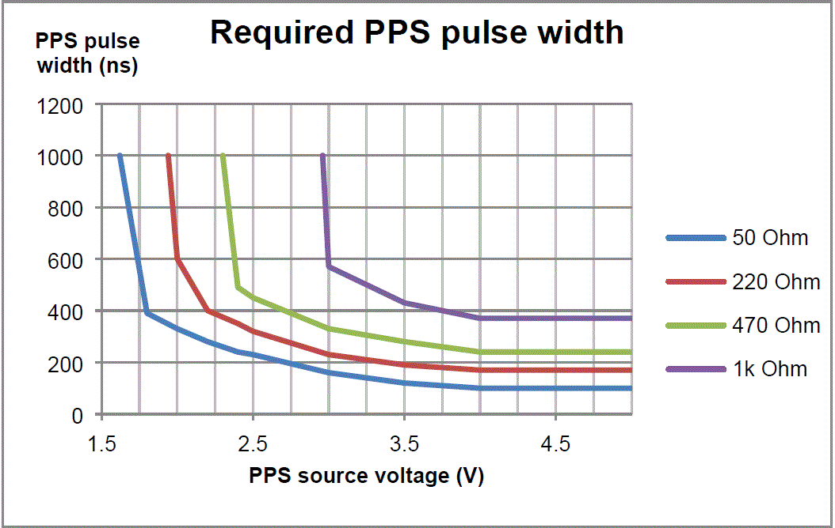
Figure 56: Required PPS Pulse Width

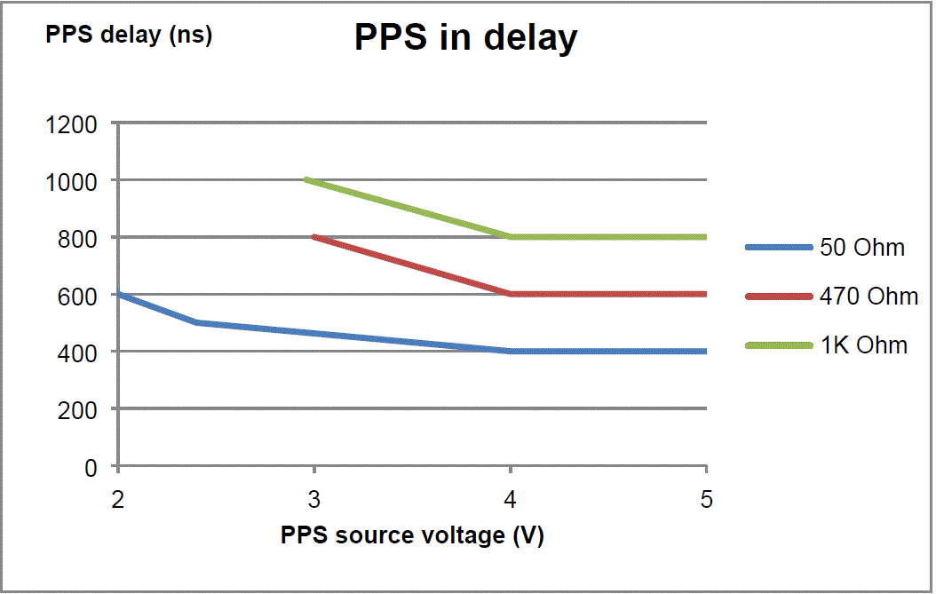
Figure 57: PPS In Delay

  - Hints and Advice
- The PPS and trigger inputs work with regular CMOS TTL outputs.
- The drive capability of a standard TTL output is inadequate to drive PPS and trigger high.
- When more systems use the same PPS source using BNC-T-adaptors it should be verified that its drive capability is sufficient.
- For distribution of the PPS pulse, "PPS out" may be used instead of the BNC-T-adaptor.
- Make sure the PPS source output is in accordance with the specifications listed in Table 20.
- Operation is ensured if the source resistance is less than 470 Ohm, the drive voltage is greater than 3V, and the pulse width is greater than 1µs.

The PPS/trigger described is the externally available signal. The signal is conditioned before it is internally distributed.

Figure 58: PPS/Trigger Signal

Error Messages (Trigger Related)
Message | Description | Action | Type
Trigger out length (x) is invalid | An unsupported value was received for trigger setup. | Check settings in user interface. | External Trigger
Trigger out offset (x) is invalid | An unsupported value was received for trigger setup. | Check settings in user interface. | External Trigger
Trigger out offset + length (x) exceed limit of 20ms | An unsupported value was received for trigger setup. | Check settings in user interface. | External Trigger

Measured at the BNC terminals.
Voltages beyond maximum limits may cause permanent damage to the input.
Completely unconnected input guaranteed to be low.

