Enabling New Techniques in Environmental Assessment Through Multi-Sensor Hydrography
Eric J. Martin, David W. Caress, Hans Thomas, Brett Hobson, Richard Henthorn, Michael Risi, Charles K. Paull, James P. Barry⇤, and Giancarlo Troni†
⇤Monterey Bay Aquarium Research Institute
Moss Landing, CA 95039 Email: emartin@mbari.org
†Pontificia Universidad Cato´lica de Chile
Santiago, Chile

Abstract—A suite of complementary survey tools aimed at producing 1-cm resolution bathymetric models co-registered with 2-mm pixel color photography has been assembled. The design goal is to produce quantitative documentation of both geological and biological features that will allow change over time to be assessed at vertical and lateral scales approaching one centimeter. The current suite of tools combines multibeam sonar, stereo cameras with dual xenon strobes, lidar, and an inertial navigation system (INS) aided by Doppler velocity log (DVL). This sensor package is mounted beneath remotely operated vehicles (ROV) and used to map the seafloor from low altitudes. A 100-m by 100-m survey can be accomplished in a single ROV dive. All surveys are conducted with scripted station-keeping control loops operating on the ROV, resulting in more efficient area coverage through tended automation.
Fine scale surveys of a chemosynthetic biological community at 2850-m depth show that individual clams can be observed in both lidar bathymetry and photographic imagery. Repeat surveys over multiple years have been conducted in the morphologically active floor of Monterey Canyon. Comparison of these data resolve subtle transitions from depositional to erosional textures, and reveal the changes associated with frequent sediment transport events down the active canyon. The rocky, high relief environment of Sur Ridge offshore California hosts sponge and deep water coral habitats. Here the combination of acoustic and optic sensing proves particularly useful for quantitatively characterizing the benthic community. The multibeam sonar measures bathymetry without sensing soft animals, while the lidar measures a sur- face that includes these animals. Subtracting the multibeam bathymetry from the lidar bathymetry maps the locations and sizes of soft animals.

- INTRODUCTION
The Monterey Bay Aquarium Research Institute has es- tablished a core technical roadmap in which the theme of visualizing the ocean is a vital component. In many fields, imaging provides insights into the inner workings of the environment under study. In the ocean, the methods of imaging are limited by the harsh constraints of the environment. Ship- based sonars provide data at varying scales, driven primarily by water depth. Over the past fifteen years, improvements in autonomous underwater vehicles (AUV) and sonar tech- nologies have yielded AUVs optimized for 1-m scale seafloor mapping at abyssal depths [1] [2]. Autonomous underwater vehicles (AUVs) can conduct hydrographic surveys with finer control and constant altitudes in targeted areas. These vehicles

are typically designed in such a way to survey a large area per mission, limited by battery duration. The availability of these higher definition mapping tools has revealed a variety of seafloor features not seen before, and allowed for mea- surement of seafloor changes associated with phenomena such as submarine volcanic eruptions and sediment transport in canyons. These features are often investigated by scientists from remotely operated vehicle (ROV) platforms.
The problem we intend to address is that ROV-based surveys can be costly and inefficient for tasks that extend beyond targeted sampling, without providing quantitative assessments of the environment. ROV dives that revisit areas for repeated surveys can also disturb the areas under study, invalidating planned future surveys. Many ROVs are limited by sensors that can visualize only the immediate area around the vehicle. Specifically, we propose that there is a domain of surveys that span the divide of traditional AUV-collected hydrographic data and the common data collected during an ROV dive. These surveys cover areas in which specialized systems are needed to detect minute change over practical periods of time. This observational range has been characterized as a survey covering a 100-m by 100-m area. Factors driving that size goal are discussed in the description of the payload to follow in Section II.
Our working group has taken the first steps by assembling and integrating a set of observational tools aimed at collecting information at resolutions no larger than 1-cm and as small as 1-mm. This is an approach focused on developing the tools and data processing techniques first. By testing first on an ROV, the gained knowledge can eventually be used to better inform the design process of an autonomous platform aimed at conducting surveys using this payload. The three primary data collection tools are multibeam sonar, lidar, and stereo imagery. Improved accuracy of the overall survey can be accomplished by merging these data. Here some cases where more complex comparison of the data can also yield unique observations are presented.
Light detection and ranging (lidar) has a growing role in underwater research, both in topographic data collection as part of coastal assessment, often coupled with other optical systems [3]. Merging these data with sonar data has also oc-

curred [4] [5], resulting in comprehensive topography needed for environmental assessment. These examples all discuss lidar data gathered from airplane synthesized with multibeam sonar data to create improved results. The challenge to move these solutions forward is to package lidar for underwater use and to assemble a stable platform that can collect these data coincidentally at the scales discussed.
In testing, each sensor has produced high quality and self- consistent data fit for hydrographic survey operations. Surveys conducted with this prototype system demonstrate the benefits for studying fine scale changes in the seafloor. Section III presents detail regarding how these coincident surveys are con- ducted. Initial comparison of the data sets will be discussed. Other results show how progressive changes in seafloor mor- phology can be quantified at this resolution. Specifically, we will discuss on how repeat mapping (Section IV) techniques can yield insights into long timescale changes in observed benthic environments, highlighting a site in the Monterey
Canyon.
By investigating the relationships between these concur- rently collected survey data, another observational technique has emerged. In Section V, a case is presented in which benthic animals can be identified by subtracting acoustic map data from lidar map data. Simultaneously, the photographic imagery allows animal health to be assessed.
- PAYLOAD DESCRIPTION
MBARI operates two working-class ROVs [6] [7] that can accommodate what are referred to as “tool-sleds”. These are structural frames that mount underneath the ROV and extend the existing frame of the vehicle, with space available for science tools specific to each ROV mission. The initial development of the survey system required that all components be mounted in such a way that could later transition into deployment onto an AUV. Thus all items were mounted in- line, fore to aft, and with their principal observation direction oriented vertically down. Swaths and widest aspects are ar- ranged port to starboard. Figure 1 shows two configurations of the sled mounted on MBARI ROVs.
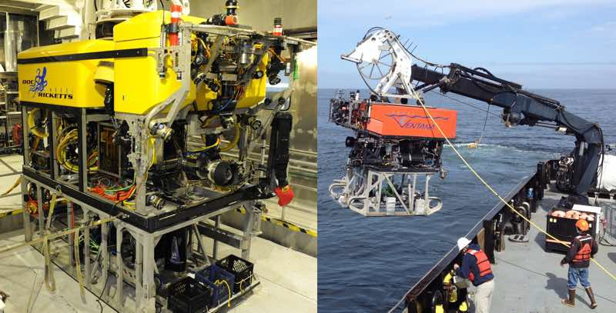
Fig. 1. The imaging arrays mounted on two ROVs: Doc Ricketts (left), and Ventana (Right)

- Multibeam Sonar
Mounted centrally in the sled, and collecting cross-track scans of the seafloor, lies the Teledyne-Reson Seabat 7125
multibeam. This 400-kHz sonar has a swath angle of 1400, extending along track less than 10. At a typical 3-m altitude, individual beams can resolve detail at 5-cm horizontally, and 6-mm vertically. This is the same system that is often used to collect data from our 0.55-m (21-in) diameter Dorado class mapping AUVs [8]. This model provides a very accurate and highly configurable hydrographic mapping tool. In application, the data collected using this sensor can help in co-locating previous maps collected by the Dorado AUVs.
- Stereo Camera System
The photographic imaging data are sourced by a pair of stereo cameras. The digital industrial cameras are both Allied Vision model GX1920C. These color cameras have 5mm lenses and corrective optics attached. Imaging through a domed glass port, the diagonal field of view of the cam- era is 900. Since typical surveys are conducted near 3-m altitude, these cameras have been placed cross-track, spaced 0.2-m apart. Software that operates these cameras is exe- cuted remotely aboard the ship, and also collects images synchronously from both imagers. Leveraging the vendor programming interface, this software was developed initially at the University of Michigan’s Perceptual Robotic Laboratory [9] and has been modified to fit our needs.
Illumination of the photography is provided by a pair of Ocean Imaging Systems Model 3831 Strobes. Available off- the-shelf, these 200 watt-second xenon lamps provide adequate illumination of seafloor and are hardware synchronized to image acquisition through isolated trigger signals generated in the camera electronics. Their 2 second recharge cycle is the limiting factor in defining the maximum frame rate of the camera system. In typical seawater conditions, this system can image at altitudes from 2-m to 5-m. At 3-m altitudes, individual pixels represent a 2-mm square.
- Lidar
The lidar sensor used by this payload is the SL-1, offered by 3DatDepth Inc. This laser ranging device is an extremely ac- curate time-of-flight system that employs 2-axis galvanometer mirror control of a pulsed laser. Since this payload is a moving platform, the lidar is operated in a back and forth scanning mode to collect data along a fixed swath. However, the option to tilt the swath has been employed to collect better data in certain terrain. This range-gate device has been mounted on moving platforms in the past [10], used for equipment inspection purposes.
The swath width of the SL-1 is 300, clearly the narrowest observation of the three systems. This is currently the limiting case for our primary line spacing when designing surveys. Sur- veys conducted at 3-m altitude produce 1-cm lateral resolution topographic data.
- Navigation
Position and attitude data are provided by a SeaDeViL, manufactured by the Kearfott Corporation. This unit is an inertial navigation system (INS) with an internal laser ring

gyro coupled directly to a Doppler velocity logger (DVL) which produces velocities relative to seafloor. It employs a Kalman filter to estimate attitude and position, which is aided by external data sources. Those external sources include GPS position while the ROV is on deck, ultra-short baseline (USBL) acoustic ship-mounted tracking, and a Paroscientific DigiQuartz pressure sensor (vehicle depth). This position is critical to the software used to station keep the ROV, discussed later in Section III.
When aided properly, the navigation solution will experi- ence drift less than 0.05% of distance traveled. This is a critical data source for co-locating the individually collected survey data sets. All acquisition platforms have their main processor clocks disciplined by a single source clock via network time protocols (NTP). Some items have also been upgraded to also discipline their clocks via GPS time strings coupled to 1PPS (Pulse Per Second) clock signals, passed down from the surface vessel.
- FINE SCALE SURVEYS
This section will describe the manner in which surveys have been conducted. Planning and executing these surveys in a controlled manner ensures 100% coverage of the area. The 12- hr MBARI operations limit for ROV dives imposes a constraint on the survey coverage.
- Survey Design
All surveys to date have been planned based on data col- lected previously by MBARI’s Dorado class mapping vehicles. These data, collected typically by a 200-kHz multibeam sonar, yield maps with 1-m horizontal resolution and 0.1-m vertical precision. From these maps, scientists at MBARI identify areas of interest. In many instances, ROVs are used to conduct video reconnaissance mission to validate these areas as targets for the fine scale surveys. A site is primarily considered for these specialized surveys because the area is either unique or likely to experience a change. Following sections will discuss specific cases of these targets.
Surveys are tailored to the site of interest, but generally follow a “lawnmower” style of motion, with the platform always moving forward, turning before each line. Since the lighting around the cameras is symmetrically spread, this has little impact on the stereo imaging data when processed post- dive. In sites that are visited in repeated dives, a simple marker may be dropped central to the survey area so that repeated surveys can be more readily co-located. More optimally, a bottom feature that is unlikely to move is identified near enough to serve the same purpose as the marker.
Cross-track coverage is limited primarily by the field of view of the lidar system, and as such lines are tightly spaced for only a small amount of lidar overlap. The limiting factor to along-track speed is the acquisition rates of the stereo cameras due to the recharge cycle of the xenon strobe system.
- Station-Keeping Software
MBARI software engineers have collaborated with Stanford scientists to aid in development of a station-keeping that we
have employed for use in these surveys. This software acts as a “backseat driver” to the ROV control set, effectively replacing the joystick control with computerized thruster con- trol. What separates this software from similar efforts [11] is an interface that allows an entire survey to be scripted by a set of relative movement instructions. An origin within the survey is identified, and once the scripted survey begins, all movements reference this point. Horizontal positions are defined as waypoints. A constant altitude is specified, along with a desired heading. Finally horizontal speed is defined so that along-track resolution can be maintained.
These control features encompass a basic required of infor- mation to conduct a rigorous survey at the desired scales of operation. Typically, surveys are flown at 3-m altitude. Survey speeds are 0.2-m/s. Under these parameters, a 100-m by 100- m box can be covered using 1.5-m line spacing, and finished in approximately 10 hours of operation.
- Example Survey - Clam Community
Once surveys are collected, the data are processed using MB System [12]. Within the Monterey Bay National Marine Sanctuary, there is a site at 2850-m depth within the Monterey Canyon which houses a community of chemosynthetic clams. Figure 2 depicts a survey conducted at this site. The three panes provide a comparison of the capabilities of each sys- tem. On the left is the multibeam 5-cm resolution data, and bathymetry is the main feature, with the clam communities resolved as a texture.
The middle pane represents 1-cm resolution bathymetry collected using the lidar. The clam community is better defined here, and individual clams can be observed. The third pane is the photo-mosaic of the same region. Clams are clearly visible, and provides ground-truthing to targets we can identify and measure in the lidar. The map generated from lidar data exhibits features that the multibeam sonar or the photography have failed to capture, most notably the individual tracks left by the clams as they move across the seafloor.
- REPEAT MAPPING
Repeat mapping is a technique in which highly resolved surveys are collected, and then repeated on a later deployment, in order to observe measurable change to the area of interest. Many geological and biological processes of interest (e.g. fault creep, sedimentation, scour by low intensity currents, growth or movement of benthic animals) can produce seafloor changes on the order of 1 cm/year. The ability to conduct repeated mapping was a primary reason why this system was developed, and those changes have driven design requirements. At the 1- m scale, this technique has been employed using data from the Dorado class AUV in the past for mapping large scale lava flows from Axial volcano [13]. One example will be presented here to illustrate the usefulness of extending this analysis into the scale collected by this low altitude survey system.
The Monterey Canyon contained within the Monterey Bay National Marine Sanctuary is a highly dynamic system of sediment transport. The active canyon is comprised of features

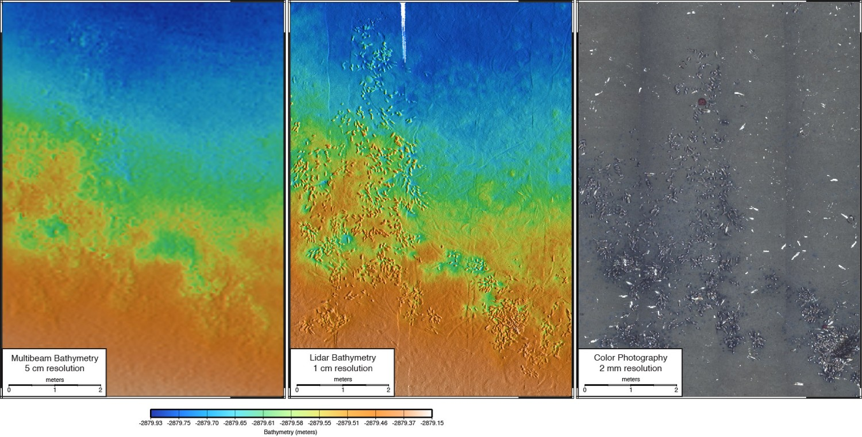

Fig. 2. Three maps, collected simultaneously by multibeam sonar (left), lidar (center) and stereo cameras (right).

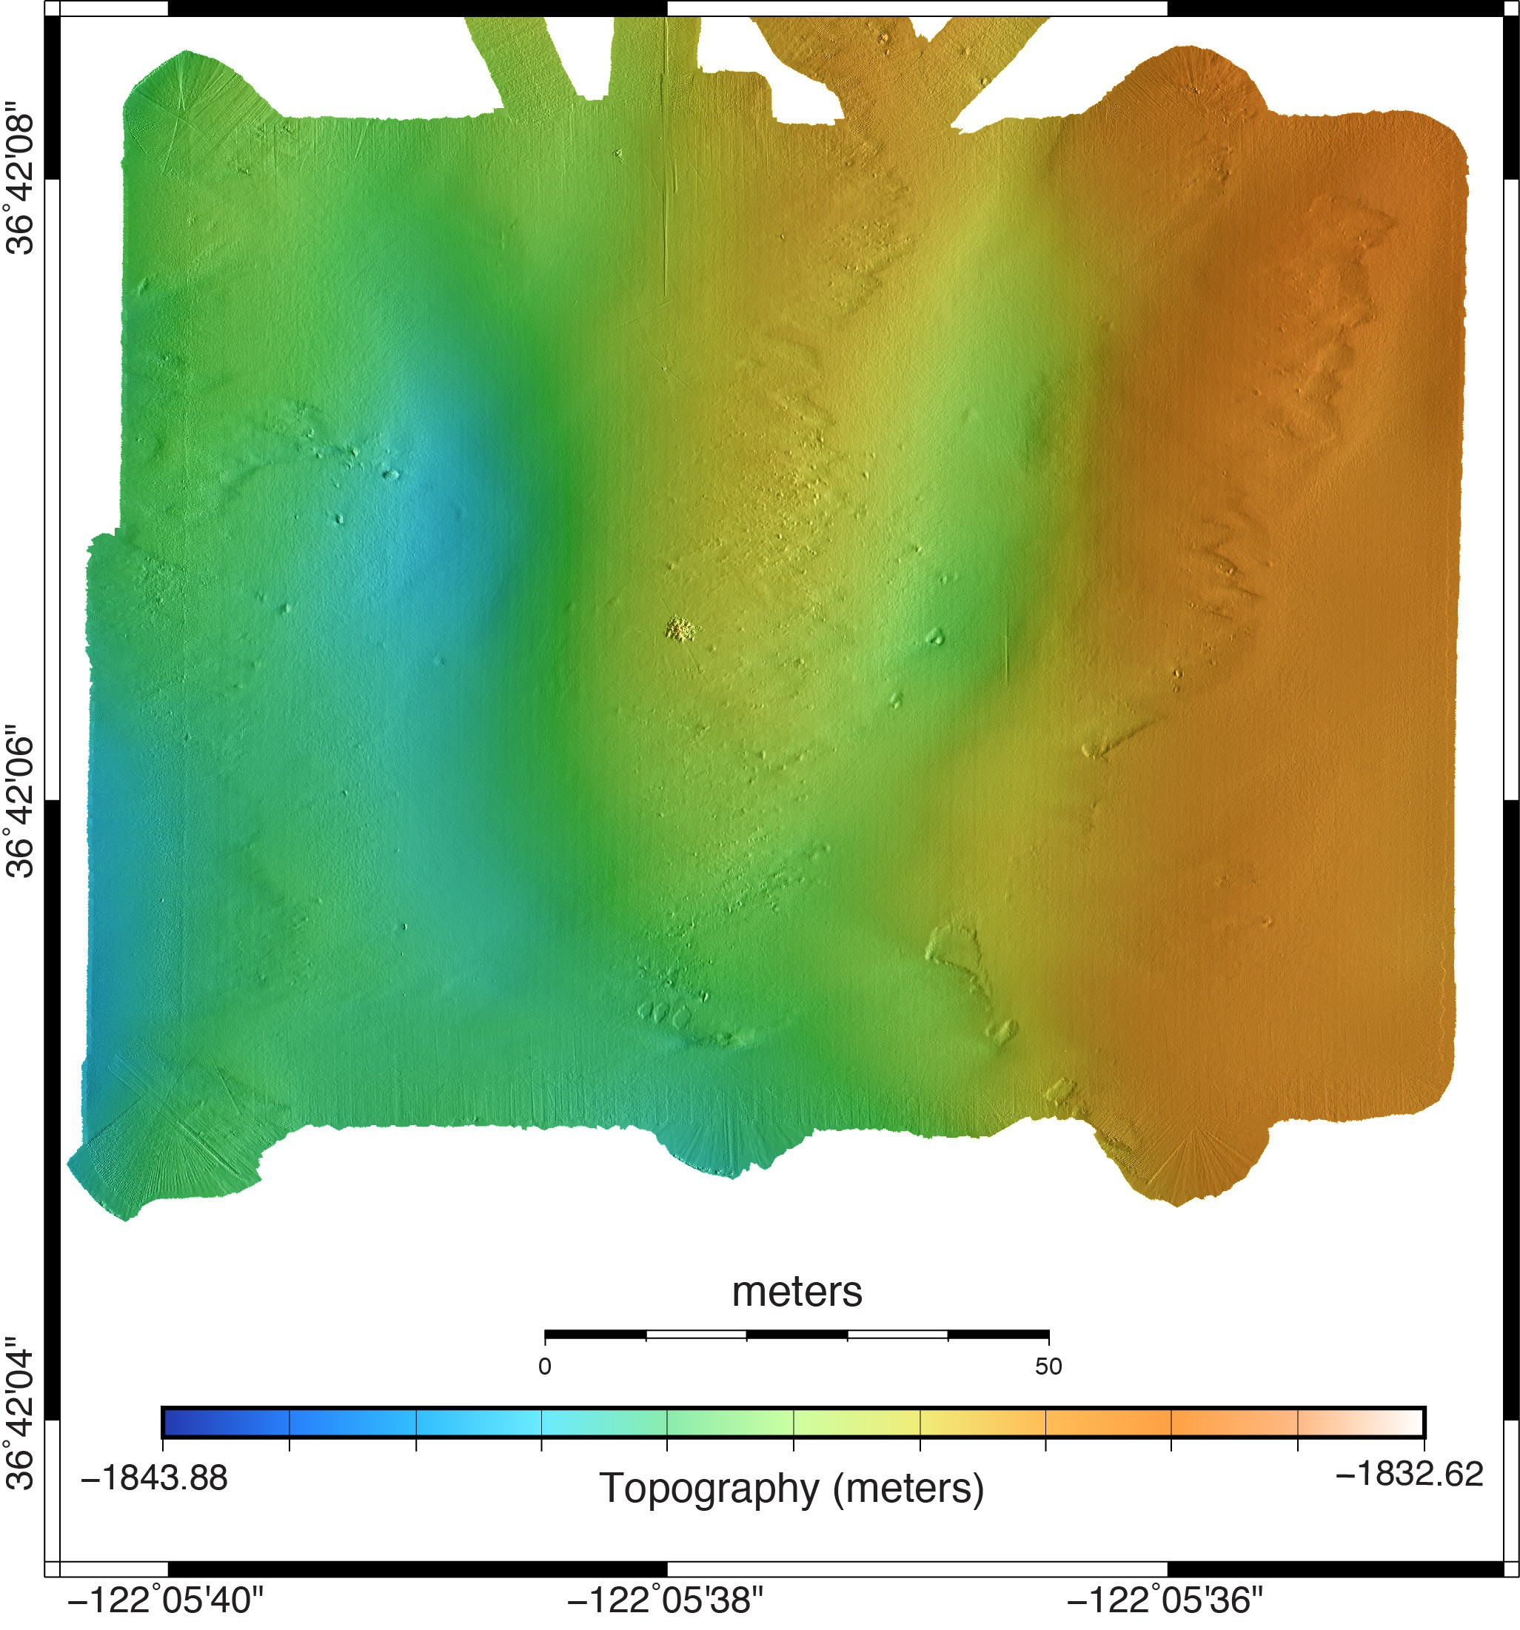
that can be observed though these imaging efforts. Using this payload, it is possible to determine a wide array of geomorphic change. This site is of particular interest to MBARI scientists. A multi-year operation, known as the Coordinated Canyon Experiment [14] has emplaced a network of sensors in the Monterey Canyon targeted at detecting benthic events associ- ated with canyon dynamics studies. On January 15th, 2016, an event was detected by that network of sensors.

The imaging payload has conducted surveys on this area before and after the event. Figures 3 and 4 represent two 5- cm resolution topography maps collected using the 400-kHz multibeam sonar before and after the incident. The benthic event in this area involved sediment transport entering the survey area from the upper canyon wall to the east and creating clear changes in the seafloor. Most notable changes are in the southern regions where there are new depressions. Overall, more texture appears to be present in November’s survey when compared to May.

Since these measurements are all made by self-consistent and highly accurate systems, we are able to quantitatively compare the two surveys. Figure 5 depicts the measured difference in topography. Total change measures up to nearly 1.2-m of deposition, and nearly 0.9-m of erosion in some areas.

These types of data are vital to understand the total change over this 100-m by 100-m area. This location was chosen for detailed mapping becuase there was a cluster of monitoring in- struments deployed nearby. Thus the maps and direct physical measurements can ultimately be compared.

Fig. 3. Multibeam sonar 5cm resolution map of the 1850m Bin Site, collected in November 2015.

- BENTHIC ORGANISM DETECTION
In repeated mapping, we are comparing two datasets col- lected by the same instruments at the same location, varying the time between collection. In the following example we describe a method in which differences are observed between

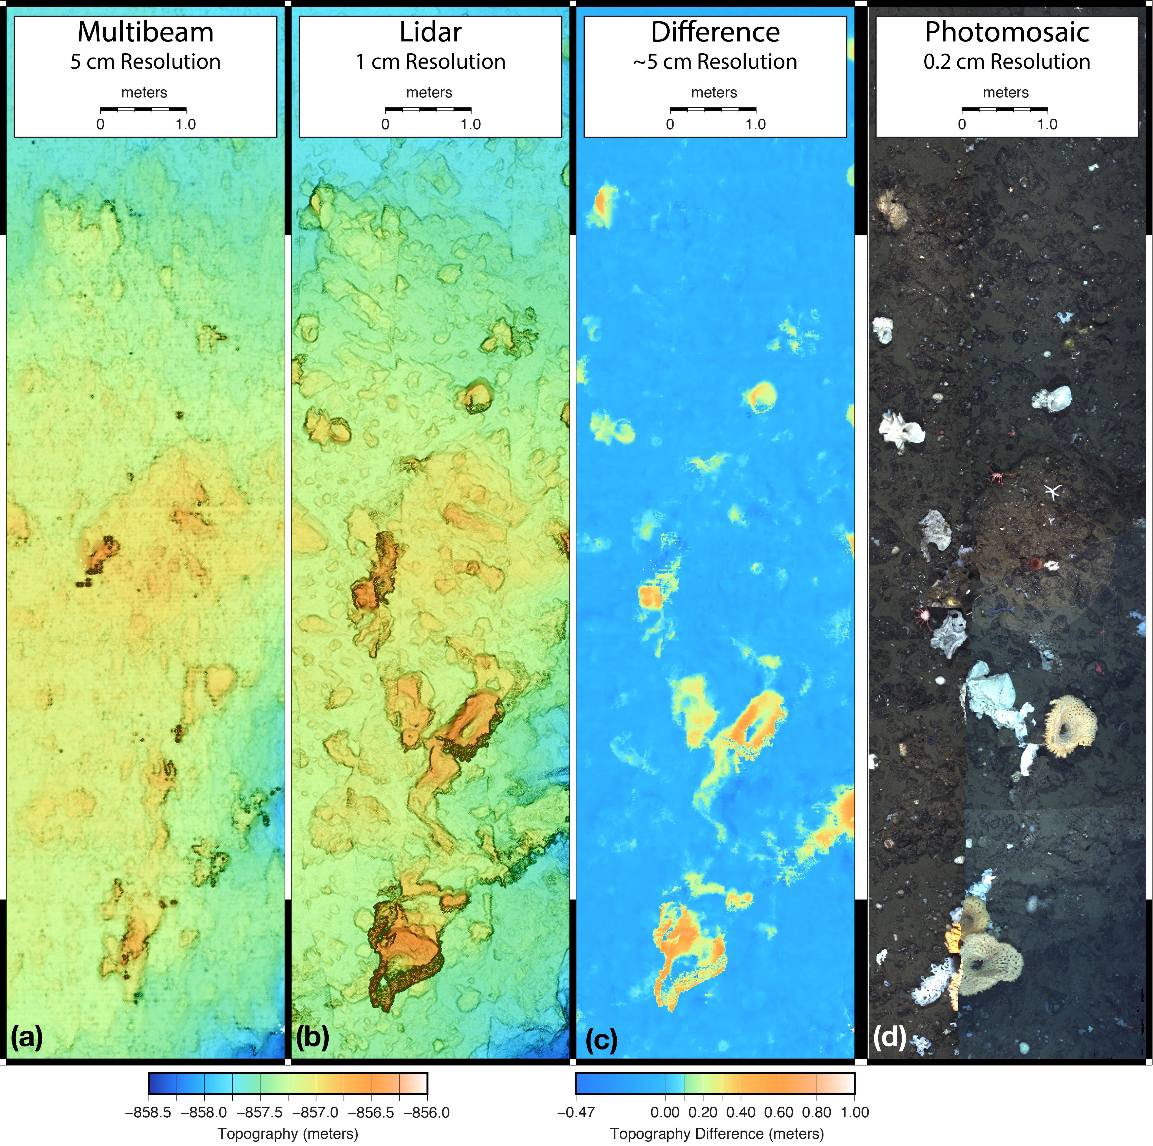
Fig. 6. Topographic representations of a section of the Sur Ridge crest, as obtained by (a) multibeam sonar, (b) lidar, (c) subtraction of lidar from sonar, and
(d) photomosaic.

be possible. Overall, these examples all validate that study over these scales can produce quantitative measures of change and state for systems difficult to characterize.
VII. FUTURE TASKS
The development of this platform is an ongoing effort at the Monterey Bay Aquarium Research Institute. The sensor selection, however, has nearly reached its maturity. The cur- rent configuration’s coverage rates are limited by the small swath of the available lidar. Better integration of the system

components is still in progress, most notably extending 1PPS time discipline to all systems. There are two major directions that future developments are intended to take.

Currently in development is a modified ROV tool-sled that will mount all active sensor components on an articulating frame. This effort will gather more detailed data in high-relief environments. For example, our surveys at Sur Ridge to date have focused on horizontally level sectors of this feature. By tilting the sensor array, we will be able to collect data from

the vertical walls of the ridge, where many animals of interest to our biologists inhabit. Repeat surveys of Monterey Canyon walls will allow us to study the slope failures that lead to some of the results shown in Section IV. This task involves some challenging efforts in navigation and mission planning to maintain the array as normal to the target plane as possible. The second effort is to continue to develop software and control algorithms that can allow this package to eventually be adapted to an autonomous platform. This involves software efforts to add autonomy to all aspects of the system, as well as implementing subsea data storage. Major challenges include quality control on the stereo vision system, adaptive range control on both the lidar and sonar, and creating real- time available data from survey systems for use in navigation
solutions.
ACKNOWLEDGEMENTS
Support for the ocean imaging project at MBARI is provided by the David and Lucile Packard Foundation. We would like to thank the crews of the R/V Western Flyer and the R/V Rachel Carson for their support.
REFERENCES
[1] W. J. Kirkwood, “Development of the dorado mapping vehicle for multibeam, subbottom, and sidescan science missions,” Journal of Field Robotics, vol. 24, no. 6, pp. 487–495, 2007. [Online]. Available: http://dx.doi.org/10.1002/rob.20191
[2] D. W. Caress, H. Thomas, W. J. Kirkwood, R. McEwen, R. Henthorn,
D. A. Clague, C. K. Paull, J. Paduan, and K. Maier, “High-resolution multibeam, sidescan, and subbottom surveys using the MBARI AUV D. Allan B,” in Marine Habitat Mapping Technology for Alaska. Alaska Sea Grant, 2008, pp. 47–70. [Online]. Available: http://dx.doi.org/10.4027/mhmta.2008.04
[3] J. C. Brock and S. J. Purkis, “The emerging role of lidar remote sensing in coastal research and resource management,” Journal of Coastal Research, pp. 1–5, 2009. [Online]. Available: http://dx.doi.org/10.2112/SI53-001.1
[4] S. L. Greenwood, C. C. Clason, H. Mikko, J. Nyberg, G. Peterson, and C. A. Smith, “Integrated use of lidar and multibeam bathymetry reveals onset of ice streaming in the northern bothnian sea,” GFF, vol. 137, no. 4, pp. 284–292, 2015. [Online]. Available: http://dx.doi.org/10.1080/11035897.2015.1055513
[5] G. Foster, B. K. Walker, and B. M. Riegl, “Interpretation of single- beam acoustic backscatter using lidar-derived topographic complexity and benthic habitat classifications in a coral reef environment,” Journal of Coastal Research, pp. 16–26, 2009. [Online]. Available: http://dx.doi.org/10.2112/SI53-003.1
[6] Department of Marine Operations, “ROV Doc Rick- etts core vehicle specifications,” 2015. [Online]. Available: http://www.mbari.org/at-sea/vehicles/remotely-operated- vehicles/rov-docricketts-specifications-2/
[7] ——, “ROV Ventana core vehicle specifications,” 2015. [Online]. Available: http://www.mbari.org/at-sea/vehicles/remotely- operated-vehicles/rov-ventana-specifications/
[8] E. Martin, D. W. Caress, H. Thomas, and B. Hobson, “Seafloor mapping and imaging efforts using autonomous underwater vehicles,” in The Eighteenth International Symposium on Unmanned Untethered Submersible Technology, 2013, pp. 269–275.
[9] R. Eustice, “PeRL: The Perceptual Robotics Laboratory at the University of Michigan,” 2008-2015. [Online]. Available: http://robots.engin.umich.edu
[10] D. McLeod, J. Jacobson, M. Hardy, and C. Embry, “Autonomous inspection using an underwater 3d lidar,” in 2013 OCEANS - San Diego, Sept 2013, pp. 1–8.
[11] L. Whitcomb, D. Yoerger, H. Singh, D. Mindell, and D. M. Zx, “Towards precision robotic maneuvering, survey, and manipulation in unstructured undersea environments,” in Robotics Research - The Eighth International Symposium. Springer-Verlag, 1998, pp. 45–54.
[12] D. Caress and D. Chayes, “MB-System: Mapping the Seafloor Open source software distributed from the MBARI and L-DEO,” 2011. [Online]. Available: http://www.mbari.org/data/mbsystem/
[13] D. Caress, D. Clague, J. Paduan, and J. Martin, “Repeat Bathymetric Surveys at 1-Metre Resolution of Lava Flows Erupted at Axial Seamount in April 2011,” Nature Geoscience, vol. 5, pp. 483–488, 2012.
[14] C. K. Paull, “MBARI: Coordinated Canyon Experiment,” 2015. [Online]. Available: http://www.mbari.org/science/seafloor-processes/geological- changes/coordinated-canyon-experiment/

