
7700 Sandholdt Road
Moss Landing, CA 95039

WiSSL Gen 2 Thermal Calibration Test
26th March, 2024

OVERVIEW
MBARI is expecting a new Gen2 System delivered in 2024. We need to evaluate its ability to take thermal measurements.

REQUIREMENTS
- Hot water for the lidar to look at from about 10 m distance
- Should produce a repeatable and known temperature profile
- Should be detectable within the limits of the lidar system in both temperature and spatial accuracy.
  - Elevated from background tank temperature by few deg C
  - 30x30x30cm target volume
- Should be observable from above and from the side

TEST CONCEPTS

Concept A - Continuously Pumped Steady State Plume
Create a plume of hot water in the test tank to analyze from above and from the side. Practical flow rate and volume restrictions would limit this to a jet geometry much smaller than an expected voxel but close to boiling in temperature.
About 300 KW is required to heat a garden hose up to 90 C continuously. Only practical to preheat a large tank and supply a short burst.
Approximate discharge rate at example tank volumes.
- 250 gallon tank with garden hose max flow rate ~15 min
  - 500 gallon -> 30min
- 500 gallon tank with fire hose flow rate ~3 min
Open Questions:
- What is the ideal plume size vs temperature delta trade off for maximum detectability by the equipment.

SAFETY CONSIDERATIONS
- The new system will be a Class IV laser, which present considerable risk to eyes exposed to the pulsed laser system.
- Large tank of hot water possible scald risk depending on temperature needed
- Overnight unattended heating of hot water tank at high voltage.

APPENDIX

General Energy Calcs
ThermalVentCalibration.ipynb
Note: use https://colab.research.google.com/drive/ to open if drive doesn’t prompt you.

Itemized Bill of Materials
Thermal Calibration Experiment BOM
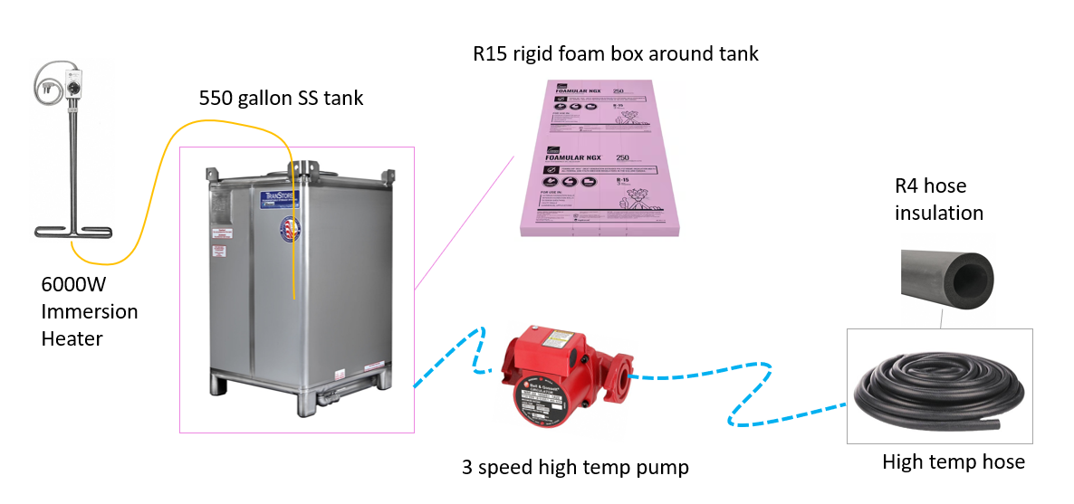

Flow calculations
Dispersion away from the jet axis is very sensitive to mesh size and meshing scheme. Thermal and Velocity profiles seem well matched in the higher velocity region near to the jet. Using PIV in conjunction with a thermistor at the source could be a good calibration technique. Reaches steady state within 1m from source in less than 5sec.

Single Nozzle Plume shape

Fine mesh
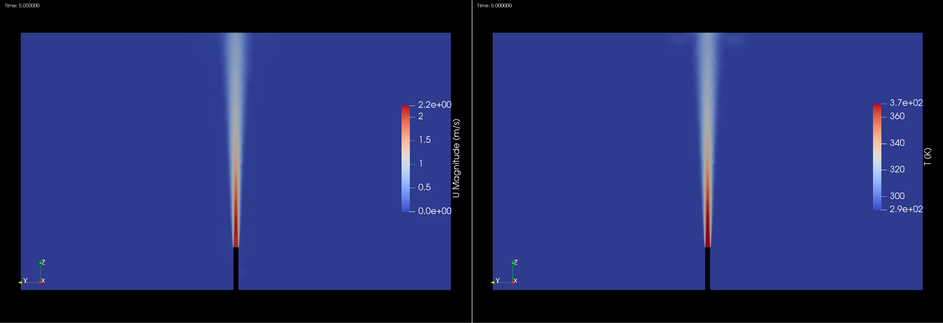

Coarse mesh
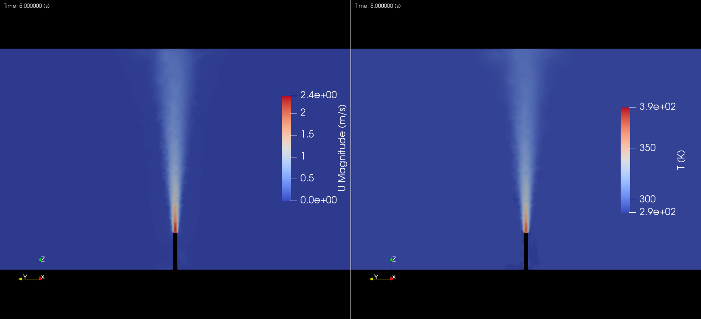
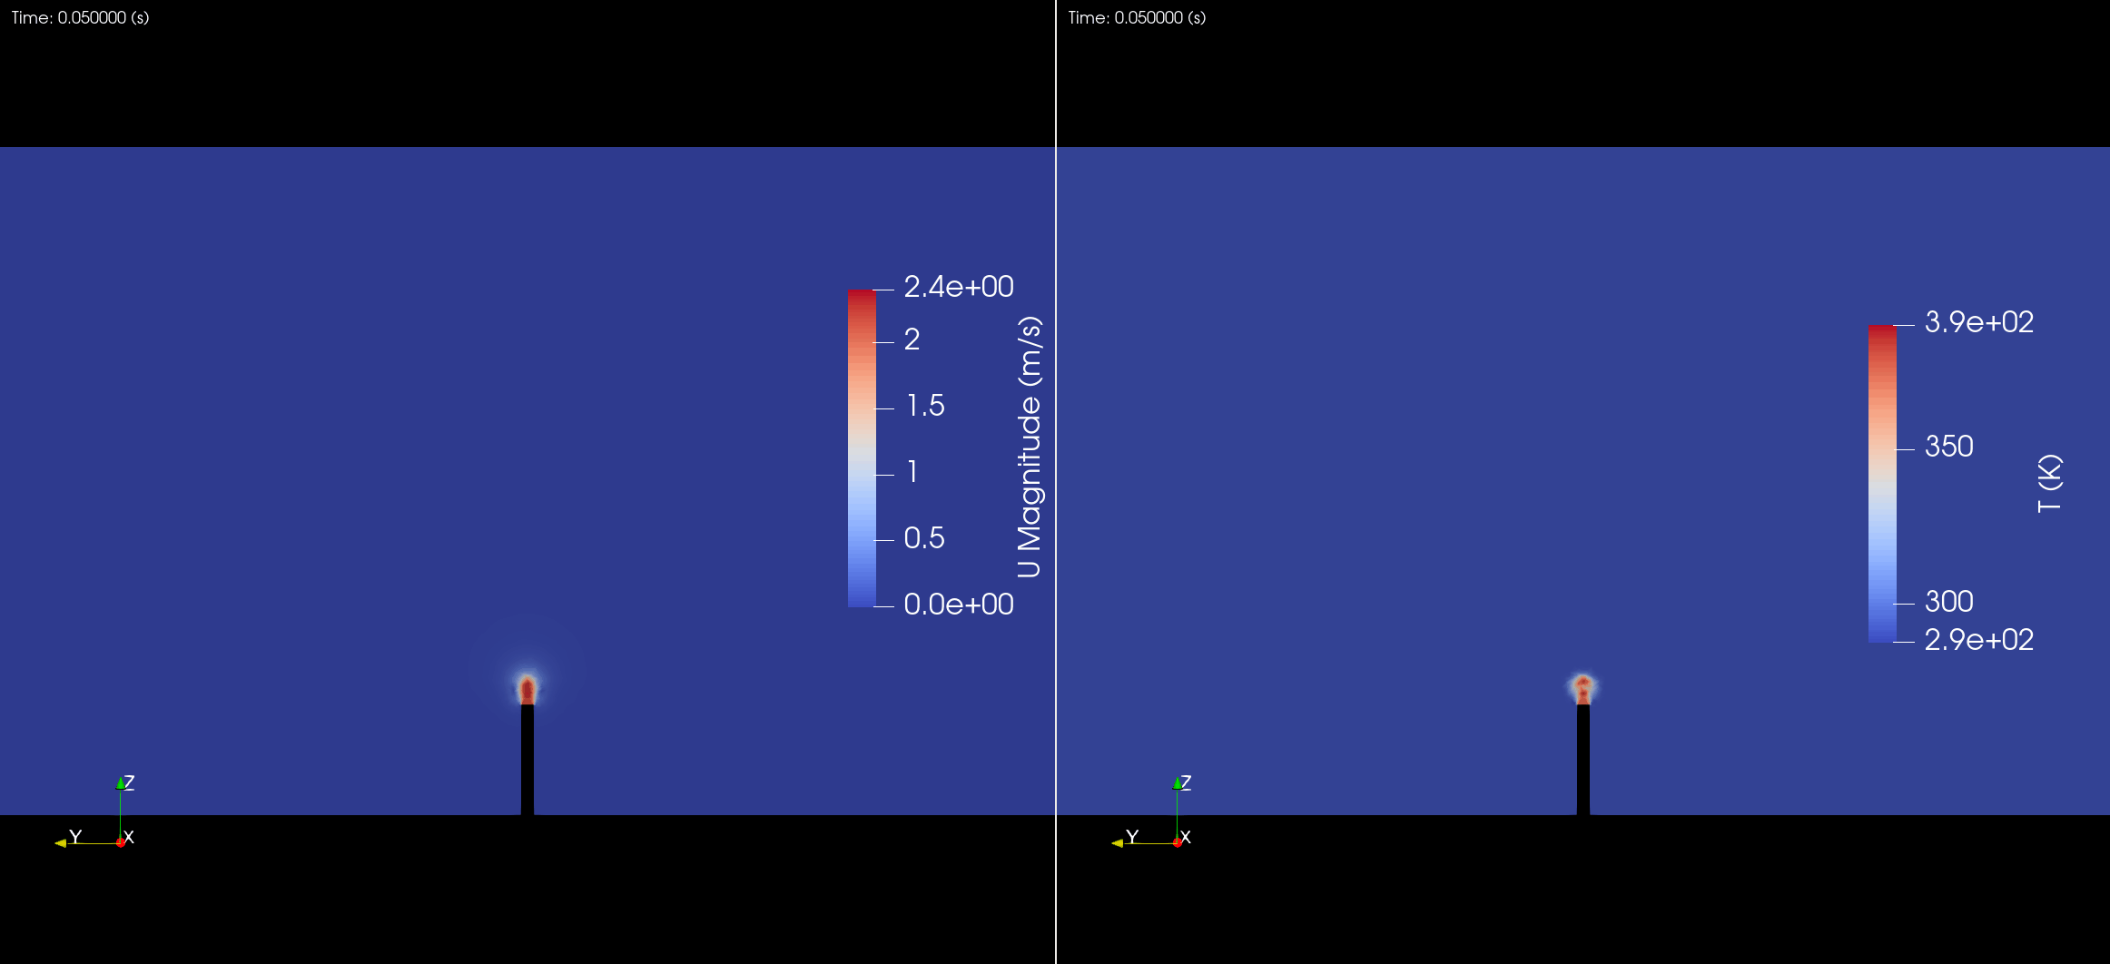

Extended distance and mixed resolution mesh results

Multi Nozzle Configuration
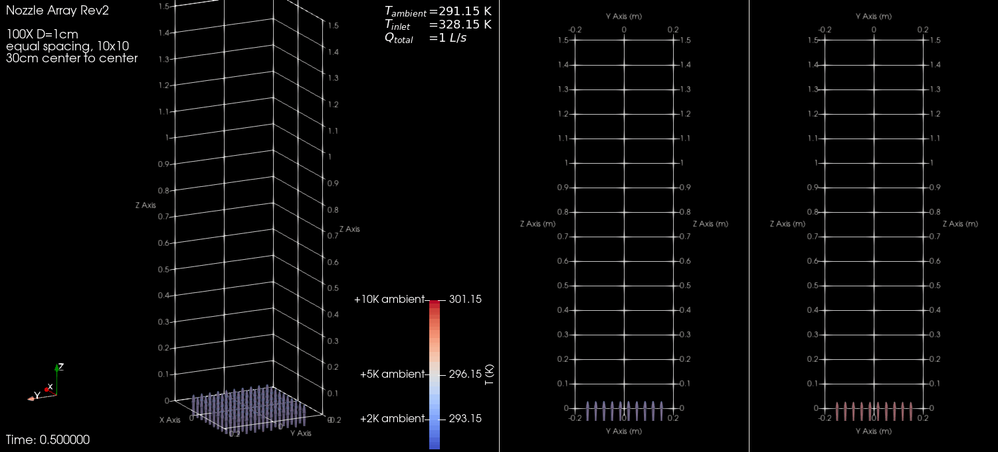

Thermal loss resulting in temperature drop along jet hose
Temperature drop of 2C expected along 20m hose
