GOB
LASS System Board

Technical Manual, v0.1

Monterey Bay Aquarium Research Institute

December 18, 2024

Table of Contents
General Oceanographic Board (GOB) Stack Overview 4
GOB Computer Board 4
Internal Environmental Sensing 4
GOB Power Supply Board 4
GOB LASS System Board 4
Acoustic Trigger Generation 4
Camera and Strobe Trigger Distribution 5
PPS Distribution 5
Medium Power Relay Board 5
Low Power Relay Board 7
LASS LED Shield 8
LASS Stack Software 8
RP2040 Firmware 8
PC/Touchscreen GUI 9
Serial (Terminal) USB Interface 9
LASS Stack Bench Testing / Operation 9
Medium Power Relay Board 9
Low Power Relay Board 9
References 9
Appendices 10

Figure 8: Revision C of the Medium Power Relay Board 7
Figure 9: Revision B of the Low Power Relay Board 8

Table 4: Medium Power Relay Board Load Channels 6
Table 5: Low Power Relay Board Load Channels 8

Appendix 1: appendix1 21
Appendix 2: appendix2 21
Appendix 3: appendix3 21
Appendix 4: appendix4 21
Appendix 5: appendix5 21

General Oceanographic Board (GOB) Stack Overview

GOB Computer Board

Internal Environmental Sensing

A board level environmental sensor, the BME280, is used to measure temperature, humidity, and pressure inside of the LASS housing. The TB utilizes the SPI bus to communicate with it, however, it also can be accessed via i²c.The environmental data is sent topside and is accessible through the LASS GUI. The BME280 has specific mounting and soldering instructions and should be followed diligently during the board layout and population phases.

GOB Power Supply Board

GOB LASS System Board

The LASS System Board (LB) performs all of the functions unique to the Seafloor Mapping’s Low Altitude Survey System (LASS). Most of these functions consist of trigger generation and signal routing to and from externally mounted instruments. The onboard RP2350A microcontroller generates triggers and communicates to the Computer Board (CB) via serial communication.

Acoustic Trigger Generation

The LASS system contains three acoustic devices: the Reson T50S imaging sonar, a Norbit forward looking sonar (FLS), and a SeaDevil DVL (attached through the Kearfott INS). These devices need to synchronized, and potentially offset in time, to prevent interference amongst themselves.

Camera and Strobe Trigger Distribution

The LASS platform has a pair of stereo cameras, these are mounted near the center of the rotating platform. Each camera has a dedicated strobe, located on retractable arms on the port and starboards sides of the LASS tool sled.

The timing trigger for the strobes can be generated in either camera (software selectable). The camera trigger is split and optically isolated before going to the strobe housings. Prior to the optical isolators, the TTL camera trigger is level shifted to EIA-232 level and sent to the Focal board. This signal is transmitted topside as a timed record of when the stereo cameras fired.

[generate simple diagram of camera/strobe trigger flow]

PPS Distribution

The topside GPS unit sends a pulse per second (PPS) signal down to the LASS through the optical fiber and Focal stack pair. This PPS signal gets level shifted back to TTL level and distributed to the Reson, LIDAR, and Kearfott INS.

[generate simple diagram of PPS signal flow]

Medium Power Relay Board

The MPRB has two input connectors for switched power, J6 and J7. J6 provides switching power to channels three and four, while J7 provides switching power to channels one and two.
For the LASS application, channels one and two use 24Vdc_Strobe to switch power to the port and starboard camera strobes. Channels three and four switch the main system 24Vdc to the Reson imaging sonar and the ImageneX. Each of the four circuits are individually fused, using Mini-Blade automotive style fuses.

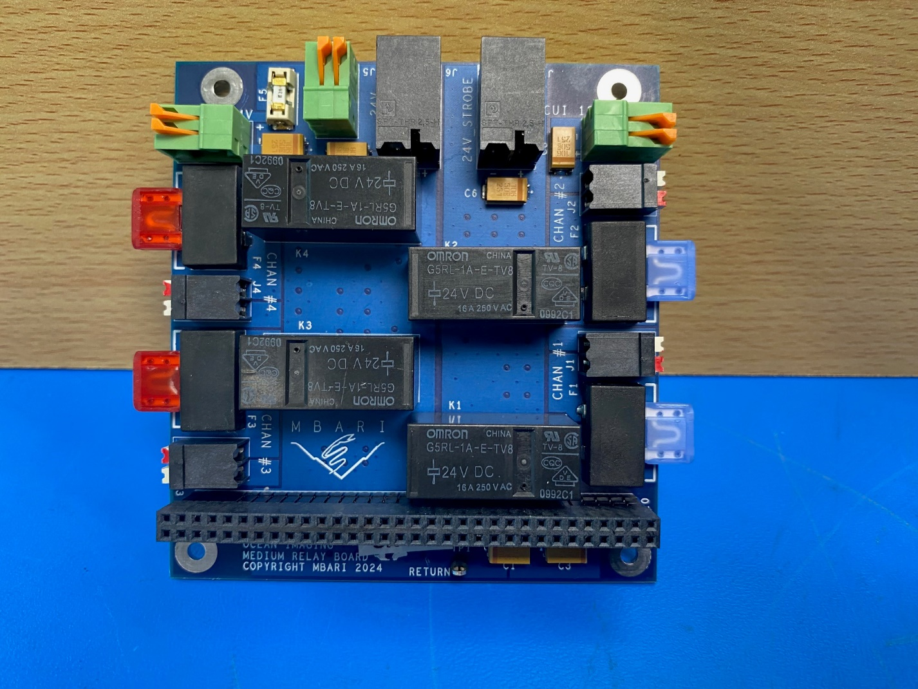
Figure 8: Revision C of the Medium Power Relay Board

The drive circuit for the loads is comprised of an N-channel mosfet (IRLML0030) and an output relay (G5RL-1A-E-TV8). The mosfet is driven from the digital expander (MCP23S17) on the trigger board. Its output level is 2.8V so a mosfet with a low Vgs threshold was chosen. This mosfet also has a very low Rds on for an N-channel part. The version of the output relay was chosen to handle large in-rush current and a sustained average current of 15 amps at the operating voltage of 24Vdc. The coil voltage was chosen to be 24V (instead of 3.3V or 5V) in order to minimize the wattage level needed for the low voltage DC regulators.

Channel Number | Switching Voltage Input Connector | Fuse | Fuse Rating | Output Connector | Backplane Signal
1 | J7 | F1 | 15 Amps | J1 | STROBE1_RELAY_CTRL
2 | J7 | F2 | 15 Amps | J2 | STROBE2_RELAY_CTRL
3 | J6 | F3 | 10 Amps | J3 | RESON_RELAY_CTRL
4 | J6 | F4 | 2 Amps | J4 | SPARE_RELAY_CTRL
Table 4: Medium Power Relay Board Load Channels

The fifth drive circuit is dedicated to an off-board relay (G9EJ-1-E) which powers up the 3D at Depth LIDAR. An N-channel mosfet acts as a low-side switch for the G9EJ relay. The flyback diode for the coil is mounting directly onto the relay.

The MPRB also supplies 24Vdc to an offboard 24V:12V DC-DC converter (PYBE30-Q24-S12-T). This is a 30W converter which provides 2.5 amps of 12V.

Low Power Relay Board

The LPRB is an eight-channel load switching board. Each channel is configurable, via zero-ohm selection resistors, to output either 12Vdc or 24Vdc. Each channel is also individually fused, using Nano² 452 cartridge style fuses and the maximum current per channel is 3 amps.

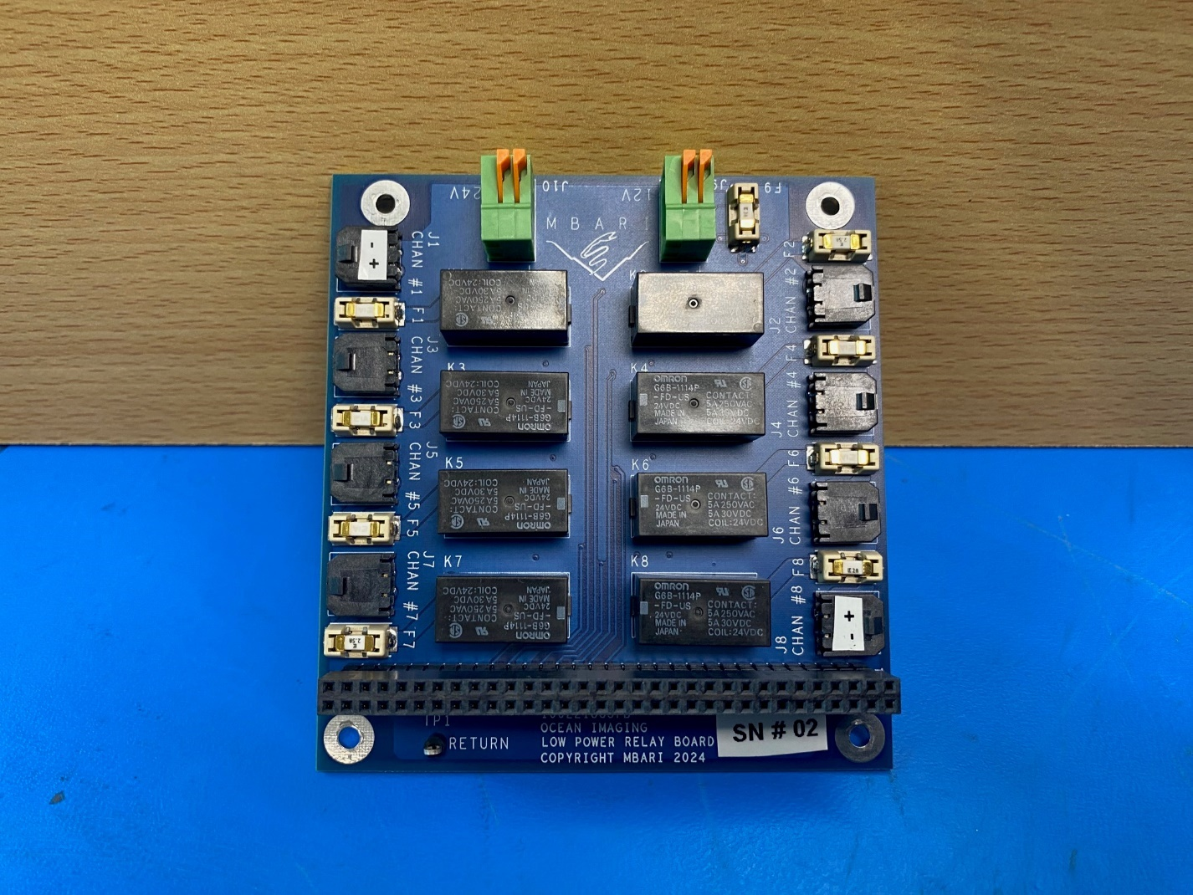
Figure 9: Revision B of the Low Power Relay Board

The drive circuit for the load is comprised of an N-channel mosfet (IRLML0030) and an output relay (G6B-1114P-FD-US-DC24). The mosfet is driven from the digital expander (MCP23S17) on the trigger board. Its output level is 2.8V so a mosfet with a low Vgs threshold was chosen. This mosfet also has a very low Rds on for an N-channel part. The version of the output relay was chosen to handle large in-rush current and a sustained average current of 3 amps at either operating voltage. The coil voltage was chosen to be 24V (instead of 3.3V or 5V) in order to minimize the wattage level needed for the low voltage DC regulators.

Channel Number | 24 Vdc Selection Resistor | 12 Vdc Selection Resistor | Switched Voltage | Fuse | Fuse Rating | Output Connector | Backplane Signal
1 | R17 | R18 | 24 Vdc | F1 | 1 Amp | J1 | CTD_RELAY_CTRL
2 | R9 | R10 | 24 Vdc | F2 | 2.5 Amps | J2 | ROT1_RELAY_CTRL
3 | R19 | R20 | 24 Vdc | F3 | 1 Amp | J3 | KEAR_RELAY_CTRL
4 | R1 | R2 | 24 Vdc | F4 | 1 Amp | J4 | LCAM_RELAY_CTRL
5 | R3 | R4 | 24 Vdc | F5 | 1 Amp | J5 | RCAM_RELAY_CTRL
6 | R27 | R28 | 12 Vdc | F6 | 1 Amp | J6 | VN100_RELAY_CTRL
7 | R11 | R12 | 24 Vdc | F7 | 2.5 Amps | J7 | ROT2_RELAY_CTRL
8 | R25 | R26 | 12 Vdc | F8 | 2 Amps | J8 | PARO_RELAY_CTRL
Table 5: Low Power Relay Board Load Channels

The LPRB also supplies power to two off board devices: 24Vdc for the Ethernet switch and 12Vdc for the Focal stack.

LASS LED Shield

LASS Stack Software

RP2040 Firmware

PC/Touchscreen GUI

Serial (Terminal) USB Interface

LASS Stack Bench Testing / Operation

As with all new circuit boards, care should be taken when initially testing them. Visually inspect the pcbs for any improperly installed components, or incorrect soldered jumpers. For the LASS stack, it is recommended to test each one individually (as much as possible), prior to assembling the stack.

Medium Power Relay Board

Low Power Relay Board

References

Appendices

Appendix 1: appendix1

Appendix 2: appendix2

Appendix 3: appendix3

Appendix 4: appendix4

Appendix 5: appendix5

