LASS Board Stack
Technical Manual, v0.1

Monterey Bay Aquarium Research Institute

June 21, 2024

Table of Contents
LASS System Overview 5
LASS Power / Interface Can 5
LASS Stack Hardware Description 6
Board Functions and Backplane Definition 7
Trigger Board 9
Raspberry Pi RP2040 10
Relay Control 11
System Trigger Generation 11
Camera and Strobe Trigger Distribution 16
PPS Distribution 16
Internal Environmental Sensing 16
Medium Power Relay Board 16
Low Power Relay Board 18
External BME280 Eval Board (Optional) 19
LASS LED Shield 19
LASS Stack Software 19
RP2040 Firmware 19
PC/Touchscreen GUI 20
Serial (Terminal) USB Interface 20
LASS Stack Bench Testing / Operation 20
Trigger Board 20
Medium Power Relay Board 21
Low Power Relay Board 21
References 21
Appendices 21

Figure 1: The LASS sled, unpacking for deployment in September 2021 5
Figure 2: Simplified block diagram of the Power/ Interface Can 6
Figure 3: Revision C of the LASS Trigger Board 9
Figure 4: MC14536B Programmable Timer in Monostable Mode 12
Figure 5: LASS Trigger Generation Circuit 13
Figure 6: Truth Tables for the MC14536 Programmable Timer 14
Figure 7: LASS Trigger Distribution 15
Figure 8: Revision C of the Medium Power Relay Board 17
Figure 9: Revision B of the Low Power Relay Board 18

Table 1: Backplane signal list 8
Table 2: RP2040 GPIO Definitions 10
Table 3: LASS System Trigger Output Selection 14
Table 4: Medium Power Relay Board Load Channels 17
Table 5: Low Power Relay Board Load Channels 19

Appendix 1: appendix1 21
Appendix 2: appendix2 21
Appendix 3: appendix3 21
Appendix 4: appendix4 21
Appendix 5: appendix5 21

LASS System Overview
The Low Altitude Survey System (LASS) is an ROV-mounted mapping platform that uses color stereo cameras, a Wide Swath Subsea Lidar (WiSSL), and an imaging sonar to provide high resolution maps of the seafloor. A dedicated tool sled, for use on either the ROV Doc Ricketts or ROV Ventana, contains all of the subsea sensors and electronics needed for operation.

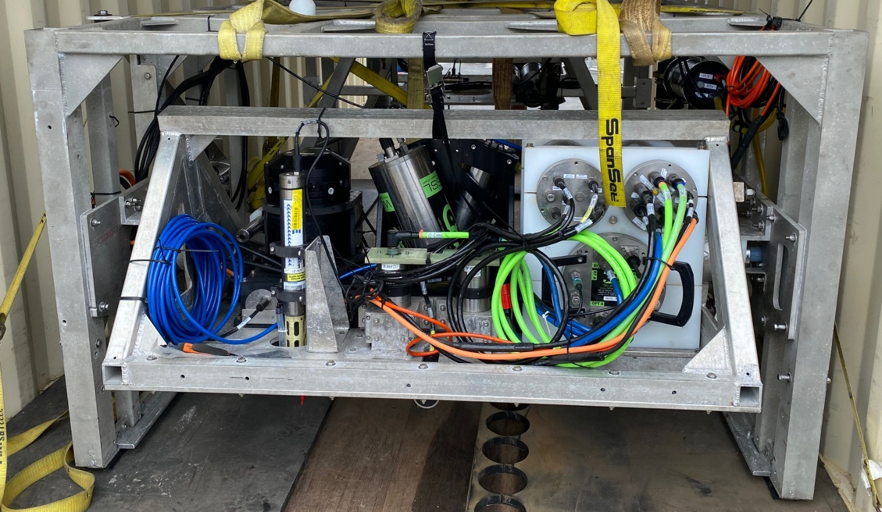
Figure 1: The LASS sled, unpacking for deployment in September 2021

LASS Power / Interface Can

The Power/Interface Can (PIC) is the primary interface between the ROV+Ship and all of the sensors attached to the LASS sled, and is responsible for distributing power, communications, and triggers to the various instruments and sensors. The ROV provides 1800W of AC power and a single mode optical fiber for communications to the PIC. The PIC converts the AC power to the various DC low voltages needed and converts the optical communication into Ethernet and RS-232 and RS-485 serial communication signals.

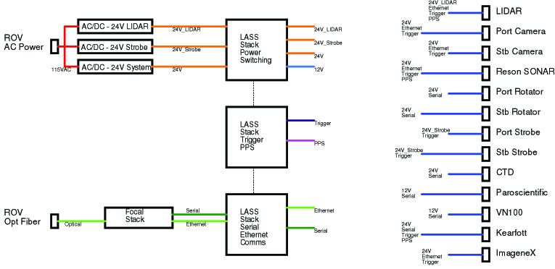
Figure 2: Simplified block diagram of the Power/ Interface Can

LASS Stack Hardware Description

A custom pcb stack which resides in the PIC has been developed to consolidate power switching, communications, trigger generation, and other tasks. This LASS Stack consists of three boards: The Trigger Board, the Medium Power Relay Board, and the Low Power Relay Board.

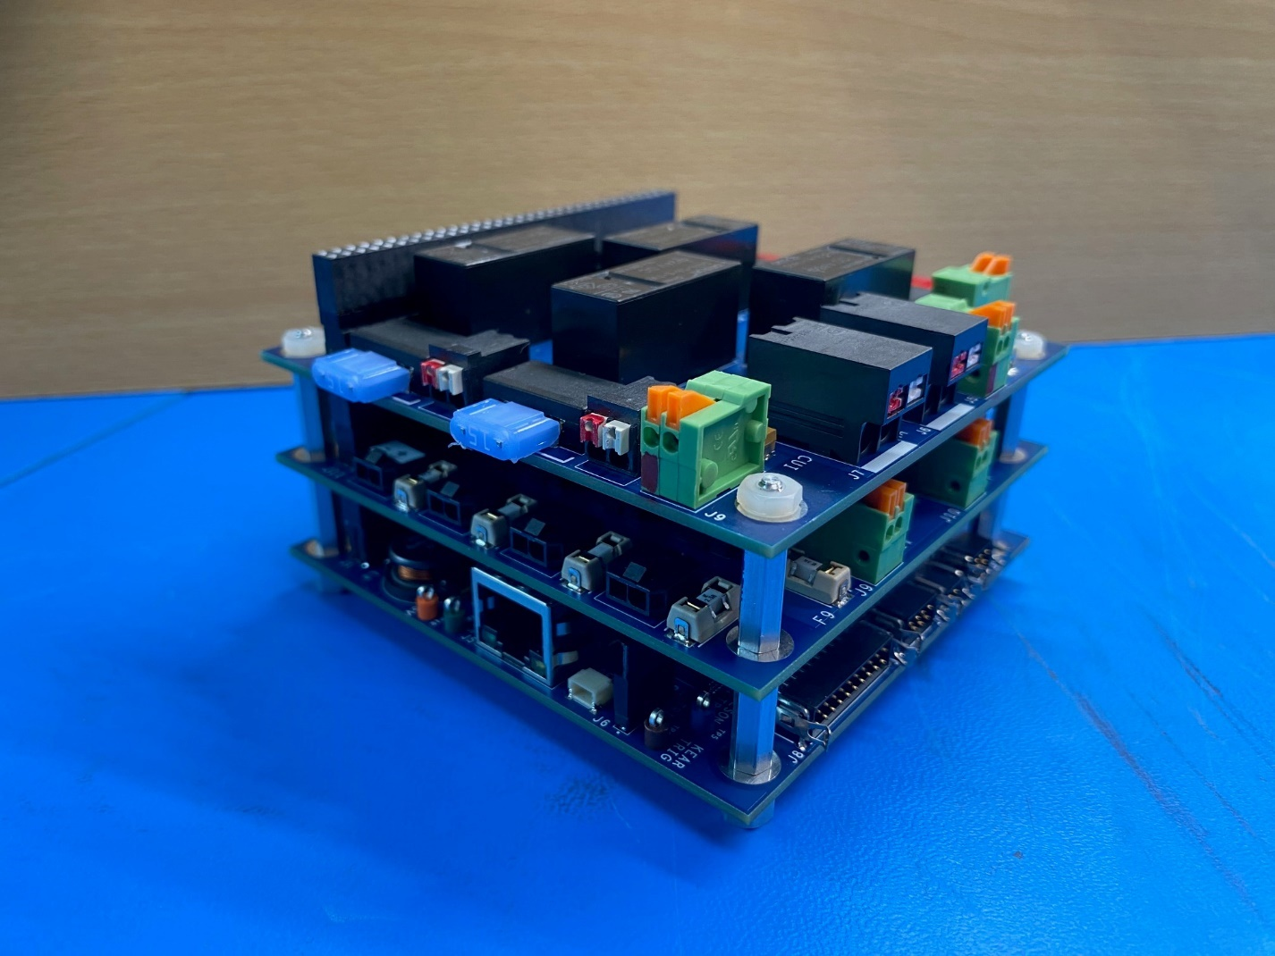
Figure 3: The LASS Stack from bottom to top, the Trigger Board, the Low Power Relay Board, and the Medium Power Relay Board.

Board Functions and Backplane Definition

The Trigger Board (TB) is the heart of the LASS stack; it contains a Raspberry Pi processor, an RP2040, which controls all of the stack functions. These functions include: digital control of all relays, system trigger generation, camera+strobe trigger distribution, PPS distribution, and measuring internal housing environmental data.

The Medium Power Relay Board (MPRB) has four individual switching circuits for external loads; the maximum current for each circuit is fifteen amps. The four channels are split into pairs, with separate inputs for the desired switching voltages. A fifth channel provides power to the activation coil for the LIDAR relay. The MPRB also provides 24Vdc to an external 12Vdc DC:DC converter.

The Lower Power Relay Board (LPRB) has eight individual switching circuits for external loads; the maximum current for each is three amps. Each channel can be configured to supply either 24Vdc or 12Vdc. The LPRB also supplies power to the Ethernet switch and to the Focal stack.

A 64-pin backplane is utilized for power and signal distribution throughout the LASS stack.

5Vdc | 1 | 2 | 3.3Vdc
5Vdc | 3 | 4 | 3.3Vdc
12Vdc | 5 | 6 | Ground Return
12Vdc | 7 | 8 | Ground Return
12Vdc | 9 | 10 | Ground Return
24Vdc | 11 | 12 | Ground Return
24Vdc | 13 | 14 | Ground Return
24Vdc | 15 | 16 | Ground Return
24Vdc | 17 | 18 | Ground Return
SPI1_MISO | 19 | 20 | Ground Return
SPI1_MOSI | 21 | 22 | Ground Return
SPI1_SCK | 23 | 24 | Ground Return
GP8 | 25 | 26 | Ground Return
GP7 | 27 | 28 | Ground Return
GP6 | 29 | 30 | Ground Return
GP3 | 31 | 32 | Ground Return
LCAM_RELAY_CTRL | 33 | 34 | Ground Return
RCAM_RELAY_CTRL | 35 | 36 | Ground Return
ROT1_RELAY_CTRL | 37 | 38 | Ground Return
ROT2_RELAY_CTRL | 39 | 40 | Ground Return
CTD_RELAY_CTRL | 41 | 42 | Ground Return
PARO_RELAY_CTRL | 43 | 44 | Ground Return
KEAR_RELAY_CTRL | 45 | 46 | Ground Return
VN100_RELAY_CTRL | 47 | 48 | Ground Return
STROBE1_RELAY_CTRL | 49 | 50 | Ground Return
STROBE2_RELAY_CTRL | 51 | 52 | Ground Return
RESON_RELAY_CTRL | 53 | 54 | Ground Return
SPARE_RELAY_CTRL | 55 | 56 | Ground Return
LIDAR_RELAY_CTRL | 57 | 58 | Ground Return
SPARE_GPIO1 | 59 | 60 | Ground Return
SPARE_GPIO2 | 61 | 62 | Ground Return
TaSPARE_GPIO3 | 63 | 64 | Ground Return
Table 1: Backplane signal list

Trigger Board

The TB is a programmable computer board which controls all peripheral boards attached to the stack. It also performs many other functions which are output directly from the TB. Originally designed for dedicated usage in the LASS experiment, however starting with revision C, the circuits have been modified to make the board usable by other scientific groups.

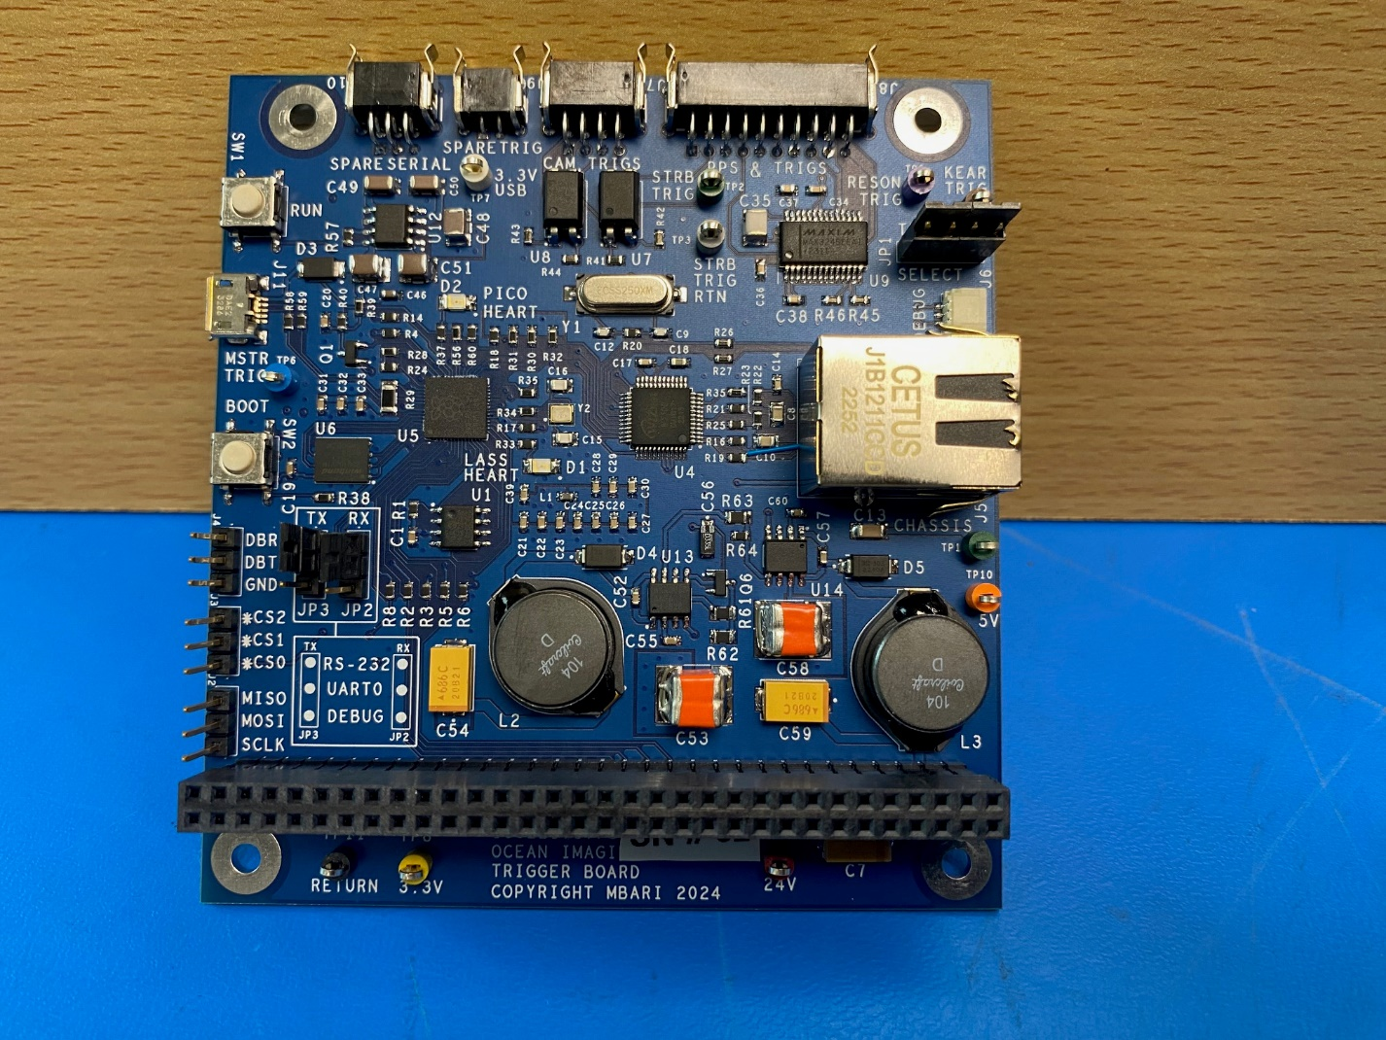
Figure 3: Revision C of the LASS Trigger Board

Raspberry Pi RP2040

[general description of the 2040]

Pin # | Name | TB Signal | Type | Backplane Pin
2 | GPIO0 | UART0_TX | Digital Output
3 | GPIO1 | UART0_RX | Digital Input
4 | GPIO2 | DIG_RESET | Digital Output
5 | GPIO3 | GP3 | Digital Output | 31
6 | GPIO4 | UART1_TX | Digital Output
7 | GPIO5 | UART1_RX | Digital Input
8 | GPIO6 | GP6 | Digital Output | 29
9 | GPIO7 | GP7 | Digital Output | 27
11 | GPIO8 | GP8 | Digital Output | 25
12 | GPIO9 | SPI1_CS1 | Digital Output
13 | GPIO10 | SPI1_SCK | Digital Output | 23
14 | GPIO11 | SPI1_MOSI | Digital Output | 21
15 | GPIO12 | SPI1_MISO | Digital Input | 19
16 | GPIO13 | SPI1_CS0 | Digital Output
17 | GPIO14 | LASS_HEARTBEAT | Digital Output
18 | GPIO15 | GP14 | Digital Output
27 | GPIO16 | SPI0_MISO | Digital Input
28 | GPIO17 | SPI0_CSn | Digital Output
29 | GPIO18 | SPI0_SCLK | Digital Output
30 | GPIO19 | SPI0_MOSI | Digital Output
31 | GPIO20 | RSTn | Digital Output
32 | GPIO21 | INTn | Digital Input
34 | GPIO22 | TRIG_RESET | Digital Output
35 | GPIO23 | GP23 | Digital Output
36 | GPIO24 | USB_DET | Digital Input
37 | GPIO25 | PICO_HEARTBEAT | Digital Output
38 | GPIO26/ADC0 | GP26 | Digital Output
39 | GPIO27/ADC1 | SP1_CS2 | Digital Output
40 | GPIO28/ADC2 | TRIG_OSCILLATOR | Digital Output
41 | GPIO29/ADC3 | REG_FDBK | Analog Input
Table 2: RP2040 GPIO Definitions

More detailed information on the RP2040 can be found at RP2040.

Relay Control

Due to the high number of relay channels available on the LASS stack, a Microchip MC23S17 16-channel I/O digital expander chip was chosen to save GPIO pins on the RP2040. It utilizes the SPI1 bus, using chip select 0. In addition to the 13 relay channels, there are 3 spare digital lines brought out to the backplane. The relays that control the loads are all single-side stable, so bringing the output of the expander high turns the relays on.

System Trigger Generation

The LASS system contains two acoustic devices: the Reson T50S imaging sonar, and a SeaDevil DVL (attached through the Kearfott INS), and these two devices need to be synchronized together. The Reson can be configured to either output a master trigger to other devices, or can be configured to accept an external trigger. When the Reson is acting as the master trigger, the frequency can only be changed through a port on the endcap and using the manufacturer’s software. To give the users the capability of changing the operating frequency mid-deployment, a system trigger generation circuit was developed.

Configured as a monostable multivibrator, the MC14536B Programmable Timer chip outputs the timing trigger at the desired frequency and pulse width. The operating frequency of the system can be programmed between 1Hz and 8Hz; the pulse width can be from 1 µsec and 20µsec.The following technical description of the MC14536B refers to Figures 4 and 5 below.

The RP2040 microprocessor outputs a square wave clock signal whose frequency is dependent upon the chosen system operating frequency; this is fed to the IN₁ input. Inputs A, B, C, and D are configured as either high or low and these four values set the internal counter decimation level (1 < n < 24). See Figure 6 below for the truth table definitions. After (2^{n}/2) clock cycles, the Decode Out pin will go high for the desired pulse width. The pulse width is determined by a high precision resistor and capacitor pair. This process continues as long as the input square wave is present.

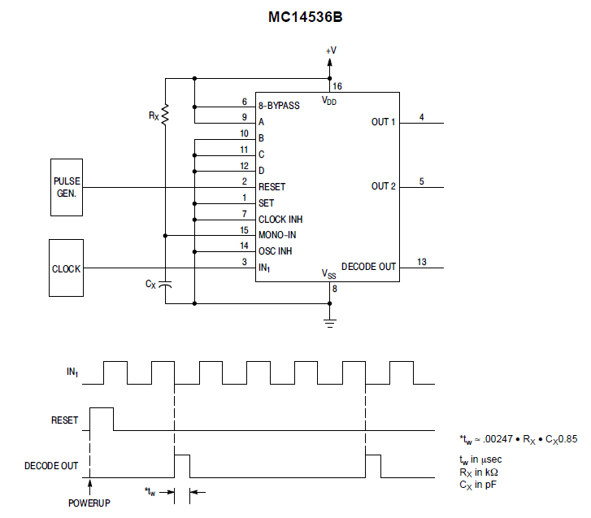
Figure 4: MC14536B Programmable Timer in Monostable Mode

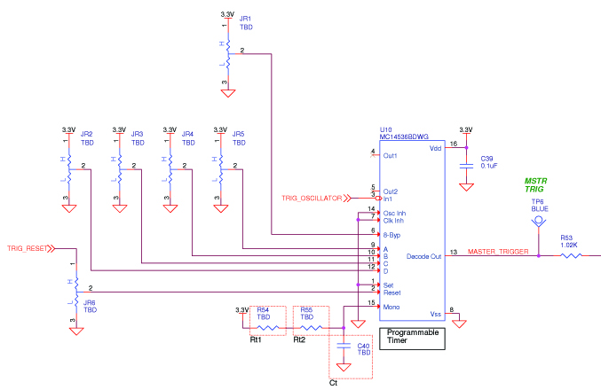
Figure 5: LASS Trigger Generation Circuit

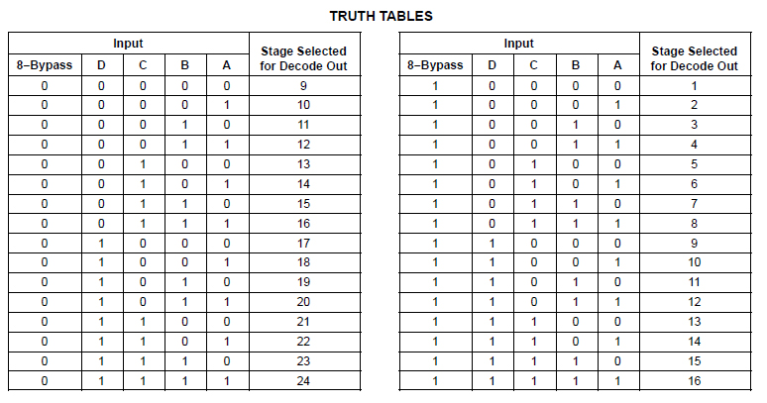
Figure 6: Truth Tables for the MC14536 Programmable Timer

The MC14536B is powered by 3.3Vdc, and its Decode Out signal is a 0 to 3Vdc pulse. The Reson T50S and SeaDevil DVL both require 5Vdc pulses. A series of NPN transistors boost the pulse to 5Vdc and distribute it to multiple locations. Refer to Figure 7 below for the distribution circuit. JP1 is available in the event that the user desires to have the Reson act as the master trigger. J9 was originally installed as a back up spare trigger signal; it is now being used by ImageneX forward looking sonar.

Trigger Type | JP1: 1,2 | JP1: 2,3 | JP1: 3,4
System Master | Shorted | Open | Shorted
Reson Master | Open | Shorted | Open
Table 3: LASS System Trigger Output Selection
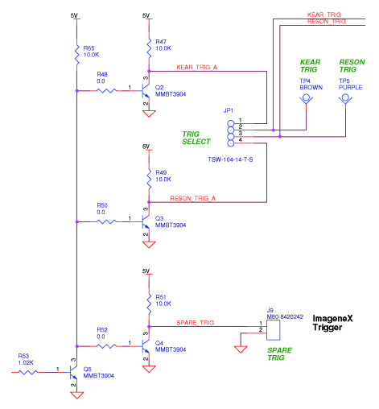
Figure 7: LASS Trigger Distribution

Camera and Strobe Trigger Distribution

The LASS platform has a pair of stereo cameras, each with its own dedicated strobe, these pairs are located on the port and starboards sides of the LASS tool sled.

[verify which (both?) cameras send the trigger, both of them have an output connected]

The camera trigger is split and optically isolated before going to the strobe housings. Prior to the optical isolators, the TTL camera trigger is level shifted to EIA-232 level and sent to the Focal board. This signal is transmitted topside as a timed record of when the stereo cameras fired.

[generate simple diagram of camera/strobe trigger flow]

PPS Distribution

The topside GPS unit sends a pulse per second (PPS) signal down to the LASS through the optical fiber and Focal stack pair. This PPS signal gets level shifted back to TTL level and distributed to the Reson, LIDAR, and Kearfott INS.

[generate simple diagram of PPS signal flow]

Internal Environmental Sensing

A board level environmental sensor, the BME280, is used to measure temperature, humidity, and pressure inside of the PIC. The TB utilizes the SPI bus to communicate with it, however, it also can be accessed via i²c.The environmental data is sent topside and is accessible through the LASS GUI. The BME280 has specific mounting and soldering instructions and should be followed diligently during the board layout and population phases.

Medium Power Relay Board

The MPRB has two input connectors for switched power, J6 and J7. J6 provides switching power to channels three and four, while J7 provides switching power to channels one and two.
For the LASS application, channels one and two use 24Vdc_Strobe to switch power to the port and starboard camera strobes. Channels three and four switch the main system 24Vdc to the Reson imaging sonar and the ImageneX. Each of the four circuits are individually fused, using Mini-Blade automotive style fuses.

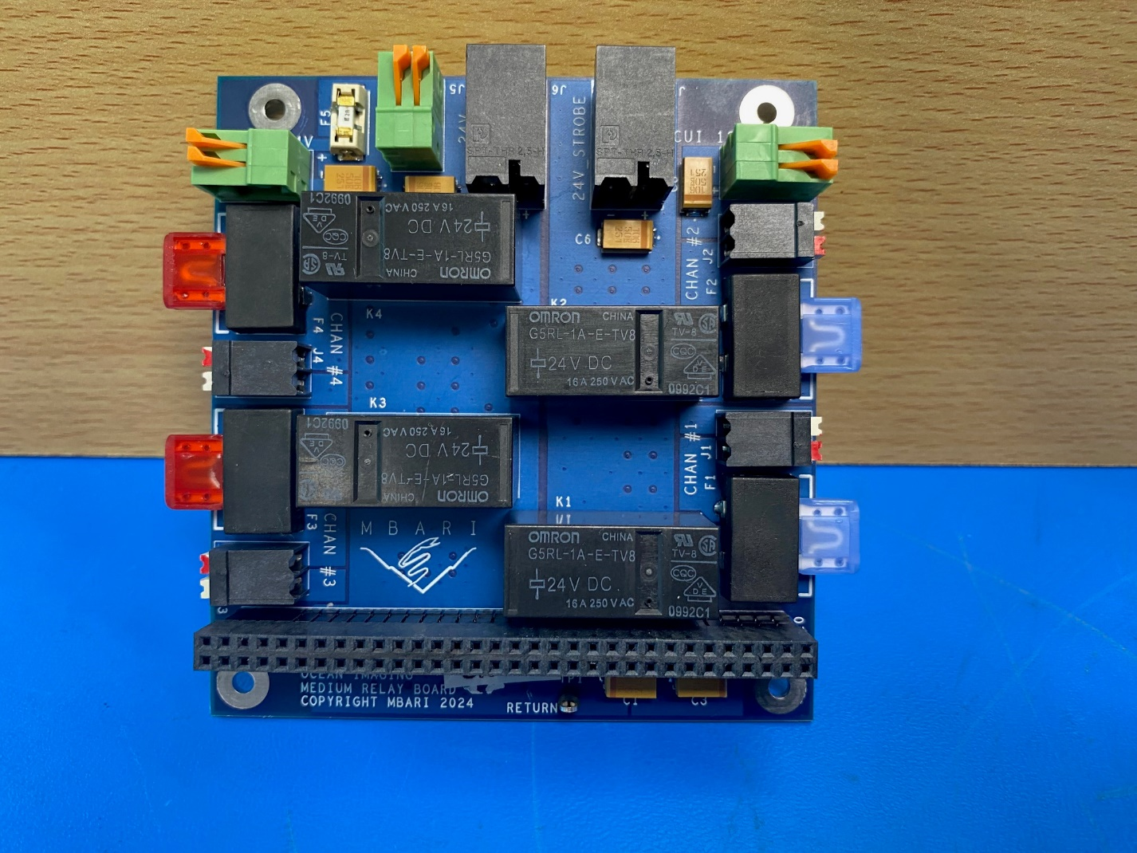
Figure 8: Revision C of the Medium Power Relay Board

The drive circuit for the loads is comprised of an N-channel mosfet (IRLML0030) and an output relay (G5RL-1A-E-TV8). The mosfet is driven from the digital expander (MCP23S17) on the trigger board. Its output level is 2.8V so a mosfet with a low Vgs threshold was chosen. This mosfet also has a very low Rds on for an N-channel part. The version of the output relay was chosen to handle large in-rush current and a sustained average current of 15 amps at the operating voltage of 24Vdc. The coil voltage was chosen to be 24V (instead of 3.3V or 5V) in order to minimize the wattage level needed for the low voltage DC regulators.

Channel Number | Switching Voltage Input Connector | Fuse | Fuse Rating | Output Connector | Backplane Signal
1 | J7 | F1 | 15 Amps | J1 | STROBE1_RELAY_CTRL
2 | J7 | F2 | 15 Amps | J2 | STROBE2_RELAY_CTRL
3 | J6 | F3 | 10 Amps | J3 | RESON_RELAY_CTRL
4 | J6 | F4 | 2 Amps | J4 | SPARE_RELAY_CTRL
Table 4: Medium Power Relay Board Load Channels

The fifth drive circuit is dedicated to an off-board relay (G9EJ-1-E) which powers up the 3D at Depth LIDAR. An N-channel mosfet acts as a low-side switch for the G9EJ relay. The flyback diode for the coil is mounting directly onto the relay.

The MPRB also supplies 24Vdc to an offboard 24V:12V DC-DC converter (PYBE30-Q24-S12-T). This is a 30W converter which provides 2.5 amps of 12V.

Low Power Relay Board

The LPRB is an eight-channel load switching board. Each channel is configurable, via zero-ohm selection resistors, to output either 12Vdc or 24Vdc. Each channel is also individually fused, using Nano² 452 cartridge style fuses and the maximum current per channel is 3 amps.

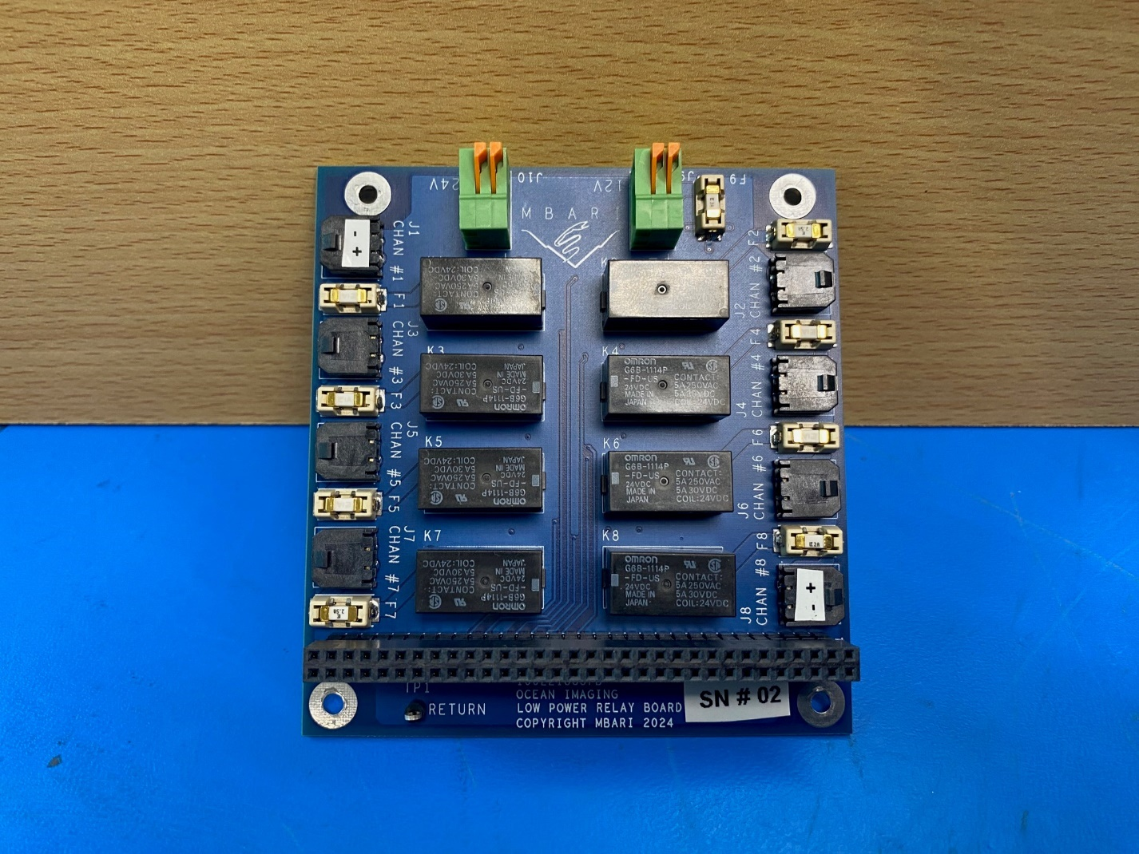
Figure 9: Revision B of the Low Power Relay Board

The drive circuit for the load is comprised of an N-channel mosfet (IRLML0030) and an output relay (G6B-1114P-FD-US-DC24). The mosfet is driven from the digital expander (MCP23S17) on the trigger board. Its output level is 2.8V so a mosfet with a low Vgs threshold was chosen. This mosfet also has a very low Rds on for an N-channel part. The version of the output relay was chosen to handle large in-rush current and a sustained average current of 3 amps at either operating voltage. The coil voltage was chosen to be 24V (instead of 3.3V or 5V) in order to minimize the wattage level needed for the low voltage DC regulators.

Channel Number | 24 Vdc Selection Resistor | 12 Vdc Selection Resistor | Switched Voltage | Fuse | Fuse Rating | Output Connector | Backplane Signal
1 | R17 | R18 | 24 Vdc | F1 | 1 Amp | J1 | CTD_RELAY_CTRL
2 | R9 | R10 | 24 Vdc | F2 | 2.5 Amps | J2 | ROT1_RELAY_CTRL
3 | R19 | R20 | 24 Vdc | F3 | 1 Amp | J3 | KEAR_RELAY_CTRL
4 | R1 | R2 | 24 Vdc | F4 | 1 Amp | J4 | LCAM_RELAY_CTRL
5 | R3 | R4 | 24 Vdc | F5 | 1 Amp | J5 | RCAM_RELAY_CTRL
6 | R27 | R28 | 12 Vdc | F6 | 1 Amp | J6 | VN100_RELAY_CTRL
7 | R11 | R12 | 24 Vdc | F7 | 2.5 Amps | J7 | ROT2_RELAY_CTRL
8 | R25 | R26 | 12 Vdc | F8 | 2 Amps | J8 | PARO_RELAY_CTRL
Table 5: Low Power Relay Board Load Channels

The LPRB also supplies power to two off board devices: 24Vdc for the Ethernet switch and 12Vdc for the Focal stack.

External BME280 Eval Board (Optional)

Due to the difficulties of soldering the BME280 module onto pcbs, there is an option of mounting an external (pre-populated) BME280 eval board. On the revC version of the Trigger board, this mini add-on board will plug into a portion of the backplane. On revD, there will be a single row 6-pin header where the eval board can be soldered in, or inserted into a female receptacle.

LASS LED Shield

LASS Stack Software

RP2040 Firmware

PC/Touchscreen GUI

Serial (Terminal) USB Interface

LASS Stack Bench Testing / Operation

As with all new circuit boards, care should be taken when initially testing them. Visually inspect the pcbs for any improperly installed components, or incorrect soldered jumpers. For the LASS stack, it is recommended to test each one individually (as much as possible), prior to assembling the stack.

Trigger Board

Power supplies (5Vdc and 3.3Vdc)
Verify USB connection disables onboard 3.3Vdc regulator
Confirm trigger jumpers and pulse width components
Install debug jumpers
Load firmware
Verify heartbeats (visually)
Verify comms to term software
Read environmental data
Install trigger jumper(s)
Measure Trigger frequency and pulse width
Change frequency in GUI and verify signal follows
Install LED shield
Test all digital channels (one at time) to the LED shield

Medium Power Relay Board

Low Power Relay Board

References

Appendices

Appendix 1: appendix1

Appendix 2: appendix2

Appendix 3: appendix3

Appendix 4: appendix4

Appendix 5: appendix5

