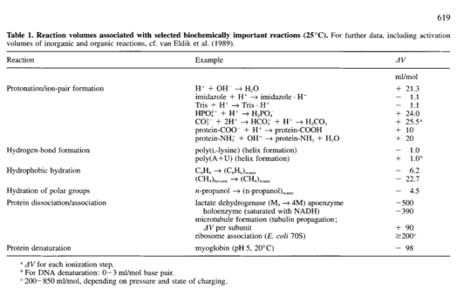

Pressure apparatus schematics from literature
- Gross and Jaenicke 1994 Fig. 1B: T-path fluoro cell
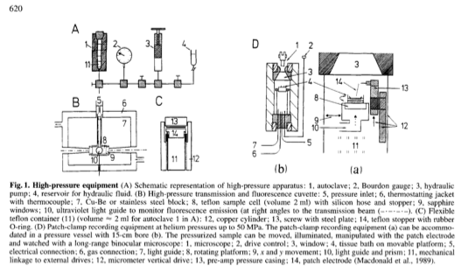
- Mustafa, Moon and Hochachka 1971 Fig. 1: 5 cc 2-window cell with cleanout
NOTES:
  - This is the cell Erik has.
  - It undergoes 12% expansion of path length (from 10 to 12 mm) at P > 2000 PSI.
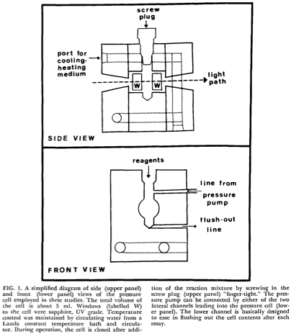

3. See Paladini and Weber 1981 for detailed drawings of a 2-4-window sealed-cuvette cell similar to what’s offered by ISS.

