Self-Contained Plankton Imager (SCPI) Overview
PI: Steven Haddock, Ken Smith
PM: Chad Kecy

Several research groups at MBARI have expressed a strong interest in camera-based instruments that can be deployed across a variety of platforms. Specific imaging goals include zooplankton (Haddock Lab, CANON PIs, AUV groups, Vrijenhoek Lab), and particle flux dynamics (Ken Smith). SCPI develoment is driven by meeting these goals, with a priority on macrozooplankton identification, since that is the technological capability that is currently most lacking in marine research.

The technical imaging requirements for this system were set by target size that will be quantified. It is difficult to evaluate whether an image is of sufficient quality without resorting to subjective terms. To quantify differences between camera options, and to evaluate prototypes and subsequent iterations of SCPI, one of the metrics we will use is how many species we can effectively count. This will be a function of the lighting and sensor capabilities, as already demonstrated in our laboratory tests under realistic conditions. As shown in figure 1, the prototype system built during 2012 should be able to resolve Moon Jellies (A) and Sea Nettles (B) well enough to allow for species quanitification. As development proceeds, we will be able to target more difficult species. Future versions of SCPI will aim to resolve other common species such as Aegina (small circles in C and D) and Nanomia (large circle in D). The second near-term requirement will be to image particles for several sediment trap systems. These will be evaluated based on particle size that can be counted, since the lighting and lens settings will be adapted to those goals rather than visualizing larger zooplankton.

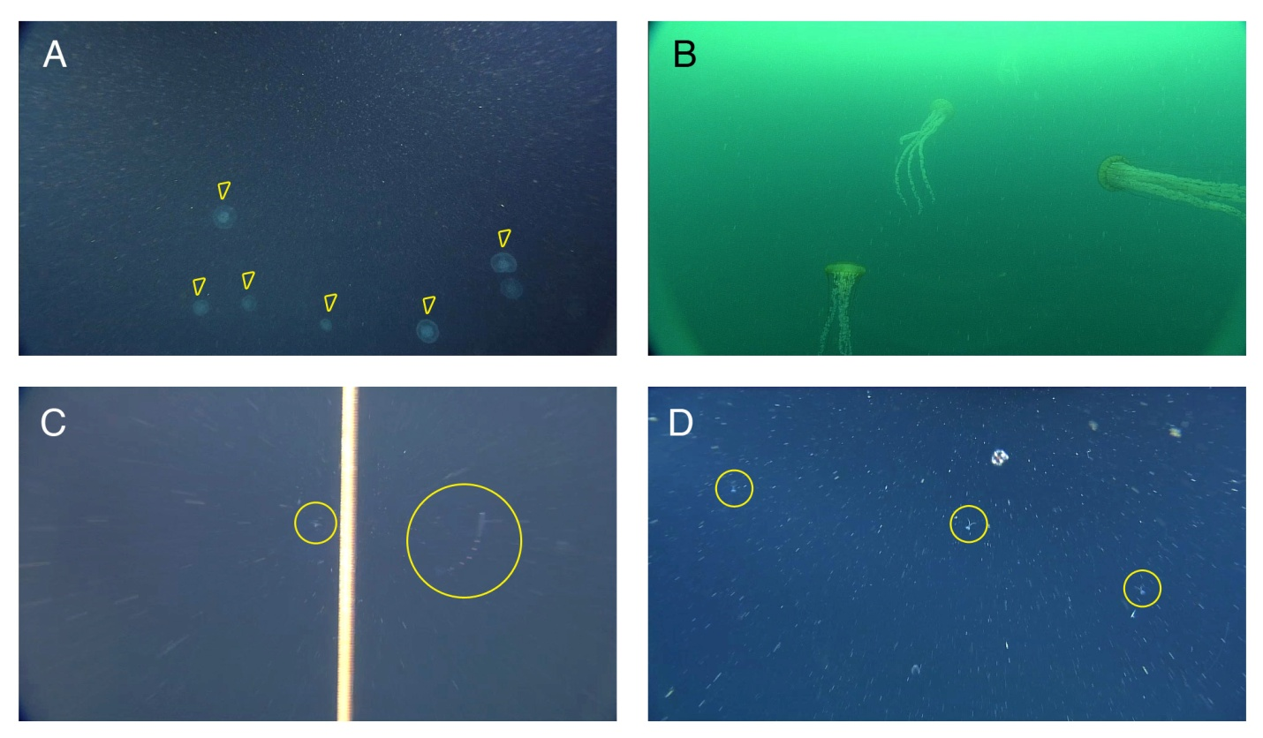
Figure 1: Species to be quantified by SCPI

Based on the wide variety of potential platforms, we decided to pursue a modular approach to SCPI. Separating the camera, light, and battery modules, gives the user maximum deployment flexibility. The relative orientations of the modules can be utilized to image a wide range of species.

The modules are made from 3.5" inner diameter schedule 80 PVC and have interchangeable endcaps. Each module is a different length but steps were taken to keep the size as small as possible to enable SCPI to be mounted in hard to get to locations. Figure 2 illustrates the modular components of SCPI and the electrical interconnections.

Figure 2: Modular approach to SCPI

The camera module contains the camera and the autonomous control board. This board contains a microcontroller which is programmed to take photos and/or video at a predetermined rate as well as the timing of the light (LED) module.

The light (LED) module contains two circuit boards: one contains a series of LEDs with beam forming reflectors, the other is the driver board for the LEDs. The beam forming reflectors direct the available light into the target area. Figure 3 shows the overlapping area (red) of the camera field of view (blue) and the LED beam pattern (yellow). The target imaging plane is a one meter square area one meter away from the camera.

The battery modules contains 16 Nickel Metal Hydride (NiMH) batteries. NiMH batteries were chosen due to their superior performance during periods of high current draw. The LED module will draw upto approximately 3 amps while being fired. Future versions of SCPI could also use primary lithium batteries as well.

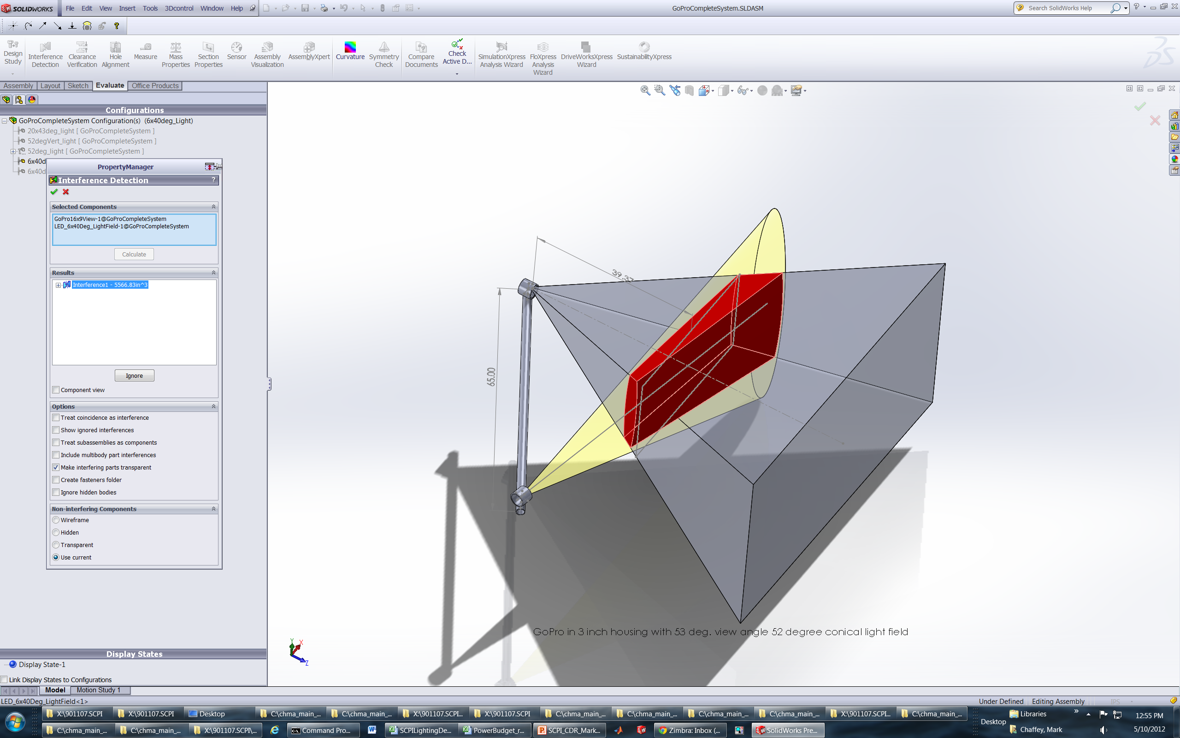
Figure 3: Cross sectional area of illuminated target area
Figure 4: Mounting arrangement of the 2012 prototype version of SCPI

Completed camera assessment in March 2012
Completed light quanitifcation requirements in April 2012
Conducted a Concept Design Reveiw in May 2012

Battery housing has been fabricated (August 2012)
LED housing has been fabricated (September 2012)
LED circuit board has been fabricated (September 2012)
NiMH battery packs are on order (due next week)
The software is 90% complete (tested on a proto control board)

LED driver board is in final layout
Camera control board is in final layout (expect to have it populated by mid November)
Camera housing is in final design
We're having spare housings and endcaps made (order to go out next week)
Connectors and cables due to arrive next week (Oct 29)

