2015 Annual Report input for the SeeStar Project

Project Number: 901107
Principal Investigator: Steven Haddock, PhD
Project Manager: Chad Kecy
Project Team: Chad Kecy (EE), Francois Cazenave (ME), Thom Maughan (SE), Danelle Cline (SE)

In 2015 the team performed a number of upgrades on the original SeeStar imaging system. The resulting improved SeeStar II is more user-friendly to program, easier to build, and costs $500 less to fabricate than the original system. In order to be more in line with the open source community, we switched over to an Arduino as the main CPU. We also used all commercial-off-the-shelf parts with the sole exception of the custom CPU controller shield. The depth rating of the system has been extended to 1500 meters due to the new aluminum housings from a private manufacturer. We have been assisting researchers from various institutions including the Farallon Institute, Oakland University, and The Noyo Center for Marine Science. The team also completed the online open source build documentation; these plans allow any researcher to build or modify their own SeeStar system. The team demonstrated the SeeStar II system at the Bay Area Maker’s Faire in May 2015.

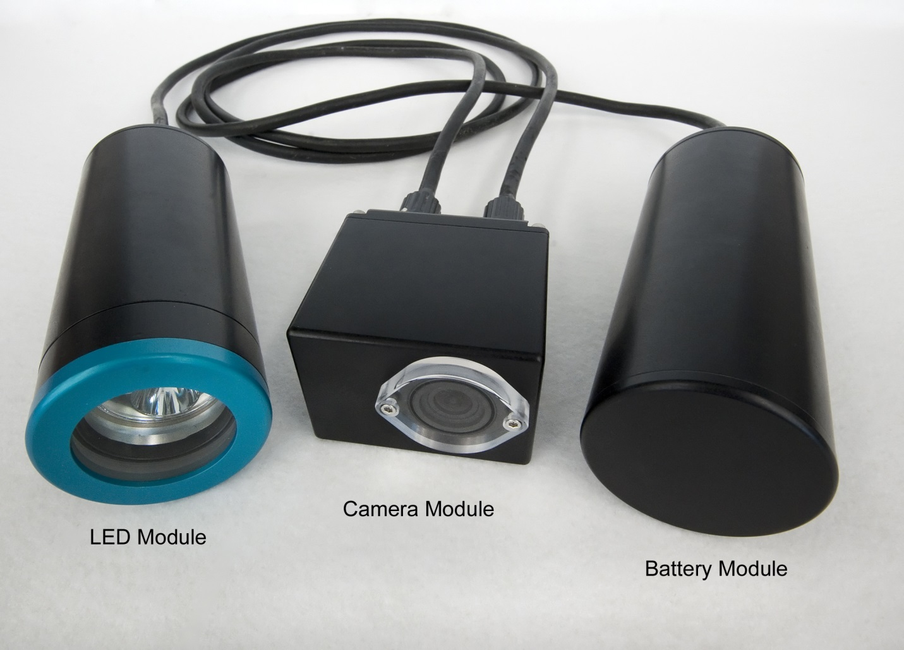
Picture of the SeeStar II Imaging System

