SeeStar Hero3+ USB Transfer Procedure
Chad Kecy
04-09-2014

This document covers the steps necessary to access the micro SD card housed in the GoPro Hero 3+ without the need to open the underwater SeeStar camera housing. The procedure outlined here also works for the Hero 3 cameras.

Items Needed:
SeeStar Camera Housing
Host Computer (with DB9 serial or USB to Serial adaptor)
SeeStar Test Cable
DC Power Supply (minimum 15V, 1A)
USB Cable (mini B to Type A)
Hyperterminal (or equivalent)

Note to user:
The GoPro cameras and the host computer may have USB compatibility issues. Some USB 3.0 enabled ports on computers will not work with the GoPro cameras. Also, excessively long USB cables may prevent proper USB handshaking to occur. If USB handshaking is not achieved, try a different physical USB port or a different computer.

Step 1: Gather all required items.

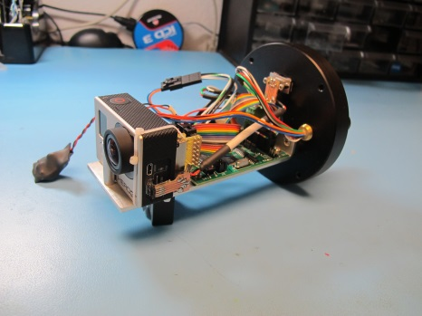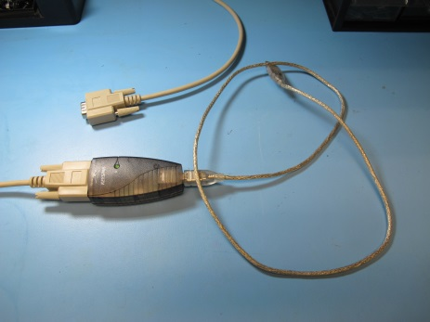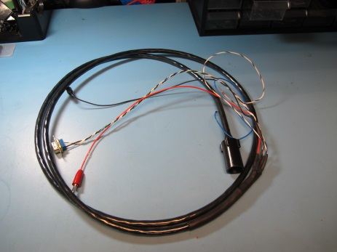
SeeStar Camera Housing USB-Serial Adaptor SeeStar Test Cable

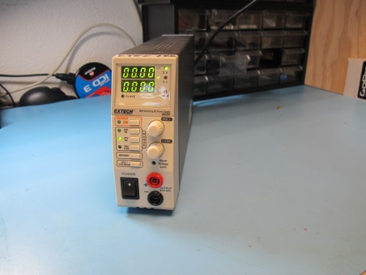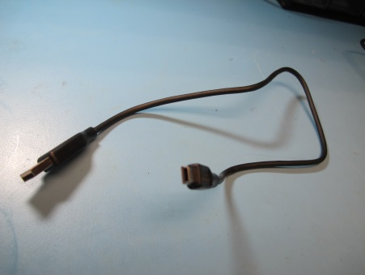
DC Power Supply Mini-B to Type A USB Cable

Step 2: Setup the DC Power Supply

The voltage range for the SeeStar System is 12Vdc to 22Vdc. A safe operating voltage is 18Vdc. Set the current limit to at least 1 amp.

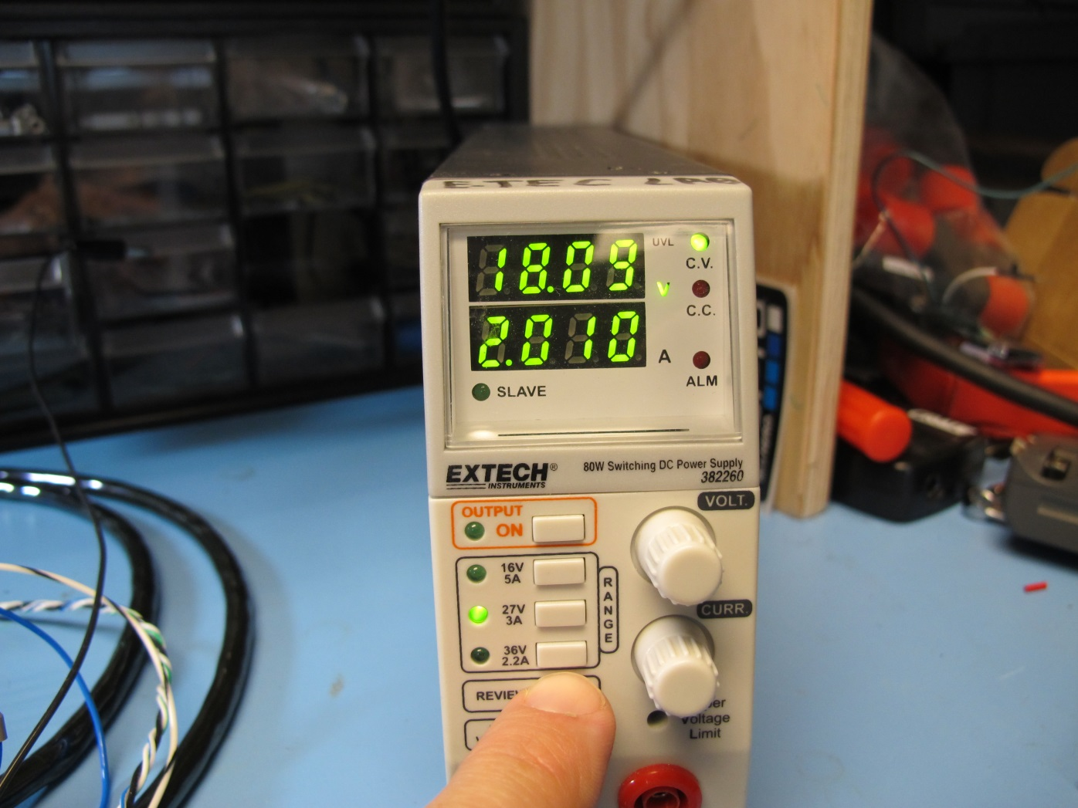

Step 3: Connect the SeeStar Test Cable.

Plug the power connectors (red positive and black return) into the DC power supply. Plug the DB9 connector into your USB-Serial adaptor (gender changer may be necessary). The two spare pins are currently not used, leave them aside.

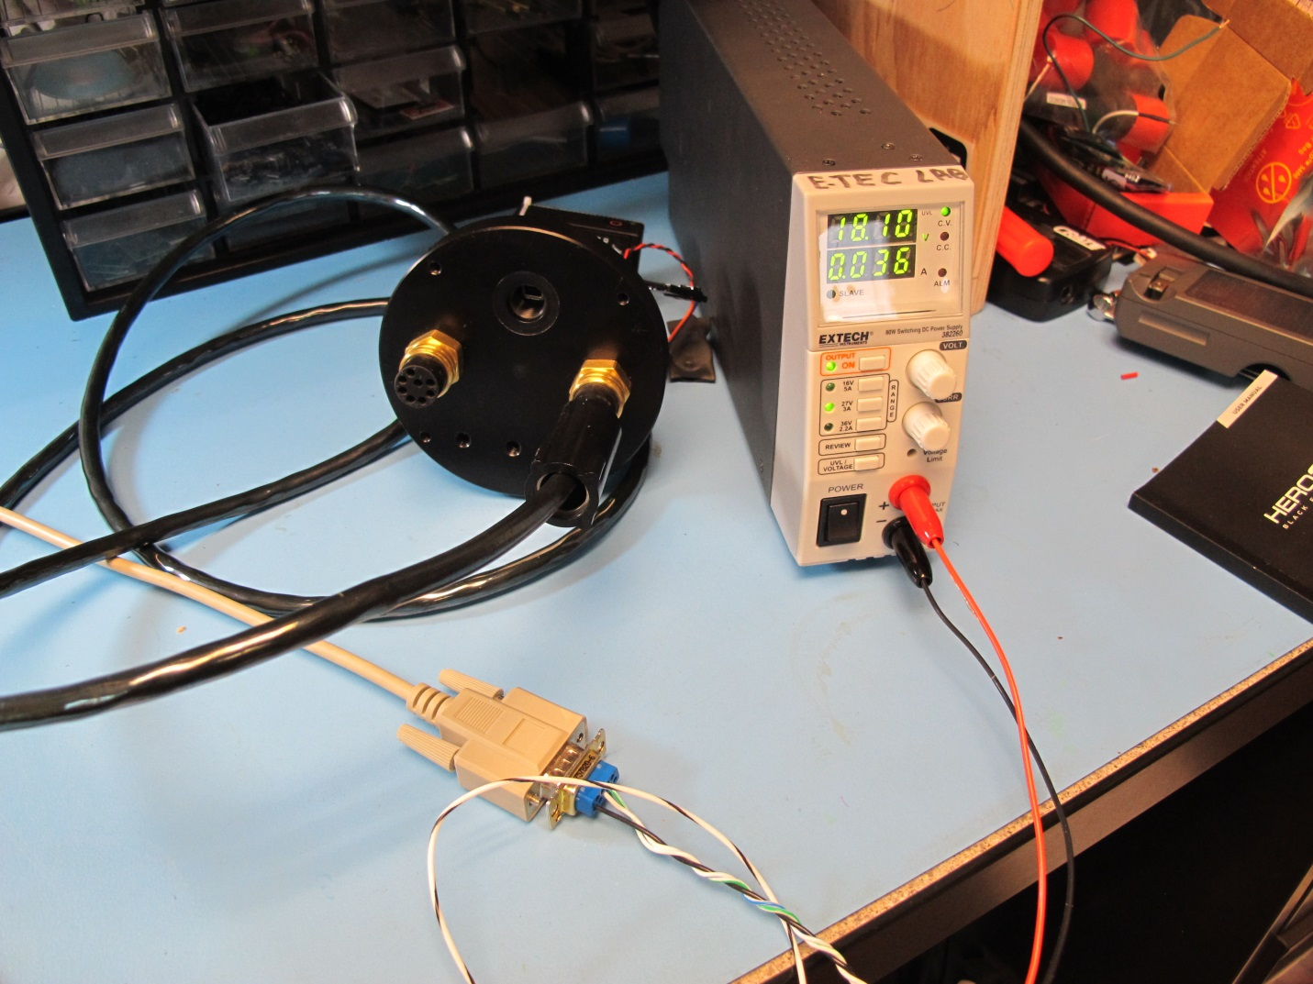

Step 4: Verify serial communication

Open up a hypterminal window. Start a new session using the correct COM port. The serial settings for the SeeStar camera module are 9600, n, 8, 1, no flow control. After applying power from the DC supply, a splash screen should appear. Typing Help All lists all of the available commands. Turn off the DC power supply once serial communication has been verified.

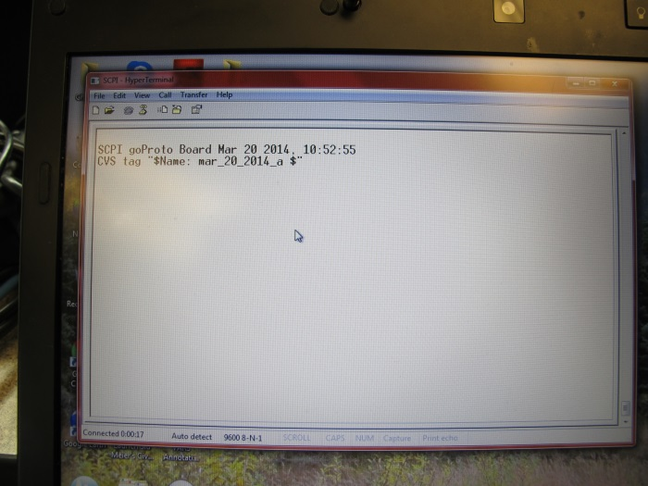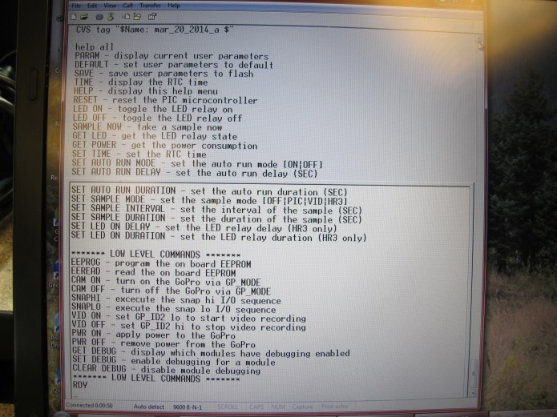
Welcome splash screen Help All command listing

Step 5: Connect the USB cable to the SeeStar camera module

The type B USB connector is located behind the water tight SAE port. Remove the SAE fitting and attach the USB cable.

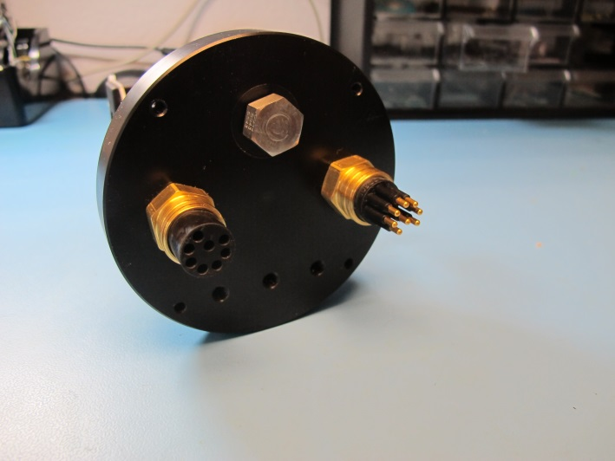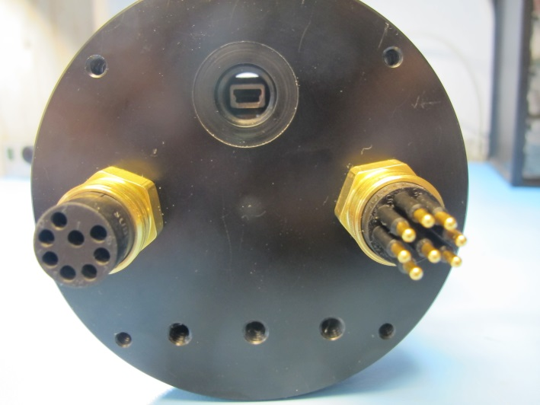

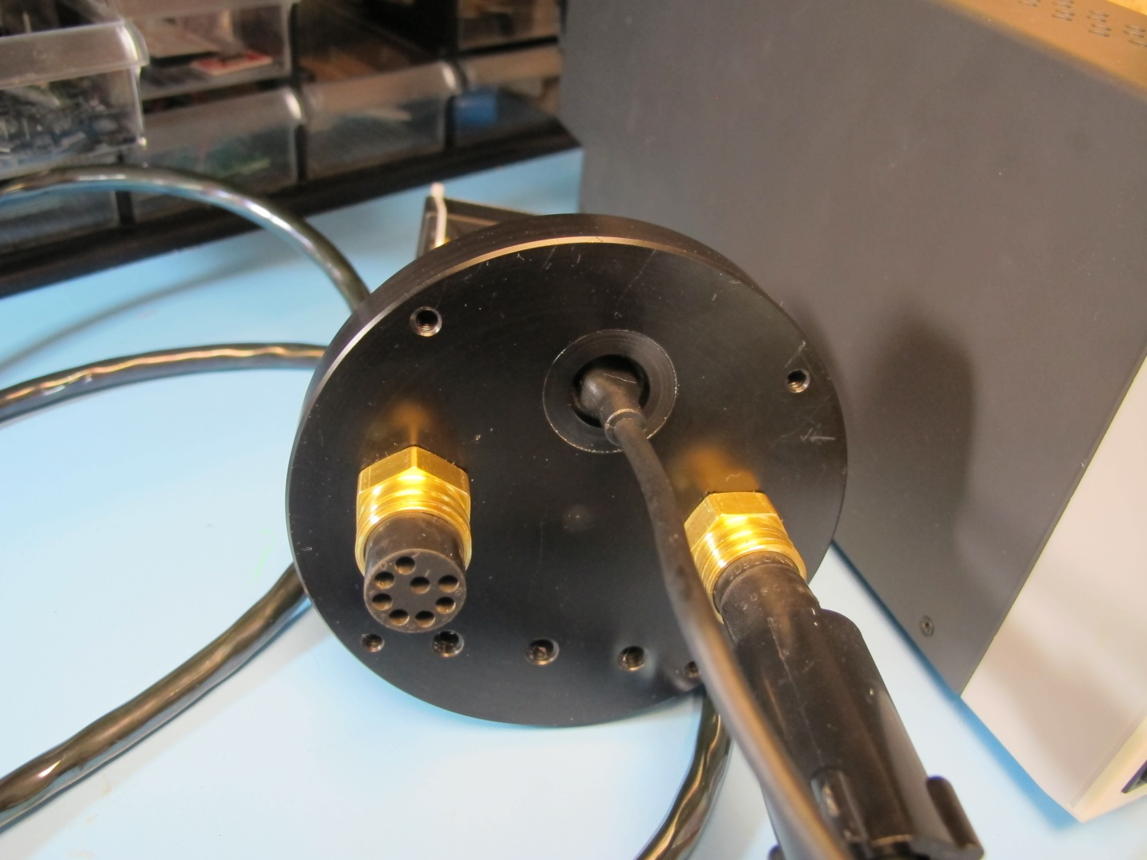

Step 6: Plug the USB cable into the host computer

As stated before, use a USB 2.0 port and if not successful, try an alternate USB port.

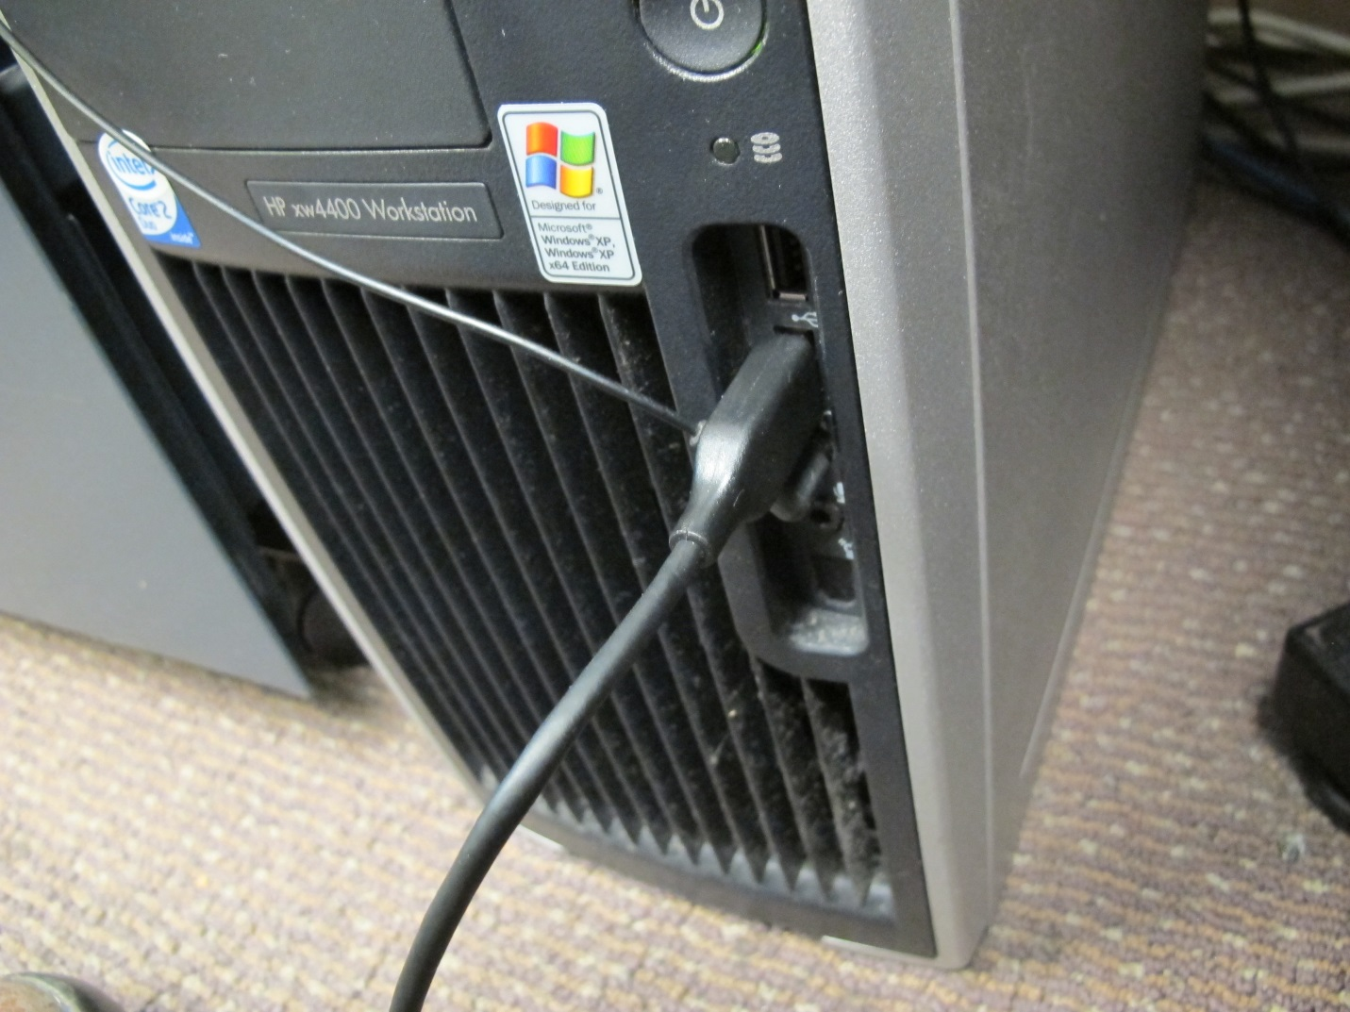

Step 7: Establish USB handshaking

Turn on the DC power supply. The splash screen should appear. Type PWR ON. This command passes the 4.2Vdc GoPro battery voltage to the camera, but does not turn it on.

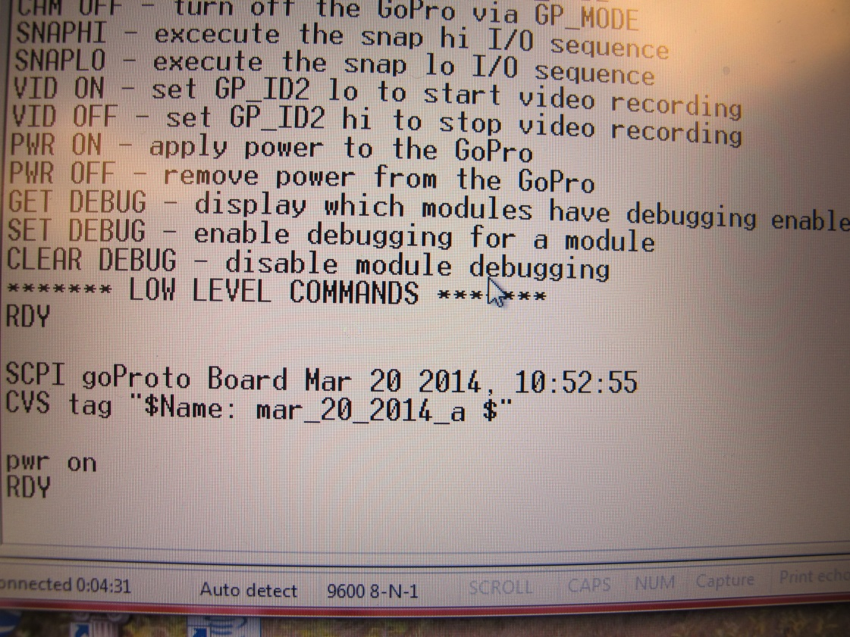

Wait 10 seconds and type CAM ON. This command mimics a human pressing the physical ON button on the GoPro Hero 3+.

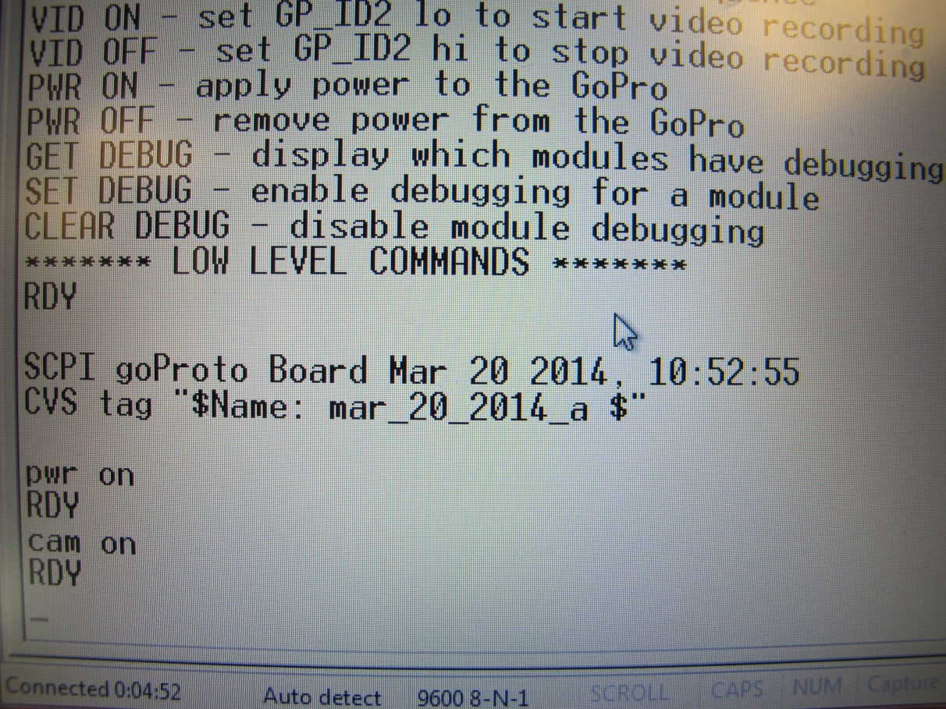

At this point, the camera should turn on, and USB handshaking should initiate. The LCD screen on the Hero 3+ will display the USB transfer symbol.

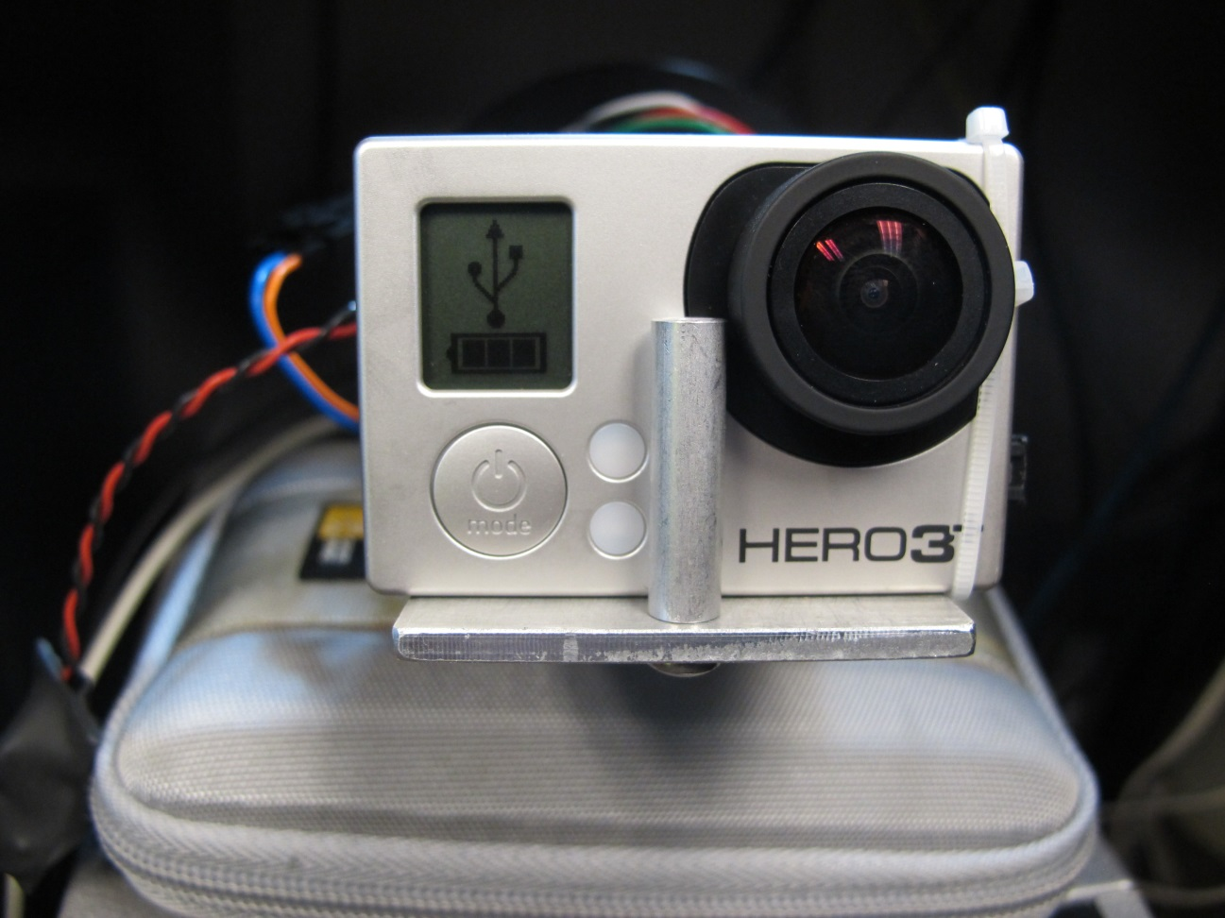

The host computer should recognize the Hero 3+ as a USB device.

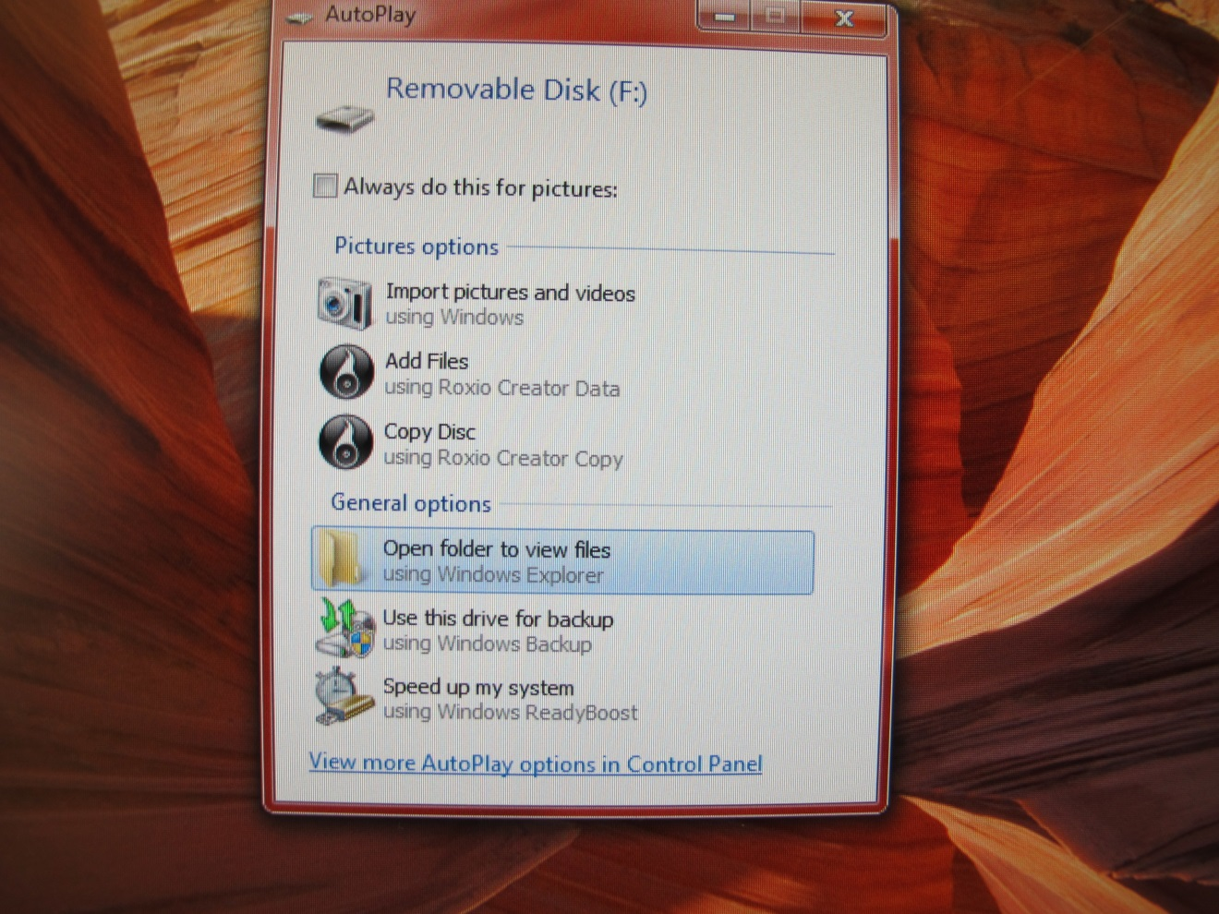

The user can now open a new Windows Explorer folder and navigate down to the Hero 3+ pictures and/or videos for transfer to the host computer and deletion from the SD card.

