SeeStar Imaging System
Operations Manual
v0.1

Monterey Bay Aquarium Research Institute

Aug. xx, 2014



Table of Contents
Introduction 4
System Level Description 4
System Capabilities 5
Preparing SeeStar for Deployment 5
Programming the SeeStar System 5
Establishing Serial Communication 6
GoPro Hero 3/3+ Camera Setup 6
GoPro Hero 3/3+ Scripts 6
Commands 6
Example Scripts 8
HERO 3 8
HERO 3+ 8
Installing a Script 9
USB Image/Video Transfer 10

Figure 1: The SeeStar Imaging System 4
Figure 2: Block diagram of SeeStar 5
Figure 3: Location of the autoexec.ash file on the SD card 9
Figure 4: SeeStar camera housing 10
Figure 5: USB-Serial adaptor 10
Figure 6: SeeStar test cable 10
Figure 7: DC Power supply 10
Figure 8: Mini-B to Type A USB cable 10
Figure 9: Configuring the DC power supply 11
Figure 10: Powering the SeeStar camera module 12
Figure 11Welcome splash screen 13
Figure 12: Help All command listing 13
Figure 13: Camera endcap with SAE fitting 13
Figure 14: Camera endcap showing USB connection 13
Figure 15: Downloading images via USB 14
Figure 16: USB cable in computer 15
Figure 17: PWR ON command 16
Figure 18: CAM ON command 17
Figure 19: USB transfer indication on Hero 3+ 18
Figure 20: Opening an SD card 19
Figure 21: File listing of SD card 20

Introduction

SeeStar is an open-source oceanographic imaging system developed at the Monterey Bay Aquarium Research Institute (MBARI). It is a modular, low-cost, and light weight subsea imaging system for mid- to long term monitoring of marine ecosystems. The system can be deployed in a variety of scenarios taking either still images or video and can be operated either autonomously or tethered on a range of platforms including ROVs, AUVs, landers, piers, or moorings. The design priorities included using off-the-shelf and easily available components as much as possible, and to provide all designs, schematics, and fabrication documents online as open source, so that others can easily build and adapt the imaging system for their own needs.

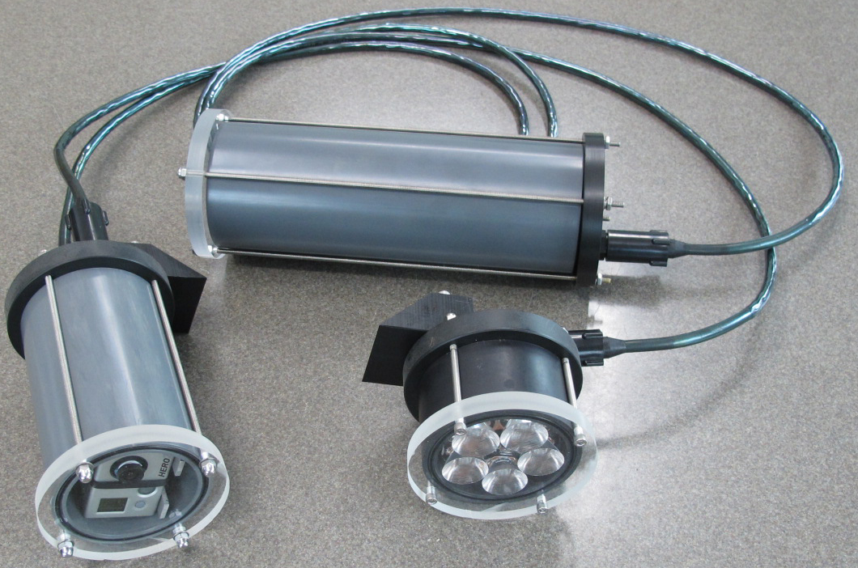
Figure 1: The SeeStar Imaging System

System Level Description

SeeStar is composed of separate camera, LED light, and battery modules, each rated to 300 meters of depth. They share a common 8-pin bus using the micro series of underwater connectors and cables from SubConn. The camera module contains a microcontroller based board which acts as the brains of the system; it is responsible for triggering the camera and LED lights.

Figure 2: Block diagram of SeeStar

System Capabilities

SeeStar is capable of taking still images or video at a user programmable rate.

uses a GoPro Hero 3/3+ as the imager

Preparing SeeStar for Deployment

Sealing the housings

Programming the SeeStar System

Programming a SeeStar for a deployment consists of three main steps: setting up the GoPro Hero 3/3+ camera, writing and transferring the script file, and programming the Controller board. Each of these steps is covered in detail in separate sections.

Establishing Serial Communication

GoPro Hero 3/3+ Camera Setup

Basic operation of GoPro (modes, etc...)
How to manually power up the GoPro when installed in SeeStar

GoPro Hero 3/3+ Scripts

The Hero 3/3+ cameras can be controlled remotely via the use of command scripts stored on the SD card. When the Hero 3/3+ is powered up, the script is automatically executed. The scripts can be written to emulate most Hero 3/3+ functions usually available to the user via the power and mode buttons. While there is an extensive list of commands available for use with the scripts, this document will cover only the basic commands for taking images and videos.

Note to user:
Some of the script commands are not compatible for both the Hero 3 and Hero 3+. Verify your camera model before transferring the script onto the SD card.

Commands

t app appmode [photo | video]

Description:

Places the Hero 3/3+ in either photo or video mode.

Usage: t app appmode photo (put the Hero 3/3+ in image taking mode)

t app button [power | shutter] [P | R]

Description:

Software equivalent of pressing either power or shutter button.

power: Power button

shutter: Shutter button

P: Press

R: Release

Usage: t app button shutter P (press the shutter button)
t app button shutter R (release the shutter button)
t app button shutter PR (press and then immediately release the shutter button)

t app sleep [x]

Description:

Pause between actions.

Argument: x, time in seconds

Usage: t app sleep 5 (wait 5 seconds)

poweroff yes reboot yes

Description:

Powers down the Hero 3+. (Only works on the Hero 3+, not Hero 3)

Usage: poweroff yes
reboot yes

Note to user:
To power down a Hero 3, do so using the power button commands:

t app button power P
sleep 3
t app button power R

Example Scripts

HERO 3

**** Take one image, wait 5 seconds and power down ****
sleep 5
t app button shutter PR
sleep 5
t app button power P
sleep 3
t app button power R

Note to user:
The Hero 3 must be set to come up in photo mode for the above script to work.

**** Take 60 seconds of video, wait 10 seconds and power down ****
sleep 5
t app button shutter PR
sleep 60
t app button shutter PR
sleep 10
t app button power P
sleep 3
t app button power R

Note to user:
The Hero 3 must be set to come up in video mode for the above script to work.

HERO 3+

**** Take one image, wait 5 seconds and power down ****
sleep 5
t app button shutter PR
sleep 5
poweroff yes
reboot yes

Note to user:
The Hero 3 must be set to come up in photo mode for the above script to work.

**** Take 60 seconds of video, wait 10 seconds and power down ****
sleep 5
t app button shutter PR
sleep 60
t app button shutter PR
sleep 10
poweroff yes
reboot yes

Note to user:
The Hero 3 must be set to come up in video mode for the above script to work.

**** Put the Hero 3+ in photo mode, wait 5 seconds, take one image, wait 5 seconds and power down ****
sleep 5
t app appmode photo
sleep 5
t app button shutter PR
sleep 5
poweroff yes
reboot yes

Installing a Script

When generating a script, verify that the text (or hex) editor is capable of saving the file in Unix format. This means that there is only a LF after each statement (no CR’s). If saved with carriage returns, the scripts will not execute. The scripts need to be named autoexec.ash and saved into the root directory of the SD card.

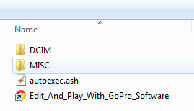
Figure 3: Location of the autoexec.ash file on the SD card

USB Image/Video Transfer

This section covers the steps necessary to access the micro SD card housed in the GoPro Hero 3+ without the need to open the underwater SeeStar camera housing. The procedure outlined here also works for the Hero 3 cameras.

Items Needed:
SeeStar Camera Housing
Host Computer (with DB9 serial or USB to Serial adaptor)
SeeStar Test Cable
DC Power Supply (minimum 15V, 1A)
USB Cable (mini B to Type A)
Hyperterminal (or equivalent)

Note to user:
The GoPro cameras and the host computer may have USB compatibility issues. Some USB 3.0 enabled ports on computers will not work with the GoPro cameras. Also, excessively long USB cables may prevent proper USB handshaking to occur. If USB handshaking is not achieved, try a different physical USB port or a different computer.

Step 1: Gather all required items.

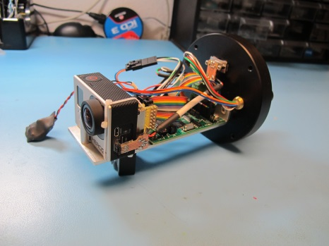
Figure 4: SeeStar camera housing
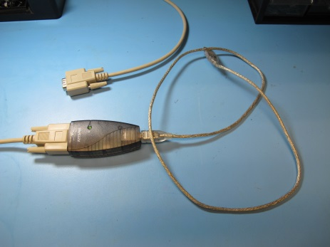
Figure 5: USB-Serial adaptor
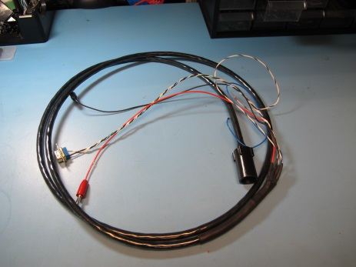
Figure 6: SeeStar test cable

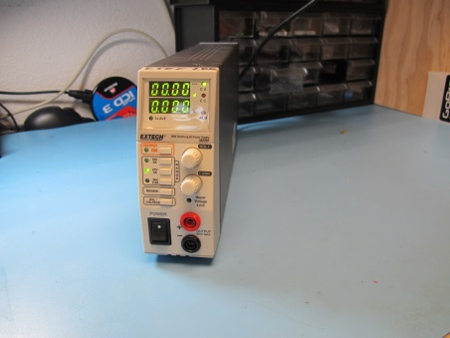
Figure 7: DC Power supply
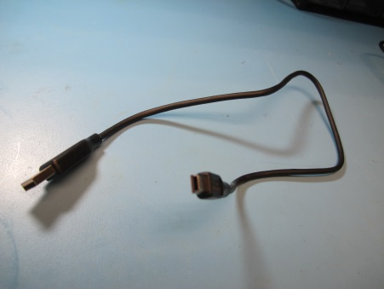
Figure 8: Mini-B to Type A USB cable

Step 2: Setup the DC Power Supply

The voltage range for the SeeStar System is 12Vdc to 22Vdc. A safe operating voltage is 18Vdc. Set the current limit to at least 1 amp.

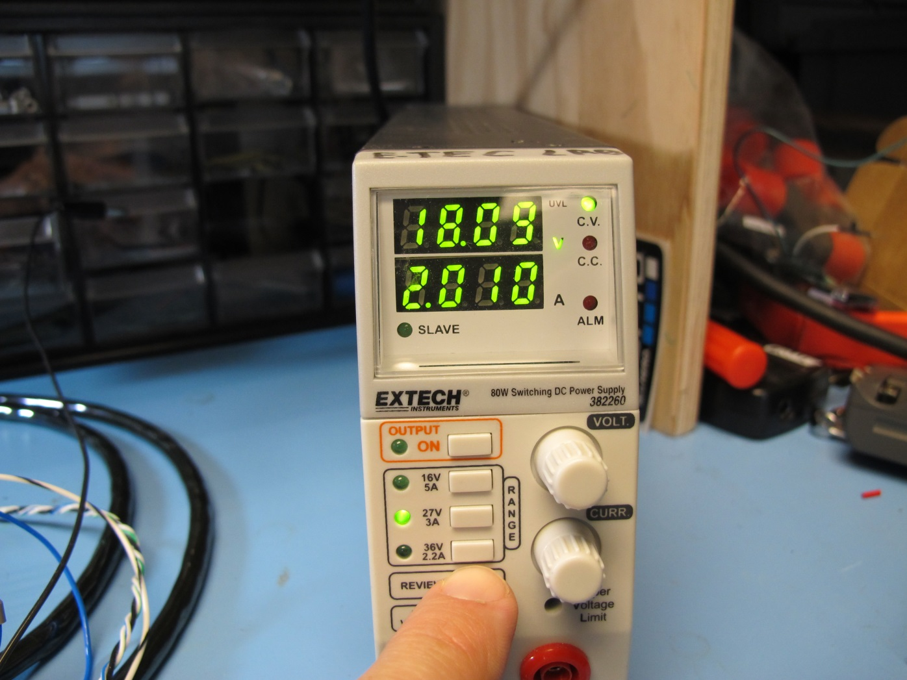
Figure 9: Configuring the DC power supply

Step 3: Connect the SeeStar Test Cable.

Plug the power connectors (red positive and black return) into the DC power supply. Plug the DB9 connector into your USB-Serial adaptor (gender changer may be necessary). The two spare pins are currently not used, leave them aside.

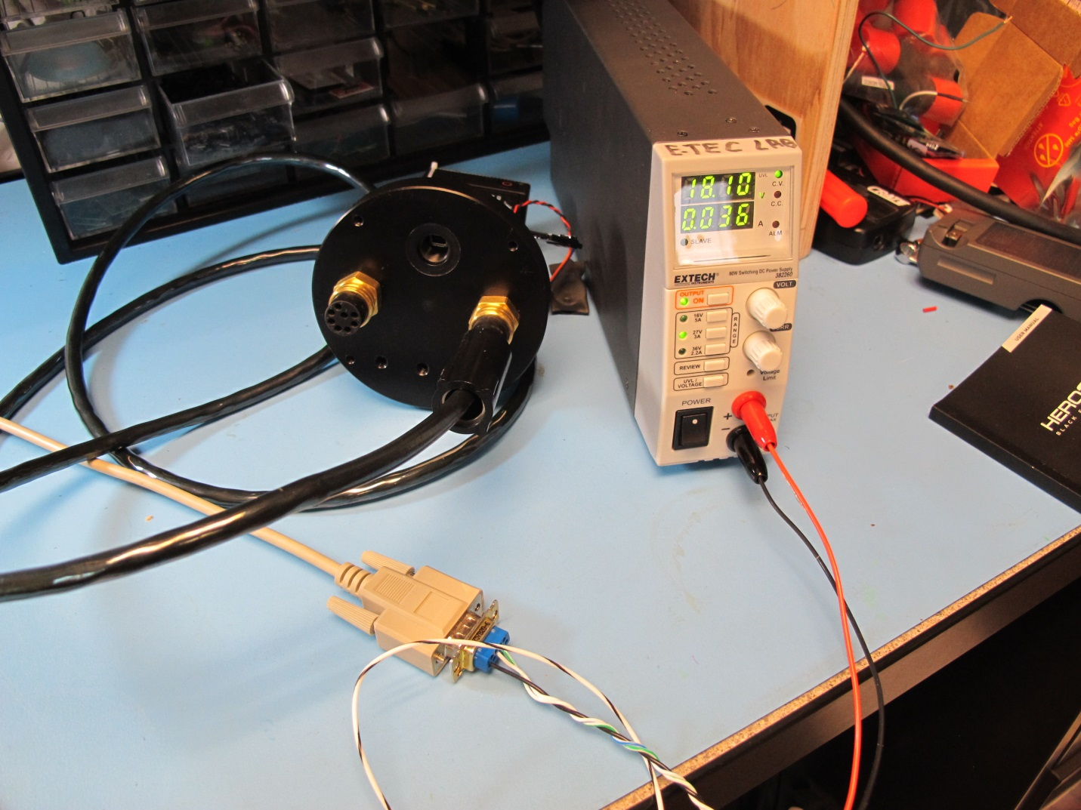
Figure 10: Powering the SeeStar camera module

Step 4: Verify serial communication

Open up a hypterminal window. Start a new session using the correct COM port. The serial settings for the SeeStar camera module are 9600, n, 8, 1, no flow control. After applying power from the DC supply, a splash screen should appear. Typing Help All lists all of the available commands. Turn off the DC power supply once serial communication has been verified.

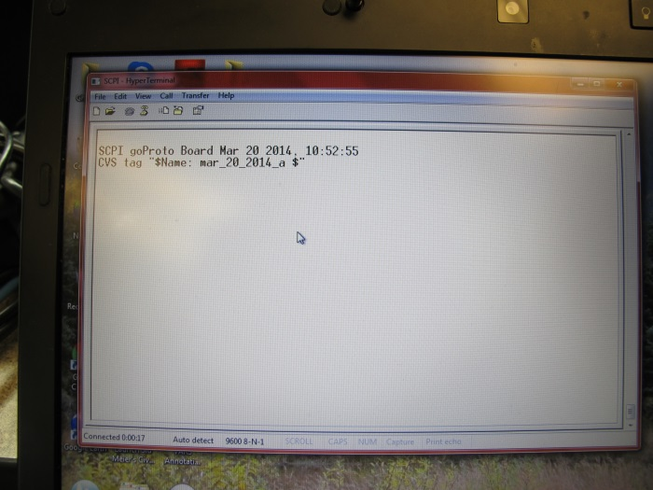
Figure 11Welcome splash screen
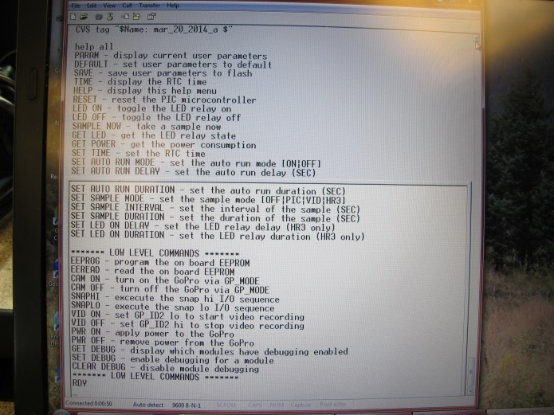
Figure 12: Help All command listing

Step 5: Connect the USB cable to the SeeStar camera module

The type B USB connector is located behind the water tight SAE port. Remove the SAE fitting and attach the USB cable.

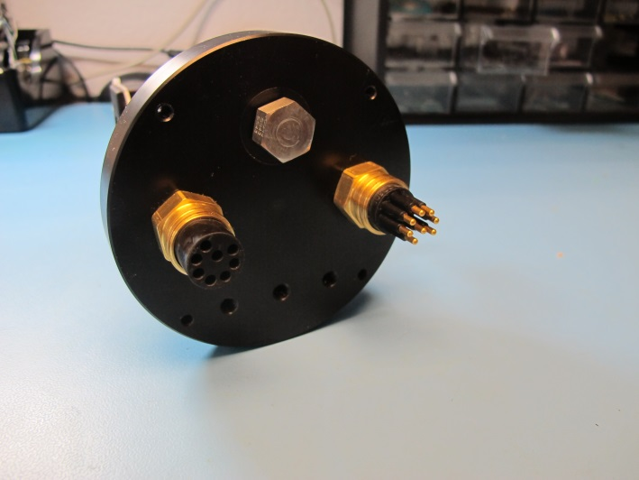
Figure 13: Camera endcap with SAE fitting
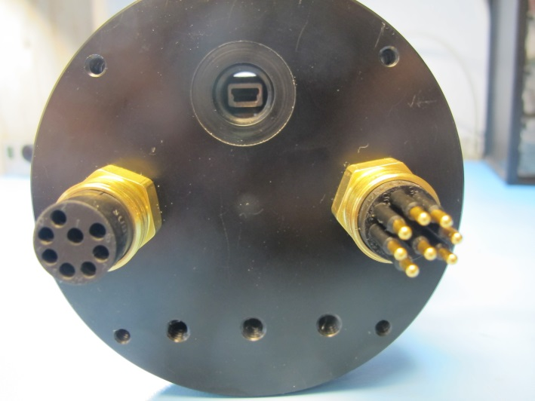
Figure 14: Camera endcap showing USB connection

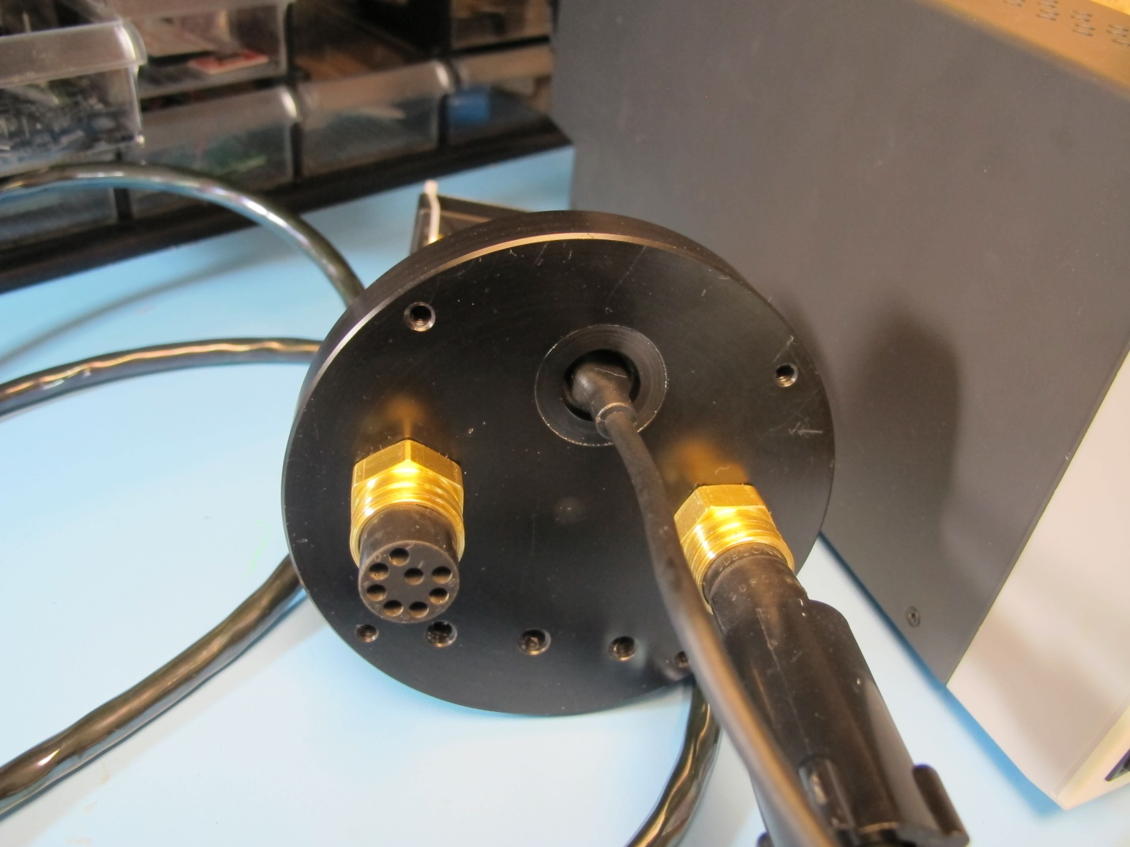
Figure 15: Downloading images via USB

Step 6: Plug the USB cable into the host computer

As stated before, use a USB 2.0 port and if not successful, try an alternate USB port.

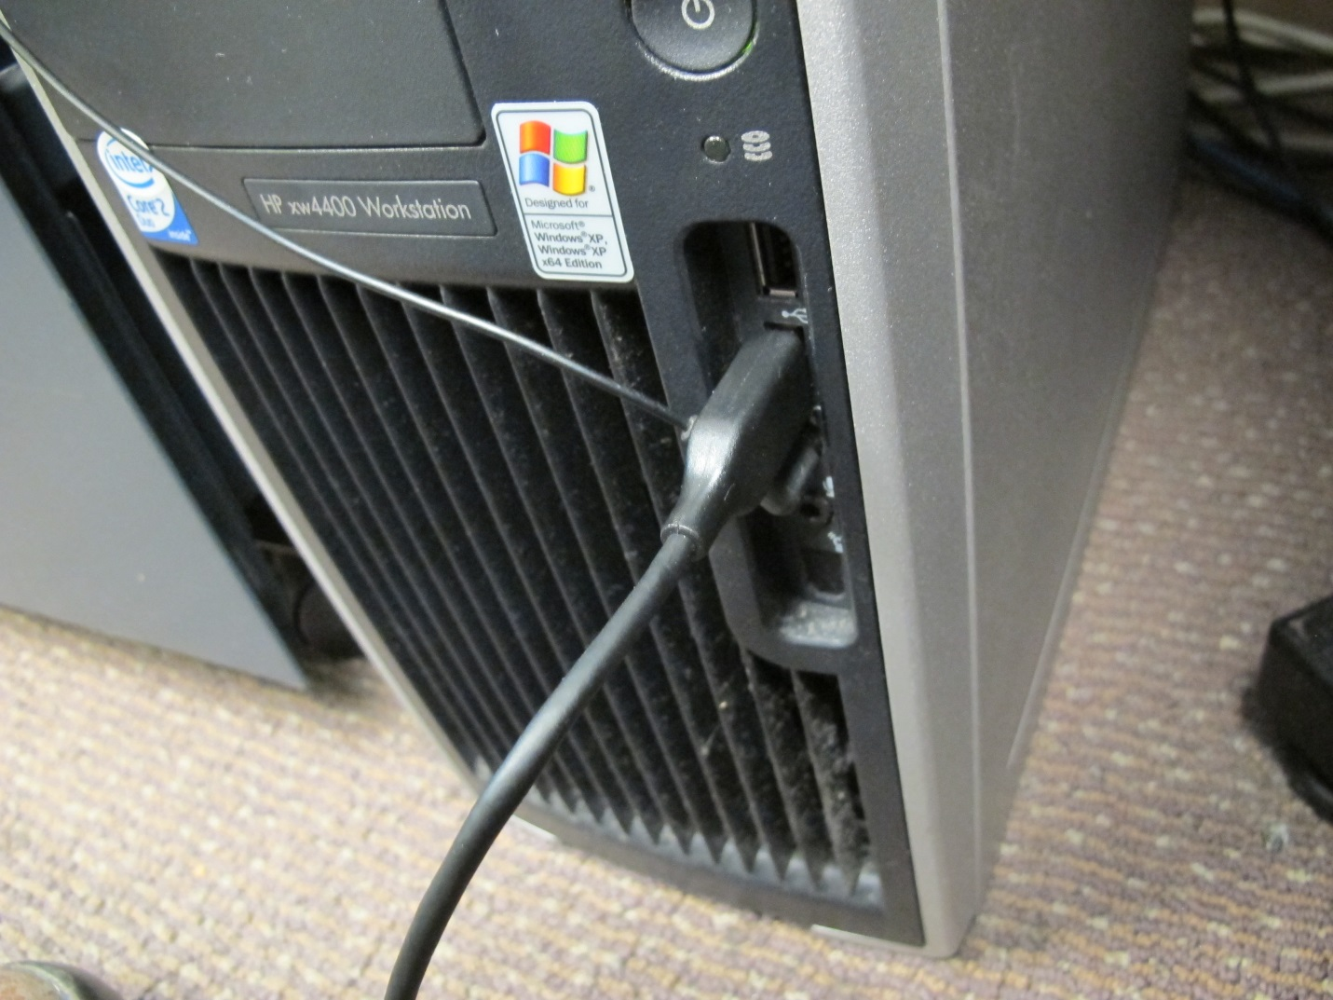
Figure 16: USB cable in computer

Step 7: Establish USB handshaking

Turn on the DC power supply. The splash screen should appear. Type PWR ON. This command passes the 4.2Vdc GoPro battery voltage to the camera, but does not turn it on.

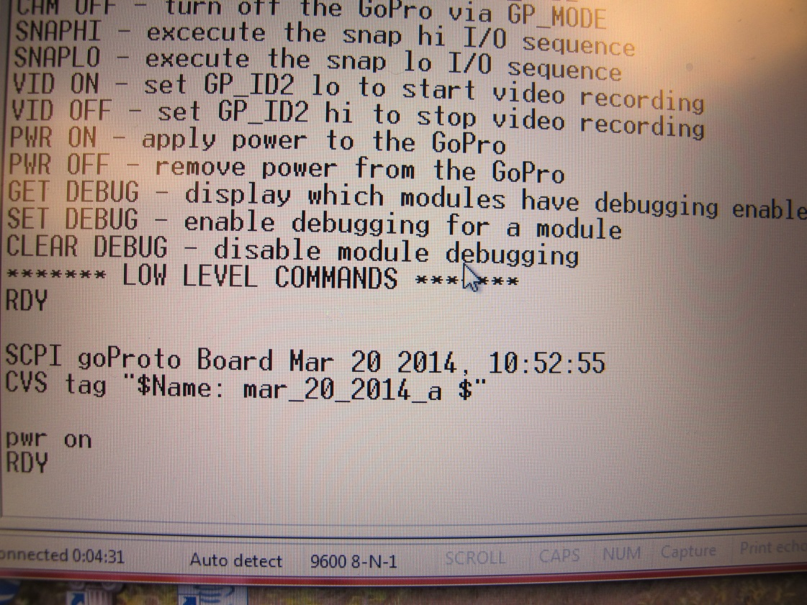
Figure 17: PWR ON command

Wait 10 seconds and type CAM ON. This command mimics a human pressing the physical ON button on the GoPro Hero 3+.

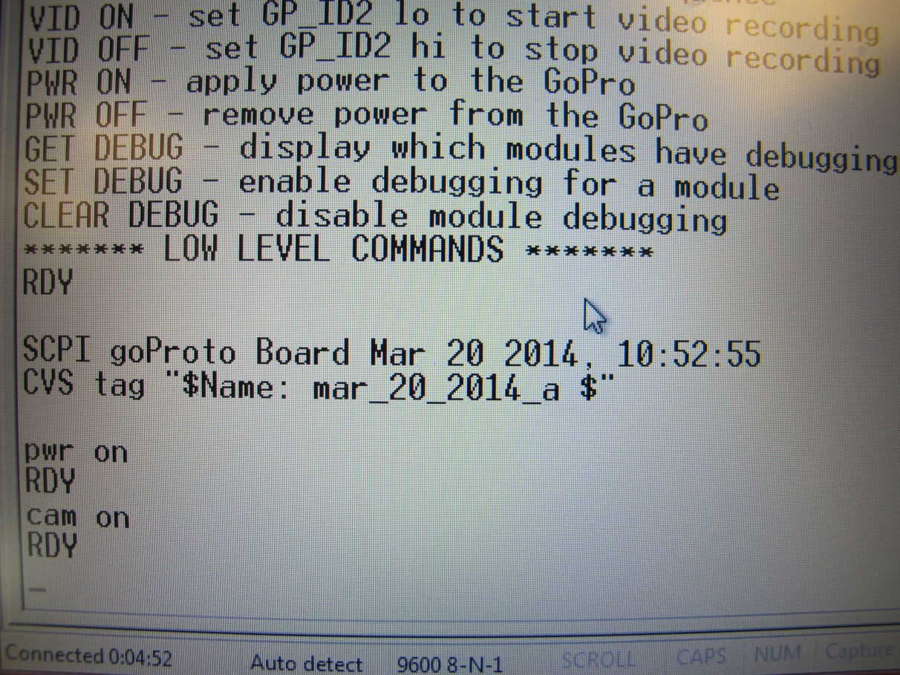
Figure 18: CAM ON command

At this point, the camera should turn on, and USB handshaking should initiate. The LCD screen on the Hero 3+ will display the USB transfer symbol.

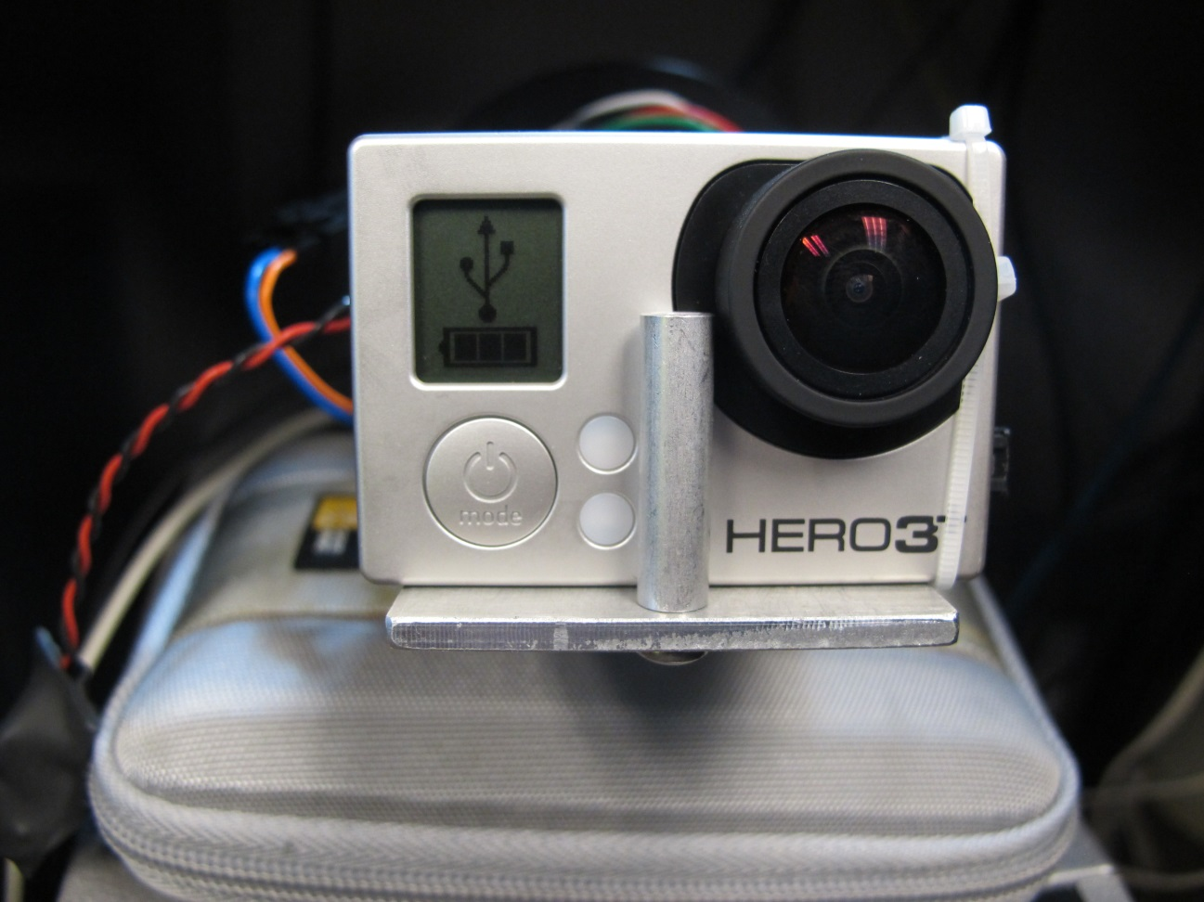
Figure 19: USB transfer indication on Hero 3+

The host computer should recognize the Hero 3+ as a USB device.

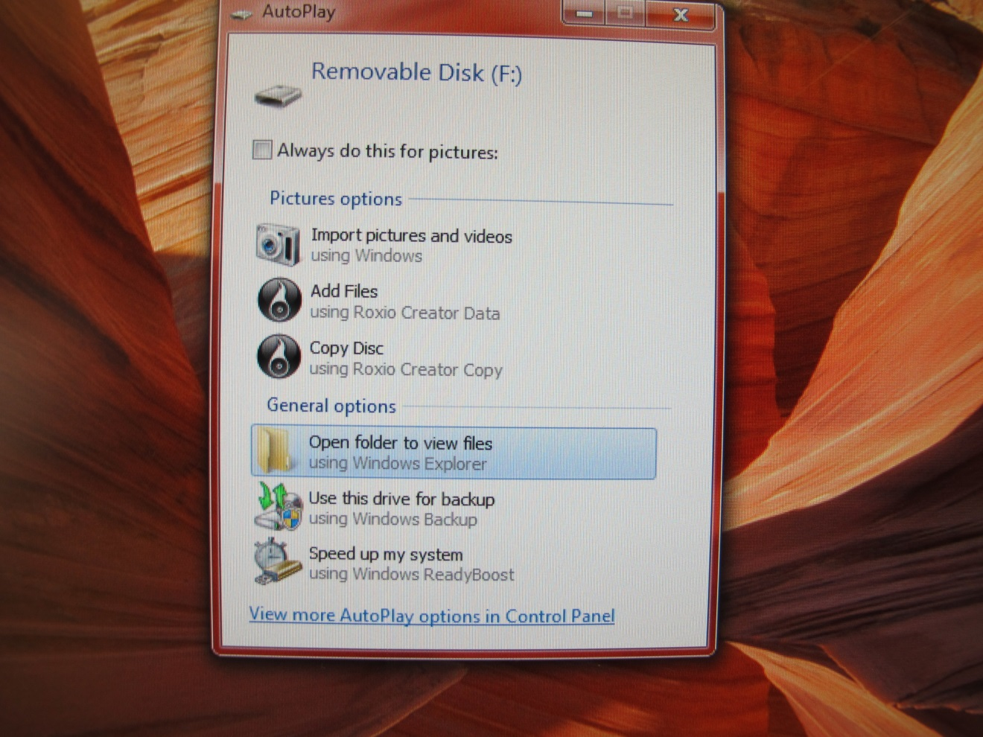
Figure 20: Opening an SD card

The user can now open a new Windows Explorer folder and navigate down to the Hero 3+ pictures and/or videos for transfer to the host computer and deletion from the SD card.

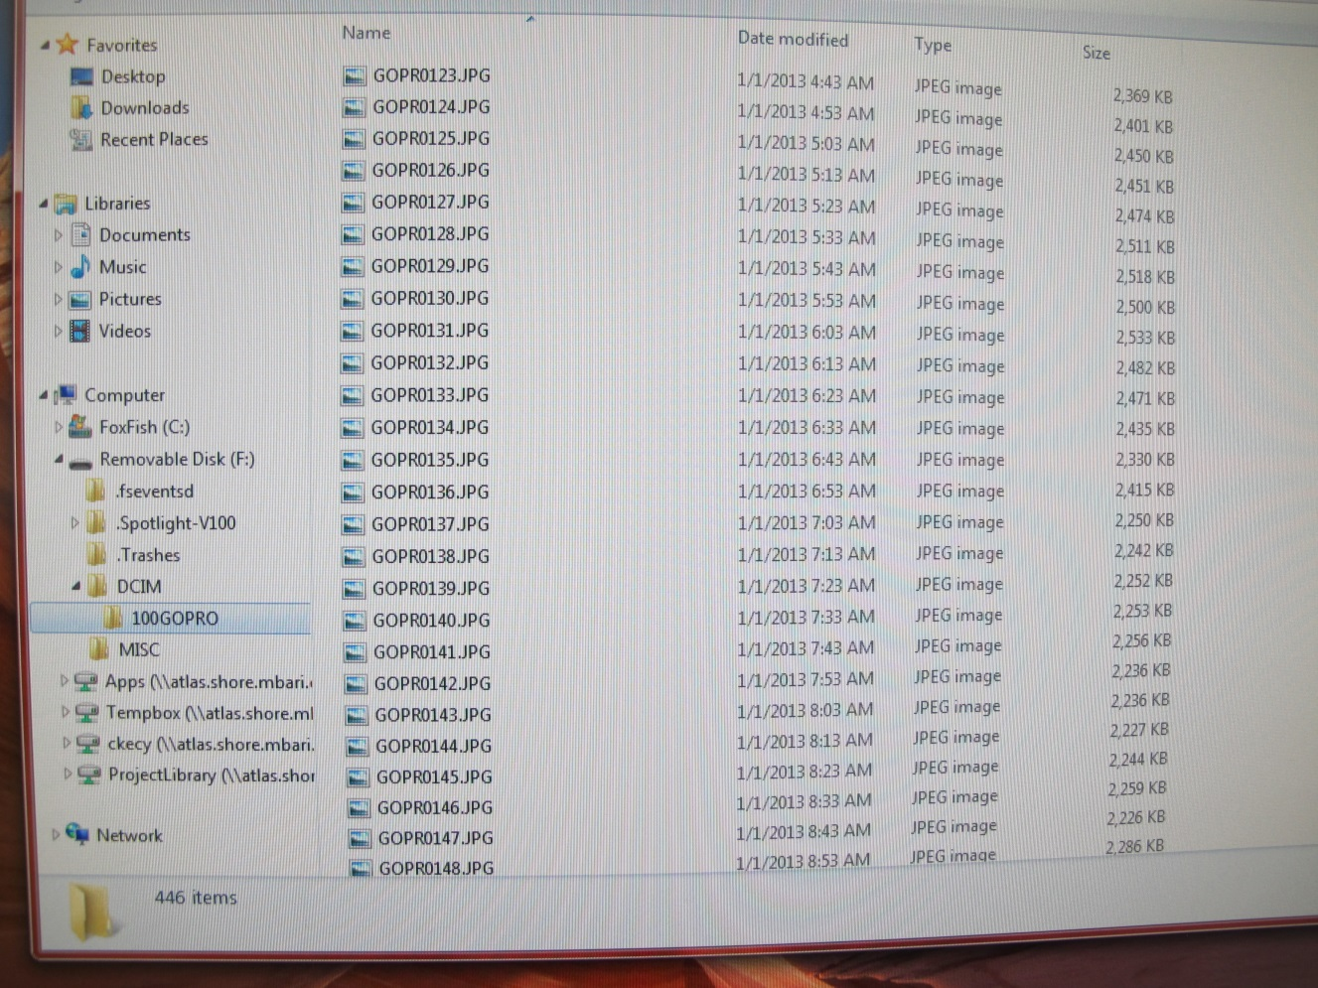
Figure 21: File listing of SD card

