Arduino controlled video recording using the LANC port
LANC is a SONY development and stands for "Local Application Control Bus". It is a two-way serial open collector 9600 baud protocol with inverted logic. The LANC line is pulled high to about +5v and is pulled low to send commands or status information.
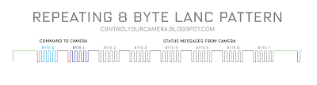
The data stream is 8 bytes, followed by a longer than 5 millisecond pause until the end of the current frame. Then come another 8 bytes for the next frame and another pause and so on.
There's a short pause between individual bytes. Each byte is preceded by a start bit.
LANC is a single wire serial connection and because of this timing is critical. The camera can only listen to commands for the first half of the signal pattern.
The camera listens to the first 4 bytes and sends status information in the last 4 bytes. Only the first two bytes are needed to control a video camera. The rest can be ignored.
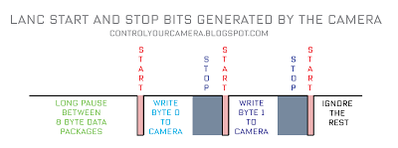
To send a command to the camera the command has to be synchronized to the LANC signal from the camera. The camera puts out a start bit before and a stop bit after each byte. The first command byte from the controller (Arduino) has to be transmitted exactly between the start bit that follows the long pause between the 8 byte data packages and the following short stop bit. Then the second byte must be send to the camera. After sending those two bytes the LANC signal must be be left alone and put back to LOW i.e +5V.
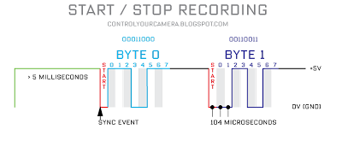
The commands for starting and stopping video recording are 18 and 33 in hexadecimal format or 00011000 and 00110011 in binary format. The bytes must be put out with the least significant, right-most bit (bit 0) first i.e. 00110011 is put out 11001100. Note that in a LANC signal LOW is +5V and HIGH is 0V. LANC commands must be repeated 4 times in order to be accepted by the camera.

