SeeStar III Battery Module
Technical Manual, v0.1

Monterey Bay Aquarium Research Institute

December 21, 2017



Table of Contents
Overview 5
System Level Description 5
NiMH Cells 5
Polyfuse 6
Charging the Battery Module 6
Discharge Profile 7
Assembly Instructions 8
Tools and Parts Needed for Assembly 9
Assembly 9
References 13
Appendices 14

Figure 1: Picture of the SeeStar III imaging system 5
Figure 2: SeeStar III battery module block diagram 5
Figure 3: A single D10000 NiMH cell 6
Figure 4: Charge curve of the battery module at a 0.33C rate 7
Figure 5: Discharge curve of the 12-cell NiMH battery 8
Figure 6: The 12-cell NiMH battery pack from All-Battery (PN# 11704) 9
Figure 7: Endcap with connector 10
Figure 8: The battery wired to the output connector 11
Figure 9: Battery inserted into the housing 12
Figure 10: The complete battery module (with dummy plug) 13

Table 1: Polyfuse electrical characteristics 6

Appendix 1: Electrical Specifications 14
Appendix 2: Mechanical Specifications 14
Appendix 3: Battery Module External Connector Pinout 14
Appendix 4: Calculation of C rate 15
Appendix 5: Wiring Diagram of the SeeStar Battery Module 16

Overview
SeeStar III is an autonomous and modular imaging system (Fig. 1). It is programmed prior to deployment and can be left unattended for months at a time. It is an open source project and is distributed under a Creative Commons Attribution-ShareAlike 4.0 License. SeeStar III consists of three individual modules: the camera, battery, and LED. The battery module contains the 12-cell battery and polyfuse.

Figure 1: Picture of the SeeStar III imaging system

System Level Description
The battery module is the energy source for the SeeStar Imaging System. The SeeStar III battery module contains 12 rechargeable NiMH cells in series for a nominal bus voltage of 14.4Vdc and a capacity of 10000mAh. The battery resides in a housing which is rated to a depth of 300 meters under water. The battery module attaches to the camera module with an 2-pin inter-module cable and can be recharged without opening the housing. Figure 2 displays a block diagram of the battery module.

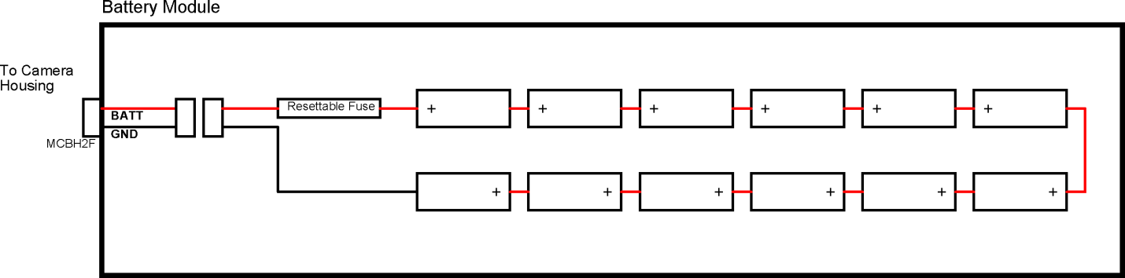
Figure 2: SeeStar III battery module block diagram

NiMH Cells
The battery from All-Battery contains 12 Tenergy D10000 rechargeable Nickel Metal Hydride (NiMH) cells in series. The D10000 is a D size cell with a diameter of 32.5mm and a height of 61mm. The battery has a capacity of 10000 mAH and a nominal bus voltage of 1.2Vdc. See the datasheet for more details.


Figure 3: A single D10000 NiMH cell

Polyfuse
The battery module contains an inline resettable fuse in the event of a catastrophic failure. The part used is a TE Connectivity SRP350F PolySwitch PTC (Positive Temperature Coefficient) Device.

 | I_{HOLD} | I_{TRIP} | V_{MAX} | I_{MAX} | P_{D MAX} | Max Time-to-Trip |  | R_{MIN} | R_{MAX} | R_{1MAX}
Part # | (amps) | (amps) | (Vdc) | (amps) | (watts) | (amps) | (seconds) | (ohms) | (ohms) | (ohms)
SRP120F | 1.20 | 2.70 | 15 | 100 | 1.2 | 6.00 | 5.0 | 0.085 | 0.160 | 0.220
SRP175F | 1.75 | 3.80 | 15 | 100 | 1.5 | 8.75 | 5.0 | 0.050 | 0.090 | 0.120
SRP200F | 2.00 | 4.40 | 30 | 100 | 1.9 | 10.00 | 4.0 | 0.030 | 0.060 | 0.100
SRP350F | 3.50 | 6.30 | 30 | 100 | 2.5 | 20.00 | 3.0 | 0.017 | 0.031 | 0.050
SRP420F | 4.20 | 7.60 | 30 | 100 | 2.9 | 20.00 | 6.0 | 0.012 | 0.024 | 0.040
Table 1: Polyfuse electrical characteristics

Charging the Battery Module
There are numerous methods for recharging NiMH batteries (See Ref. 2, pp. 17), and they depend upon a number of variables, the most important being the charge level of the battery prior to re-charging. In general, the charge rate should never exceed 1C. See appendix 5 for details on how to calculate the C rate.

The preferred method of charging is actually a combination of different rates; this method requires monitoring cells temperatures and a smart charger that can change charge rates on the fly. With typical use, the batteries can safely be charged using a medium charge rate (0.33C) with an occasional trickle charge (0.1C) to top off batteries that have been stored.

The battery module can either be charged assembled or disassembled. As the fully charged battery voltage can go as high as 16.8Vdc, the DC charging source should be set to 18.0Vdc.

Figure 4: Charge curve of the battery module at a 0.33C rate

[Figure 4 needs to be updated with new batteries]

Discharge Profile
Figure 5 displays the discharge profile of the battery pack under a 0.2C condition. The curve is nearly identical in shape to that of a single cell. The battery should typically not be discharged below 12.0Vdc (1.0Vdc per cell) as this will shorten the overall lifespan of the battery. The Controller Shield in the camera module monitors battery voltage and the Arduino sketch (code) can be written such that operation of the camera and lights is not possible when the battery reaches a specified voltage level.

Figure 5: Discharge curve of the 12-cell NiMH battery

[Figure 5 needs to be updated with new batteries]

Assembly Instructions

The assembly of the battery module is very simple and should take no longer than 30 minutes. Care should be taken when dealing with the exposed battery leads. The battery contains 4.5 amp-hours of energy and an accidental shorting of the postive and negative leads can lead to damage and, potentially, injury. There is an internal polyfuse in the battery assembly, but even it may be damaged with a direct short.

Tools and Parts Needed for Assembly

- All parts for battery module (See appendix 4)
- Flathead screwdriver, small
- Wire cutters
- Wire stripper (Covering 18AWG to 22AWG)
- O-ring grease (Type 55 Molykote, Parker O-lube, or similar)
- Foam sheet, anti-static Polyethylene (or similar)

Assembly

- The NiMH battery from Battery Specialties arrives with 18” leads. These need to be cut back in length due to the tight spacing in the housing. Cut each wire separately back to approximately 6”. Do not cut them at the same time as this will short out the battery!

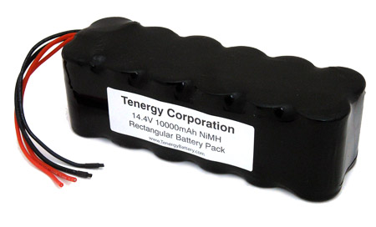
Figure 6: The 12-cell NiMH battery pack from All-Battery (PN# 11704)

- The battery leads can now be screwed into the terminal strip. To prevent possible shorting of the battery, do this one lead at a time. Strip back the red lead ¼” and screw into the terminal strip. Repeat for the black lead.
- Apply O-ring grease on the O-ring for the 8-pin Subconn connector. Only a very thin layer is required; wipe any excess with your fingers. Make sure there is no lint or hair on the O-ring.
- Insert the connector into the threaded hole on the rear endcap and thread into it.
- The default lengths of the wires attached to the connector are 12”. Cut them down to approximately 6”.
- Using wire strippers, strip back the black, white, red, and green wires approximately ¼”. The wires are 20AWG so use the 20AWG multi-stranded setting on the wire strippers. Note: some connectors arrive with all white wires which are labeled 1-8. If this is the case, strip back 1-4.

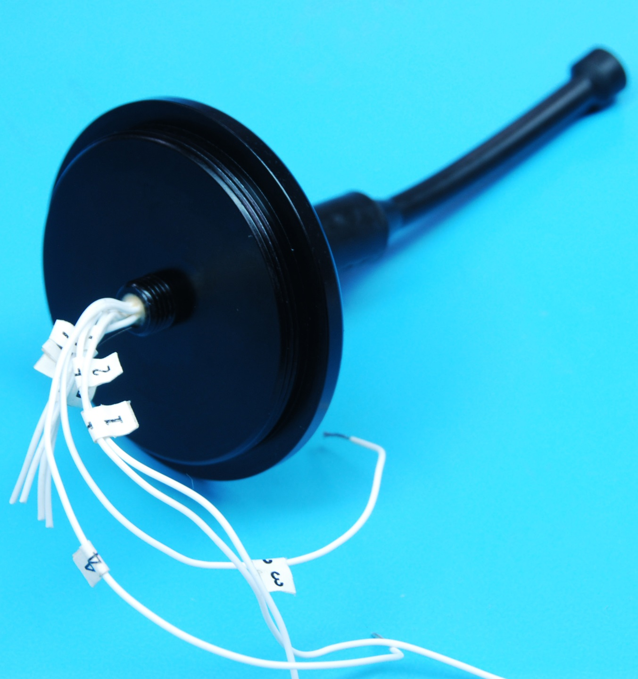
Figure 7: Endcap with connector

- Apply O-ring grease on the O-ring for the connectorized endcap. Only a very thin layer is required; wipe any excess with your fingers. Make sure there is no lint or hair on the O-ring.
- The connector leads can now be screwed into the terminal strips. Screw the black and white wires (or #1 and #2) into the terminal strip opposite the red wire from the battery.
- Screw the red and green wires (or #3 and #4) into the terminal strip opposite the black wire from the battery.

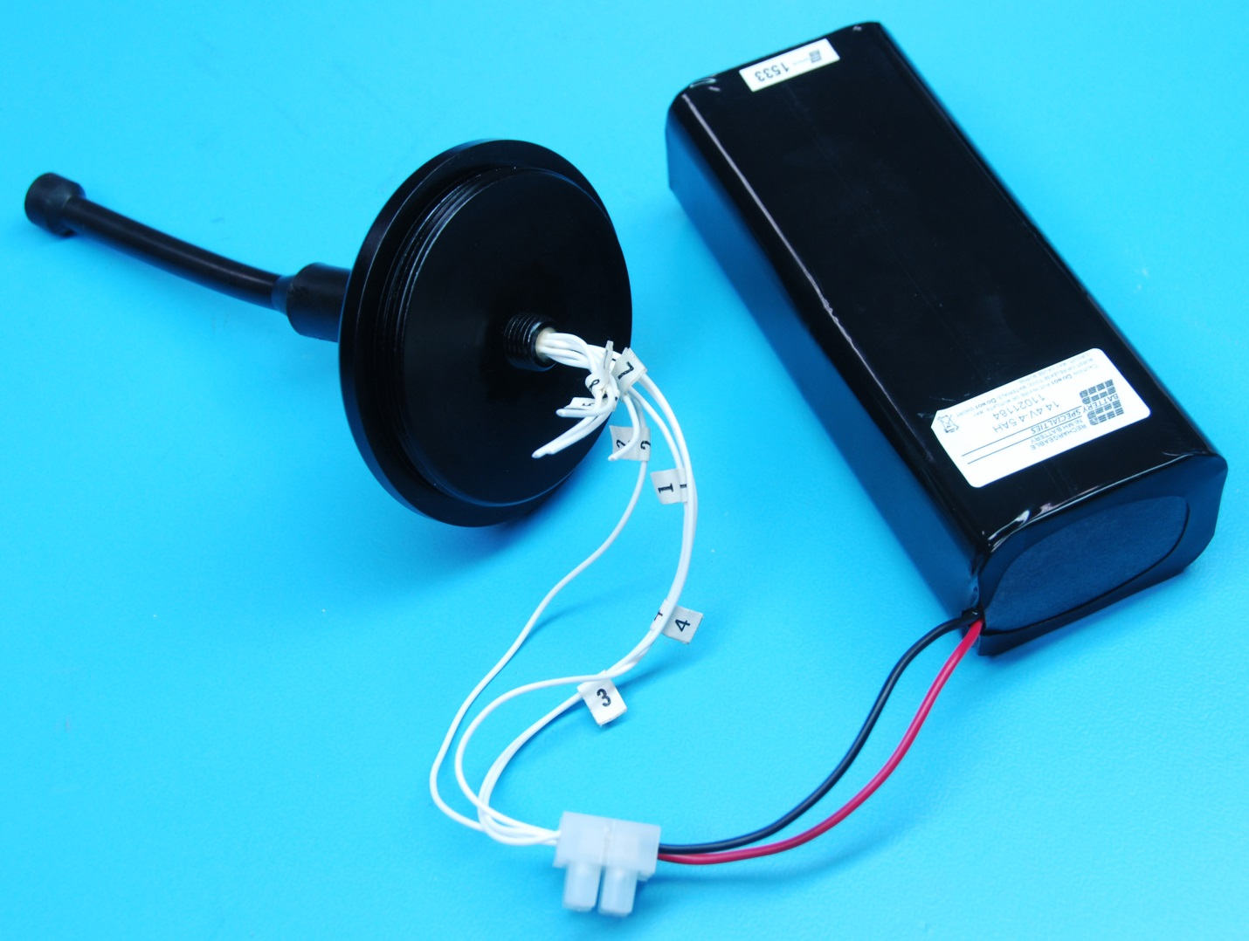
Figure 8: The battery wired to the output connector
[Figure 8 needs updated]

- Cut a 5” by 10” sheet from the foam packing material.
- Wrap the battery with the cut sheet from step #9.

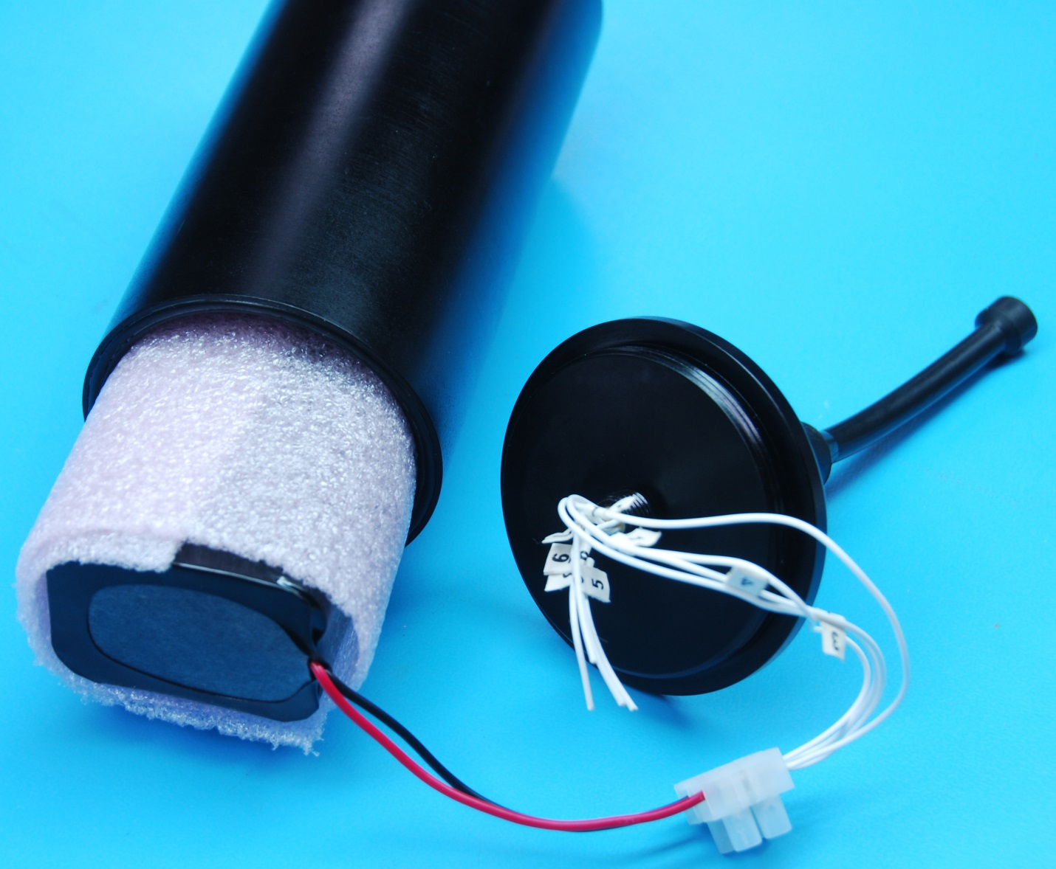
Figure 9: Battery inserted into the housing
[Figure 9 needs updated]

- Slide the wrapped battery into the housing. It should be a snug fit.
- Apply O-ring grease on the O-ring for the blank endcap. Only a very thin layer is required; wipe any excess with your fingers. Make sure there is no lint or hair on the O-ring.
- Screw the blank endcap on the non-connectorized side of the battery housing.
- Carefully screw the connectorized endcap on the other end. You may need to pre-twist the endcap so the wires coil nicely ontop of the battery.

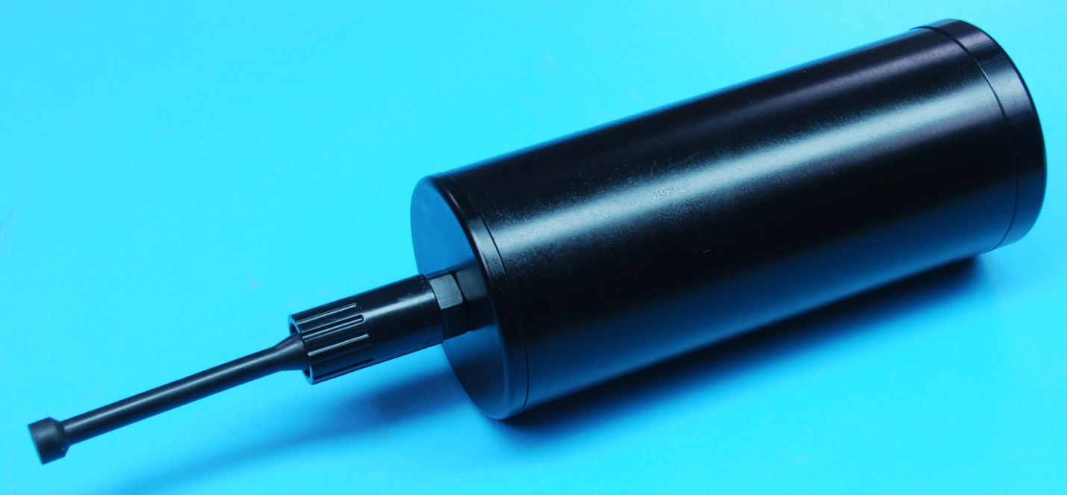
Figure 10: The complete battery module (with dummy plug)

References

(1)

(2) Panasonic Nickel Metal Hydride Handbook
http://www.mouser.com/pdfdocs/PanasonicBatteries_NI-MH_Handbook.pdf

(3) Handbook of Batteries, Third Edition, McGraw-Hill Handbooks ISBN 0-07-135978-8

Appendices

Output Voltage | 9-15 Vdc
Current Limit | 3.5 Amps
Appendix 1: Electrical Specifications

Length | 4 $1/2$ in
Diameter | 3 in
Operating Temperature (Min) | 0ºC
Operating Temperature (Max) | 70ºC
Operating Depth | 1500m
Dry Weight | 3.53 lbs
Wet Weight | 1.69 lbs
Appendix 2: Mechanical Specifications

Battery Module J1 (To Camera Module)
Pin # | Signal Name | Description
1 | BATT_POS | Positive Battery Voltage
2 | BATT_NEG | Battery Voltage Return
Appendix 3: Battery Module External Connector Pinout

The “C” Rate is a common method for expressing the charge and discharge rates of batteries and is defined by:

I = M x C_{n}

where:
I = Electrical current in amps
M = Multiple or fraction of C
C = Numerical value of rated capacity of the battery in ampere-hours (Ah)
n = time, in hours, for which rated capacity is declared

In the case of the SeeStar battery, C=4.5 Ah.

Charging the battery at 0.5C (or C₂) would require:
I = 0.5 (1/hour) x 4.5 (amp-hour)
I = 2.25 amps
and take 2 hours

To calculate the current needed for a 0.33C (or C₃) discharge:
I = 0.33 (1/hour) x 4.5 (amp-hour)
I = 1.50 amps
and take 3 hours

Appendix 4: Calculation of C rate
Appendix 5: Wiring Diagram of the SeeStar Battery Module

