SeeStar III Camera Module
Technical Manual, v0.1

Monterey Bay Aquarium Research Institute

December 21, 2017



Table of Contents
Overview 5
System Level Description 5
Sony RX0 Camera 5
Vector Carrier Board 7
Sleepy Pi 2 8
SeeStar III Dedicated Signals 9
Programming Signals 11
Sparkfun Serial Transceiver Board 12
Grove 2-Coil Latching Relay Board 12
Fotga RM-VS1 Remote Controller 13
Pinout of Multi-Terminal Connector 14
Electronics Assembly 16
Carrier Board Assembly and Soldering 16
Tools and Parts Required 16
Vector Board Preparation 16
Sleepy Pi 2 Preparation 20
Serial Transceiver Preparation 22
Low-Power Switch (optional) Preparation 22
Multi-Terminal Connector / Remote Wiring 24
Carrier Board Soldering 24
Internal Point-to-Point Wiring 24
Serial Connections to Endcap Connectors 24
Optional Low Power Mode Wiring 24
References 26
Appendices 26

Figure 1: Sony RX0 Camera 5
Figure 2: Simplified Block Diagram of the Camera Module 6
Figure 3: A Blank Vector Proto Board 7
Figure 4: Populated and Labeled Camera Carrier Board 8
Figure 5: The Sleepy Pi 2 9
Figure 6: The Dual Serial Transceiver Board 12
Figure 7: Phoenix Combicon 10-pin header 12
Figure 8: The Latching Relay Board 13
Figure 9: Operation of the Latching Relay 13
Figure 10: RM-VS1 Remote Control for Sony Cameras 14
Figure 11: Multi-Terminal Connector, Signal Side 15
Figure 12: Multi-Terminal Connector, USB Side 15
Figure 13: Carrier Board Marked for Cutting 16
Figure 14: Tools Used to Cut the Carrier Board 17
Figure 15: Sanding Down the Cut Edge of the Carrier Board 18
Figure 16: Carrier Board Ready for Drilling (25 Holes x 51 Holes) 19
Figure 17: Sleepy Pi 2 with low profile header installed 20
Figure 18: 40-pin header (with 0.394" legs) installed onto Sleepy Pi 2 20
Figure 19: 40-pin header (with 0.1875" legs) installed onto Carrier board 21
Figure 20: Installation of Sleepy Pi 2 onto the Carrier board 21
Figure 21: Schematic of the Low Power Switch 22
Figure 22: Parts for the Low Power Switch 23
Figure 23: Camera Power Wiring 25
Figure 24: Camera Power Wiring with Low Power Modification 25

Table 1: Sleepy Pi 2 Digital Output Assignments for SeeStar III 10
Table 2: Multi-Terminal Connector, Signal Side 15
Table 3: Multi-Terminal Connector, USB Side 15

Appendix 1: Camera Module Point-to-Point Wiring 27
Appendix 2: Camera Power Wiring 28
Appendix 3: Camera Power Wiring, Low Power Option 28
Appendix 4: Schematic of the Camera Module 29
Appendix 5: Bottom View of the Camera Module Carrier Board 29

Overview
SeeStar III is an autonomous and modular underwater imaging system. It is programmed prior to deployment and can be left unattended for months at a time. It is an open source project and is distributed under a Creative Commons Attribution-ShareAlike 4.0 License. SeeStar III consists of up to four individual modules: the camera, the sensor data logger, battery, and LED. This document covers the technical details of the camera module.

[insert picture of complete SeeStar III system in housings]

System Level Description

The camera module is responsible for capturing the still images and/or videos, powering and triggering the external lights, and commanding the sensor module to initiate data logging. The system is compatible with a large number of Sony cameras (see appendix xx for a comprehensive list). The initial SeeStar III prototype utilizes a Sony RX0 camera as its imager.

Figure one is a simplified block diagram of the camera module; it consists entirely of commercially available parts. A Sleepy Pi 2 acts as the central computer. A pair of relay boards switches power to the external Sensor Module and LED Module. A dual serial transceiver board is used to level shift the serial communication signals. A low powered, adjustable DC-DC converter is used to generate power for the Sony camera. A remote control is used to assist with camera video control. All of these individual modules are mounted onto a blank proto board and will be covered in more detail below.

Sony RX0 Camera

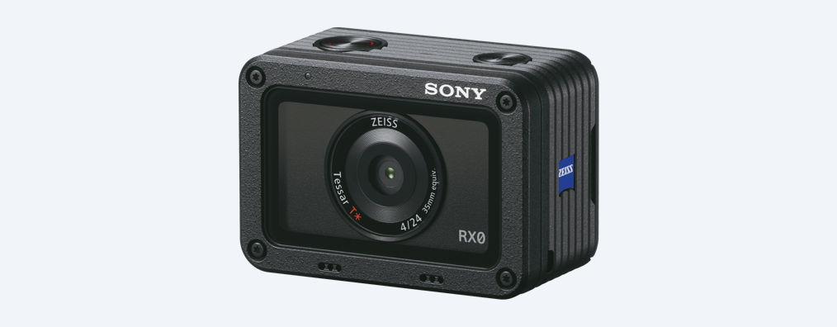
Figure 1: Sony RX0 Camera
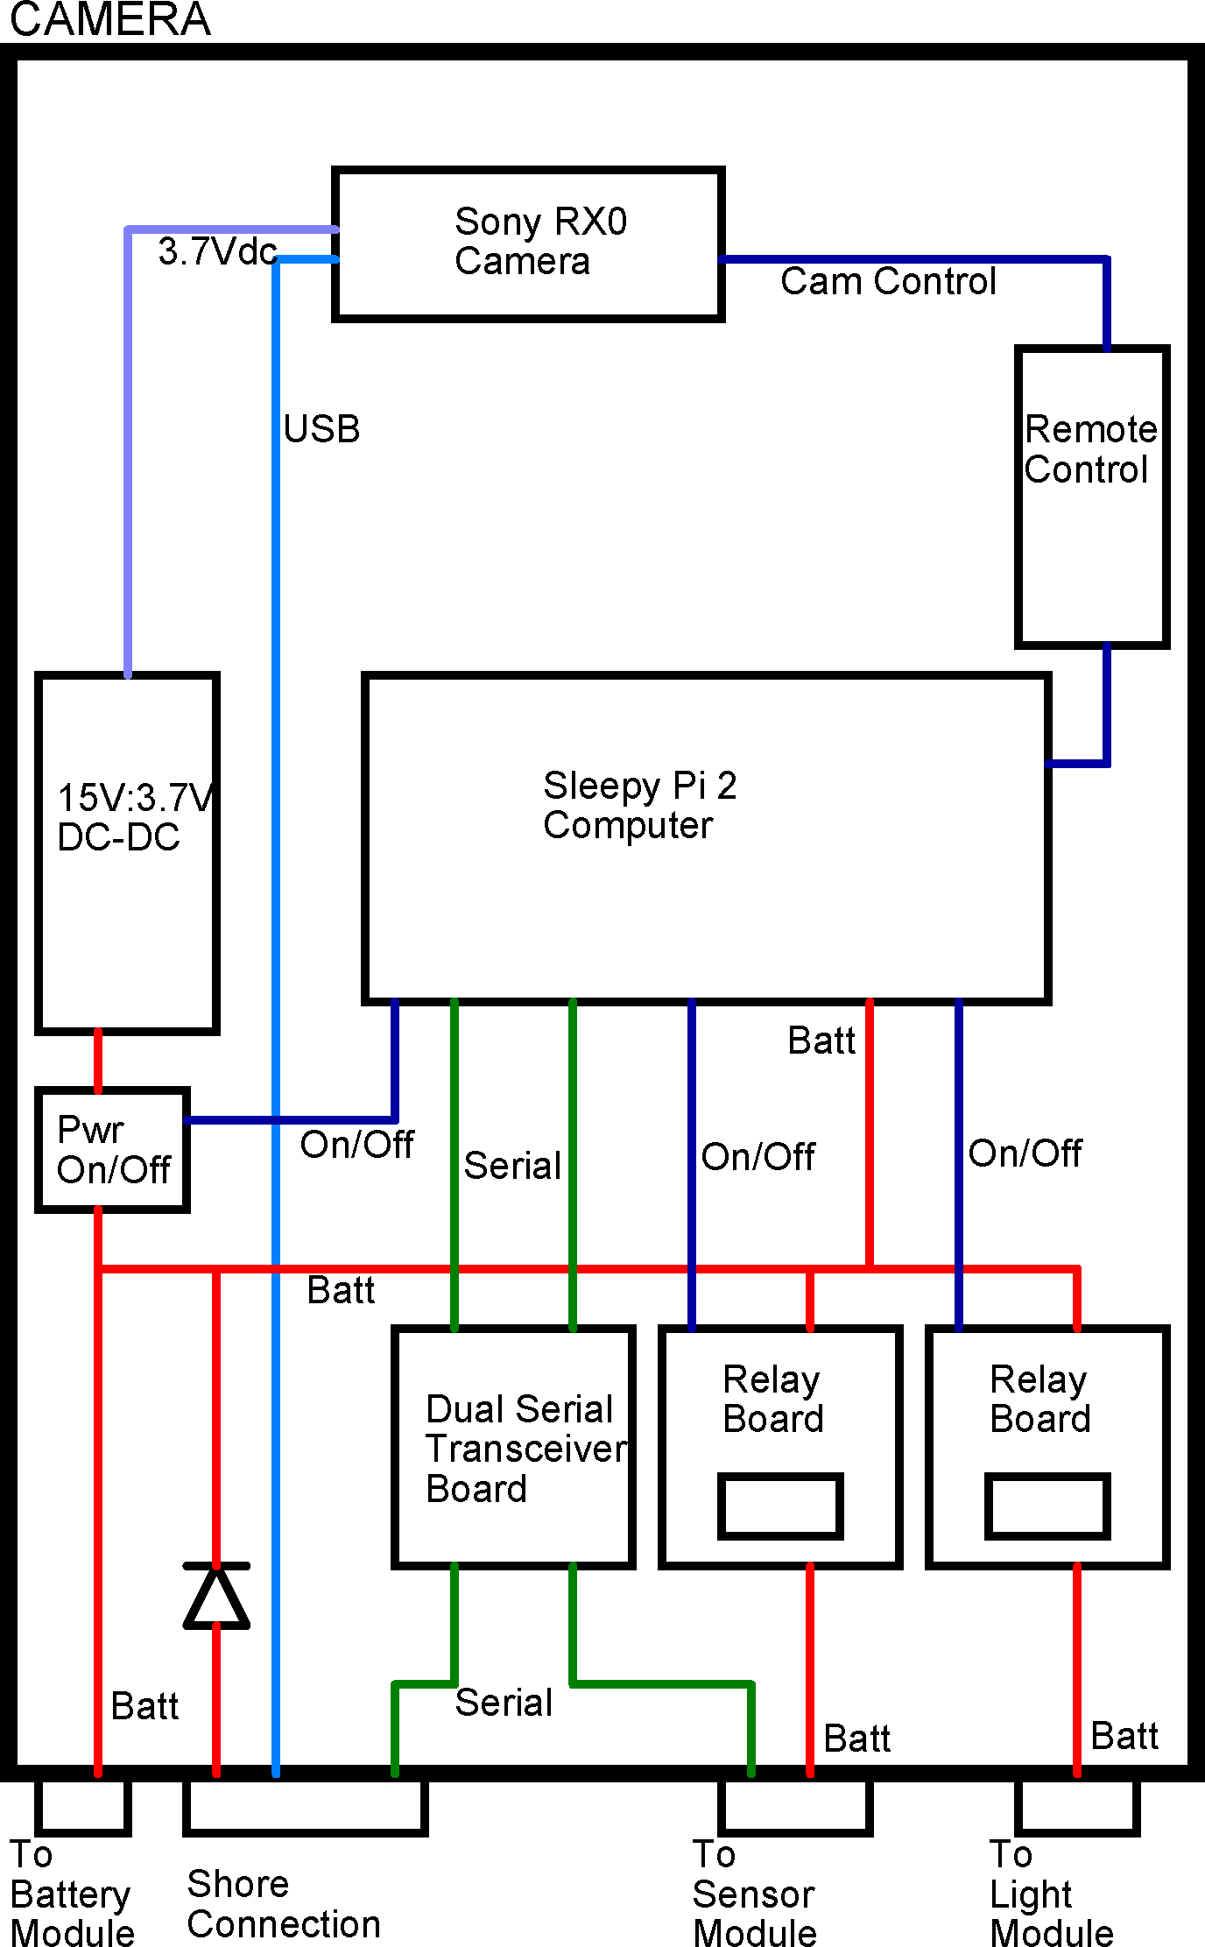
Figure 2: Simplified Block Diagram of the Camera Module

Vector Carrier Board

A blank proto board with 0.1” hole spacing is used to mount all of the individual electronic units. While almost any blank proto board would work, keeping the width of the board as short as possible helps keep the overall width of the underwater housing small. The chosen board from Vector is very close to the required dimensions; the modifications to the proto board are covered in a later section.

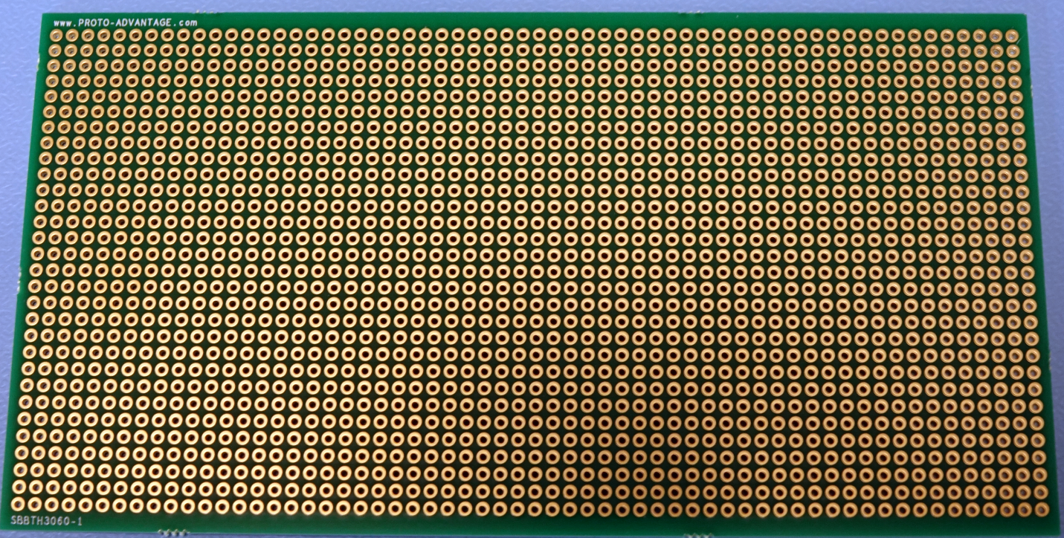
Figure 3: A Blank Vector Proto Board

Some basic soldering is required to assemble this board. The bottom of the board consists of bus wires for the separate DC voltages and returns. The top of the board contains all of the electronic modules and point-to-point wiring of the digital signals via screw terminal connectors. Detailed instructions covering its fabrication are found in the Electronics Assembly section of this document.

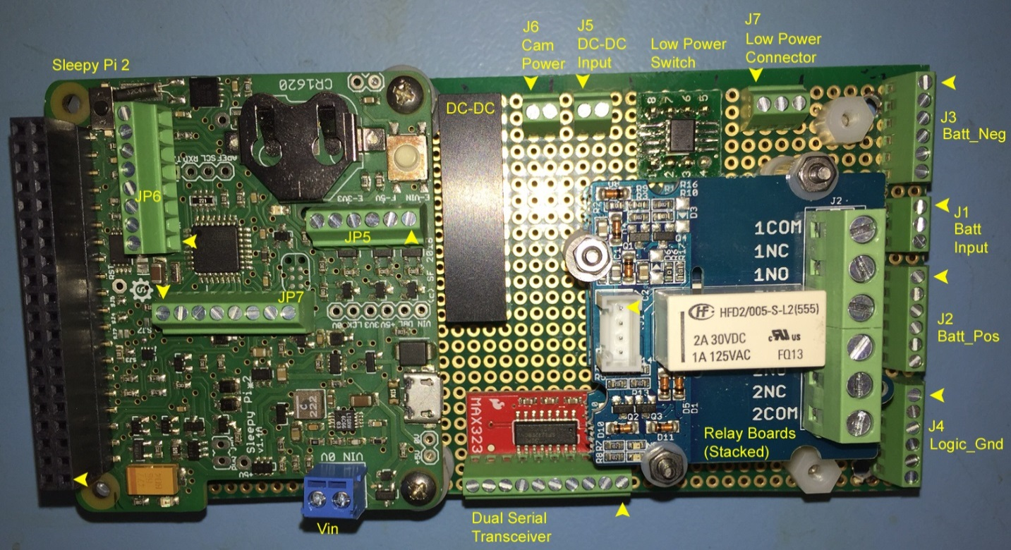
Figure 4: Populated and Labeled Camera Carrier Board

Sleepy Pi 2

A Sleepy Pi 2 (SPi2) is used as the camera controller as well as the central computer for the entire SeeStar III system. The SPi2 was designed to operate in conjunction with the family of Raspberry Pi (RPi) products. The RPi boards don’t have the ability to operate in a low power mode, or to put themselves to sleep. The SPi2 was designed to plug into the RPi and put it to sleep while not being actively used. However, the SPi2 also has its own microprocessor which can be programmed to operate in a standalone mode. The SeeStar III system operates with a standalone SPi2; however, the user also has the option to add in an RPi board in the future based on their operational needs.

The SPi2 is powered directly from the battery input (range is 5.5V to 30V) and it contains onboard converters for 5V and 3.3Vdc. The RPi2 provides the 3.3Vdc bus to the rest of the camera module electronics.

The Sleepy Pi 2 does not have a written or electronic user’s guide. However, there are online FAQs from the manufacturer at:

https://spellfoundry.com/product/sleepy-pi-2/
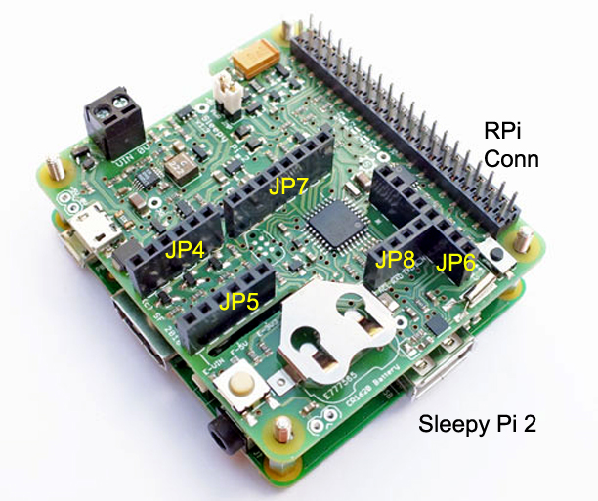
Figure 5: The Sleepy Pi 2

SeeStar III Dedicated Signals

The SPi2 uses both serial communication and digital signals to control the SeeStar III system. It also has dedicated signals on its 40-pin bus which are used to interface the family of RPi boards. Some, but not all, of these signals are also brought out to smaller headers on the SPi2. Table one lists the pinouts of JP6 and JP7 along with the name assigned by SeeStar. All of the signals in blue, other than the two TTL serial lines are [open collector] digital outputs. More detailed information on the signals follows.

JP6 | ATMEGA328P | SeeStar Name |  | JP7 | ATMEGA328P | SeeStar Name
1 | PD5_(PWM)_5 | LED_TRIGGER |  | 1 | PB1_(PWM)_9 | SENSOR_RELAY_CONTROL
2 | PD6_(PWM)_6 | CAM_POWER_ON_OFF |  | 2 | PB2_(PWM)_10 | SENSOR_TTL_TXD
3 | PB0_8 | LED_RELAY_CONTROL |  | 3 | PB3_MOSI_(PWM)_11 | SENSOR_TTL_RXD
4 | (AIN1)PD7 | PI_IS_RUNNING |  | 4 | PB4_(P_MISO)_12 | CAM_SHUTTER
5 | (ADC4)PC4 | SDA_18 |  | 5 | (INT0)PD2 | *ALARM
6 | (INT1)PD3 | ON/OFF |  | 6 | PC0_(ANALOG)_14 | CAM_ON_OFF
7 | (ADC3)PC3 | CMD_PI_SHUTDOWN |  | 7 | PC1_(ANALOG)_15 | CAM_FOCUS
8 | PB5_INT_P_SCK_13 | CAM_VIDEO_REC |  | 8 | Gnd
Table 1: Sleepy Pi 2 Digital Output Assignments for SeeStar III

LED_TRIGGER
The LED_CONTROL signal turns on the flashlight LED module (by simulating pressing the mode button). It will only work if power has been previously applied via the LED_RELAY_CONTROL signal. This is an output digital TTL signal located at JP6-1 and is port PD5. It is an active low signal which needs to be asserted for 100msec.

CAM_POWER_ON_OFF
The CAM_POWER_ON_OFF signal is used to activate the DC-DC converter which applies power to the Sony camera. Pulling the signal high turns on the converter and applies power to the camera. Pulling the signal low turns off the converter, and removes power from the camera. This is an output digital TTL signal located at JP6-2 and is port PD6.

** Optional Low Power Configuration **
If the low power option was added to the board, the CAM_POWER_ON_OFF signal can be used to completely remove power from the DC-DC converter when not being used. This reduces the overall quiescent current of the system. To change the location, unscrew the blue wire from J1-2 and move to J7-2.

LED_RELAY_CONTROL
The LED_RELAY_CONTROL signal controls a latching relay board which is responsible for powering the LED module. This signal both sets and resets the latching relay depending on which edge of the signal is used. Going from a low-to-high (positive edge) resets the relay and connects the Common and Normally Closed contacts. This removes power from the LED module. Going from high-to-low (negative edge) sets the relays and connects the Common and Normally Open contacts. This applies power to the LED module. This is an output digital TTL signal located at JP6-3 and is port PB0.

CAM_VIDEO_REC
CAM_VIDEO_REC is an active low signal used to start and stop video recording on the Sony camera. To begin recording, pulse this signal low for 500msec. To stop recording, pulse this signal low for 100msec. This is an output digital TTL signal located at JP6-8 and is port PB5.

SENSOR_RELAY_CONTROL
The SENSOR_RELAY_CONTROL signal controls a latching relay board which is responsible for powering the Sensor module. This signal both sets and resets the latching relay depending on which edge of the signal is used. Going from a low-to-high (positive edge) resets the relay and connects the Common and Normally Closed contacts. This removes power from the Sensor module. Going from high-to-low (negative edge) sets the relays and connects the Common and Normally Open contacts. This applies power to the Sensor module. This is an output digital TTL signal located at JP7-1 and is port PB1.

SENSOR_TTL_TXD
SENSOR_TTL_TXD is the serial transmit out line to the Sensor module. This is a standard GPIO pin, not a built in UART. This is an output digital TTL signal located at JP7-6 and is port PC0.

SENSOR_TTL_RXD
SENSOR_TTL_RXD is the serial receive in line from the Sensor module. This is a standard GPIO pin, not a built in UART. This is an output signal located at JP7-7 and is port bit PC1.

CAM_SHUTTER
CAM_SHUTTER is an active low signal used to take still images with the Sony camera. To take a picture pulse this signal low for 100msec. This is an output digital TTL signal located at JP7-4 and is port PB4.

CAM_ON_OFF
CAM_ON_OFF is an active low signal used to turn the Sony camera on and off. To turn the camera on, pulse the signal low for 500msec. To turn the camera off, pulse the signal low for 100msec.This is an output digital TTL signal located at JP7-2 and is port PB2.

CAM_FOCUS
[optional signal; may not be needed]
CAM_FOCUS is an active low signal used to focus the Sony camera prior to taking a still image. To focus the camera, pulse this signal low for 500msec. Keep this signal low when de-asserting CAM_SHUTTER to take a picture. This is an output digital TTL signal located at JP7-3 and is port PB3.

Programming Signals

Three additional signals not originating on the SPi2 are also used. These three signals are brought out to the shore connector and are used to communicate with and program the SPi2 between deployments.

SHORE_*RESET
description

PROG_TTL_TXD
description

PROG_TTL_RXD
description

Sparkfun Serial Transceiver Board

Level shifting of the serial signals between TTL and EIA-232 is performed by a dual serial transceiver board. The board includes the charge pump capacitors and operates at either 3.3V or 5V. A 10-pin header is soldered onto the serial board to assist with the physical wiring.

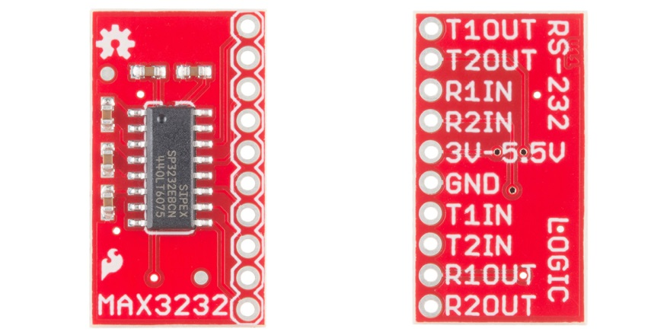
Figure 6: The Dual Serial Transceiver Board

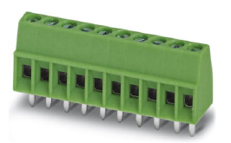
Figure 7: Phoenix Combicon 10-pin header

Grove 2-Coil Latching Relay Board

In order to extend the life of the system battery, power to the Sensor and LED modules can be switched off via a pair of relay boards. These are latching, double-pole, double-throw (DPDT) relays. Although the relay has two separate coils, onboard electronics allow the use of only one control signal by employing edge detection of the incoming control signal to either Set or Reset the relay. See the signal descriptions in the Sleepy Pi 2 section for details.

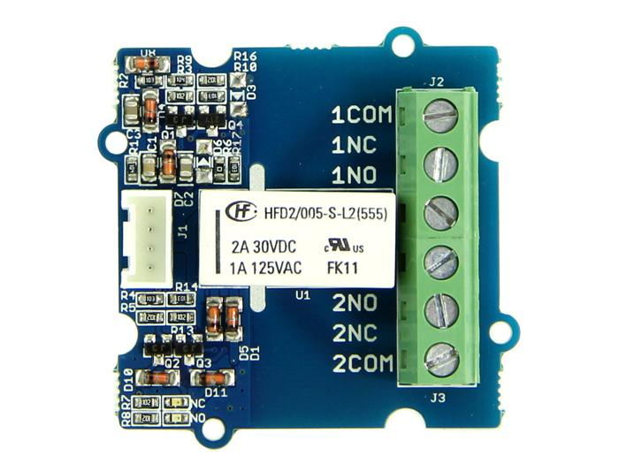
Figure 8: The Latching Relay Board

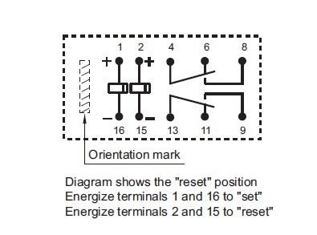
Figure 9: Operation of the Latching Relay

Fotga RM-VS1 Remote Controller

Many modern Sony interchangeable lens cameras contain a USB port which has been combined with an additional proprietary electrical interface. This interface is referred to as the Multi-Terminal connector and limited camera functions are available through this connection. These functions include turning the camera on and off, shutter focus, shutter release, and video record and stop. All of these functions are performed by simulating button presses by pulling an appropriate signal low except for the video record and stop. The video record and stop functions use a proprietary Multi-Terminal Protocol. This protocol is not documented and the SeeStar development team has not reverse-engineered it (yet). Therefore, the RM-VS1 is needed to control the video functions. Details on the wiring can be found in xxxxx (separate document or appendix ?)

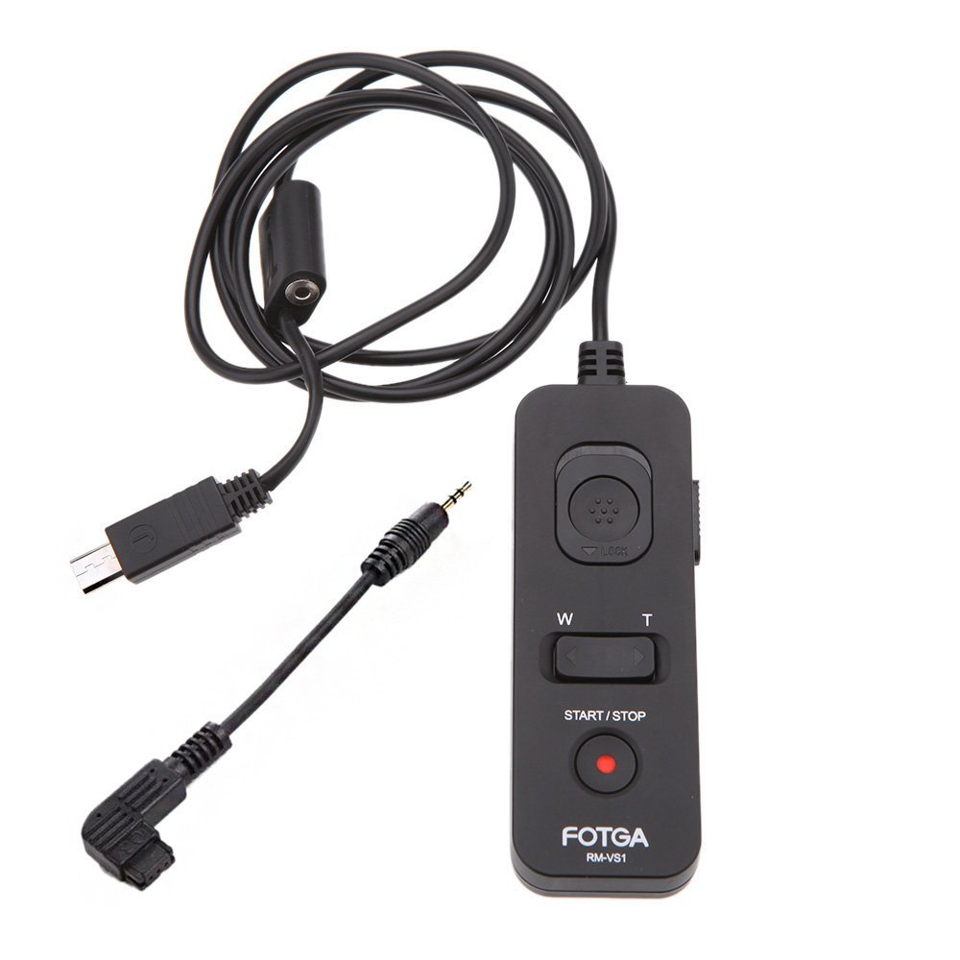
Figure 10: RM-VS1 Remote Control for Sony Cameras

Pinout of Multi-Terminal Connector

The Multi-Terminal connector is a modified Micro USB connector with ten additional pins used for camera control. There are a couple of online distributors who sell these connectors with a small attached pcb to make soldering to the pins easier. One side of the pcb contains the ten proprietary signals while the other side brings out the five USB lines. The ten proprietary signals allow access to some basic camera fucntions.

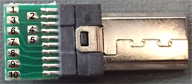
Figure 11: Multi-Terminal Connector, Signal Side

Pin # | Description
1 | Power On/Off
2 | GND
3 | Composite Video Out
4 | Audio Out L / Shutter
5 | Audio Out R / Focus
6 | Select
7 | UART RX / Boot Serial In
8 | UART TX / LANC Sig
9 | XReset Req
10 | 3.3V Output
Table 2: Multi-Terminal Connector, Signal Side

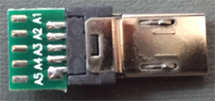
Figure 12: Multi-Terminal Connector, USB Side

Pin # | Description
A1 | 5V
A2 | USB_DATA_NEG
A3 | USB_DATA_POS
A4 | USB_ID
A5 | GND
Table 3: Multi-Terminal Connector, USB Side

Electronics Assembly

Carrier Board Assembly and Soldering

Overview

Tools and Parts Required

Comprehensive parts list needed for these steps. Tools needed.

Vector Board Preparation

The Vector proto board is approximately 3.5” by 6.25” with 0.1” spaced holes; there are 30 in the short axis and 60 in the long axis. In order to save space in the camera housing, the carrier board will need to be cut down to the minimum required size. The final dimensions will be 25 holes in the short axis and 51 in the long axis.

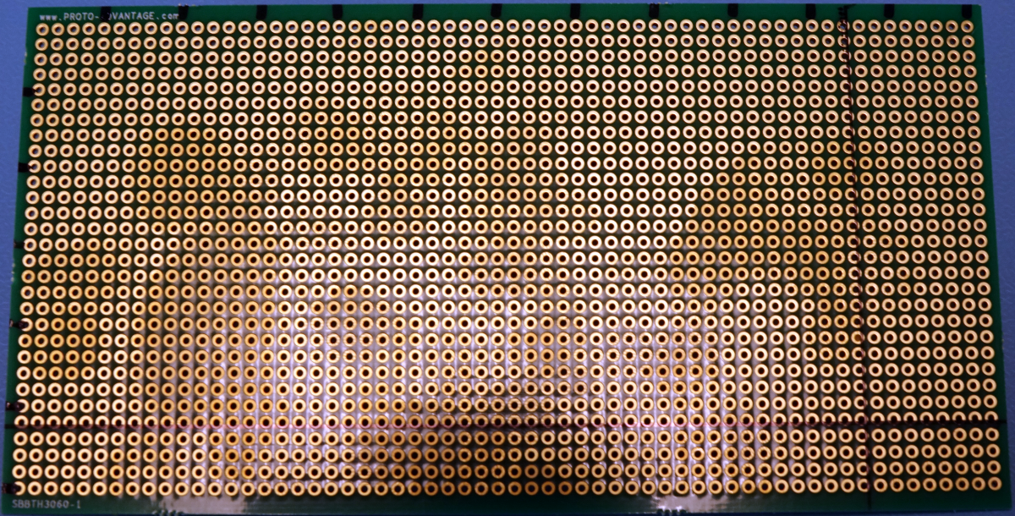
Figure 13: Carrier Board Marked for Cutting
To assist with cutting the board and future parts placement, use a felt tip pen and make a mark every five holes in both axes. Assign one corner as the (0,0) origin; this will assist with parts placement later by referring to a specific location on the Carrier board. Next, draw a straight line through the 26th row of holes in the short axis and through the 52nd column of holes in the long axis (figure 13). This will give a visual cue when cutting. With a knife, score across the drawn lines. A hack saw will easily cut through the scored line, giving a 25x51 hole proto board (figure 14). Coarse sandpaper can be used to smooth the rough cut edges (figure 15).

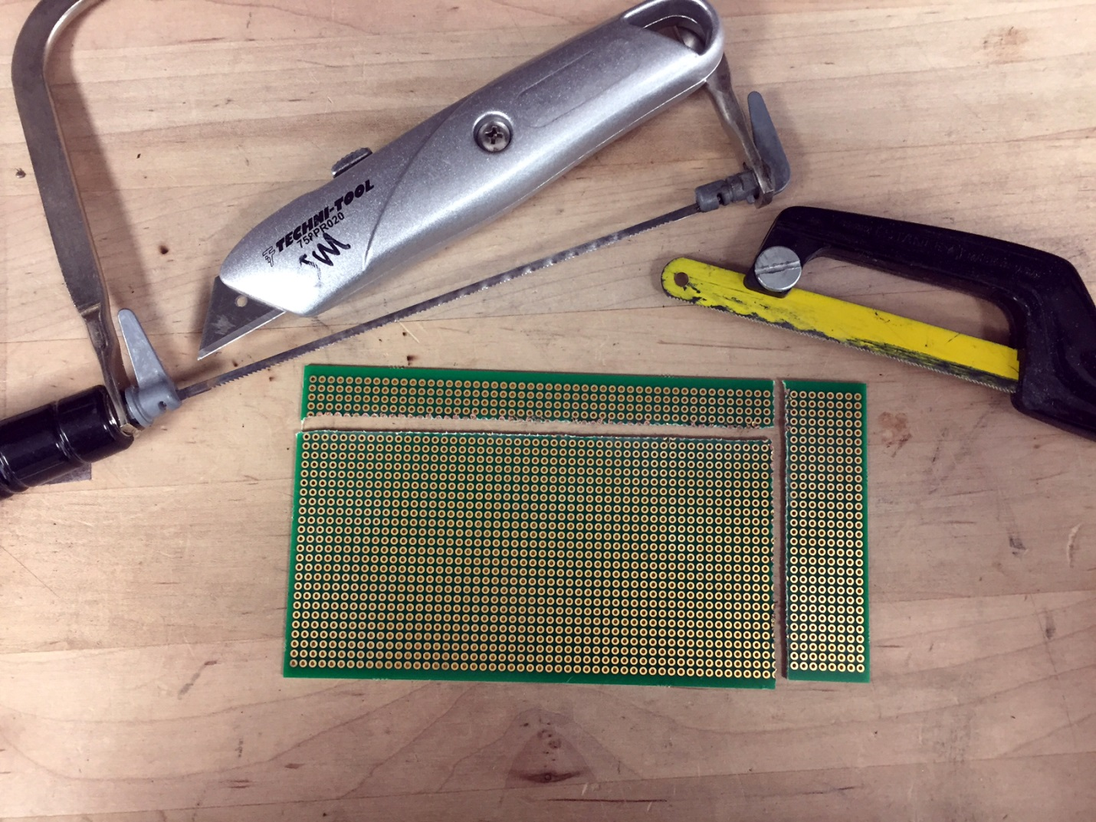
Figure 14: Tools Used to Cut the Carrier Board

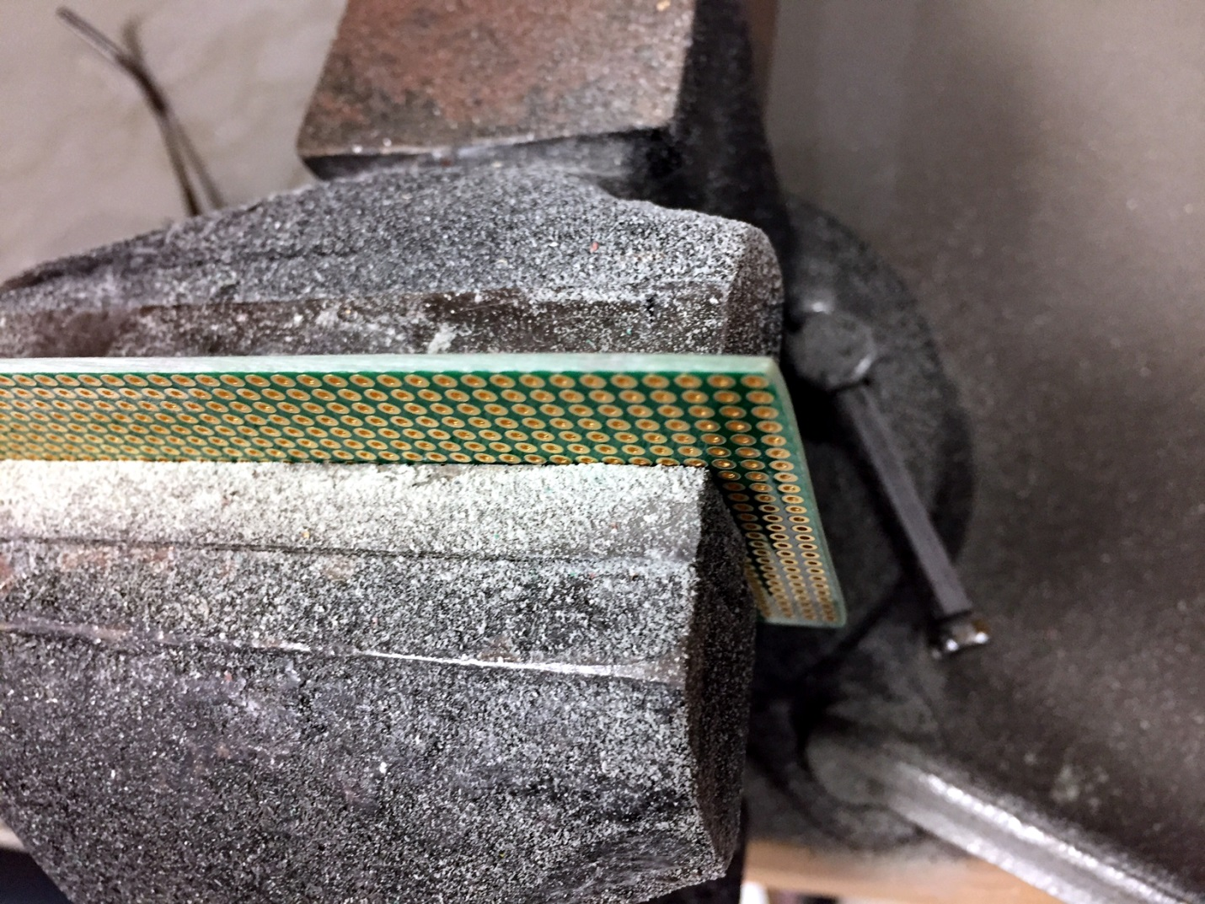
Figure 15: Sanding Down the Cut Edge of the Carrier Board

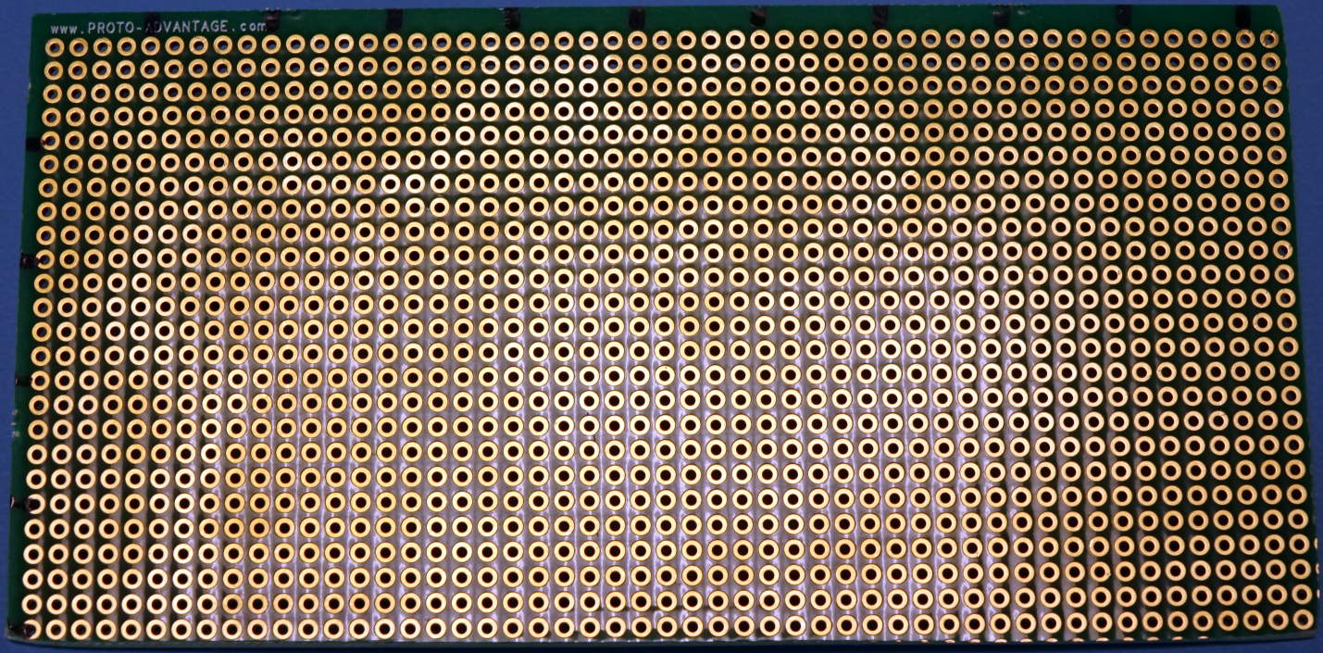
Figure 16: Carrier Board Ready for Drilling (25 Holes x 51 Holes)

Label (x/y) and cut/file board, assign top and bottom. Drill mounting holes.

Sleepy Pi 2 Preparation

Solder in topside headers. 40-pin header connection

When ordering the Sleepy Pi 2, there are two options for the 40-pin connector: low profile or stacking pins. The following instructions are for the low profile option, but either would conceivably work. When ordering the low profile version, the stackable header will be shipped with the unit anyway. This will be used on the Carrier board. An additional 40-pin header with 0.394 inch legs will be required as well (consult bill of materials for part number).

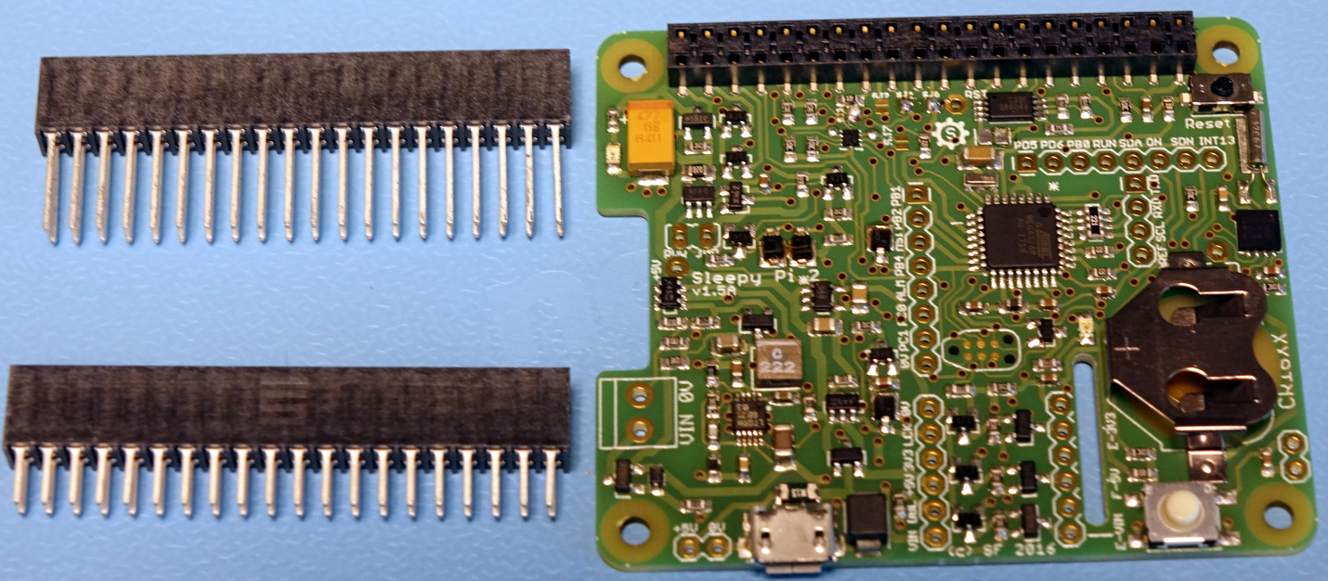
Figure 17: Sleepy Pi 2 with low profile header installed

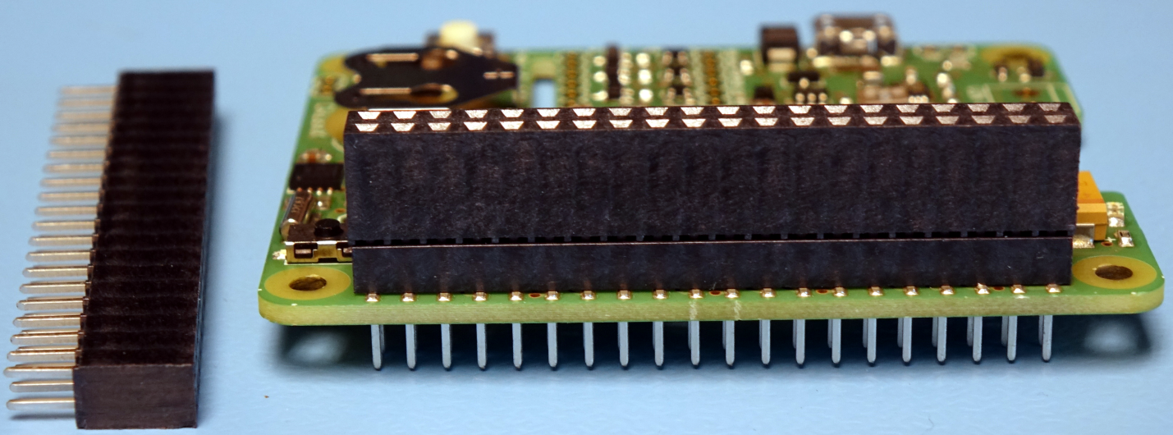
Figure 18: 40-pin header (with 0.394" legs) installed onto Sleepy Pi 2
The 40-pin header with the 0.394 inch legs can be pushed through the low profile header on the Sleepy Pi 2. The excess male pins will stick out of the bottom with about three-sixteenths of inch showing.

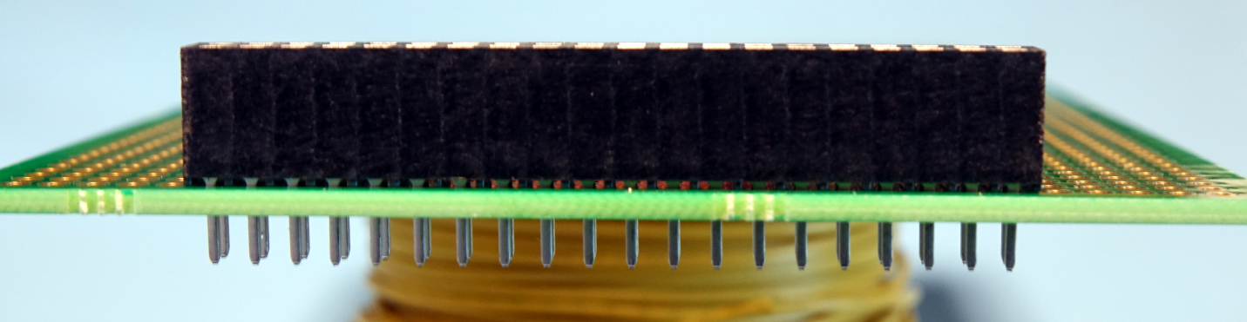
Figure 19: 40-pin header (with 0.1875" legs) installed onto Carrier board
The 40-pin header that was shipped with the SPi2 is pushed into the Carrier board and soldered into place.

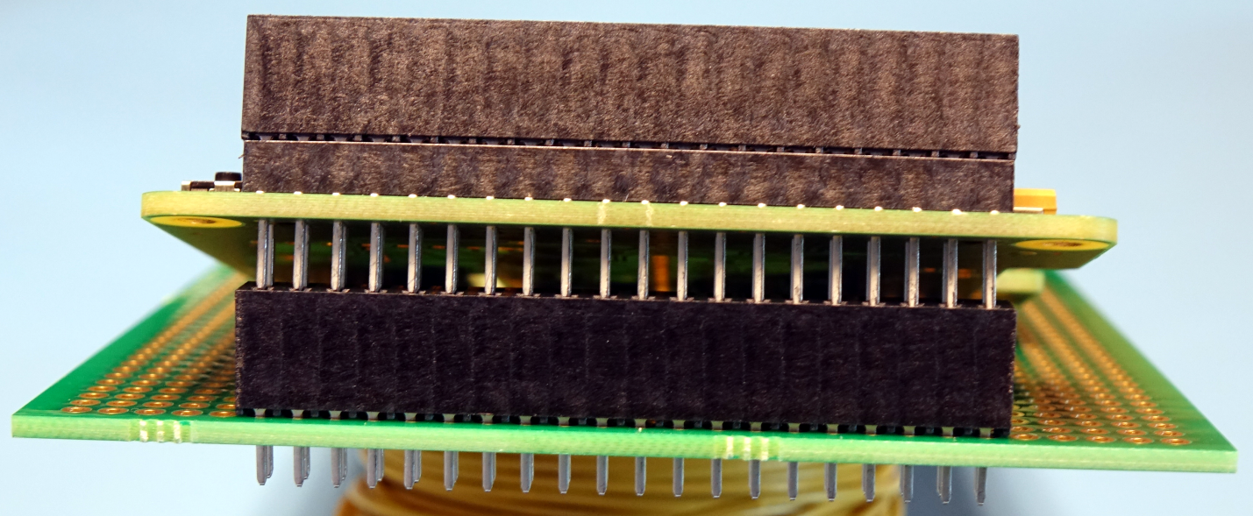
Figure 20: Installation of Sleepy Pi 2 onto the Carrier board
The SPi2 can then be installed onto the Carrier board.

Serial Transceiver Preparation

Solder in Phoenix connector

Low-Power Switch (optional) Preparation

The optional low power switch allows the user the ability to apply or remove power to the DC-DC converter which then supplies power to the Sony camera. The switch is a dual N+P channel mosfet. A logic level signal from the Sleepy Pi 2 is applied to the N-channel which in turn controls the state of the P-channel, which is used to switch the battery voltage on and off to the DC-DC converter. Figure 17 is a schematic of the low power switch. Q1 (the mosfet) is mounted on an adaptor board while R1 and R2 are soldered directly onto the Carrier board.

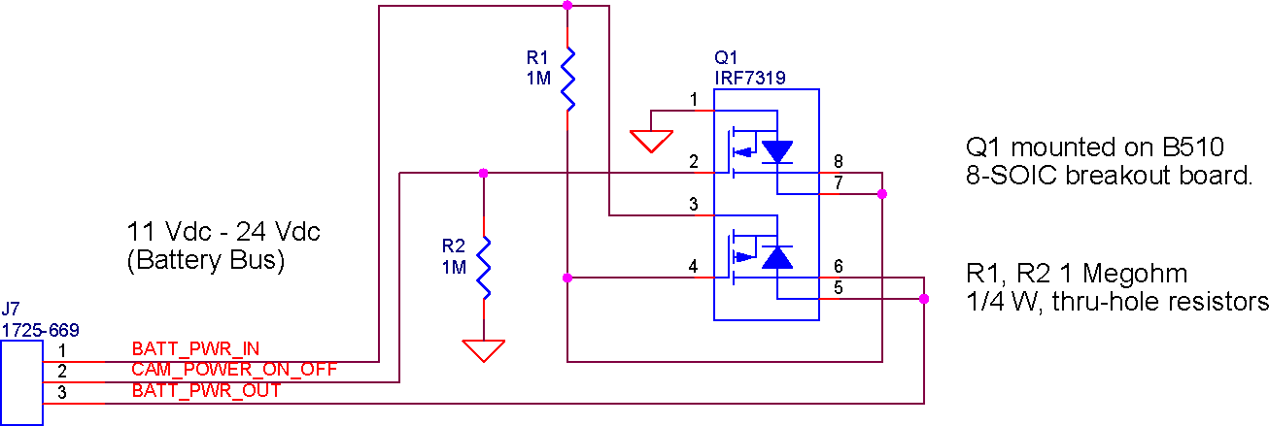
Figure 21: Schematic of the Low Power Switch

The IRF7319 N+P mosfet is an 8-SOIC package. To simplify installation into the camera module, the mosfet needs to be soldered onto an adaptor board. The B510 adaptor board converts an 8-SOIC package to an 8-DIP footprint; this allows the part to be inserted into any 0.1” pitch protoboard, such as the Carrier board.

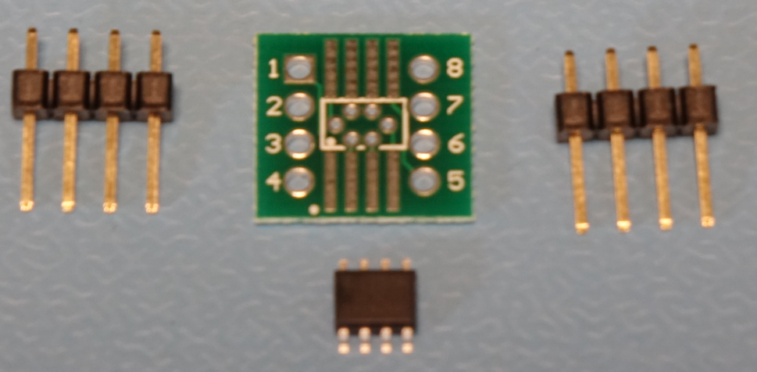
Figure 22: Parts for the Low Power Switch

Multi-Terminal Connector / Remote Wiring

Carrier Board Soldering

Internal Point-to-Point Wiring

Reference to appendix

Serial Connections to Endcap Connectors

Twisted pair connections

Optional Low Power Mode Wiring

An onboard DC-DC converter creates the 3.7Vdc needed by the Sony RX0. When the camera is not needed, this voltage can be removed to save battery power. The converter, the Recom R-625.0x, has a built-in On/Off input which allows for enabling and disabling the DC output. However, the quiescent current of the converter can be as high as 10ma while the converter’s output is disabled. This will be a constant drain on the SeeStar battery.

In order to help conserve battery power, the Carrier board can be wired in one of two methods regarding the way the camera is powered. With the first method, the CAM_POWER_ON_OFF signal from the Sleepy Pi 2 directly enables/disables the DC-DC converter (figure 19). In this configuration, battery power is always applied to the DC-DC converter and the quiescent current will be 10ma.

In the second method, the CAM_POWER_ON_OFF signal is instead connected to the low power switch (fabrication detailed above). By wiring in the low power switch, battery voltage to the DC-DC converter can be switched on and off. This will cause the DC-DC converter to draw no power while not being used. This is a more energy efficient solution, but requires the additional soldering and fabrication of the low power switch.

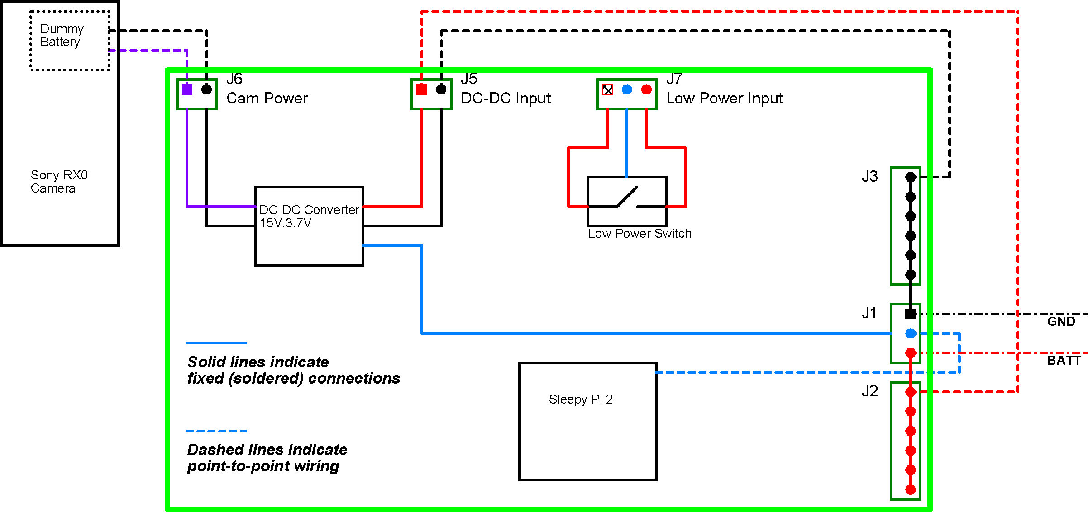
Figure 23: Camera Power Wiring

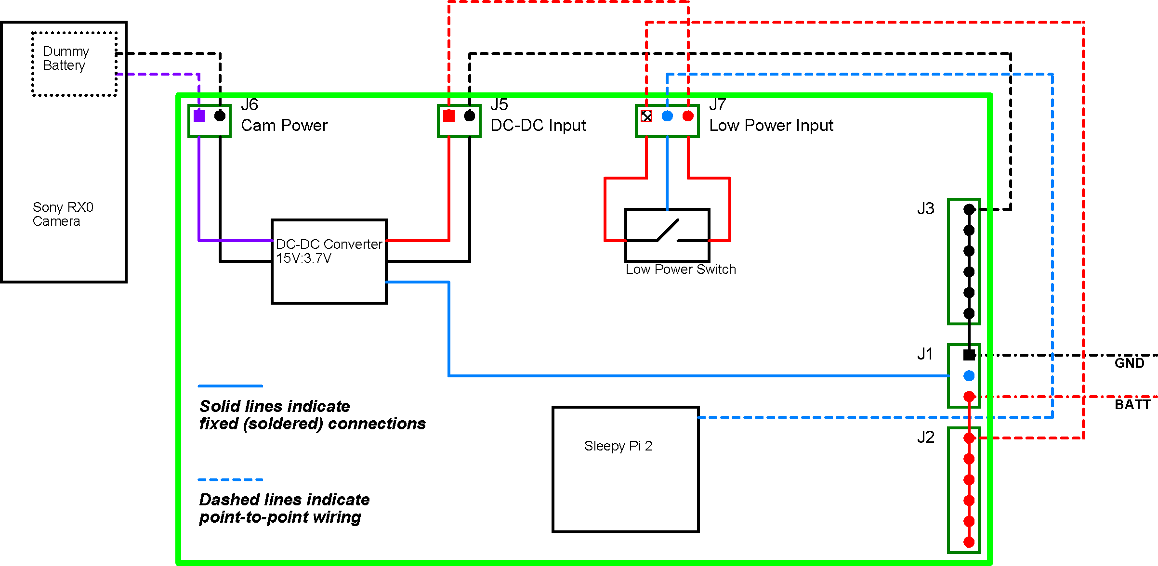
Figure 24: Camera Power Wiring with Low Power Modification

References

Appendices

Appendix 1: Camera Module Point-to-Point Wiring

Appendix 2: Camera Power Wiring

Appendix 3: Camera Power Wiring, Low Power Option

RX10, RX100ii, RX100iii, RX100iv,
ILCE 3000,
DSC-QX30,
DSC-HX400V,
A7, A7ii,
A5000, A6000,
SLT-A65, SLT58, etc

Appendix 4: Schematic of the Camera Module

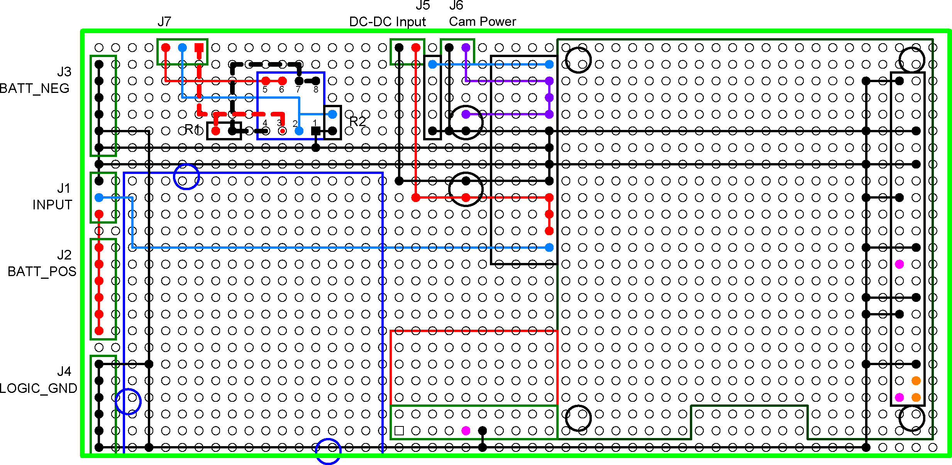
Appendix 5: Bottom View of the Camera Module Carrier Board

