SeeStar III LED Module
Technical Manual, v0.1

Monterey Bay Aquarium Research Institute

December 18, 2017



Table of Contents
Overview 5
System Level Description 5
Functional Descriptions 6
DC-DC Converter 6
LED Flashlight 7
Assembly Instructions 8
Tools and Parts Needed for Assembly 8
Disassembling the Flashlight 10
Attaching the Rear Connector Wires 13
Wiring the DC-DC Converter 14
Wiring the Flashlight PCBs 15
Final Assembly 18
Appendices 21

Table 1: Pinout of Murata DC-DC Converter 7

Figure 1: Picture of the SeeStar III Imaging System 5
Figure 2: LED Module Block Diagram 5
Figure 3: A sealed LED module ready for deployment 6
Figure 4: Murata UEI30-033-Q12P-C DC-DC Converter 6
Figure 5: Lingsfire 7-LED Flashlight 8
Figure 6: Exploded View of Lingsfire Flashlight 10
Figure 7: Reflector removed from flashlight 11
Figure 8: LED board removed 11
Figure 9: Removing the driver board from the flashlight 12
Figure 10: The driver board (left) and the LED board (right) removed from the flashlight 12
Figure 11: The LED module endcap with connector wired 13
Figure 12: The DC-DC converter wired 14
Figure 13: DC-DC Converter with protective heat shrink 15
Figure 14: LED board with 20AWG wire installed 16
Figure 15: Driver board, DC-DC Converter, and LED board (under heatsink) wired together 17
Figure 16: DC-DC Converter output wires soldered to the driver board 18
Figure 17: Final assembly of the LED module 19
Figure 18: Installing the endcap onto the LED module 19
Figure 19: Installing the glass port onto the LED module 20

Appendix 1: Electrical Specifications 21
Appendix 2: Mechanical Specifications 21
Appendix 3: Optical Specifications 21
Appendix 4: LED Module J1 Pinout 21
Appendix 5: Wiring Diagram of the SeeStar LED Module 21
Appendix 6: Exploded view of the SeeStar II LED module 22

Overview
SeeStar II is an autonomous and modular imaging system (Fig 1). It is programmed prior to deployment and can be left unattended for months at a time. It is an open source project and is distributed under a Creative Commons Attribution-ShareAlike 4.0 License. SeeStar II consists of three individual modules: the camera, battery, and LED. The LED module contains the LED lights and a power converter board.

Figure 1: Picture of the SeeStar III Imaging System

System Level Description
The LED module provides external illumination for the SeeStar II imaging system during the recording of videos or taking of still images. The LED module contains the LED board and driver board from a commercial flashlight as well as a DC-DC converter module; they reside in a housing which is rated to a depth of 1500 meters under water. An 8-pin inter-module cable connects the LED and camera modules. The battery bus voltage is switched to the LED via the camera module; a separate trigger signal actually turns the light on. Figure two displays a block diagram of the LED module while figure three shows a sealed LED module.

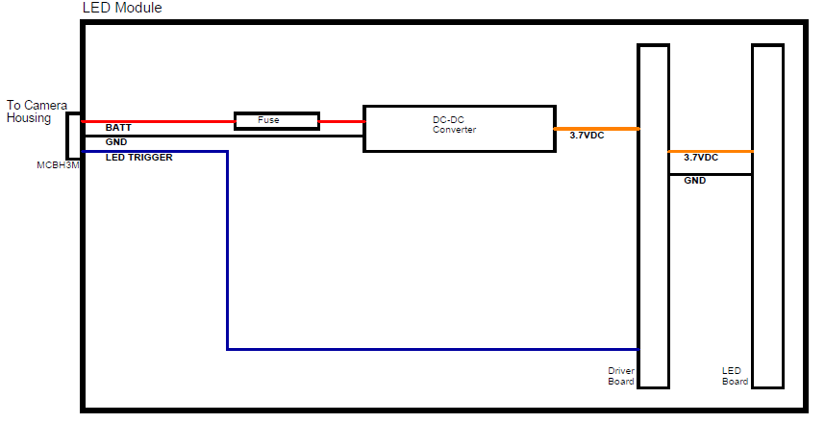
Figure 2: LED Module Block Diagram

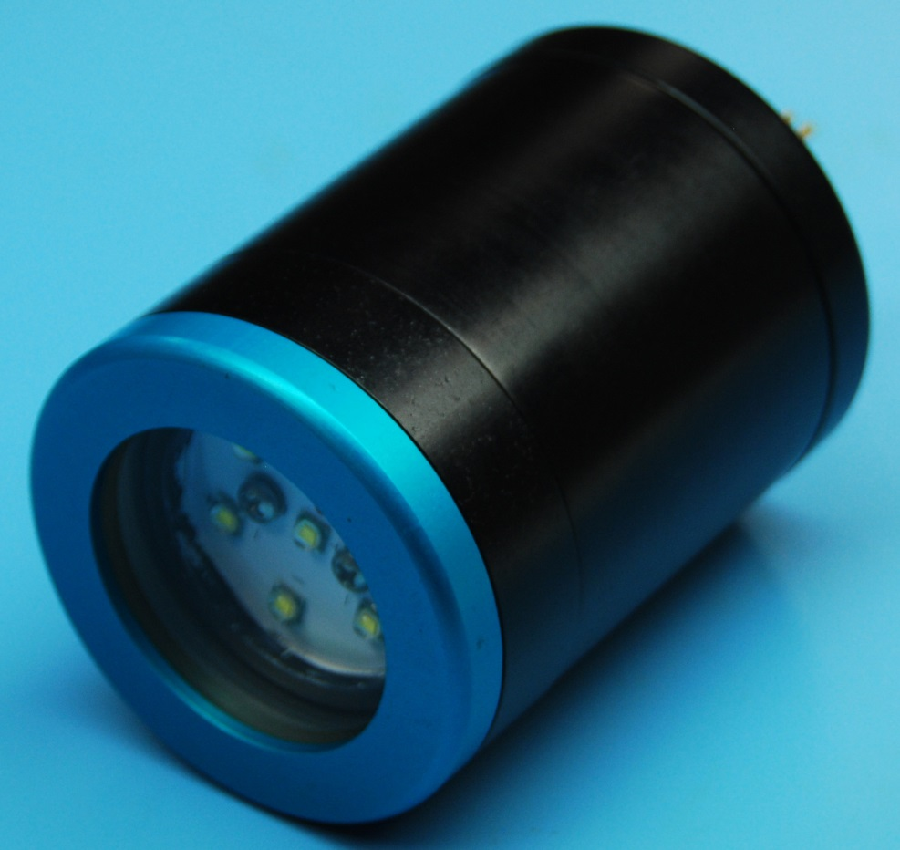
Figure 3: A sealed LED module ready for deployment

Functional Descriptions

DC-DC Converter
The DC-DC converter steps down the incoming battery bus voltage to ~3.8Vdc, the operating level of the series of LED flashlights used in the LED module. The Murata UEI30-033-Q12P-C has an average efficiency of 88%, is rated at 30W and can deliver up to 10 amps to the LED.

A single programming resistor (between –Vout and Trim) is needed to set the output voltage:

R_{Trim} (Ω) = (12775/(V_{Out} – 3.3V)) - 2050

A 1% 23.7K resistor gives approximately 3.80Vdc output.

[Need picture of new DC-DC converter]

Figure 4: Murata UEI30-033-Q12P-C DC-DC Converter

Pin # | Signal
1 | +Vin
2 | -Vin
3 | On/Off
4 | +Vout
5 | -Vout
6 | Trim

Table 1: Pinout of Murata DC-DC Converter

LED Flashlight
Components from an off-the-shelf flashlight are used as the light source for the SeeStar III system. There are a number of nearly identical commercial flashlights available online. We chose the 10-LED version from LingsFire due to its specified optical power rating of 10000 lumens and low cost (~$50). We have determined that it’s easier and cheaper to use components from this flashlight rather than to purchase individual components, even though many of the flashlight’s components are not needed.

The Lingsfire flashlight comes standard with three operating modes, chosen using the Mode button on the side. Depressing the mode button quickly alternates between On (high), On (low), and Off. Holding the mode button in for approximately one second places the flashlight into a Strobe mode.

The SeeStar III controller shield in the camera module is responsible for the operation of the light. It first applies battery power to the LED module; the DC-DC converter then generates the 3.70Vdc needed by the flashlight (which is still off at this time). The controller shield will then pull the LED_ON signal low for ~100 milliseconds, which simulates pressing the Mode button. The flashlight is now turned on (high setting). To turn off the light, the controller shield simply removes the battery voltage. The Mode button has no memory so the process starts anew when the light is needed next.

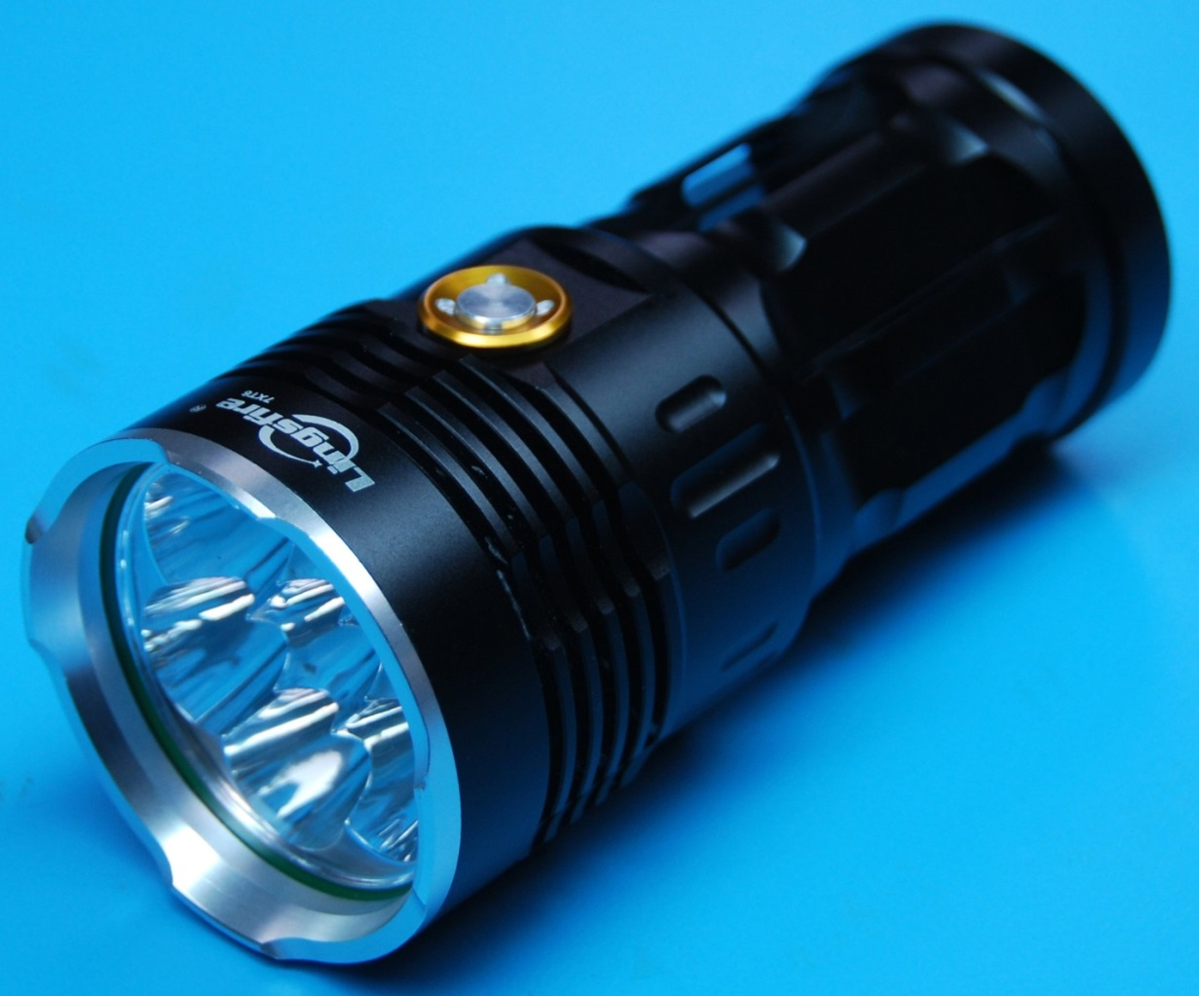
Figure 5: Lingsfire 7-LED Flashlight

Assembly Instructions

The assembly of the LED module is a fairly straightforward procedure with five major steps which are outlined below.

The flashlight will be disassembled and the two internal circuit boards will be removed and reused in the LED module; the remaining flashlight parts are not used.

Tools and Parts Needed for Assembly

- All parts for LED module (See appendix 4)
- Flathead screwdriver, small
- Phillips screwdriver, medium
- Exacto knife
- Wire stripper (covering 18AWG to 22AWG)
- Wire cutters
- Soldering iron & solder
- O-ring grease (Type 55 MolyKote, Parker O-lube, or similar)
- Silicone heat sink compound (Dow Corning 340 or similar)
- 18AWG wire, red and black (Approx 8 inches each)
- 20AWG wire, red and black (Approx 4 inches each)
- 22AWG wire, red and black (Approx 6 inches each)
- Heat shrink, inner diameter approx. 3mm (Approx 6 inches)
- Heat shrink, inner diameter approx. 1 inch (Approx 4 inches)
- Thin walled Teflon tubing, inner diameter approx. 30.5mm (Approx 2 inches)
- Four plastic standoffs (Male-female type, ½” long, 4-40 thread, nylon )
- Two plastic screws (1/4” long, 4-40 thread, nylon)
- Two stainless steel screws (1/4” long, 6-32 thread)

Disassembling the Flashlight

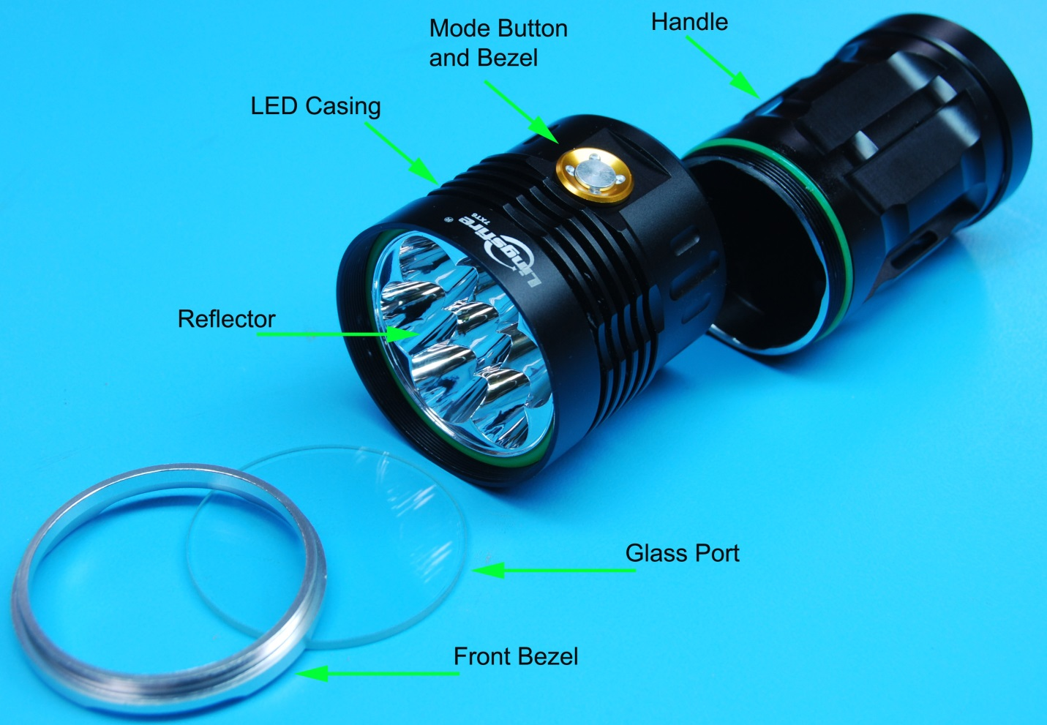
Figure 6: Exploded View of Lingsfire Flashlight
- Unthread the handle from the LED casing.
- Unthread the front bezel from the LED casing.
- Hold the LED casing upside down and catch the glass port.
- Use a small flathead screwdriver to carefully remove the o-ring.
- The LED reflector should now be loose. It is connected to the driver board by two wires.
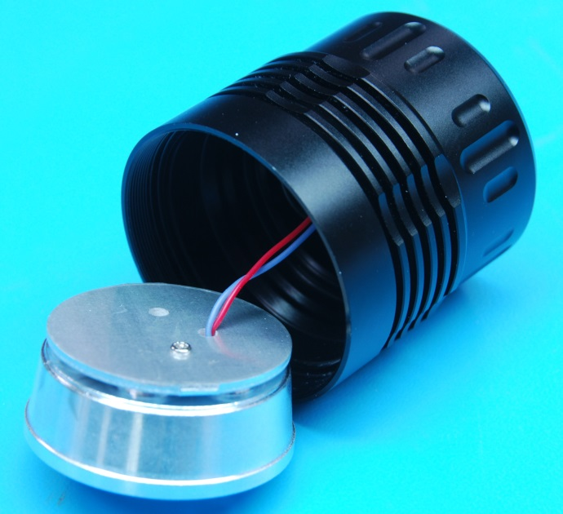
Figure 7: Reflector removed from flashlight

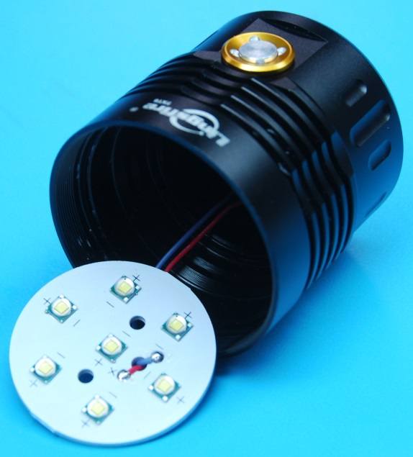
Figure 8: LED board removed

- The LED board is connected to the reflector by one small screw. Remove the screw. The reflector may now be removed. There are also seven circular insulators between the individual LEDs and the reflector; remove them from the LED board.
- The driver board is held in the LED casing by a small amount of adhesive. Before removing the board, unscrew the bezel around the mode button on the side of the LED casing. Both the bezel and the button can be removed. The mode switch board should now be loose.
- Using something non-metallic and smooth (like a pen or wooden dowel), gently tap on the driver board to break it free from the adhesive. Be sure to tap where there are no electronic components.

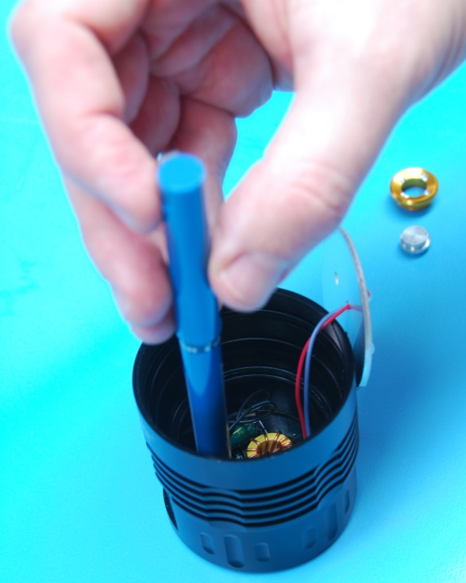
Figure 9: Removing the driver board from the flashlight
- Note that the mode switch board is connected to the driver board by two wires labeled as K and V-. De-solder or cut them at the mode switch board end. The mode switch board can be removed.
- The LED board is connected to the driver board by two wires labeled L+ and L-. Cut the two wires; these two wires will be replaced by thicker gauge wire later.
- Both boards should now be free of the LED casing.

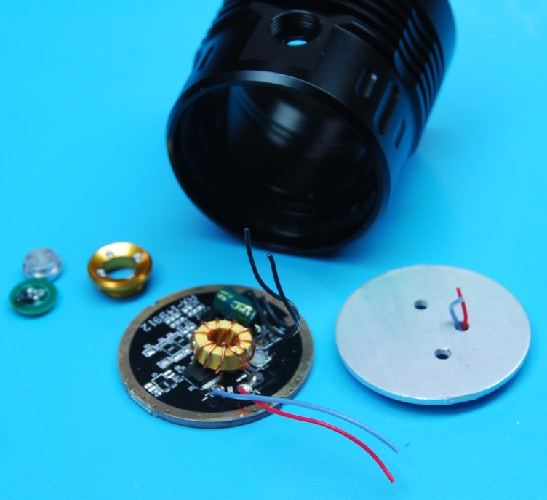
Figure 10: The driver board (left) and the LED board (right) removed from the flashlight

Attaching the Rear Connector Wires

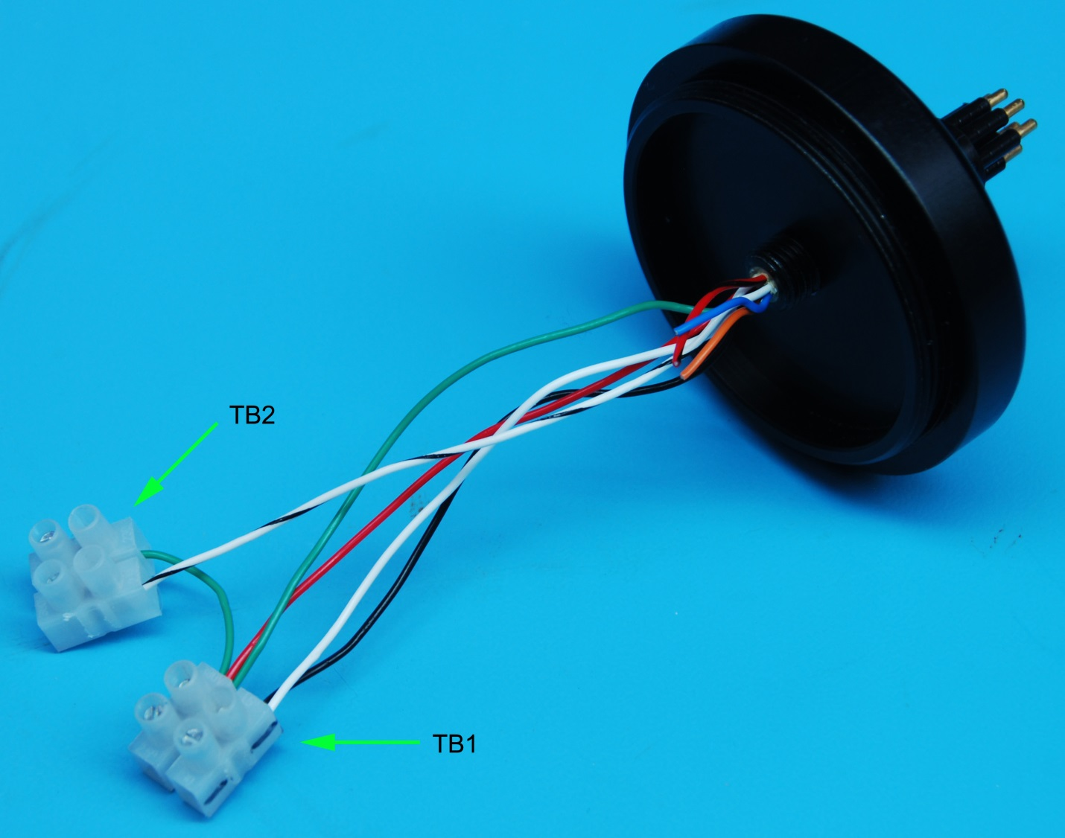
Figure 11: The LED module endcap with connector wired
- Apply O-ring grease on the O-ring (2-014) for the 8-pin Subconn connector. Only a very thin layer is required; wipe any excess with your fingers. Make sure there is no lint or hair on the O-ring. Apply the same method to other o-rings.
- Insert the connector into the threaded hole on the rear endcap and thread into it.
- The default lengths of the wires attached to the connector are 12”. Cut them down to approximately 6”.
- Using wire strippers, strip back the black, white, red, green, and white/black wires approximately ¼”. The wires are 20AWG so use the 20AWG multi-stranded setting on the wire strippers.
- Cut a section of black 20AWG wire approximately 2 inches in length. Strip both ends back 1/4”.
- Insert the black and white wires [BATT_POS] into one of the openings on TB1.
- Insert the red, green, and one end of the 2” black wire [BATT_NEG] into the adjacent opening on TB1.
- Insert the other end of the 2” black wire [GND] into one of the openings on TB2.
- Insert the white/black wire [LED_ON] into the adjacent opening on TB2.

Wiring the DC-DC Converter

- Cut two sections of red 18AWG wire, each approximately 3” in length.
- Cut two section of black 18AWG wire, each approximately 3” in length.
- Strip all four wires back approximately ¼”.
- Tin the tips of one end of each of the four wires. (Pre-filling the stranded wire with solder aids in the subsequent soldering)
- Cut (4) 1” sleeves of heat shrink with an inner diameter of $1/8$ inch. (Standard 18AWG wire has an outer diameter of 0.05 inch including the insulation).
- Place heat shrink over the tinned ends of the black and red wires.
- Solder a red wire to pin 1 of the DC-DC Converter
- Solder a black wire to pin 5.
- Solder a red wire to pin 7.
- Solder a black wire to pin 6.
- Slide the heat shrink sleeves down over the pin/wire junctions from steps 7-10. Shrink the sleeves using a heat gun.

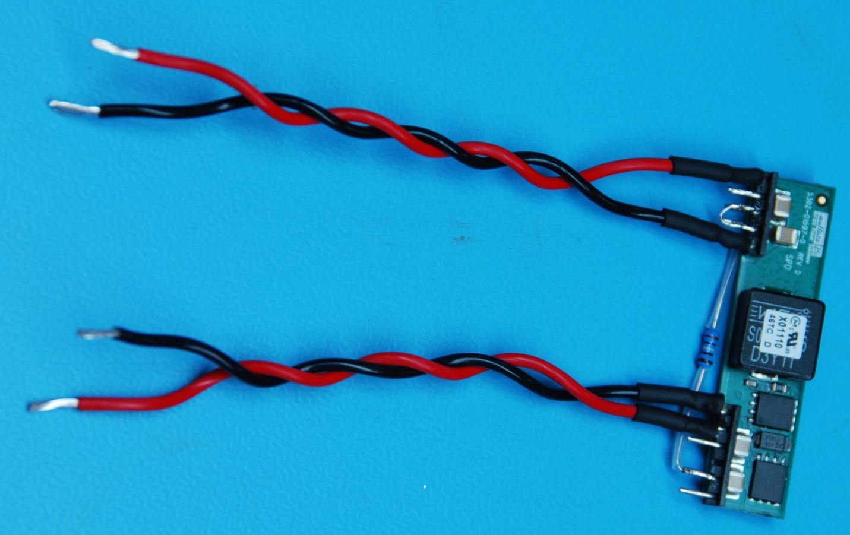
Figure 12: The DC-DC converter wired
[Figure 12 needs updated with new DC-DC converter]

- Label the red/black pair from pins 6 and 7 as the input.
- Label the red/black pair from pins 1 and 5 as the output.
- The programming resistor will be soldered between pins 5 and 10 of the DC-DC Converter. Pin 5 already has heat shrink on it so the resistor will be soldered to the pad on the opposite side of the board. Cut the leads of the resistor so that it fits nicely between pins 5 and 10.
- If available, cut two lengths of Teflon tubing to place over the exposed resistor leads.
- Solder one end of the resistor to the read pad of pin 5; solder the other end to pin 10.
- Solder a solid core wire (20-22AWG) between pins 3 and 4 of the DC-DC Converter.
- Place a large diameter (1”) sleeve of heat shrink over the DC-DC Converter; position the wires so they exit from one side only. Heat the sleeve.

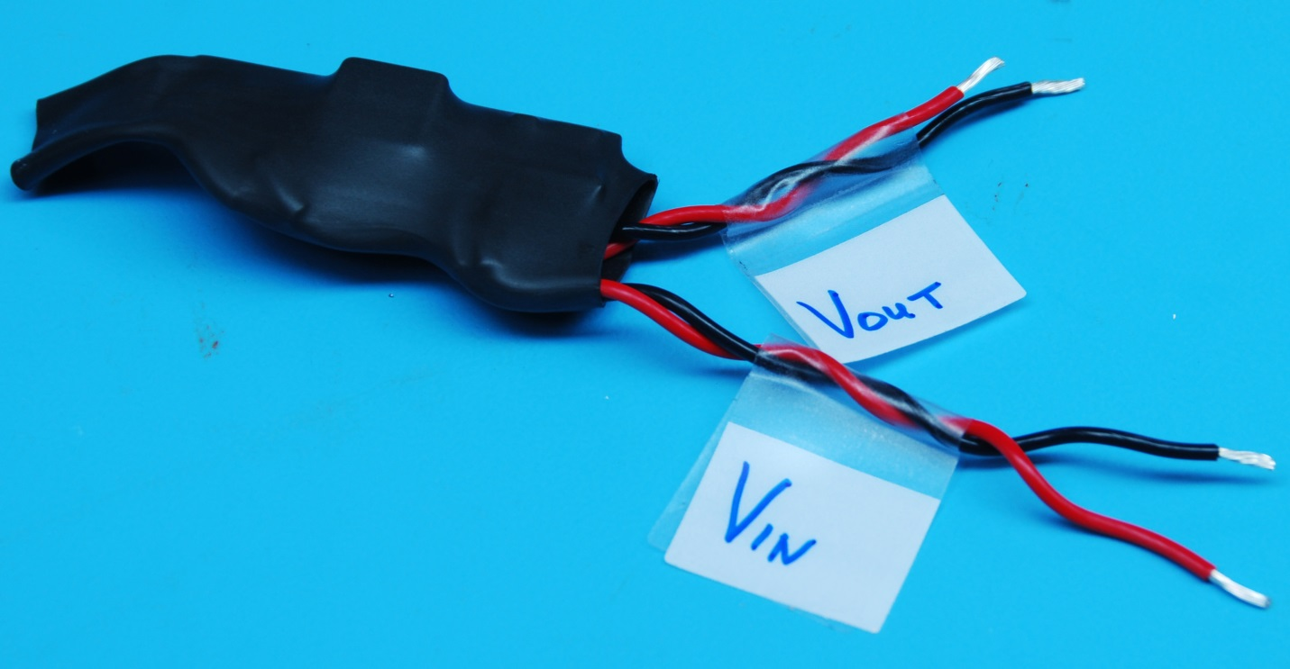
Figure 13: DC-DC Converter with protective heat shrink
[Figure 13 needs updated with new DC-DC converter]

Wiring the Flashlight PCBs

- Cut a red and black section of 20AWG wire, each approximately 4” in length.
- Strip both ends of the wires back approximately ¼”.
- Tin both ends of both wires.
- On the front side of the LED board, de-solder the original red and black wires on the + and – terminals.
- Using a deburring tool, smooth the front and rear edges of the hole the red and black wires had been in.
- Insert one end of both 20AWG wires through the center hole of the LED board, from the rear to the front.
- With a pair of needle nose pliers, bend the wires near the tinned tips at a 90º angle. Make sure the angle of the bend occurs on the insulated portion, not the exposed wires.
- Solder the red wire to the positive trace, making sure the bent portion of the wire coming through the hole is insulated.
- Solder the black wire to the negative trace, making sure the bent portion of the wire coming through the hole is insulated.

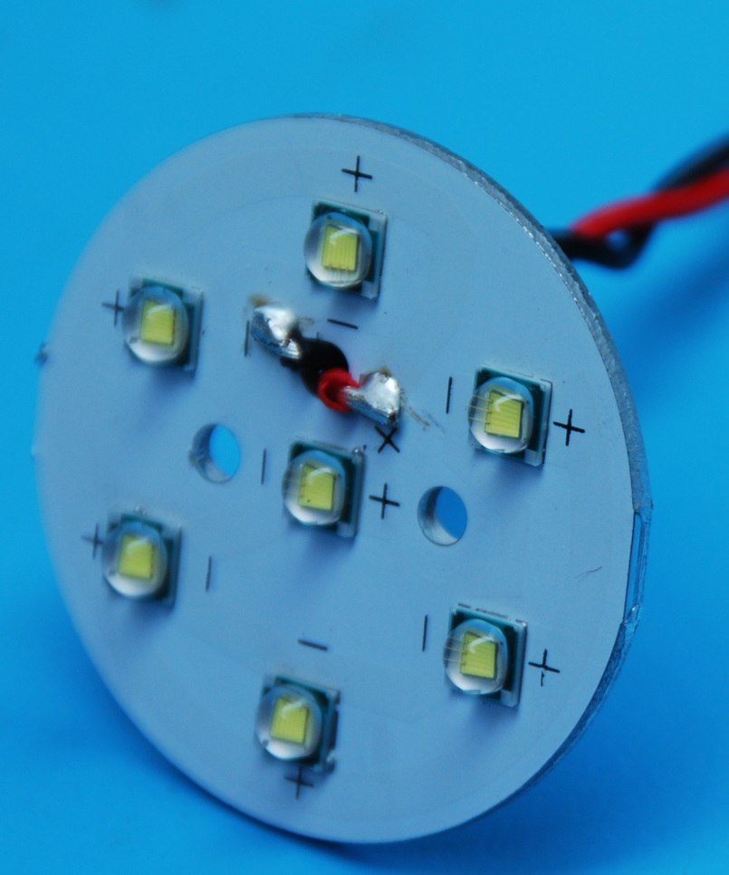
Figure 14: LED board with 20AWG wire installed
[Figure 14 needs updated with 10-LED board]

- Apply a thin coat of thermal compound to the recessed portion of the heatsink.
- Insert the opposite ends of the wires through the heat sink plate. The LED board should be recessed into the heat sink.
- If the LED board does not fit easily into the recessed portion of the heat sink, the LED board may need to be slightly filed. Inspect the edges of the board and file down any rough edges.
- Screw the LED board onto the heatsink with (2) ¼” long, 6-32 thread screws and washers.
- Solder the wires from step 6 onto the driver board. Red is tied to L+, black to L-.
- Cut a red and black section of 22AWG wire, each approximately 4” in length.
- Strip both ends of the wires back approximately 1/4”.
- Tin one end of the wires.
- Solder the red wire to the solder pad labeled K on the driver board.
- Solder the black wire to the solder pad labeled V- on the driver board.

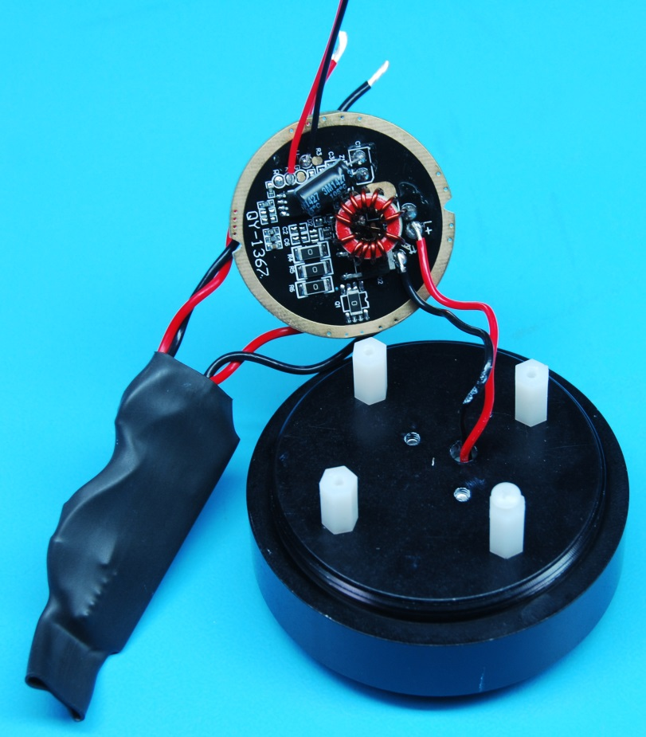
Figure 15: Driver board, DC-DC Converter, and LED board (under heatsink) wired together
- Solder the red wire (labeled output on the DC-DC Converter) to the rear side of the driver board to the middle copper disc.
- Solder the black wire (labeled output on the DC-DC Converter) to the rear side of the driver board to the outer copper disc.
- Screw in the four plastic standoffs onto the rear of the heatsink component holding the LED board.
- Position the driver board over the standoffs so the two notches line up with two standoffs.
- There are two notches on opposite sides of the driver board. These may need to be slightly increased in diameter prior to being screwed down. Use a metal file to increase the size of the notches.
- Screw down the driver board using two 4-40 plastic screws

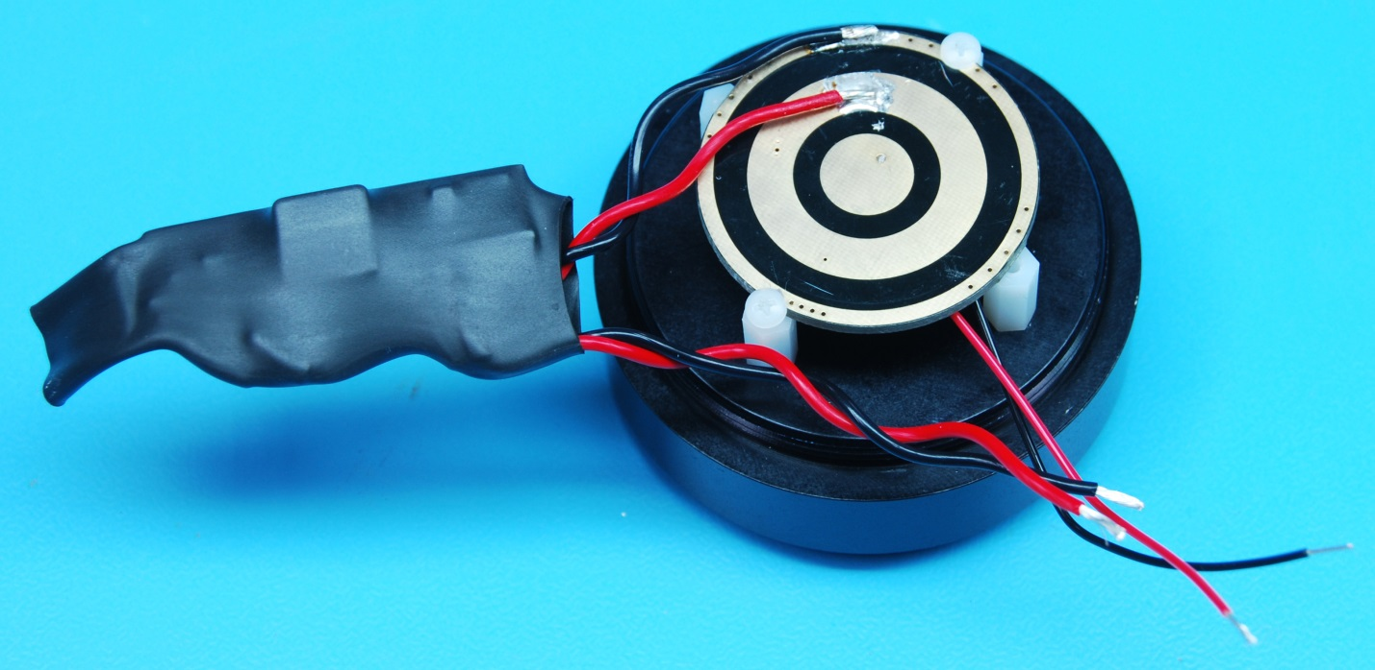
Figure 16: DC-DC Converter output wires soldered to the driver board

Final Assembly

- Apply O-ring grease on the O-rings (2-146) for both ends of the center housing. Only a very thin layer is required; wipe any excess with your fingers. Make sure there is no lint or hair on the O-ring.
- Before screwing any of the wires into the terminal strips, slide the short housing section (Groupbinc_GPH_Short) over the wires.
- Insert the black wire (labeled input on the DC-DC Converter) into TB1 (connected to the red & green wires).
- Insert the red wire (labeled input on the DC-DC Converter) into TB1 (connected to the black & white wires).
- Attach the red wire soldered to pad K on the driver board to TB2 (connected to the white/black wire).
- Attach the black wire soldered to pad V- on the driver board to TB2 (connected to the black wire).
- Apply O-ring grease on the O-ring (2-033) for the glass port. Only a very thin layer is required; wipe any excess with your fingers. Make sure there is no lint or hair on the O-ring.
- Place the glass port over the LED board.
- Screw the LED retainer over the glass port.
- Place the DC-DC converter board in the housing over the rear side of the driver board.
- Carefully screw in the endcap, making sure the wires have a natural twist to them.

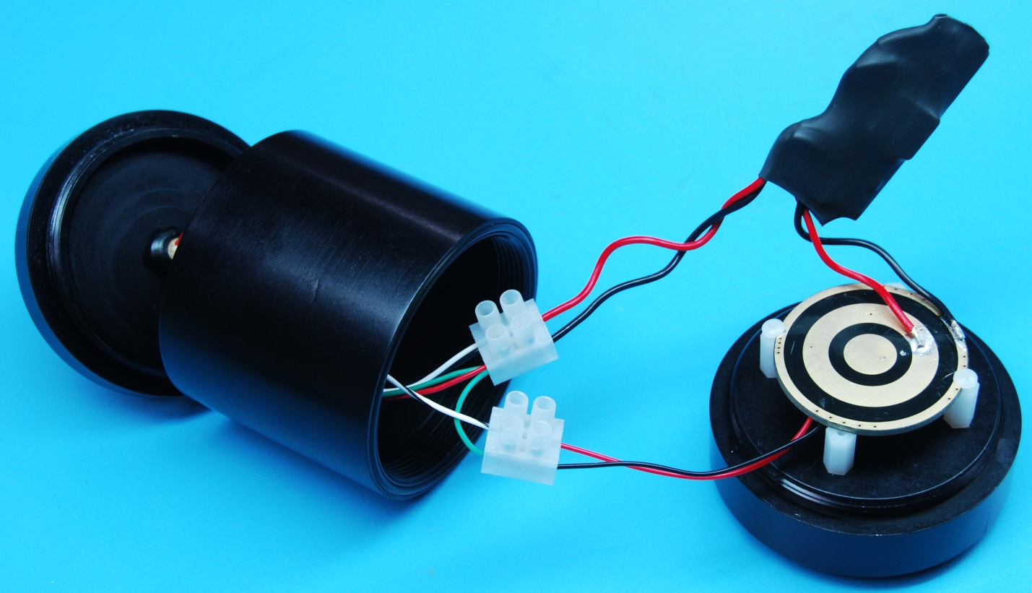
Figure 17: Final assembly of the LED module

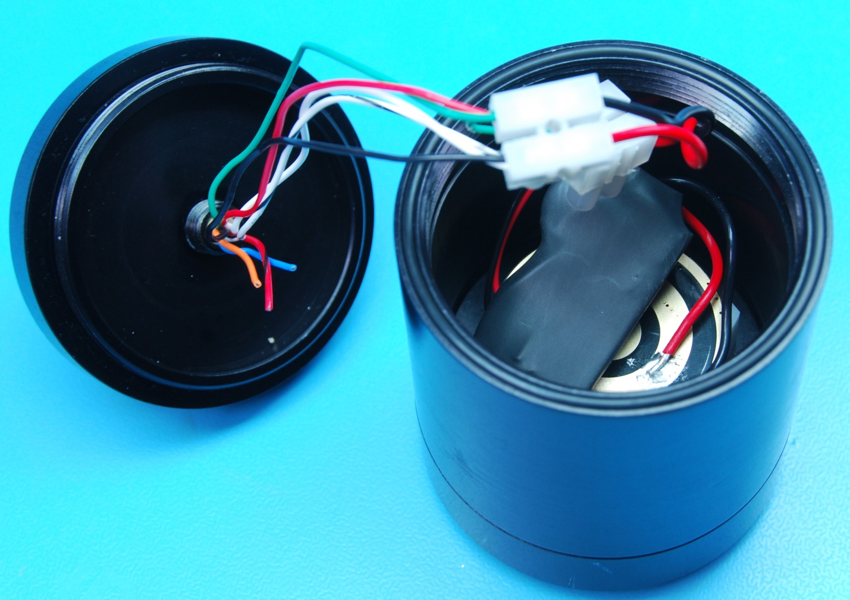
Figure 18: Installing the endcap onto the LED module

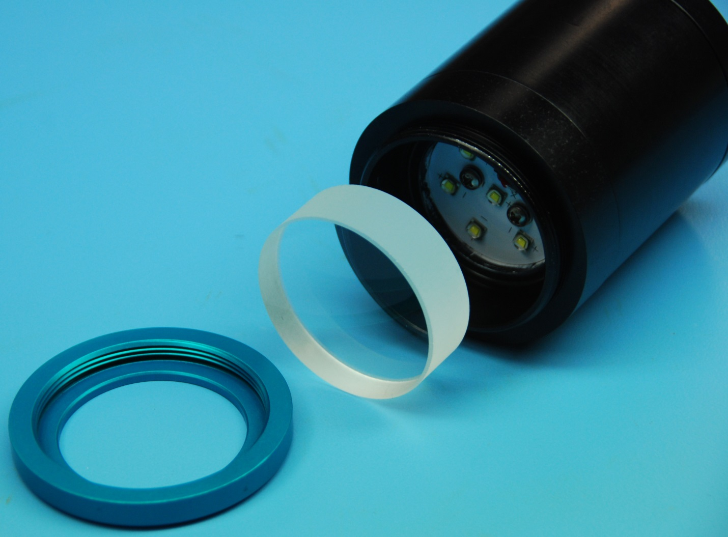
Figure 19: Installing the glass port onto the LED module

Appendices

Input Voltage | 9-15 Vdc
Current Draw (Max) | 3 Amps
Current Draw (Typ) | 1.5 Amps
Appendix 1: Electrical Specifications

Length | 6 in
Diameter | 3 in
Operating Temp (Min) | 0° C
Operating Temp (Max) | 70° C
Operating Depth | 1500m
Dry Weight | 1.3 lbs
Wet Weight | 1.0 lbs
Appendix 2: Mechanical Specifications

Light color | Cool white
Brightness | 7000Lm
Beam pattern in water | Approx. 95º
Color temperature | 5000K-8300K
Appendix 3: Optical Specifications

Appendix 4: LED Module J1 Pinout

Appendix 5: Wiring Diagram of the SeeStar LED Module
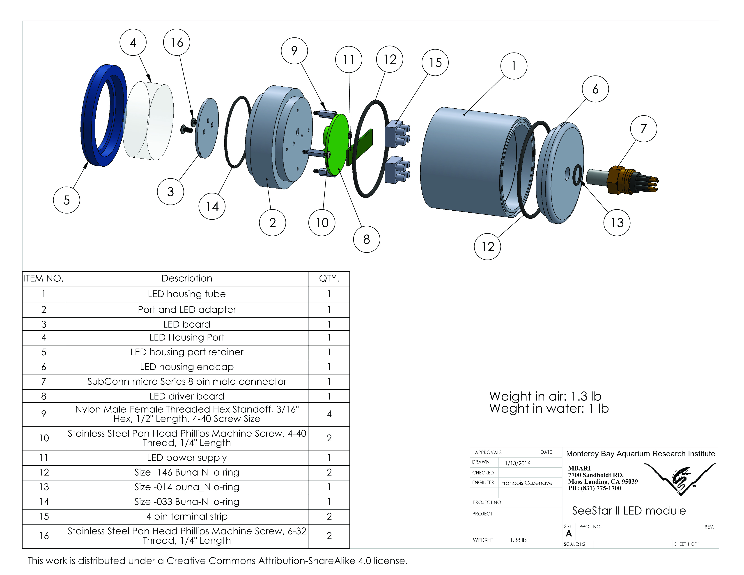
Appendix 6: Exploded view of the SeeStar II LED module

