SeeStar: a low-cost, modular and open-source camera system for subsea observations

François Cazenave, Chad Kecy, Michael Risi, Steven H.D. Haddock,
Monterey Bay Aquarium Research Institute
Moss Landing, CA, USA

Abstract— Scientists and engineers at the Monterey Bay Aquarium Research Institute (MBARI) have collaborated to develop SeeStar, a modular, light weight, self-contained, low-cost subsea imaging system for mid- to long-term monitoring of marine ecosystems. SeeStar is composed of separate camera, battery, and LED lighting modules, each rated to 300 meters depth. The system can be deployed in a variety of scenarios utilizing stills and video and can be operated either autonomously or tethered on a range of platforms, including ROVs, AUVs, landers, piers, and moorings. The priorities for implementation included using off-the-shelf and readily available components as much as possible, and providing all designs, schematics and fabrication documents online as open source, so that others can easily build and adapt the camera system for their own uses. The long-term goal of this project is to have a widely distributed marine imaging network across thousands of locations, to develop baselines of biological information.
Keywords—underwater camera; open-source; low-cost; autonomous; ecosystem monitoring; GoPro camera.

Introduction
While chemical and physical data are relatively well quantified by small instruments, time series of biological data are often difficult to monitor using automated instruments and methods. Phenomena like jellyfish blooms, seastar-wasting syndrome, urchin barrens, and other ecosystem changes cannot be detected by most instruments; all require photographic data to document and quantify. One way to generate these datasets is through camera deployments, as is often done in terrestrial research. Imaging systems that can operate in challenging marine environments, though, are often expensive and bulky, requiring a dedicated ship-based system to deploy (reviewed by Benfield, et al. 2007) [1], or the more compact systems are often unable to provide illumination that is synchronized with the image capture. Also, many imaging systems available on the market are only rated to diving depth (less than 60m).
To solve these problems, a team of engineers and scientists at MBARI have developed SeeStar (Fig. 1), a camera system that is low-cost, light weight, modular and adaptable to many applications. The individual modules of SeeStar are connected by off-the-shelf cables allowing for maximum mounting flexibility. The camera module contains a GoPro camera and a custom controller board used to trigger the camera and the light. The system can be used for video or still images for deployments ranging from a few minutes to several months.
The goal is to make this technology accessible to as broad an audience as possible. The system is made of components that can be ordered or easily fabricated and the drawings and instructions have been posted online on a repository [2]. The design is protected by a Creative Commons Attribution Share-Alike license (CC-BY-SA) [3], allowing anyone to use the design for commercial or non-commercial purposes. Users are encouraged to contribute by posting improvements or modifications to the design on the repository. Many cameras were considered and evaluated for this system. The GoPro was chosen because of its low cost ($200 to $400), ease of integration, relatively high image quality, small size and because many people are familiar with it or own one. However we are aware that these cameras have serious limitations in imaging capabilities (lack of manual control, fixed optics, poor low-light imaging and limited dynamic range), so SeeStar can be adapted to accommodate other cameras.
The total parts cost of the system is approximately $2900 and can be broken down as follows: camera module: $1180, battery module: $400 (price varies with type of battery chemistry and size), lighting module: $900, system cables and connectors: $430.

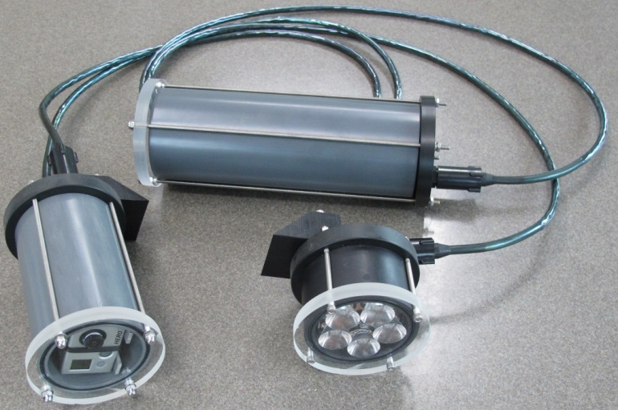 Fig. 1. SeeStar is composed of a camera module (left), a battery module (top) and a LED lighting module (bottom). It can easily be adapted and mounted on various platforms.
This paper contains a detailed description of the system in its current state, with sections on mechanical design, electrical design and the control system. Several deployments of the SeeStar as part of scientific experiments are described in section V. The development of an Arduino-based controller for SeeStar is underway; this work is described in section VI.

Mechanical design
When designing SeeStar’s mechanical components, special attention was paid to keeping the cost as low as possible. Ease of fabrication, robustness and adaptability were also important design drivers. SeeStar is composed of three modules: a battery module, a camera module, and a light module. All three share similar design characteristics and dimensions.
The camera housing (Fig. 2) and the battery housing (Fig. 3) are made of 3-inch schedule 80 PVC pipe, an inexpensive and readily available material. The pipe is cut to length and a groove for an o-ring face seal is machined in each end. The length of the battery housing can be adjusted to accommodate battery packages of different sizes.
The LED housing (Fig. 4) can also be made out of 3" schedule 80 PVC, however, PVC being a poor heat conductor, the light cannot be left on for more than 30 seconds, followed by 10 minutes of cooling (in air at room temperature, less in cold water). An anodized aluminum housing is therefore required for application where the light must be left on for long durations. With the aluminum housing, the light can be left on indefinitely, even in air.
The end caps of the housings are made with disks of acrylic (for optical openings) or acetal copolymer (for opaque end caps), ½" or 5/8" thick and approximately 4 1/8" in diameter. The end caps are mounted to the housing using threaded stainless steel rods.
Using finite-element analysis, and pressure testing, the housings were rated to 300m depth. The ½" end caps were also rated to 300m depth, however 5/8" end caps were used in most deployments because they are more robust.
Thanks to its small size and light weight, SeeStar can easily be mounted on many types of platforms. It can either be mounted using threaded holes drilled in the end caps, or using clamps around the housing.
Components inside the camera housing (camera and PCB) are held in position on a sheet metal tray that is attached to the rear end cap.
The acrylic flat port used on the camera housing has some limitations: the field of view of the camera is reduced by about 30% (Snell’s law), and there is some chromatic aberration and radial distortion near the edges of the image. The GoPro camera has a wide angle lens and is therefore sensitive to these problems. A narrower lens would not be affected as much. For some applications we have changed out the lens on the GoPro Hero 2 with a standard M12 mount lens with a narrower field of view, but this requires taking the camera apart.

Fig. 2. Camera module contains a GoPro camera and a controller PCB.

Fig. 3. The battery housing is made of 3” PVC pipe. Its length can easily be adjusted to accommodate battery packages of different sizes.

Fig. 4. Lighting module, with exploded view.

Electrical Design

System Level
The three individual modules share a common eight-pin bus which alleviates the need for unique cables (Fig. 5). Two pins are reserved for input or output triggers with devices such as motion sensors, strobe outputs, or for synchronization between multiple cameras. All three modules use the same 8-pin micro series of underwater mateable connectors from SubConn. The choice of this connector was a tradeoff between cost, depth rating, and availability. The modular design facilitates multiple deployment scenarios. For instance, if deploying on an AUV, the battery pack can be eliminated and power to SeeStar can be delivered directly from the vehicle’s battery bus.

Battery Module
The original design specification for energy usage was 1440 images and a maximum of a two-month deployment. Based on calculations of 3mAh/image, this corresponded to approximately 4320mAh of energy storage. While primary batteries tend to have higher energy densities, it was decided to use secondary batteries during the initial test phase for cost reasons. Nickel Metal Hydride (NiMH) cells were chosen for their energy density, relative flat discharge curve and mild temperature de-rating. Sixteen series cells provide a bus voltage of 19.2Vdc to 16.0Vdc with a capacity of 4500mAh. Subsequent design changes in the camera housing and tight timing with the LED module caused the energy used per image to be reduced to 1.4mAh which allowed the total number of images to double to 2900.

A second battery module based on Lithium Sulfur Dioxide (LiSO2) primary cells was also designed. Six cells in series provided a bus voltage of 16.8Vdc to 13.2Vdc with a capacity of 16500mAh. These are more costly battery packs but they allow for more images and/or a longer unattended deployment.

Fig. 5: SeeStar simplified system level diagram demonstrating the modular concept.

As stated previously, the SeeStar camera system was designed to be modular and adaptable. Based on individual users’ needs, a wide range of DC sources could be used to power the SeeStar system. The only limitations are providing a bus voltage of 12Vdc to 26Vdc and the capability to provide up to 3A current surges.

LED Module
The LED module comes in two configurations, a 9-LED unit rated at 3675 lumens and a 5-LED unit rated at 2000 lumens. Each module uses the same LED current value and has been optimized to run at an operating point close to the maximum light output within the thermal constraints of the electrical components and available heat sink capacity. The LED units use metal core printed circuit card material (MCPCB) and can be housed in either aluminum or low-cost PVC housings. A thermal shutdown feature reduces the light output when the LED PCB reaches a temperature of 24°C.

The LED PCBs were designed to accommodate a family of commercially available light reflectors. These various reflectors give the user the option of shaping the light pattern to suit their imaging needs. The LED modules provide wide angle uniform illumination when the reflectors are not installed.

Camera Module
The camera module consists of the GoPro camera, a controller board, and various interconnection cables. The USB port of the GoPro is accessible on the rear end cap by removing an SAE fitting. Two simple, yet mechanically stable, circuit boards were fabricated to interface both the USB port to the GoPro and to the USB connector on the end cap. One of the challenges in designing an imaging system based on a commercial camera is to achieving autonomous control. For the GoPro based SeeStar system, it was decided to design a custom controller board. The controller board is compatible with the Hero 2 and subsequent Hero 3/3+ cameras, but the basic triggering circuitry could be applied to other cameras with little modification.

Controller

Hardware
The SeeStar controller (Fig. 6) is a user-programmable interface board for the GoPro Hero 2 and Hero 3/3+ cameras. The design goals for the SeeStar controller focused on reliability, low power consumption, low cost and ease of assembly. To meet these goals, a highly integrated PIC microcontroller must be used as the main processor for the SeeStar controller. The Microchip PIC24FJ64GA104 was selected for this task. The microcontroller is programmable in ‘C’ using free software tools available from the chip vendor. The microcontroller has 64 KB of flash based code space as well as 8 KB of SRAM and also offers a variety of on board peripherals such as Universal Asynchronous Receiver/ Transmitter (UART) modules, Serial Peripheral Interface (SPI) modules, and Analog to Digital Conversion (ADC) modules. The integrated peripherals allow the SeeStar controller to have numerous features, yet maintain a relatively low part count. Images are stored onboard the camera, so the board only needs to hold the instruction set.
Functionally, the SeeStar controller provides complete control over the accessible features of the camera and light modules. The PIC24 directly interfaces the GoPro camera over the Hero bus; this gives the controller the ability to power on the GoPro and to initiate video or still imaging. An onboard switching regulator generates the DC voltage (4.2Vdc) necessary to power the GoPro camera. In combination with a commercially available blank battery eliminator [6], this enables the user to power the GoPro directly from SeeStar and not rely on the small capacity standard batteries. Current and voltage monitoring circuits of the battery bus give the user the ability to calculate the amount of energy remaining or cease operations below a certain level. An electromechanical relay switches the battery bus to the light module. An onboard real time clock (RTC) allows for accurate timing intervals. Configuration parameters are stored in non-volatile memory, while a one megabyte eeprom allows for diagnostic data storage during deployments. A serial port, accessible by removing a SAE o-ring plug from the end cap, allows the user to change the operating parameters without opening the underwater housing.
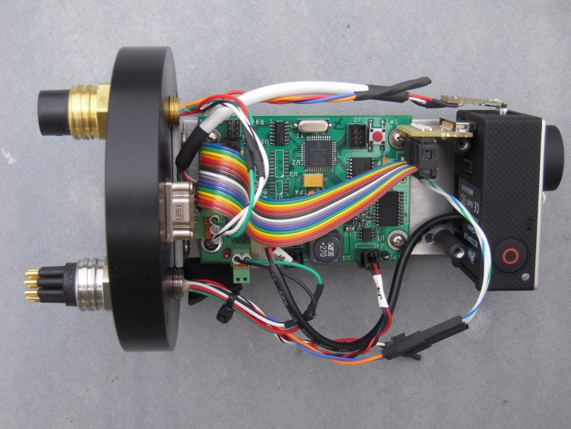
Fig. 6. Picture of the SeeStar controller, with wiring, camera and end cap.

Software
Software development for SeeStar was driven largely by the controller design. The software had to operate within the constraints of the selected microcontroller, yet still be easily configurable and have the option for future modifications and expansion as necessary. The software allows the controller to function as a simple intervalometer (a time lapse controller). Modification of an off-the-shelf intervalometer was not an option due to the interfacing requirements of the selected camera. and the lighting module that was developed in-house.
The SeeStar controller is configured by selecting a sample interval and a sample type, either still images or video. A start delay can also be set allowing the user to preconfigure the system before the deployment. After the initial start delay, if used, the system starts sampling at the configured sample interval (Fig. 7). With the HERO 3/3+ it is possible to capture both an image and video sequentially during a single sample event. The sample events will continue for the specified duration. Since the SeeStar controller can monitor bus voltage and current, the deployment duration could be based on the energy remaining in the battery. This would maximize the number of samples that could be gathered based on the remaining energy available, rather than a fixed deployment duration.

Controlling the GoPro Hero Camera
One of the criteria used in the camera selection process was the ease with which the camera could be interfaced to the SeeStar controller. The GoPro HERO camera provides a physical interface called the HERO Bus. The HERO Bus is a 30-pin connector on the rear of the camera that allows it to be controlled by the SeeStar controller without any modification to the camera.

HERO 2 Control
The SeeStar Controller controls the HERO 2 camera by using a physical interface and protocol used by the GoPro 3D HERO Sync Cable. The 3D Sync cable is an accessory provided by GoPro that allows two HERO 2 cameras to be synchronized over the HERO Bus for 3D photography and video. The cable allows one camera to be the master and have a second camera slaved to it. When the master camera captures an image, the slave camera captures an image simultaneously. The interface also allows the two cameras to take synchronized video. The SeeStar controller takes advantage of this interface by simulating the master side of the GoPro 3D HERO Sync Cable. The SeeStar controller can then control an attached HERO 2 via the protocol used by the 3D sync cable. GoPro has not released the details of this interface to the general public; as a result many of the details were determined by experimentation. Along with the experimentation that the SeeStar development team performed on the HERO 2 a great deal was learned about this interface by the work of users on the GoPro User Forum [4]. This forum provides a wealth of information about many of the undocumented features available on the GoPro HERO camera line.
Fig. 7. Diagram showing the sequence of events of the controller.

HERO 3/3+ Control
Upon its release the HERO 3 did not support the 3D sync cable option that was available on the HERO 2, so a second approach was needed. When coupled to a Hero 3 camera, the SeeStar controller uses a script file stored on the camera’s removable storage media (unique to the HERO 3) to control the camera. The content of the script is a list of commands that the HERO 3 executes upon power up. The SeeStar controller can power on the HERO 3 by asserting a digital input on the HERO Bus. Once powered on, the camera executes the commands contained within the script file.
The HERO 3 Black also supports a Wi-Fi interface for control of the camera. The Wi-Fi interface supports a wide variety of commands that can be used for control of the HERO 3 as well as determining its status. These commands are accessed through a collection of uniform resource locators (URLs) which convey embedded commands.

Deployments
Over the last two years, SeeStar has been deployed on a variety of platforms, as part of engineering tests or scientific experiments. Below, two of these deployments are summarized. Also, plans for a deployment under the ice in Antarctica in 2014-2015 are described.

Fish survey in Monterey Bay
As part of a multi-organizational effort, scientists of The Nature Conservancy, Moss Landing Marine Laboratories, and crew of the F/V Donna Kathleen evaluated a SeeStar system with the intention of incorporating it into their instrumentation suite for studying marine protected areas. They are interested in gathering density, size, and habitat-association data for rockfish and other demersal fish. The initial thrust of their study is on the overfished species in fishery closure areas in federal water, specifically the Rockfish Conservation Area in the Eastern Pacific.
The SeeStar system was mounted on a lander (Fig. 8) and lowered to the seafloor in several locations in Southern Monterey Bay, in approximately 100m of water. The camera was set to record video for a few minutes in each location. The quality of the video was adequate for fish identification (Fig. 9) and more surveys are being planned. Thanks to its low cost and robustness, SeeStar is being considered to be mounted on approximately 100 fish traps, as part of a large survey.

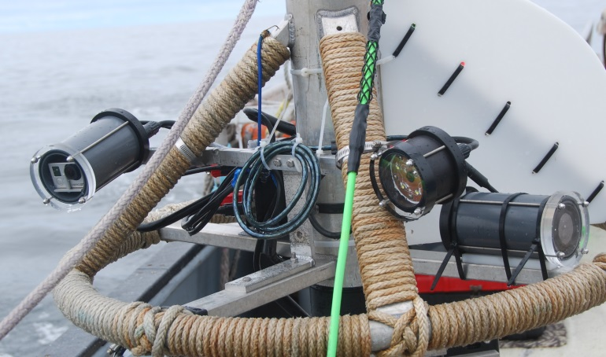Fig. 8. SeeStar was mounted on a lander and lowered to the sea floor in multiple locations. The camera module (left), the LED module (center right) and the battery module (right) can easily be mounted or various platforms.
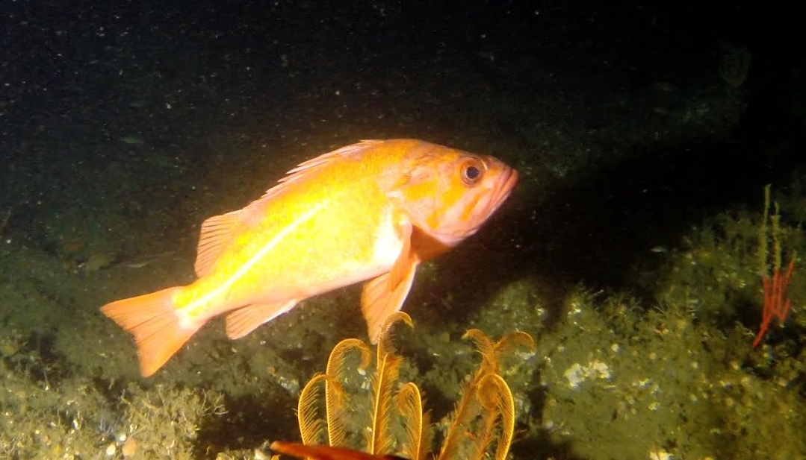
Fig. 9. Frame grab from a video recorded with SeeStar, showing a vermilion rockfish.

Video on Autonomous underwater vehicle (AUV)
A SeeStar system has been integrated onto the Tethys class of AUVs (Fig. 10) and has been utilized on several deployments. In this configuration, SeeStar is connected to the vehicle. SeeStar is then powered from the vehicle’s battery and is controlled by the vehicle’s computer, which can trigger the camera as needed. In 2013, SeeStar captured video of a Wave Glider while the AUV was actively tracking it. More recently, SeeStar has been used for zooplankton (jellyfish) recording since the suite of standard sensors cannot detect these animals. As part of a separate project, software is being developed to count jellyfish, using video recorded with SeeStar.

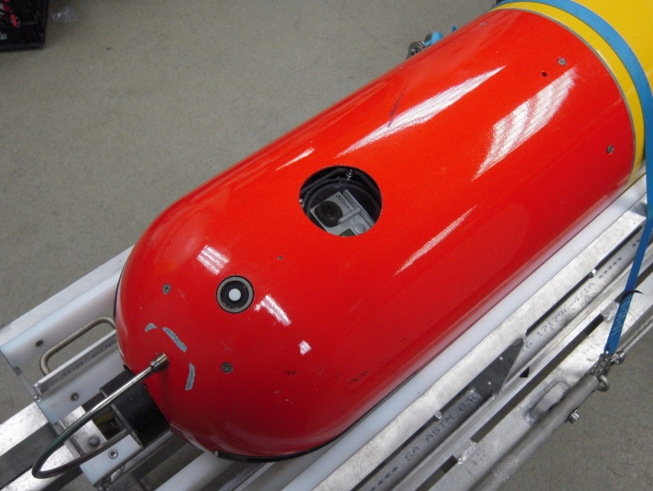
Fig. 10. SeeStar was mounted inside the nose of a long range autonomous underwater vehicle, with the camera facing upwards. The images are used to count jellyfish in the water column.

Benthic survey in Antarctica
Scientists from Moss Landing Marine Laboratories will be deploying a SeeStar system in Antarctica in late 2014 as part of a benthic ecology study at two locations near McMurdo Station.
The SeeStar system will be mounted on a special tripod that can be deployed and recovered through a 10” hole drilled in the sea-ice (Fig. 11). The legs of the tripod are spring loaded so that they can fit through the hole. The tripod will be lowered to the seafloor using a line and left in place for several weeks.
The first location, at Mystery Peak in McMurdo Sound, is in 40 meters of water; two SeeStar systems will be deployed there for 1 month, each taking an image every 20 minutes. After this test deployment, the study will move to a second location, between Tent Island and the Erebus Glacier Tongue, in 200 meters of water. Two SeeStar systems will be deployed there, this time with extended primary lithium battery packs, allowing them to take an image every 20 minutes for 3 months.
If this experiment is successful, a SeeStar system may be deployed for as long as one year in the future.

Fig. 11. The SeeStar system will be mounted on a spring loaded tripod and be lowered to the seafloor through a 10” hole in the sea ice, in McMurdo Sound, Antarctica. The field of view of the camera (in green) covers a 1m² area of the seafloor. The camera will take one image every 20 minutes, over 3 months.

Future work
The SeeStar development team has started development of a new Arduino controller (Fig 12). An Arduino controller offers some benefits over the existing Microchip PIC based controller: the ability to control the Hero 3 cameras via the Wi-Fi interface, a lower cost and more widely available development system, and a platform that would allow collaborators to easily develop new capabilities.
The new Arduino based controller would be developed as an Arduino shield. The shield could use an Arduino Pro Mini [5] for a basic level of control or an Arduino Yun [6] for a more advanced or tethered application. The Arduino shield based version will not include support for the Hero 2 camera. Since the Hero 2 camera is no longer manufactured by GoPro it was decided to drop support of the 3D sync cable interface for the Hero 2. By not including Hero 2 support, the complexity and cost of the Arduino based SeeStar controller were greatly reduced.
When used with the Arduino Pro Mini the capabilities and power consumption would be similar to the current Microchip PIC based system. It would also give collaborators a development platform for new deployment schemes.

If the shield is used in conjunction with the Arduino Yun it could take advantage of the Wi-Fi interface control of the Hero 3. The Arduino Yun would also allow the SeeStar controller to be accessed by the Internet should a connection be available. The increased control and connectivity comes at the expense of much higher power consumption, which would most likely limit this version to tethered applications where power and connectivity are readily available.

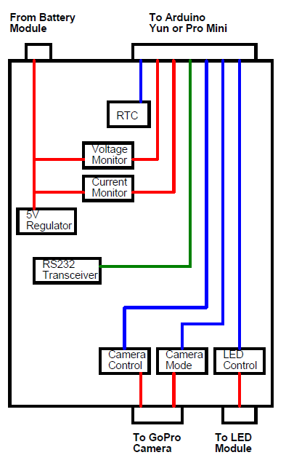

Fig. 12. Arduino SeeStar shield block diagram

Conclusion
There are many opportunities in marine ecology and conservation for technology that provides for low-cost, long-term underwater imaging. In response to this need, a low-cost subsea imaging system has been developed and tested and is now shared with the public as an open source design. Researchers and engineers are encouraged to download the documentation and build SeeStar systems for their projects. Modifications and improvements can in turn be shared with the community. The SeaStar development team at MBARI will continue to make improvements to the system, in order to make it appealing and useful to as many users as possible.

Acknowledgment
This project was supported by the David and Lucile Packard Foundation. Mark Chaffey, Andy Hamilton and Alana Sherman (MBARI) made significant contributions to the development of SeeStar.

References
[1] Benfield, M., Grosjean, P., Culverhouse, P., Irigoien, X., Sieracki, M., Lopez-Urrutia, A., et al. (2007). RAPID: research on automated plankton identification. Oceanography, 20(2), 172–187.
[2] www.mbari.org/seestar Home pages of the SeeStar project, containing links to open source documentation.
[3] http://creativecommons.org/licenses/by-sa/4.0/ Description of creative common licenses
[4] http://goprouser.freeforums.org GoPro user forum home page.
[5] http://arduino.cc/en/Main/ArduinoBoardProMini
[6] ttp://arduino.cc/en/Main/ArduinoBoardYun?from=Products.ArduinoYUN

