Budget for fabrication of 4000m rated housing for SeeStar camera:

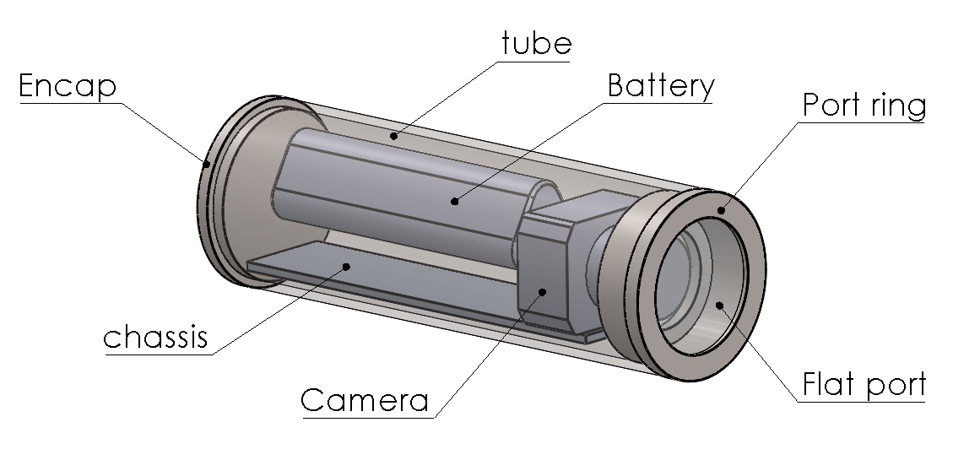

Approximate dimensions and specs:
Outside diameter: 5.5”
Inside diameter: 5”.
Length (including encaps): 17”
Flat port (BK7 or sapphire), 4” diameter
Lens: 16mm Sony e-mount.

Cost of components:

 | Material cost (USD) | Vendor | Machine shop time (hours)
Titanium endcap | 191 | titanium industries | 20
Titanium tube | 1825 | titanium industries | 20
Titanium port ring | 191 | titanium industries | 15
Flat port | 727.5 | EP Oceanographic | NA
Aluminum chassis | 50 | McMaster | 8
Vent plug | 200 | Prevco | NA
Fasteners | 50 | McMaster, United Ti | NA
Misc. hardware | 100 |  | NA
total | 3154.50 |  | 67

