SeeStar LED Design Notes and Recommended Battery Packs

Rev. E – Updated for Open Source documentation

LED Printed circuit board.
The LED light head comes in two configurations, a 9 LED prototype configuration and a 5 LED prototype configuration. The design light output for each of the two configurations is 2000 and 3675 lumens respectively and each model runs at the same LED current value. The LED driver circuit is optimized to run at an operating point close to the maximum possible light output within the thermal constraints of the power supply components and the available heat sink capacity. The prototype units use metal core printed circuit card material (MCPCB) and are in aluminum housings that provide enough heat sink capacity to operate continuously in air. A thermal shutdown feature reduces light output (and heat generation) when the LED PCB reaches 75 ºC. Full thermal shutdown occurs at 100ºC.
The thermal mass of the LED MCPCB allows the use of low cost PVC housings for ON times of 30 seconds or less provided at least 10 minutes of OFF time occurs between power cycles to allow for LED cooling. Various timing schemes may be used in a PVC or delrin housing provided the ratio of on/off times do not exceed 1:20. The thermal shutdown circuit protects the components from over temperature damage in case of over cycling. For this reason it is important to properly follow the assembly steps and bond the temperature sensing thermistor RT1 to the base of the LED PCB.

LED power supply circuit.
The operating parameters for the LED drive circuit and light heads are shown in the table below:
SeeStar LED Light Design Values | 5 LED | 9 LED | Unit
Nominal Actual Light output (note 1) | 2000 | 3675 | Lumens
LED current @ design operating point | 1600 | 1600 | milliAmperes
LED forward Voltage @ design operating point | 15.6 | 28.08 | Volts
Absolute maximum LED current (note 2) | 3000 | 3000 | milliAmperes
Input voltage minimum turn on (note 3) | 9 | 15 | Volts
Input shutdown voltage hysteresis | 2 | 2 | Volts
Input voltage absolute maximum | 40 | 40 | Volts
Output shutdown voltage | 35 | 35 | Volts
Output voltage hysteresis | 5 | 5 | Volts
Input current @ minimum V (note 4) | 2.9 | 3.3 | Amperes
Input current @ maximum V (note 4) | 1.5 | 2.4 | Amperes
Soft start ramp time | 40 | 40 | milliseconds
Thermal shutdown start (heatsink T) (note 5) | 75 | 75 | Degrees C
Max. ambient temperature for continuous operation | 27 | 27 | Degrees C
Maximum PVC Housing Diameter (nominal pipe size) | 3 | 4 | Inches
Note 1: Lab tests with Nikon 1V1 showed that the amount of illumination for a good front or side light image at 1/250, f 2.8, ISO 800 was 1000-2000 lumens m^. Recommended design value is 2000 Lumens or greater for margin.
Note 2: Driver sets LED current at the design operating point.
Note 3: 9 LED version must use NiMH battery pack.
Note 4: With Alkaline battery pack on 5 LED version. 9 LED version is with NiMH battery pack.
Note 5: Output power ramps down when heatsink temperature reaches the thermal shutdown start value.

The LED power supply provides constant current for the series LED array across the range of battery input voltages. It is based around a standard buck-boost configuration of the LM3424 switching power supply IC from National /TI. It was chosen for the design because the reference designs are well documented and the input voltage range and current capabilities meet our requirements. The circuit is designed to shut down in an input under voltage or output LED drive over voltage condition. In addition an input protection fuse, F1, is provided that will protect the circuit from accidental over voltage or reverse polarity on the input. If the fuse is inadvertently blown it must be replaced by desoldering it from the PCB and replacing it. There are two configurations of the power supply PCB, ‘A’ and ‘B’ for driving the 5 or 9 LED light heads respectively. The difference between the two configurations is the resistor values for R5 and R10. The 5 LED ‘A’ configuration requires approximately 23 Watts and may be used with any of the specified battery packs. The 9 LED 50 Watt ‘B’ configuration requires 50 Watts and is recommended to be used with the NiMH battery pack (see below). The 9 LED 50 Watt ‘B’ configuration can also operate from the lithium battery pack but only for pulsed intermittent operation. The lithium batteries experience too much self-heating for continuous operation when sourcing 50 Watts. The 9 LED 50 Watt ‘B’ configuration is not suitable for use with the Alkaline battery pack due to its large current draw and the power supplies input 15V minimum voltage.

Recommended battery packs.
The Led lighting system light output is limited both by the current sourcing capability of the camera system battery pack and the temperature rise in the power supply inductor. As can be seen in the table above the LED lights can draw over 3 Ampere currents in the nominal light output setting. These current levels shorten the operational life and output efficiency of Alkaline battery packs significantly. Nickel metal Hydride (NiMH) batteries can easily meet the system current requirements and also have the advantage of being rechargeable. The specific model of NiHM battery selected for the battery pack has excellent self-discharge characteristics for the type but still loses 15% charge per month. For long term or high energy requirement deployments another battery pack option is to use the Lithium (Li-SOCI2) primary (non-rechargeable) battery pack for the longest possible run time. Complete build specifications are provided for the recommended Alkaline, NiMH and Lithium battery packs in the design documentation. The low and high voltages for the recommended battery packs are shown in the following table. Note that the voltage on the NiMH battery pack may be higher by several volts when charging the battery pack.
The Alkaline and lithium batteries are primary cells and cannot be recharged.
It is important to not allow discharge of the NiMH and Lithium battery packs below their discharge cutoff voltage shown as the “low” output voltage in the table below. The SeeStar controller should not allow operation below this voltage and stay in a minimum discharge state.
IMPORTANT NOTE: The NiMH battery pack is to be recharged with a power supply set for a constant current of 420mA for sixteen hours.
IMPORTANT NOTE: 9 LED light version must use the NiMH or Li-SOCI2 Battery pack (see below).
SeeStar Camera Recommended Battery Configurations | Battery Pack Configuration |  | Cell Voltage |  | Output Voltage |  | Capacity (mAh) at 1.5A discharge rate | Approx. Battery pack cost
Battery Type | Banks | Cells in Series | Low | High | Low | High | Capacity (mAh) at 1.5A discharge rate | Approx. Battery pack cost
Alkaline D Cell RayOVac MAX 813 or equivalent | 1 | 12 | 0.8 | 1.5 | 9.6 | 18.0 | 5000 | $35
Panasonic HHR-450A NiMH (rechargeable) | 1 | 16 | 1.0 | 1.4 | 15.0 | 21.0 | 4200 | $112
Lithium D Cell - Primary, SAFT LSH20 | 1 | 6 | 2.0 | 3.6 | 12.0 | 21.6 | 8500 | $167

Light module and battery pack compatibility.
The nine unit LED module is configured for a minimum voltage that is not compatible with the Alkaline battery pack. The module will operate with this pack but the low voltage shutdown circuit will not allow the full capacity of the Alkaline battery pack to be utilized.
(*)IMPORTANT NOTE: The 9 unit module is not to be operated continuously from the Li-SOCI2 battery pack due to the large battery currents causing excessive battery internal heating. Intermittent operation not exceeding an on:off duty cycle of 1:20 is acceptable.
LED Power Supply Allowed Battery Configurations | 5 Unit LED Module 10020893 | 9 Unit LED Module 10020890
Battery Pack Type | All Conditions | 1:20 Duty Cycle | Continuous Duty
10020882 Alkaline Pack | Ok | No | No
10020893-3 NiMH Pack | Ok | Ok | Ok
10020893-4 Li-SOCI2 Pack | Ok | Ok | No(*)

Design part number and drawing list.
SeeStar Lighting Part Number and Drawing List
Schematics | 5 LED module
Power Supply Schematic | 10020893ASCH-1
LED Schematic | 10020893SCH-2
Battery Assembly NiMH | 10020893SCH-3
Battery Assembly Li-SOCl2 | 10020893SCH-4
Electrical Assembly | 10020893SCH-5
Mech Drawings
LED PCB | SeeStar_LED_5_PCB
Power Supply PCB | SeeStar_LED_Driver_PCB
Housing Barrel | SeeStar_LED_Housing_Tube
Housing Front End Cap | SeeStar_Front_End_Cap
Rear End Cap | SeeStar_LED_Rear_End_Cap
Mechanical Assembly | SeeStar_LED_Housing

Assembly Instructions.
  - Assemble LED and Power Supply printed circuit cards.
  - Solder 3 inches of twisted 18AWG red and black wire that is stripped and tinned on both ends to the solder pads on the LED PCB. Make sure that the polarity is correct and that the solder locations will not interfere with the clearance required for the flange on the LED lens. Install a rubber grommet in the 3/8 hole in the board. Pass the wire pigtails through the grommet.
  - Bond the thermistor RT1 to the bottom of the LED PCB in the approximate center of the board using epoxy. Make sure that the area is clear of the mating surface of the LED PCB with the housing flange.
  - Screw the LED PCP into the housing. If the housing is Aluminum then use a thin film of heatsink compound between the PCB and the housing flange. If the housing in PVC then no compound is needed. Make sure the orientation of the PCB to the housing is correct, a line through the lens alignment holes should be 90 degrees to the single hole in the outside if the housing barrel, see figure 1. If there is no hole in the hosing barrel then the alignment is not important.
  - Select the proper Power Supply configuration for the light being assembled. Configuration ‘A’ for the 5 LED light head and configuration ‘B’ for the 9 element LED light head. Note that PCB for the 9 element light head requires an additional part, the Power Supply Adapter Ring, to fit the PCB to the screw pattern of the larger housing.
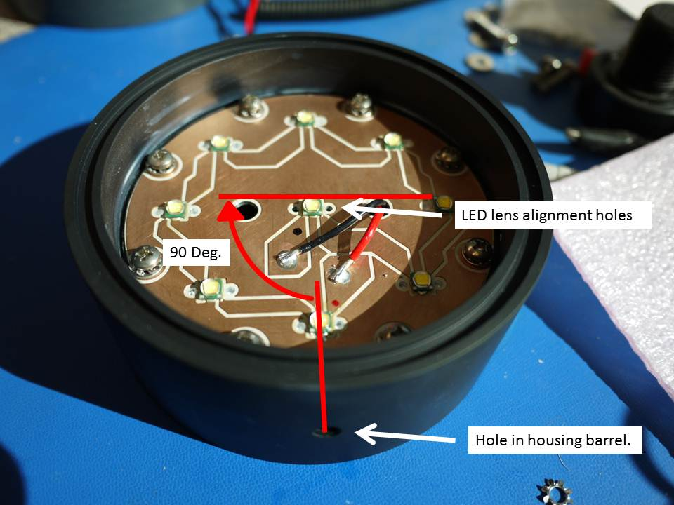
  - Install the wire pigtail for the input in-line connector on the Power Supply PCB. Insert a rubber grommet in the hole in the Power Supply PCB.
Figure 1. Proper alignment of the LED PCB with the housing mounting hole.
  - Carefully install the Power Supply in the housing while feeding the wire from the LED PCB up through the hole in the rubber grommet.
  - Solder the wire pigtails from the LED PCB to the appropriate pads on the Power Supply PCB.
  - Install the UW connector in the housing rear cover and install the inline connector on the connector pigtails.
  - Carefully install the LED lenses by removing the bonding release tape on the base and inserting into the LED lens alignment holes. Press into place firmly and make sure the lens is fitting down flush with the PCB.
  - Lightly grease the O-rings before installation and assemble the housing with the front and rear end caps after mating the in-line input connector.
  - Test the light and power supply across the range of specified input voltages.

Appendix 1. 3” nominal 5 LED Assembly, 2000 lumens output.

Appendix 2. 4” nominal 9 LED Assembly, 3675 lumens output.

