SeeStar II Arduino Controller Shield
Hardware Interface Document, v0.1

Chad Kecy
Monterey Bay Aquarium Research Institute

August 9, 2015



Table of Contents
Overview 5
System Level Description 5
Basic Operation 6
Initial Power Up 6
Functional Description 7
Arduino Pro-Mini Interface 7
Battery Monitoring and Input Protection 8
Logic Power Generation 8
GoPro Hero Power and On/Off Control 8
LED Power and Trigger 9
Real Time Clock Control 9
Serial Interface 9
Board Jumper Options 9
DC Power LEDs 9
Serial Communication Source 10
Programming and Serial Debugging 10
Board Level Signal Descriptions 10
Analog Input Signals 10
SPI Bus Signals 10
Digital Input Signals 11
Digital Output Signals 11
Appendices 12

Table 1: Arduino Pro-Mini JP7 Signals 7
Table 2: Arduino Pro-Mini JP6 Signals 7
Table 3: Board Level LEDs and Functions 9

Figure 1: Picture of the SeeStar II Imaging System 5
Figure 2: Block Diagram of SeeStar II Arduino Controller Shield 6

Appendix 1: Electrical Specifications 12
Appendix 2: Mechanical Specifications 12
Appendix 3: Controller Shield Bill of Materials 13

Overview
SeeStar II is an autonomous and modular imaging system (Fig 1). It is programmed prior to deployment and can be left unattended for months at a time. SeeStar II consists of three individual modules: the camera, battery, and LED. The camera module contains the Arduino Controller Shield which is responsible for triggering the camera and activating the lights.

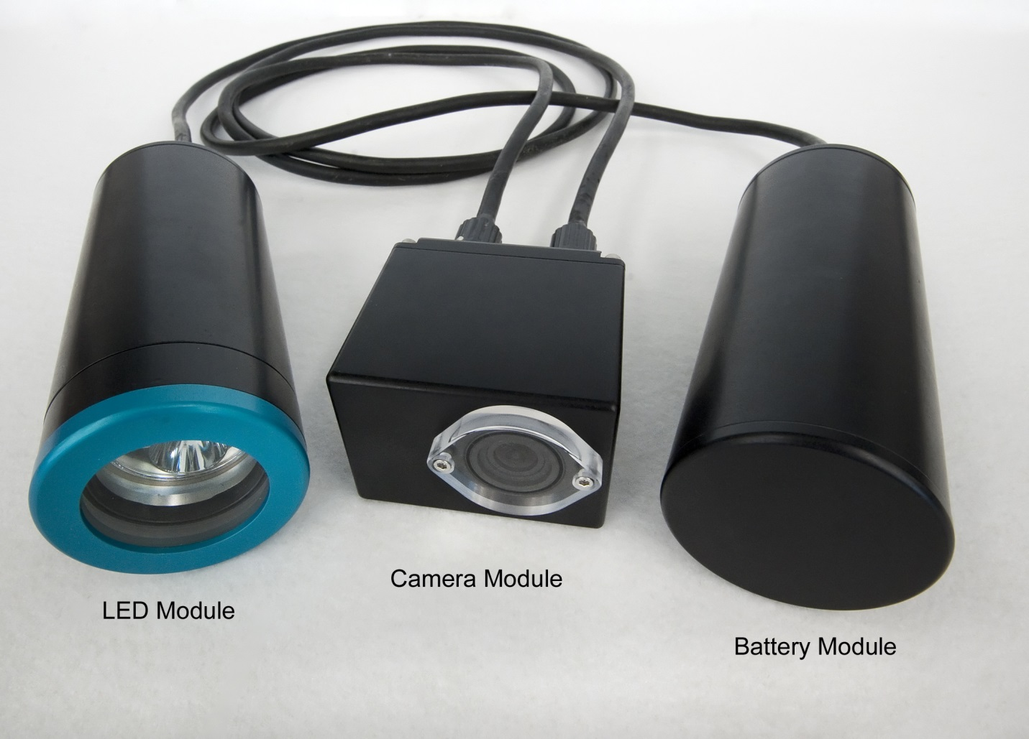
Figure 1: Picture of the SeeStar II Imaging System

System Level Description
The Controller Shield acts as the main interface between the Arduino Pro-Mini CPU board and the rest of the electronics in the imaging system. It resides in the camera module and controls the timing of the camera and LED light module. It is programmed via the FTDI port on the Pro-Mini CPU and it contains a Real Time Clock (RTC) for accurate timing.

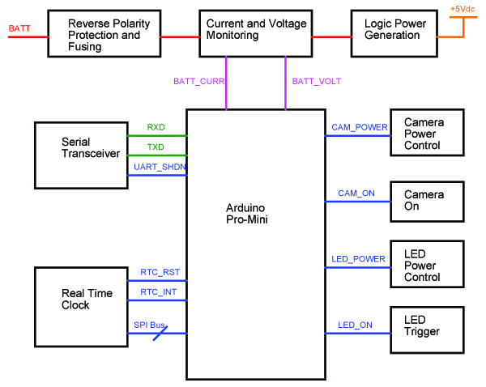
Figure 2: Block Diagram of SeeStar II Arduino Controller Shield

[insert picture of front of pcb]
Figure 3: Front side of SeeStar II Arduino Controller Shield

[insert picture of rear of pcb]
Figure 4: Rear side of SeeStar II Arduino Controller Shield

Basic Operation
This section is meant to assist the user with simple bench top testing. For details on installing it in the camera module refer to the assembly document [change to actual title later]

Initial Power Up

Functional Description

Arduino Pro-Mini Interface
The Arduino Pro-Mini plugs into the top of the Controller Shield; silkcreening on the shield indicates the position of the FTDI connector for proper orientation. The connectors on the shield were numbered to match those of the Pro-Mini (JP6 connects to J6 and JP7 connects to J7).
The usage of the Pro-Mini signals is displayed in Tables 1 and 2. Technical details of the signals are described in the board level signal section.

JP7 Pin # | Arduino Name | Shield Name | Arduino Signal Type
12 | TXO | TXD | TTL Level Serial
11 | RXI | RXD | TTL Level Serial
10 | RESET | N/A
9 | GND | GND | Ground
8 | D2 | RTC_INT | Digital Input
7 | D3 | N/A
6 | D4 | LED_ON | Digital Output
5 | D5 | RTC_RESET | Digital Output
4 | D6 | UART_SHDN | Digital Output
3 | D7 | LED_POWER | Digital Output
2 | D8 | CAM_ON | Digital Output
1 | D9 | CAM_POWER | Digital Output
Table 1: Arduino Pro-Mini JP7 Signals

JP6 Pin # | Arduino Name | Shield Name | Arduino Signal Type
1 | RAW | 5V | Input Power
2 | GND | GND | Ground
3 | RESET | N/A
4 | VCC | N/A
5 | A3 | N/A
6 | A2 | N/A
7 | A1 | BATT_CURR | Analog Input
8 | A0 | BATT_VOLT | Analog Input
9 | SCK | SCK | SPI
10 | MISO | MISO | SPI
11 | MOSI | MOSI | SPI
12 | D10 | RTC_SS | Digital Output
Table 2: Arduino Pro-Mini JP6 Signals

Battery Monitoring and Input Protection
Battery voltage is applied to the Controller Shield at J1; J1 has four pins due to the positive and negative power lines being doubled up in the intermodule cable to reduce resistive losses. Q1 offers reverse polarity protection and F1 is a replaceable fuse. The maximum current draw should never exceed 3 amps, but the traces and fuse are rated for 4 amps.

The current draw and voltage level of the battery module is monitored by the Controller Shield. U2 is a current sense amplifier which amplifies a low level voltage developed across sense resistor R1. The built-in gain of the MAX4372F is 50. The output of U2 (signal BATT_CURR) is a 0-3V analog signal that is calculated by:

BATT_CURR (volts) = IBatt (amps) x Gain x Rsense (ohms)

The battery voltage level is scaled via resistors R3 and R4. The output of op amp U3 is BATT_VOLT. It is calculated by:

BATT_VOLT (volts) = BATT (volts) x (R4/(R3+R4))

Logic Power Generation
The Controller Shield generates 5Vdc for both itself and the Arduino Pro-Mini. U1 is a switching regulator (MAX5035B) which provides 1 amp at approximately 85% efficiency. As the Controller Shield is meant to work with the 3.3V version of the Pro-Mini, the 5Vdc is connected to the RAW input.

Note: The Controller Shield can work with the 5V version of the Pro-Mini with the following changes:
1. The 5Vdc output of the Controller Shield should be jumpered to the VCC input on J6-4
2. The voltage regulator on the Pro-Mini (U2) should be removed (desoldered) from the board.

GoPro Hero Power and On/Off Control
The Controller Shield is responsible for supplying battery voltage and a control signal to the GoPro Hero camera. In order to save battery capacity, power is completely removed from GoPro between images. The factory GoPro battery is removed and a Battery Eliminator is used in its place. The Battery Eliminator accepts 9-24Vdc and generates the required voltage for the GoPro.

The active high CAM_POWER signal turns on an N-Channel MOSFET (Q2A) which then turns on a P-Channel MOSFET (Q2B) which passes battery voltage to the Battery Eliminator via J3. This applies power to the GoPro but does not turn it on (electrically equivalent to simply putting a battery in the camera).

The active high CAM_ON signal forward biases an NPN transistor (Q4). The collector of Q4 is connected to pin #12 of the exposed Hero bus on the rear of the camera. Pulling pin 12 low is equivalent to depressing the on/off button. CAM_ON needs to be held high for approximately 1000msec to turn the GoPro on.

LED Power and Trigger
The Controller Shield is responsible for supplying battery voltage and a trigger signal to the LED module.

The active high LED_POWER signal turns on an N-Channel MOSFET (Q3A) which then turns on a P-Channel MOSFET (Q3B) which passes battery voltage to the LED module via J5. This applies power to the LED but does not turn it on.

The active high LED_ON signal forward biases an NPN transistor (Q5). The collector of Q5 is connected to the on/off button on the LED. Pulling this line low turns on the LED and changes the operating mode of the LED. It is a momentary low signal and needs to be held low for approximately 500msec.

Real Time Clock Control
The Controller Shield is equipped with a 2ppm accuracy real time clock (U5). The DS3234 maintains seconds, minutes, hours, day, date, month, and year information. It also has 2 user programmable alarms via the INT open. The DS3234 communicates via the SPI bus. See the datasheet for further details.

Serial Interface
The Controller Shield has an optional serial port (via J4) for accessing the Arduino Sketch or for writing a user interface. The TTL level serial signals are shared with the FTDI port and cannot be used simultaneously. Jumper J10 disables the serial transceiver to ensure proper FTDI operation.

Board Jumper Options

DC Power LEDs
There are three board level LEDs which indicate the state of various power levels. Table three is a listing of the LEDs and levels monitored. Jumper J8 can be installed to disable all three LEDs simultaneously.

LED | Color | Function
D2 | Blue | Camera Power
D3 | Red | LED Power
D4 | Green | Logic Power
Table 3: Board Level LEDs and Functions

Serial Communication Source
The TTL level serial signals are shared by the FTDI connector and the external serial transceiver U4. (MAX3311). Attempting to use the FTDI port while the serial transceiver is active will result in miscommunication. The serial transceiver may be disabled via the UART_SHDN signal, or easier still is to place a jumper on J10. The serial transceiver will be disabled as long as jumper J10 is installed.

Programming and Serial Debugging

[input from Thom]

Board Level Signal Descriptions
All analog and digital signals originate or terminate with the Arduino Pro-Mini. Their detailed descriptions and locations are described in this section.

Analog Input Signals

BATT_CURR [A1; JP6-7]
This is a 0-3V analog voltage signal which corresponds to the current draw from the battery module. The conversion factor is Y(amps) = 1.0 x BATT_CURR (volts).

BATT_VOLT [A0; JP6-8]
This is a 0-3V analog voltage signal which corresponds to the output voltage of the battery module. The conversion factor is Y(volts) = 6.50 x BATT_VOLT (volts).

SPI Bus Signals

SCK [SCK; JP6-9]
The clock input for the SPI bus.

MISO [MISO; JP6-10]
The SPI data output of the DS3234.

MOSI [MOSI; JP6-11]
The SPI data input to the DS3234.

Digital Input Signals

RTC_INT [D2; JP6-8]
This is the active low alarm output of the DS3234 real time clock.

Digital Output Signals

RTC_SS [D10; JP6-12]
This is the active low chip select signal for the SPI bus controlling the DS3234 real time clock.

LED_ON [D4; JP7-6]
This is an active high signal which is used to turn on the LED light. This is a momentary signal and needs to stay high approximately 500msec in order for the LED to turn on.

RTC_RESET [D5; JP7-5]
This is active low reset line. It is continuously monitored as a pushbutton input for generating a reset.

UART_SHDN [D6; JP7-4]
This is an active low signal which disables the serial transceiver (U4).

LED_POWER [D7; JP7-3]
This is an active high signal which applies battery voltage to the LED module. This is a continuous signal and must remain high while the LED is in operation.

CAM_ON [D8; JP7-2]
This is an active high signal which is used to turn on the GoPro Hero camera. CAM_POWER must already have been asserted for CAM_ON to work. This is a momentary signal and needs to remain high for approximately 1000msec for the GoPro to turn on.

CAM_POWER [D9; JP7-1]
This is an active hight signal which applies battery voltage to the GoPro Battery Eliminator. This is a continuous signal and must remain high while the GoPro is in operation.

Appendices

Input Voltage | 9-15Vdc
Appendix 1: Electrical Specifications

Length | Cm
Width | Cm
Height | Cm
Operating Temperature
Min | degC
Max | degC
Operating Depth | 1500m
Appendix 2: Mechanical Specifications

Ref | Value | Manufacturer | Manufacturer PN | Description
BT1 | S8411-45R | Harwin Inc | S8411-45R | BATTERY HOLDER 12.0MM COIN SMD
C1 | 0.1uF | TDK Corporation | C1608X7R1H104K | CAP CER 0.1UF 50V 10% X7R 0603
C2 | 47uF | United Chemi-con | EMVE500ADA470MF80G | CAP ALUM 47UF 20% 50V SMD
C3 | 68uF | AVX Corporation | TAJD686K016RNJ | CAP TANTALUM 68UF 16V 10% SMD
C4 | 0.10uF | Kemet | C0603C104K4RAC | CAP, CER, 0.10uF, 16V, 10%, X7R, 0603
C5 | 0.1uF | TDK Corporation | C1608X7R1H104K | CAP CER 0.1UF 50V 10% X7R 0603
C6 | 0.10uF | Kemet | C0603C104K4RAC | CAP, CER, 0.10uF, 16V, 10%, X7R, 0603
C7 | 0.10uF | Kemet | C0603C104K4RAC | CAP, CER, 0.10uF, 16V, 10%, X7R, 0603
C8 | 0.10uF | Kemet | C0603C104K4RAC | CAP, CER, 0.10uF, 16V, 10%, X7R, 0603
C9 | 0.10uF | Kemet | C0603C104K4RAC | CAP, CER, 0.10uF, 16V, 10%, X7R, 0603
C10 | 0.10uF | Kemet | C0603C104K4RAC | CAP, CER, 0.10uF, 16V, 10%, X7R, 0603
D1 | B340A-13-F | Diodes Inc | B340A-13-F | DIODE SCHOTTKY 3A 40V SMA
D2 | LTST-C150TBKT | Lite-On Inc | LTST-C150TBKT | LED 468NM BLUE CLEAR 1206 SMD
D3 | LTST-C150KRKT | Lite-On Inc | LTST-C150KRKT | LED SUPER RED CLEAR 1206 SMD
D4 | LTST-C150KGKT | Lite-On Inc | LTST-C150KGKT | LED GREEN CLEAR 1206 SMD
F1 | 0154004.DRT | Littelfuse Inc | 0154004.DRT | FUSE SLOW 125VAC, 125VDC 4A SMD
J1 | 1725672 | Phoenix Contact | 1725672 | CONN TERM BLOCK 2.54MM 4POS
J2 | SSW-102-01-T-S | Samtec Inc | SSW-102-01-T-S | CONN RCPT .100" 2POS SNGL TIN
J3 | 1725656 | Phoenix Contact | 1725656 | CONN TERM BLOCK 2.54MM 2POS
J4 | SSW-103-01-T-S | Samtec Inc | SSW-103-01-T-S | CONN RCPT .100" 3POS SNGL TIN
J5 | 1725672 | Phoenix Contact | 1725672 | CONN TERM BLOCK 2.54MM 4POS
J6 | SSW-112-01-T-S | Samtec Inc | SSW-112-01-T-S | CONN RCPT .100" 12POS SNGL TIN
J7 | SSW-112-01-T-S | Samtec Inc | SSW-112-01-T-S | CONN RCPT .100" 12POS SNGL TIN
J8 | TSW-102-17-T-S | Samtec Inc | TSW-102-17-T-S | CONN HEADER 2POS .100" SNGL TIN
J9 | SSW-102-01-T-S | Samtec Inc | SSW-102-01-T-S | CONN RCPT .100" 2POS SNGL TIN
J10 | TSW-102-17-T-S | Samtec Inc | TSW-102-17-T-S | CONN HEADER 2POS .100" SNGL TIN
L1 | 33uH | Bourns Inc. | SRN6045-330M | FIXED IND 33UH 1.4A 188 MOHM SMD
Q1 | SI2369DS-T1-GE3 | Vishay Siliconix | SI2369DS-T1-GE3 | MOSFET P-CH 30V 7.6A TO-236
Q2 | SI6562CDQ-T1-GE3 | Vishay Siliconix | SI6562CDQ-T1-GE3 | MOSFET N/P-CH 20V 6.7A 8-TSSOP
Q3 | SI6562CDQ-T1-GE3 | Vishay Siliconix | SI6562CDQ-T1-GE3 | MOSFET N/P-CH 20V 6.7A 8-TSSOP
Q4 | MMBT3904 | Fairchild Semiconductor | MMBT3904 | TRANSISTOR GP NPN AMP SOT-23
Q5 | MMBT3904 | Fairchild Semiconductor | MMBT3904 | TRANSISTOR GP NPN AMP SOT-23
R1 | 0.02 | Stackpole Electronics | CSR1206FK20L0 | RES SMD 0.02 OHM 1% 1/2W 1206
R2 | 1.00M | Vishay | CRCW06031M00FKEA | RES 1.0M OHM 1/10W 1% 0603 SMD
R3 | 121.0K | Vishay | CRCW0603121KFKEA | RES 121K OHM 1/10W 1% 0603 SMD
R4 | 22.1K | Vishay | CRCW060322K1FKEA | RES 22.1K OHM 1/10W 1% 0603 SMD
R5 | 383.0K | Vishay | CRCW0603383KFKEA | RES 383K OHM 1/10W 1% 0603 SMD
R6 | 100.0K | Vishay/Dale | CRCW0603100KFKEA | RES 100K OHM 1/10W 1% 0603 SMD
R7 | 100.0K | Vishay/Dale | CRCW0603100KFKEA | RES 100K OHM 1/10W 1% 0603 SMD
R8 | 100.0K | Vishay/Dale | CRCW0603100KFKEA | RES 100K OHM 1/10W 1% 0603 SMD
R9 | 100.0K | Vishay/Dale | CRCW0603100KFKEA | RES 100K OHM 1/10W 1% 0603 SMD
R10 | 100.0K | Vishay/Dale | CRCW0603100KFKEA | RES 100K OHM 1/10W 1% 0603 SMD
R11 | 1.69K | Vishay | CRCW06031K69FKEA | RES 1.69K OHM 1/10W 1% 0603 SMD
R12 | 1.69K | Vishay | CRCW06031K69FKEA | RES 1.69K OHM 1/10W 1% 0603 SMD
R13 | 294 | Vishay | CRCW0603294RFKEA | RES 294 OHM 1/10W 1% 0603 SMD
R14 | 100.0K | Vishay/Dale | CRCW0603100KFKEA | RES 100K OHM 1/10W 1% 0603 SMD
R15 | 10.0K | Vishay | CRCW060310K0FKEA | RES 10.0K OHM 1/10W 1% 0603 SMD
R16 | 0.0 | Vishay/Dale | CRCW06030000Z0EA | RES 0.0 OHM 1/10W 0603 SMD
R17 | 0.0 | Vishay/Dale | CRCW06030000Z0EA | RES 0.0 OHM 1/10W 0603 SMD
R18 | 10.0K | Vishay | CRCW060310K0FKEA | RES 10.0K OHM 1/10W 1% 0603 SMD
R19 | 100.0K | Vishay/Dale | CRCW0603100KFKEA | RES 100K OHM 1/10W 1% 0603 SMD
U1 | MAX5035BASA+ | Maxim Integrated | MAX5035BASA+ | IC REG BUCK 5V 1A 8SOIC
U2 | MAX4372FEUK+T | Maxim Integrated | MAX4372FEUK+T | IC AMP GAIN +50V/V PREC SOT23-5
U3 | AD8603AUJZ | Analog Devices Inc | AD8603AUJZ-REEL7 | IC OPAMP GP R-R CMOS TSOT23-5
U4 | MAX3311CUB+ | Maxim Integrated | MAX3311CUB+ | IC TXRX RS232 460KBPS 10-UMAX
U5 | DS3234S# | Maxim Integrated | DS3234S# | IC RTC W/TCXO 20-SOIC
Appendix 3: Controller Shield Bill of Materials

