SeeStar II Camera Module
Technical Manual, v0.1

Chad Kecy
Monterey Bay Aquarium Research Institute

August 14, 2015



Table of Contents
Overview 5
System Level Description 5
Functional Description 6
GoPro Hero 3/3+ 6
Arduino Pro-Mini 7
Controller Shield 7
Assembly Instructions 7
Required Tools 7
Hero Bus Cable Assembly 7
Battery Eliminator Modification 8
Camera Installation 8
Subconn Connector Installation 9
Controller Shield Installation 10
Sealing the Underwater Housing 10
Appendices 10

Figure 1: Picture of the SeeStar II Imaging System 5
Figure 2: Camera Module Block Diagram 6
Figure 3: 30-Pin Ridax Connector. As assembled (left) and disassembled (right) 8
Figure 4: Mating Connector for GoPro Mode Signal on the Controller Shield 8
Figure 5: Battery Eliminator 8

Table 1: Subconn MCBH8 F/M Pin Descriptions 9

Appendix 1: Electrical Specifications 10
Appendix 2: Mechanical Specifications 11
Appendix 3: Camera Module J1 Pinout 11
Appendix 4: Camera Module J2 Pinout 11
Appendix 5: Camera Module Wiring Diagram 12
Appendix 6: Front View of Camera Module 13
Appendix 7: Side View of Camera Module 13
Appendix 8: Top View of Camera Module 13
Appendix 9: Oblique View of Camera Module 14

Overview
SeeStar II is an autonomous and modular imaging system (Fig 1). It is programmed prior to deployment and can be left unattended for months at a time. SeeStar II consists of three individual modules: the camera, battery, and LED. The camera module contains the camera, Arduino Pro-Mini and the Controller Shield.

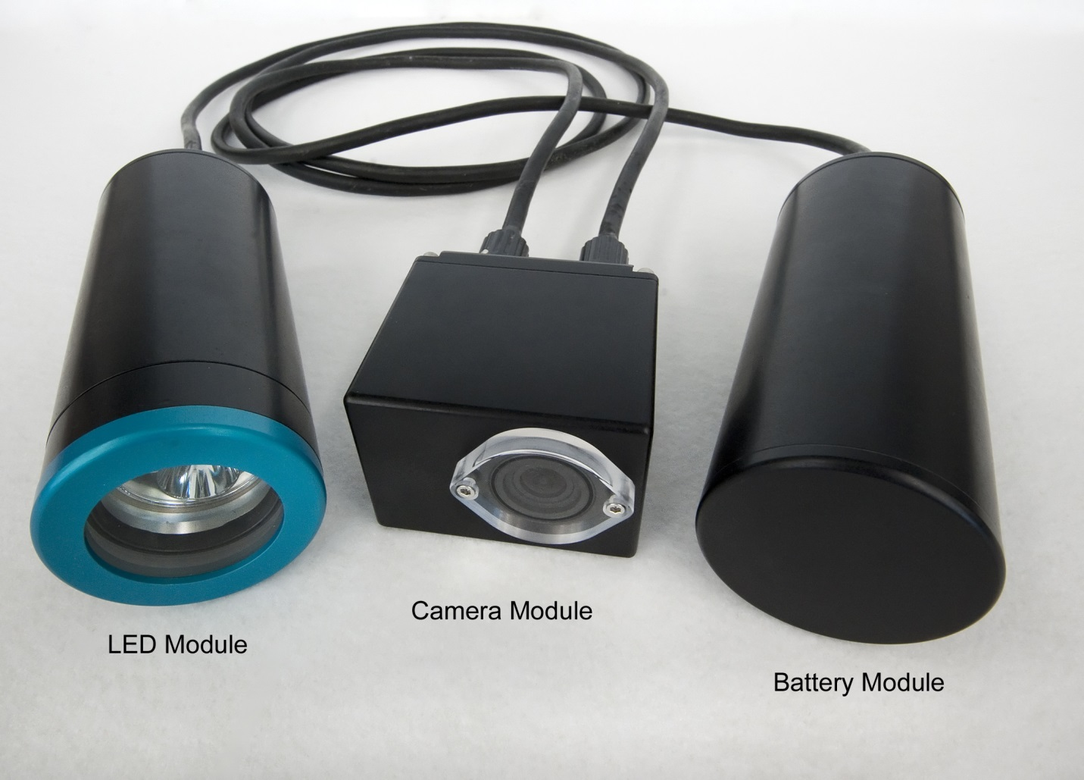
Figure 1: Picture of the SeeStar II Imaging System

System Level Description
The camera module is responsible for capturing the still images and/or videos as well controlling the power and triggering of the external LED light module. An Arduino Pro-Mini plugs into a custom control board which interfaces the GoPro Hero as well as the battery and LED modules.

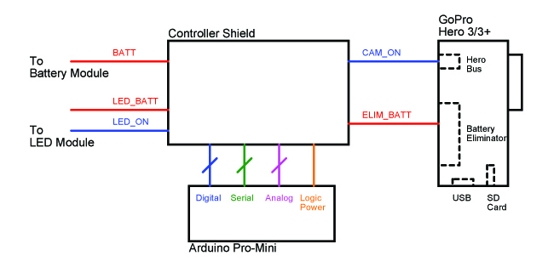
Figure 2: Camera Module Block Diagram

Functional Description

GoPro Hero 3/3+
The imager used in SeeStar II is the GoPro Hero 3 or 3+ Black. Remote operation of the Hero is accomplished via the user-defined software scripts contained in the root directory of the SD card in the Hero (see the programming documentation for details and examples). The capabilities of the Hero remain the same when installed in SeeStar; meaning that all of the resolutions and angle settings can be selected by the user. Refer to the camera-specific GoPro User’s Manual for details and descriptions of the various settings.

The standard battery is replaced with an off-the-shelf battery eliminator. The battery eliminator accepts 9-24Vdc and generates the necessary Hero battery voltage.

The Hero is turned on by pulling pin #12 on the Hero bus low for 1000msec; this is equivalent to turning on the Hero by pressing the ON button. Once on, the Hero will perform the instructions contained in the script file.

Arduino Pro-Mini
Due to the relatively simple control needed, the 3.3V 8MHz Pro-Mini was chosen. This small, low power CPU contains digital inputs/outputs, analog inputs, a SPI bus, and one serial port. An onboard FTDI connector allows programming of the Pro-Mini.

Controller Shield
The Controller Shield is the only custom made part used on SeeStar II. This board interfaces the Arduino Pro-Mini as well as all of the external peripherals such as the GoPro camera and LED module. See the Controller Shield Hardware Interface Document for detailed information.

Assembly Instructions

Required Tools
Attention was paid during the design of the SeeStar II Imaging System in order to minimize the need for specialized tools and parts. A few simple tools are all that is required to assemble the SeeStar camera module.

Philips Screwdriver #___
Flathead Screwdriver #___
___ Allen Wrench
Wire Strippers (24 AWG to 20 AWG)
Wire Cutters
Needle Nose Pliers
Soldering Iron (with fine tip)
Molykote Type 55

Hero Bus Cable Assembly
The Hero bus cable connects the Controller Shield to the GoPro Hero camera. Only two pins are used: pin 12 (mode button) and pin 30 (ground). For the fabrication of the cable assembly, a specialized high pitch 30-pin connector is needed to plug into the Hero Bus on the camera. This is item #4 on the bill of materials in appendix 5. This is a low level signal and 24 AWG wire can be used. Extra care should be taken when soldering the wires onto the pins of the Ridax connector (Fig 3) due to the pitch of the pins. The receiving connector on the Controller Shield is a 2-pin 0.025” square post socket. The other end of the cable needs only be attached to two straight pins like the one shown in Figure 4.

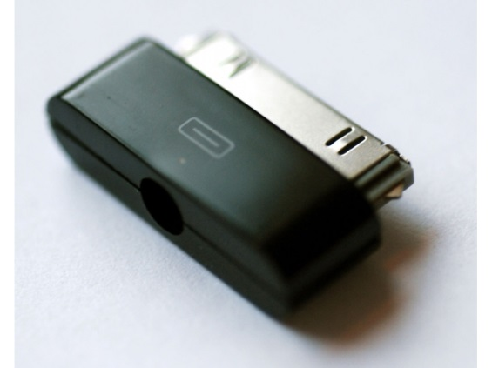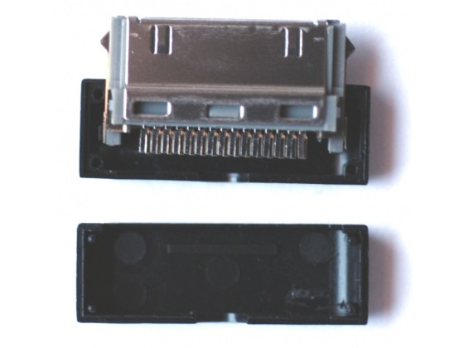
Figure 3: 30-Pin Ridax Connector. As assembled (left) and disassembled (right)

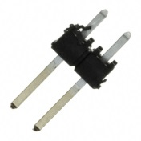
Figure 4: Mating Connector for GoPro Mode Signal on the Controller Shield

Battery Eliminator Modification
Depending on the exact type of battery eliminator is used (the output connector can be a barrel connector, USB, or unterminated) you may need to modify it. The output side needs to be unterminated in order to attach it to the wire-to-board style connector on the Controller Shield. Simply cut off the output connector and strip the two wires to expose about 12 mm of conductor (Fig. 5).

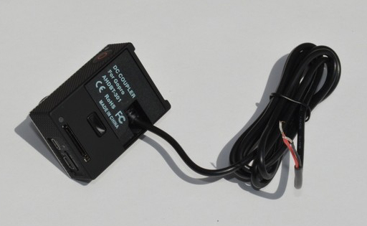
Figure 5: Battery Eliminator

Camera Installation
Prior to installing the GoPro into the underwater housing, install the battery eliminator. It snaps into place just as a standard battery would. The output wires from the eliminator should extend backwards (should be 12-15 cm in length).

[Picture of batt elim in camera]

The rectangular underwater housing from GroupBinc was designed to accommodate the GoPro Hero 3/3+ cameras. The lens mount slides into the front endcap and holds the camera in place.

[Picture of camera installed in housing]

Subconn Connector Installation

[Paragraph on physical installation of the connector onto the endcap]

The SeeStar II system has a common pinout in all of the housings, but not all signals are used in all housings. Appendices 3 and 4 list the exact pinouts of the both external connectors on the camera module while Table 1 below lists the Subconn color/size standards for the MCBH 8-pin connectors.

Subconn MCBH8F/M Pin Definitions
Pin # | Color | Gauge
1 | Black | 20 AWG
2 | White | 20 AWG
3 | Red | 20 AWG
4 | Green | 20 AWG
5 | Orange | 20 AWG
6 | Blue | 20 AWG
7 | White/Black | 20 AWG
8 | Red/Black | 20 AWG
Table 1: Subconn MCBH8 F/M Pin Definitions

[Insert a picture of wires from J1 as needed: stripped or connectorized]

[Insert a picture of wires from J2 as needed: stripped or connectorized]

Controller Shield Installation
The Controller Shield is mounted to the rear endcap using (3/4 inch?) tall plastic standoffs which accept 4-40 size screws. The height of the standoffs is crucial due to the inserts of the two external Subconn connectors behind the shield (Appendix 8). The orientation of the Controller Shield must be such that the Arduino Pro-Mini sits behind the battery eliminator. Installing in the opposite position will cause interference with the Hero Bus connector.

The wiring of the Controller Shield requires no special crimping tools. Wire-to-Board style connectors from Phoenix allow the stripped wires from the external connectors to be attached and secured using a flat head screwdriver. Appendix 5 is a wiring diagram of the camera module. A wired camera module is shown in Figure xx.

Sealing the Underwater Housing
It is a good idea to check to make sure the lenses on the GoPro camera and on the front endcap are wiped clean prior to sealing the housings. Verify all of the wired connections are secure and that the wires do no extend out to the endcap-to-housing interface. The 30-pin Hero bus connector can sometimes wiggle loose; make sure it is properly seated into the camera. Also make sure the SD card is installed (and has the proper script file on it).

The GroupBinc housing has been pressure tested to a depth of 1500 meters. To ensure a proper seal, care must be taken when closing the housing. Verify the O-Rings have a light coating of Molykote 55 on them. The surfaces should also be wiped clean to ensure there is no debris to cause a bad O-Ring seal. Even a human hair across the O-Ring can cause a slow water leak at pressure. The addition of a small desiccant pack is not required but is recommended to remove any ambient moisture in the housing.

The Allen screws holding the housing together should be tight but over tightened. [Is there a required torque?]

Appendices

Input Voltage | 9-15Vdc
Appendix 1: Electrical Specifications

Length | Cm
Width | Cm
Height | Cm
Operating Temperature
Min | degC
Max | degC
Operating Depth | 1500m
Appendix 2: Mechanical Specifications

Camera Module J1 (MCBH8M) - From Battery Module
Pin # | Signal Name | Description | Destination
1 | BATT_POS | Power Input from Battery Module | Controller Shield J1-1
2 | BATT_POS | Power Input from Battery Module | Controller Shield J1-2
3 | BATT_NEG | Power Return from Battery Module | Controller Shield J1-3
4 | BATT_NEG | Power Return from Battery Module | Controller Shield J1-4
5 | COMM_A | Serial TXD Out from Camera Module | Controller Shield J4-1
6 | COMM_B | Serial RXD In to Camera Module | Controller Shield J4-2
7 | TRIG_OUT | Trigger Output from Camera Module | N/C
8 | TRIG_IN | Trigger Input to Camera Module | N/C
Appendix 3: Camera Module J1 Pinout

Camera Module J2 (MCBH8F) - To LED Module
Pin # | Signal Name | Description | Destination
1 | LED_BATT_POS | Switched Power Output to LED Module | Controller Shield J5-1
2 | LED_BATT_POS | Switched Power Output to LED Module | Controller Shield J5-2
3 | LED_BATT_NEG | Switched Power Return to LED Module | Controller Shield J5-3
4 | LED_BATT_NEG | Switched Power Return to LED Module | Controller Shield J5-4
5 | COMM_A | Serial TXD Out from Camera Module | N/C
6 | COMM_B | Serial RXD In to Camera Module | N/C
7 | TRIG_OUT | LED_ON Signal to LED Module | Controller Shield J9-1
8 | TRIG_IN | Trigger Input to Camera Module | N/C
Appendix 4: Camera Module J2 Pinout

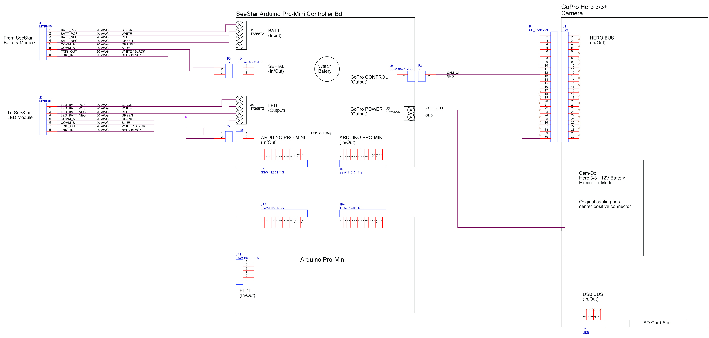
Appendix 5: Camera Module Wiring Diagram
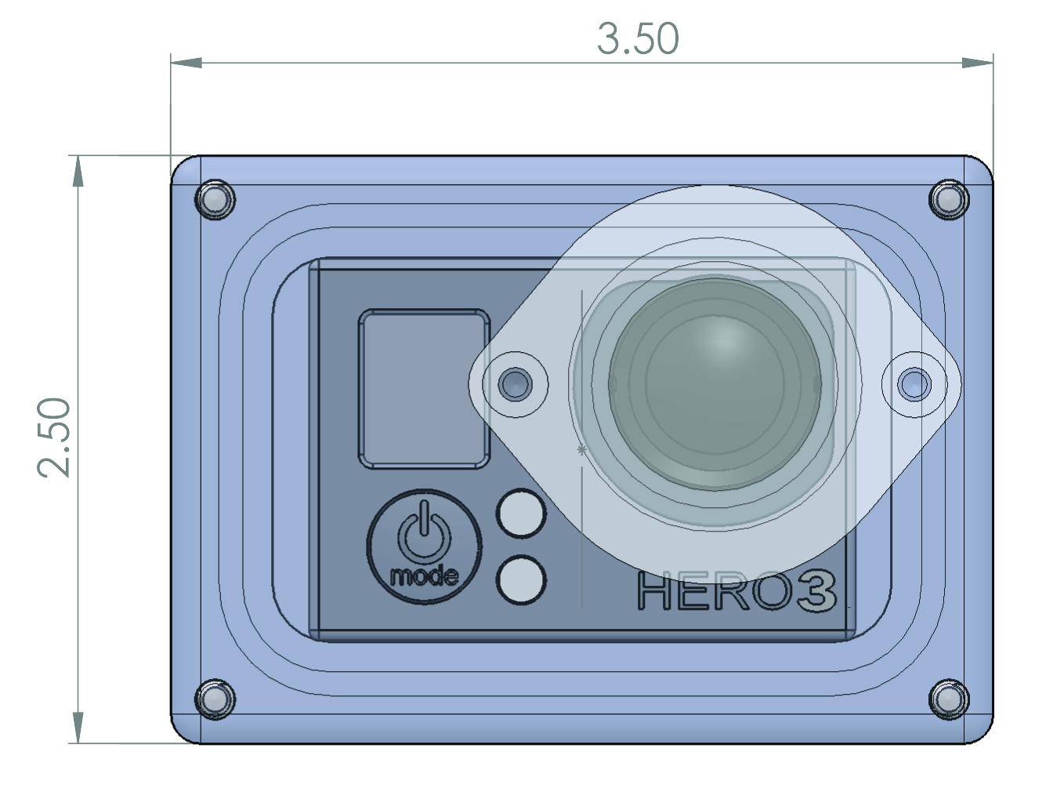
Appendix 6: Front View of Camera Module
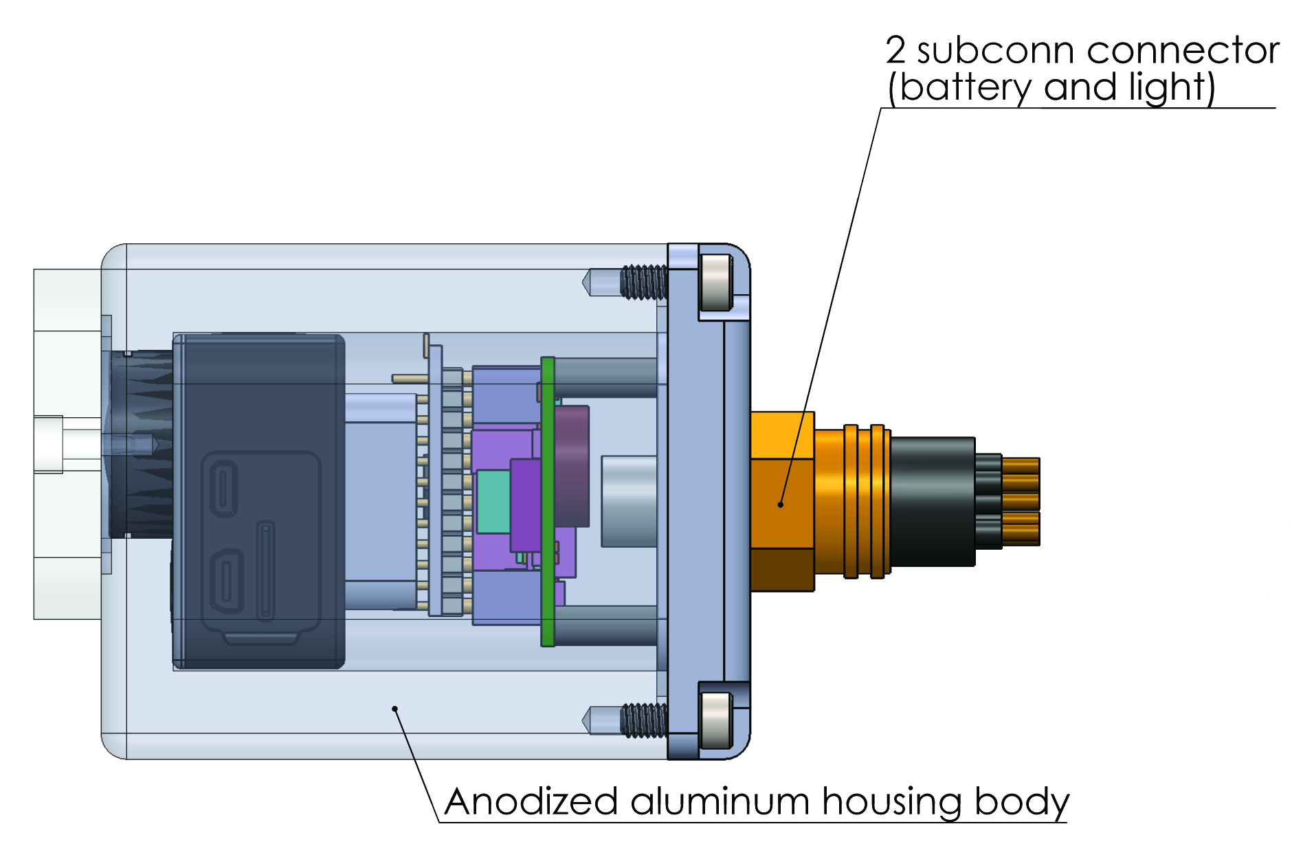
Appendix 7: Side View of Camera Module

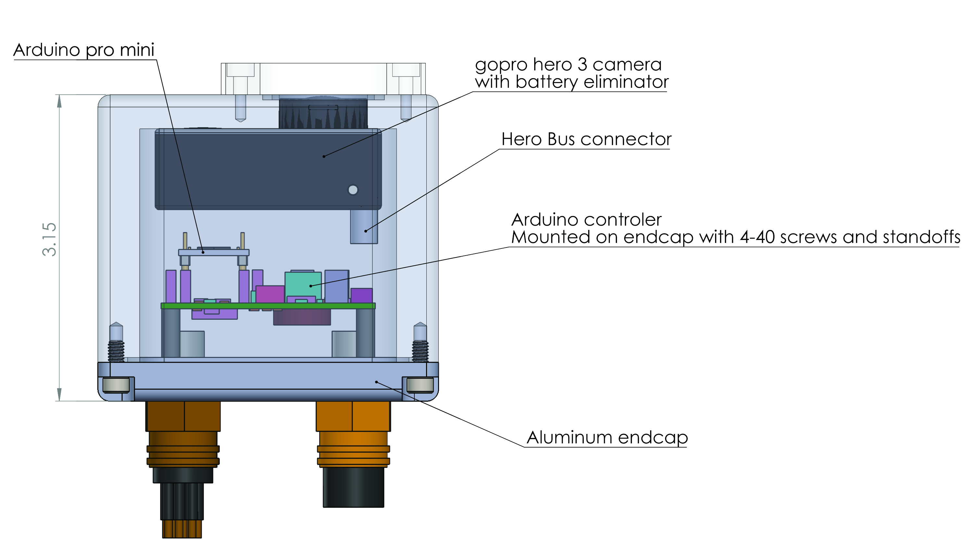
Appendix 8: Top View of Camera Module
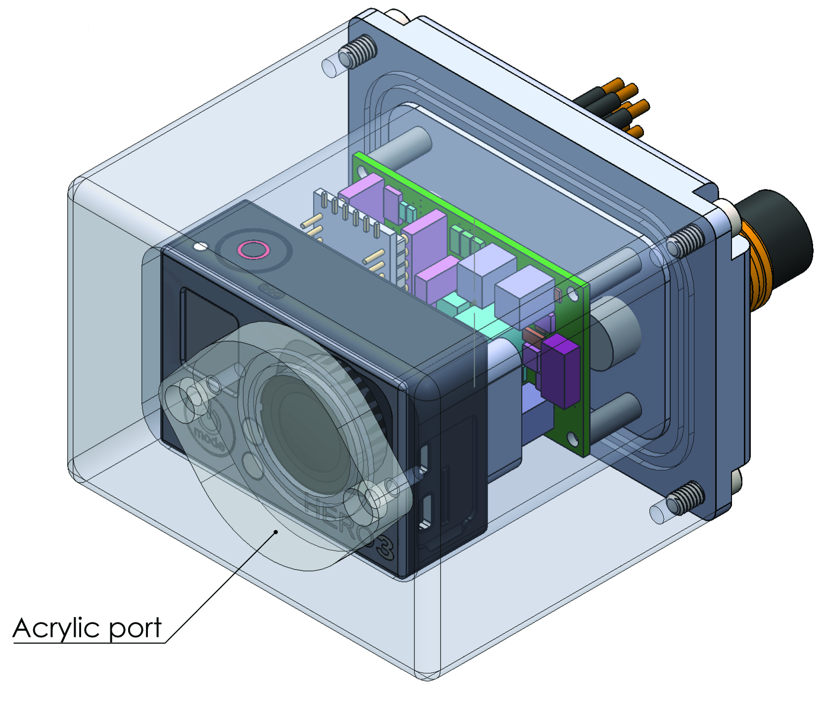
Appendix 9: Oblique View of Camera Module

