SeeStar II LED Module
Technical Manual, v0.1

Chad Kecy
Monterey Bay Aquarium Research Institute

August 14, 2015



Table of Contents
Overview 5
System Level Description 5
Functional Description 6
DC-DC Converter 6
LED Flashlight 6
Appendices 7

No table of figures entries found.

Figure 1: Picture of the SeeStar II Imaging System 5
Figure 2: LED Module Block Diagram 6

Appendix 1: Electrical Specifications 7
Appendix 2: Mechanical Specifications 8
Appendix 3: LED Module J1 Pinout 8
Appendix 4: LED Module Bill of Materials 9

Overview
SeeStar II is an autonomous and modular imaging system (Fig 1). It is programmed prior to deployment and can be left unattended for months at a time. SeeStar II consists of three individual modules: the camera, battery, and LED. The LED module contains the LED lights and a power converter board.

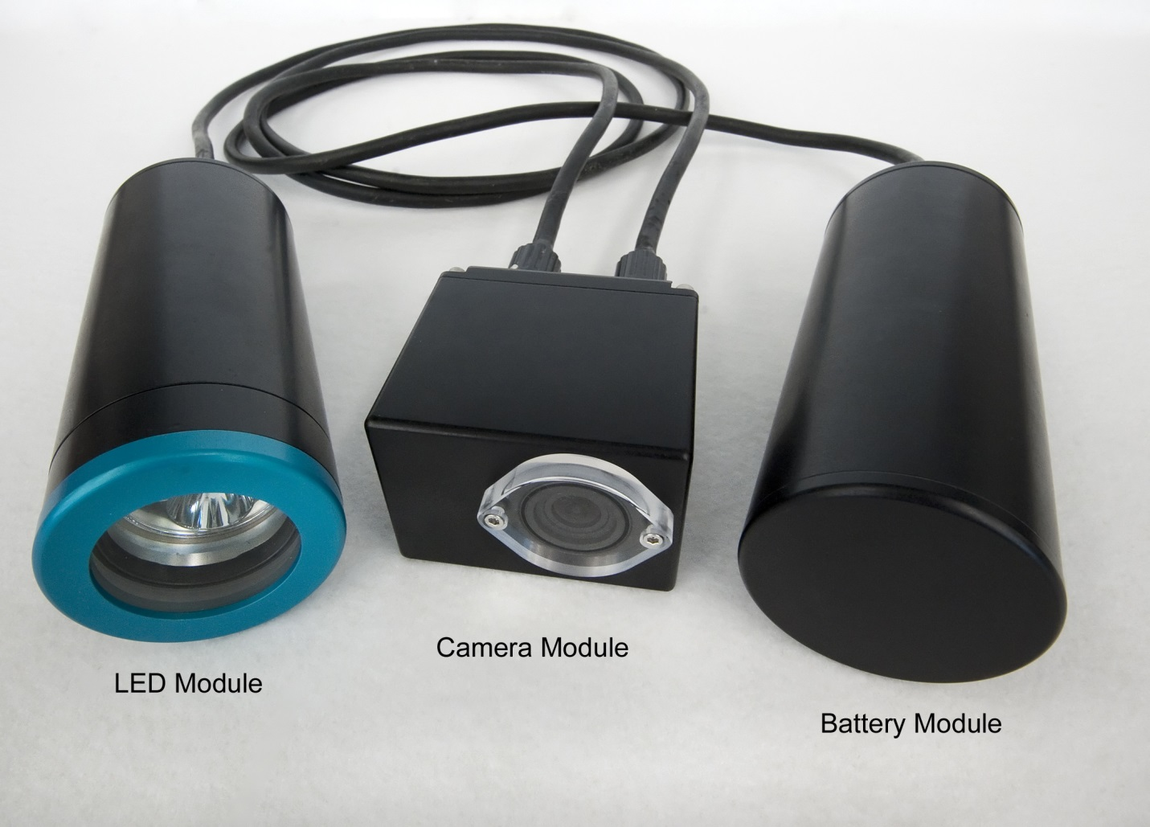
Figure 1: Picture of the SeeStar II Imaging System

System Level Description
The LED module provides external illumination during the recording of videos or taking of still images by the camera module. The LED module operates from the main battery bus which is switched on and off by the camera module. The camera module also provides a separate trigger which turns on the light.

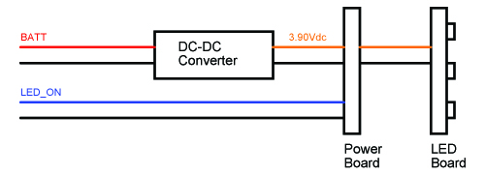
Figure 2: LED Module Block Diagram

Functional Description

DC-DC Converter
The DC-DC Converter steps down the incoming battery bus voltage to ~3.90Vdc, the operating level of the series of LED flashlights used in the LED module. The Murata OKX-T/10-D12P-C is a non-isolating Point-of-Load converter with an average efficiency of 94%. The DC-DC converter is rated at 50W and can deliver up to 10 amps to the LED. A single programming resistor is needed to set the output voltage:

R_{Trim} (Ω) = (10500/(V_{Out} – 0.7525V)) - 1000

LED Flashlight

LingsFire
TangsFire
18650

Appendices

Input Voltage | 9-15Vdc
Appendix 1: Electrical Specifications

Length | Cm
Width | Cm
Height | Cm
Operating Temperature
Min | degC
Max | degC
Operating Depth | 1500m
Appendix 2: Mechanical Specifications

LED Module J1 (From Camera Module)
Pin # | Signal Name | Description | Destination
1 | LED_BATT_POS | Switched Power Input from Camera Module | TB1-1a
2 | LED_BATT_POS | Switched Power Input from Camera Module | TB1-2a
3 | LED_BATT_NEG | Switched Power Return from Camera Module | TB1-3a
4 | LED_BATT_NEG | Switched Power Return from Camera Module | TB1-4a, TB2-2a
5 | COMM_A | Serial TXD Out from Camera Module | N/C
6 | COMM_B | Serial RXD In to Camera Module | N/C
7 | TRIG_OUT | LED_ON Signal from Camera Module | TB2-1a
8 | TRIG_IN | Trigger Input to Camera Module | N/C
Appendix 3: LED Module J1 Pinout

SeeStar LED Housing Bill of Materials
Item # | Quan | Part | Manufacturer | Manufacturer PN# | Description | Distributor | Cost
1 | 1 | LED | Lingsfire | Super Bright 7000LM 7 X CREE XM-L T6 | Underwater Flashlight | Amazon | $45
2 | 1 | DC-DC Converter | Murata | OKX-T/10-D12P-C | Adjustable DC-DC Converter | Digikey | $12
3 | 1 | Terminal Strip, 2-Pos | TE Connectivity | 1776293-2 | 2-Position Terminal Strip | Digikey | $2
4 | 1 | Terminal Strip, 4-Pos | TE Connectivity | 1776293-4 | 4-Position Terminal Strip | Digikey | $3
5 | 1 | Resistor | Yageo | MFR-25FBF52-2K32 | Resistor, 2.39K 0.25W | Digikey | $0.10
6 | 1 | Ext Connector, Male | Subconn | MCBH8M | 8-Pin Male Ext Connector | Ocean Innovations | $99
7 | 1 | Underwater Housing | Groupbinc | TBD | Cylindrical Housing | Groupbinc | $400
Appendix 4: LED Module Bill of Materials

