SeeStar II
Operations Manual, v0.1

Chad Kecy
Monterey Bay Aquarium Research Institute

August 9, 2015



Table of Contents
System Overview 5
System Documentation 5
SeeStar II Operations Manual 6
SeeStar II Programming Guide 6
Camera Module Technical Manual 7
LED Module Technical Manual 7
Battery Module Technical Manual 7
Controller Shield Hardware Interface Document 7
Setting up the Camera Module 7
Camera Timing 7
Camera Configuration 8
Script Writing 8
Arduino Programming 9
Pre-Deployment 9
Checklists 9
Camera Housing 9
LED Housing 10
Battery Housing 10
Sealing the Housings 10
Camera Housing 10
LED and Battery Housings 10
Mounting and Deployment 10
Cable and Connector Management 10
Camera and LED Orientation 11
Bio-Fouling 11
Post Deployment 11
Recovering Images/Video 11
Battery Charging 11
System Cleaning and Care 11
Appendices 12

Figure 1: Picture of the SeeStar II Imaging System 5
Figure 2: Hierarchy of the SeeStar II Documentation 6
Figure 3: Timing Diagram of the SeeStar II Imaging & Lights 8
Figure 4: Location of the script file on the SD card. 9

Appendix 1: System Level Physical Specifications 12
Appendix 2: System Level Optical Specifications 12
Appendix 3: System Level Electrical Specifications 12
Appendix 4: System Level Lighting Specifications 12

System Overview
SeeStar II is an open-source imaging system developed at the Monterey Bay Aquarium Research Institute (MBARI). All of the parts with the exception of one circuit board are commercial off-the-shelf items. The cost of the entire system is $2,500 and is rated to a depth of 1500 meters. It is an autonomous system which can take over 3,000 pictures or 3 hours of HD video on a single charge.

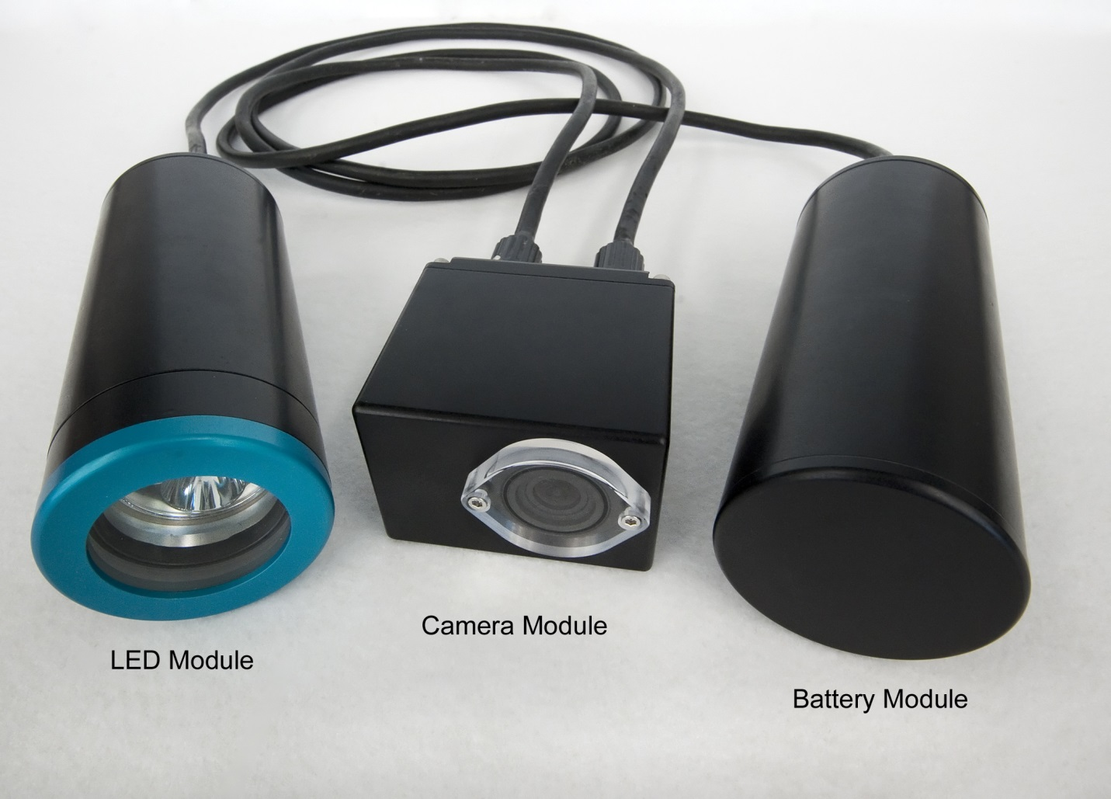
Figure 1: Picture of the SeeStar II Imaging System

System Documentation
A number of individual documents have been prepared to assist the user with the fabrication and operation of the SeeStar II Imaging System. All of the prepared documents, as well as schematics, datasheets, and mechanical drawings are available online at the SeeStar repository [add in link or reference]. Figure 2 displays the documents in a hierarchal tree format. A listing and short description of each document follows.

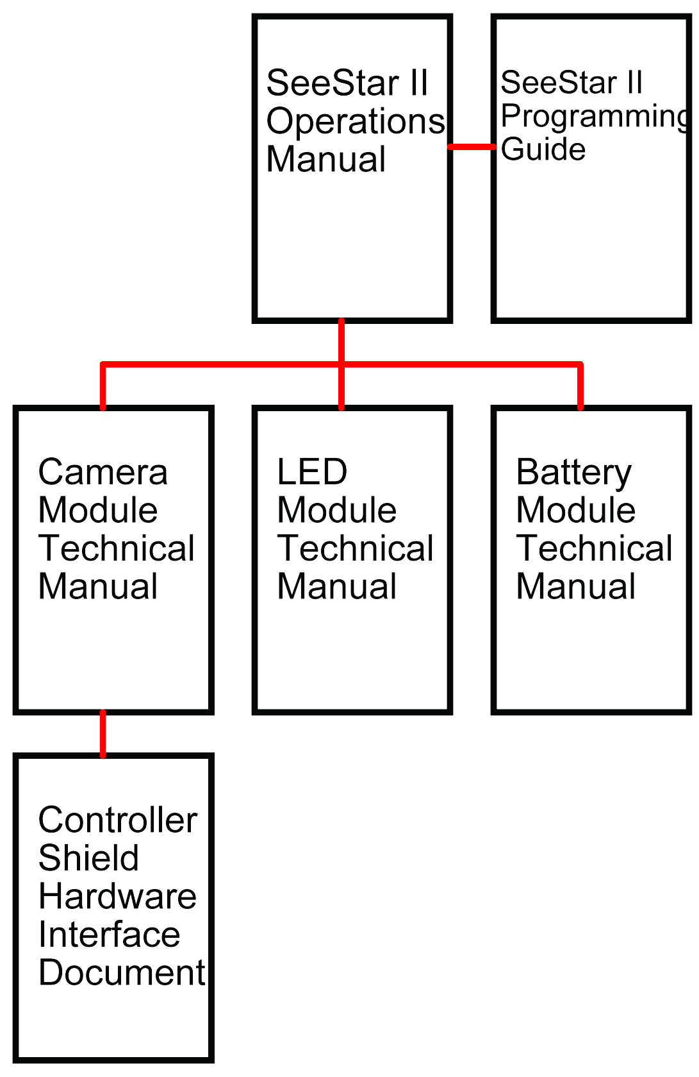
Figure 2: Hierarchy of the SeeStar II Documentation

SeeStar II Operations Manual
The operations manual is a top level document which covers the basic operation and deployment of the system. This manual allows the casual user to take a pre-assembled SeeStar II and deploy it without necessarily understanding every technical aspect of the system.
The more specific and detailed information has been left out and is covered in other documentation.

SeeStar II Programming Guide
The programming guide contains every aspect of programming SeeStar II. It covers loading the Arduino sketches, setting up the GoPro camera, writing the custom script files, and communicating to SeeStar II from an external serial cable. Example sketches and scripts can also be found online on our repository and codebender.

Camera Module Technical Manual
The camera technical manual covers every aspect of the camera module. It includes descriptions of every sub module and detailed assembly instructions. This document gives the user all of the information necessary to assemble a camera module.

LED Module Technical Manual
The LED technical manual covers every aspect of the LED module. It includes descriptions of every sub module and detailed assembly instructions. This document gives the user all of the information necessary to assemble an LED module.

Battery Module Technical Manual
The battery technical manual covers every aspect of the battery module. It includes descriptions of every sub module and detailed assembly instructions. This document gives the user all of the information necessary to assemble a battery module.

Controller Shield Hardware Interface Document
This document covers the Controller Shield circuit board contained in the camera module. This is the only custom piece of hardware in the SeeStar II system and all of the information necessary to fabricate one is contained in this document.

Setting up the Camera Module
To program the SeeStar II Imaging System for taking videos or still images, three separate, but simple, tasks need to be performed. These are: configure the GoPro camera in the desired operating mode, install the script file onto the SD card, and set the operating parameters in the Arduino sketch (code). Prior to describing the three steps, the timing of the camera will be discussed. An understanding of the timing diagram will greatly assist with future programming.

Camera Timing
Figure 3 shows a simplified timing diagram of the SeeStar II Imaging System. Below are quick descriptions of the events displayed.

CAM_POWER: Battery voltage is applied to the GoPro (but it is not turned on yet).

LED_POWER: Battery voltage is applied to the LED module (but it is not turned on yet).

CAM_ON: The GoPro is turned on.

LED_ON: The LED is turned on.

Scripts: The script file is activated.
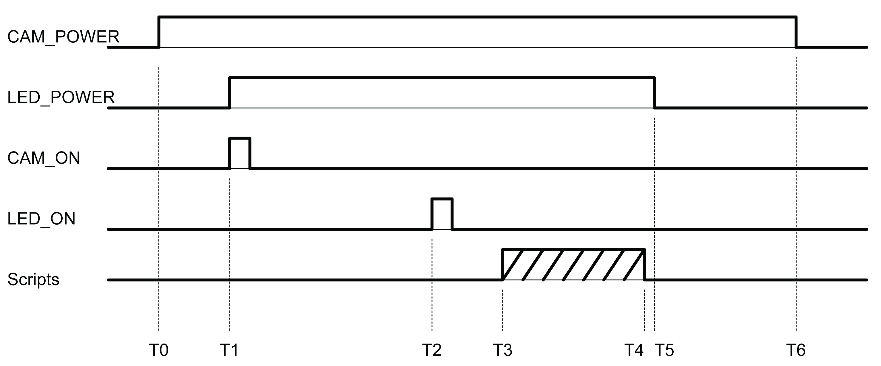
Figure 3: Timing Diagram of the SeeStar II Imaging & Lights

T0: Battery voltage is applied to the GoPro camera.
T0-T1 Delay: An approximate 5 second delay.
T1: Battery voltage is applied to the LED module and the GoPro is turned on.
T1-T2 Delay: An approximate 10 second delay in order for the GoPro to boot up.
T2: The LED is now turned on.
T3: Once the GoPro has booted up, the script file is automatically initiated.
T3-T4: The script file runs. The length is determined by the specific script function.
T5: The battery voltage is removed from the LED module (thus turning off the LED).
T5-T6 Delay: An approximate 6 second delay to ensure the SD card has finished closing files.
T6: The battery voltage is removed from the camera module (thus turning off the GoPro).

Camera Configuration
The GoPro Hero needs to be placed in the desired mode of operation prior to installation into the camera module. This can be either a video or camera mode, with multiple resolutions and viewing angles available. Refer to the programming guide or the GoPro user’s manual for specific information on those modes. The default mode, video or stills, should also be set; this causes the camera to enter that mode upon boot up (and should match the script functionality).

Script Writing
The script is a simple batch file that is initiated every time the GoPro is powered up. Simple script functions such as button presses allow software control of the GoPro. More detail is provided in the programming guide, but a sample script would look like the following:

//################################################
//# Hero3+: wait 5, PhotoMode, wait 5, Take one image, wait 5 seconds and power down #
//################################################
//
//sleep 5
//t app appmode photo
//sleep 5
//t app button shutter PR
//sleep 5
//poweroff yes
//reboot yes

The script files need to be saved in Unix format, meaning they only have a line feed (\n). (no carriage return \r). The filename of the script must be autoexec.ash and it must reside in the root folder of the SD card (Figure 4).

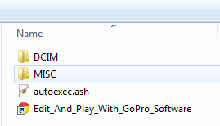
Figure 4: Location of the script file on the SD card.

Arduino Programming
[codebender and/or Arduino environment]

Pre-Deployment

Checklists
Prior to sealing up the housings, it is wise to check off items from a pre-made list. The following is a list of items the MBARI team uses before sealing up the housings.

Camera Housing
1. GoPro camera is in the desired mode (and default mode).
2. SD card is properly formatted, installed, and contains a valid script file.
3. The Arduino has been programmed with the desired deployment settings.
4. The real time clock on the Controller Shield has the current time set.
5. The Controller Shield has a watch battery installed.
6. The Controller Shield has a jumper installed to disable board level LEDs (saves power).
7. All of the internal connectors and wire-to-board connections are physically secured.

LED Housing
1. The wire connections to the internal terminal strip are physically secured.
2. The DC-DC Converter is sufficiently wrapped in non-conducting material.

Battery Housing
1. The wire connections to the internal terminal strip are physically secured.

Sealing the Housings
All of the GroupBinc housings have been pressure tested to a depth of 1500 meters. To ensure a proper seal, care must be taken when closing the housings. Verify the O-Rings have a light coating of Molykote 55 on them. The mating surfaces should also be wiped clean to ensure there is no debris to cause a bad O-Ring seal. Even a human hair across the O-Ring can cause a slow water leak at depth. The addition of a small desiccant pack in the housings is not required but is recommended to absorb any ambient moisture in the housing.

[add in pictures of O-Rings + 55 + housing]

Camera Housing
It is a good idea to check to make sure the lenses on the GoPro camera and on the front endcap are wiped clean prior to sealing the housings. Verify all of the wired connections are secure and that the wires do no extend out to the endcap-to-housing interface. The 30-pin Hero bus connector can sometimes wiggle loose; make sure it is properly seated into the camera.
The Allen screws holding the housing together should only be hand tightened.

LED and Battery Housings
Verify the clear acrylic port on the LED housing is clean. The screw-on circular endcaps should only be hand tightened.

Mounting and Deployment
SeeStar II was designed to be a platform-independent imaging system. The small size of the housings allows them to be easily mounted to nearly any type of structure or experiment. The housings can be secured using simple items such as metallic hose clamps or tie wraps.

Cable and Connector Management
The underwater cables and connectors used on SeeStar II are from the Subconn Micro line. The bulkhead connectors are male style with threads which accept a female locking sleeve found on the interconnection cables. Before deployment, Molykote 44 should be applied to all of the female connector sockets prior to mating.

[insert a picture of 44 being applied to a connector]

When mounting the individual modules on your frame or vehicle, be aware of the cables. Try to route the cable such that it can be secured to a frame with tie traps. This helps from placing unnecessary strain on the connectors.

Camera and LED Orientation
The light and camera modules were kept separate intentionally in order to maximize deployment flexibility. The GoPro Hero is generally a poor imager in low light conditions; therefore, the user should try to maximize the light distribution near the imaging plane. Our in-house testing found that a light level of 2000 lumens provides sufficient illumination for proper imaging.

Bio-Fouling
SeeStar II does not have active anti-biofouling protection. If deployed at a shallow depth for extended periods of time, bio-fouling will most likely occur. Maintenance dives to wipe the camera and LED ports may be necessary.

Post Deployment
Upon recovery, it is a good idea to rinse the SeeStar II system (and any other recovered gear) down with fresh water. Depending on the deployment turn-around time, the system can be serviced in the field. With a proper charging cable, the battery module can be recharged without opening the housing.

Recovering Images/Video
To recover the stored images or videos, the camera housing must be opened. The SD card needs to be removed in order to download the files. Swapping SD cards can shorten turn-around time if performing this onboard a ship.

Battery Charging
The battery module can either be charged assembled or disassembled. In either case, it is best to utilize a trickle charging method to extend cell life and reduce excess heat generation. As the fully charged battery voltage can go as high as 16.8Vdc, the DC charging source should be set to 18.0Vdc with a current limit of 450mA – this level will take approximately 16 hours to fully charge the battery module.

[Insert a picture of a charging battery module]

System Cleaning and Care
As mentioned previously, it is good practice to rinse off the SeeStar II system with fresh water immediately after it is recovered. A buildup of salt can lead to surface pitting and corrosion.

The housings are anodized aluminum so care should be taken to prevent scratches. Any exposed bare aluminum will oxidize rapidly and could lead to pitting. When using metallic band clamps or any other material that could scratch the housings, place a protective layer such as plastic or cloth in between them.

If the intermodule cables are removed, dummy plugs should be placed on both the bulkhead and inline connectors. Molykote 44 should be applied to the female sockets before every mating. [refer to Subconn handling document]

The desiccant packs should be replaced if the housings are opened.

Appendices

Physical
Depth Rating | 1500 m
Temperature Rating | 2 degC
Dry Weight | 18 lbs
Wet Weight | 6 lbs
Platform | Any
Appendix 1: System Level Physical Specifications

Optical
Target Size | 10 cm
Field of View | 1m x 1.5m
Max Image Resolution | 12MP
Max Video Resolution | 4K
Camera Control | Automated
Rate of Images | Once /2 sec
Image Storage | 2900
Video Storage | 2 Hrs @ 2.7K
Appendix 2: System Level Optical Specifications

Electrical
Battery Capacity | 4500 mAH
Bus Voltage | 9-16Vdc
Appendix 3: System Level Electrical Specifications

Lighting
Intensity | 2000 Lm
Angle | Any
Color | White
Appendix 4: System Level Lighting Specifications

