SeeStar II Battery Module
Technical Manual, v0.1

Chad Kecy
Monterey Bay Aquarium Research Institute

August 14, 2015



Table of Contents
Overview 5
System Level Description 5
NiMH Cells 6
Polyfuse 6
Charging the Battery Module 7
Discharge Profile 7
Assembly Instructions 7
Appendices 8

Figure 1: Picture of the SeeStar II Imaging System 5
Figure 2: SeeStar II Battery Module Block Diagram 6
Figure 3: A single HHR450A cell 6

Table 1: Polyfuse Electrical Characteristics 8

Appendix 1: Electrical Specifications 8
Appendix 2: Mechanical Specifications 8
Appendix 3: Battery Module External Connector Pinout 8
Appendix 4: Battery Housing Bill of Material 10

Overview
SeeStar II is an autonomous and modular imaging system (Fig 1). It is programmed prior to deployment and can be left unattended for months at a time. SeeStar II consists of three individual modules: the camera, battery, and LED. The battery module contains the 12-cell battery and polyfuse.

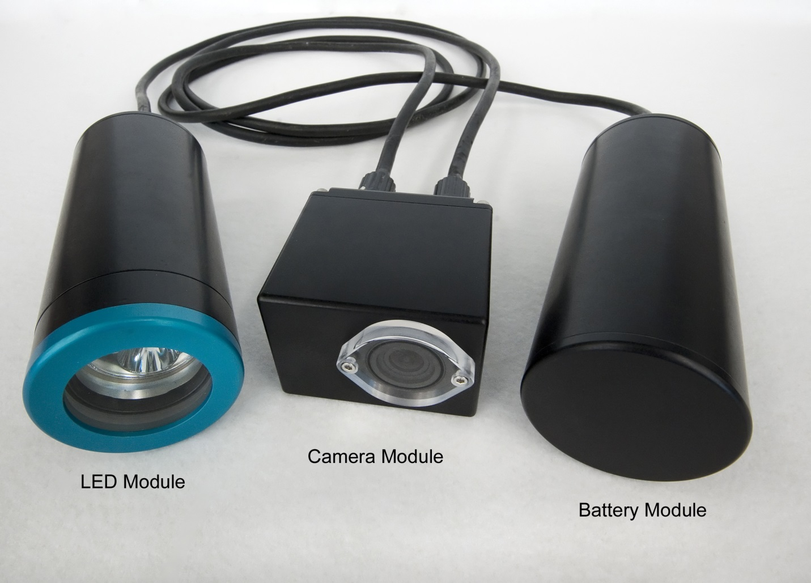
Figure 1: Picture of the SeeStar II Imaging System

System Level Description
The battery module is the energy source for the SeeStar Imaging System. The SeeStar II battery module contains 12 rechargeable NiMH cells for a nominal bus voltage of 14.4Vdc.

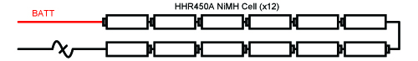
Figure 2: SeeStar II Battery Module Block Diagram

[Include a picture of the battery + housing]

NiMH Cells
The standard battery module contains 12 Panasonic HHR450A rechargeable Nickel Metal Hydride (NiMH) cells in series. The HHR450A is an L-Fat A size cell with a diameter of 18.2mm and height of 67mm. The battery has a capacity of 4500mAH and a nominal bus voltage of 14.4Vdc.

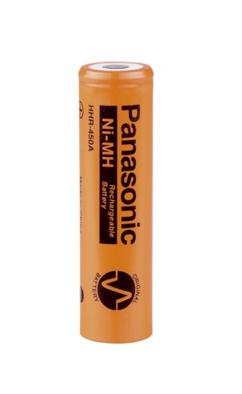
Figure 3: A single HHR450A cell

Polyfuse
The battery module contains an inline resettable fuse in the event of a catastrophic failure. The part used is a TE Connectivity SRP350F PolySwitch PTC Device.

 | I_{HOLD} | I_{TRIP} | V_{MAX} | I_{MAX} | P_{D MAX} | Max Time-to-Trip |  | R_{MIN} | R_{MAX} | R_{1MAX}
Part # | (amps) | (amps) | (Vdc) | (amps) | (watts) | (amps) | (seconds) | (ohms) | (ohms) | (ohms)
SRP120F | 1.20 | 2.70 | 15 | 100 | 1.2 | 6.00 | 5.0 | 0.085 | 0.160 | 0.220
SRP175F | 1.75 | 3.80 | 15 | 100 | 1.5 | 8.75 | 5.0 | 0.050 | 0.090 | 0.120
SRP200F | 2.00 | 4.40 | 30 | 100 | 1.9 | 10.00 | 4.0 | 0.030 | 0.060 | 0.100
SRP350F | 3.50 | 6.30 | 30 | 100 | 2.5 | 20.00 | 3.0 | 0.017 | 0.031 | 0.050
SRP420F | 4.20 | 7.60 | 30 | 100 | 2.9 | 20.00 | 6.0 | 0.012 | 0.024 | 0.040
Table 1: Polyfuse Electrical Characteristocs

Charging the Battery Module
The battery module can either be charged assembled or disassembled. In either case, it is best to utilize a trickle charging method to extend cell life and reduce excess heat generation. As the fully charged battery voltage can go as high as 16.8Vdc, the DC charging source should be set to 18.0Vdc with a current limit of 450mA – this level will take approximately 16 hours to fully charge the battery module.

Discharge Profile
[Add in plot of discharge curve once batteries arrive]

Assembly Instructions

[O-Ring care, installation of Subconn connector, attaching wires to TB1, wrapping battery, sealing the housing]

Appendices

Output Voltage | 9-15Vdc
Current Limit | 3.5 Amps
Appendix 1: Electrical Specifications

Length | Cm
Width | Cm
Height | Cm
Operating Temperature
Min | degC
Max | degC
Operating Depth | 1500m
Appendix 2: Mechanical Specifications

Battery Module J1 (To Camera Module)
Pin # | Signal Name | Description | Destination
1 | BATT_POS | Power Output to Camera Module | TB1-1a
2 | BATT_POS | Power Output to Camera Module | TB1-2a
3 | BATT_NEG | Power Return to Camera Module | TB1-3a
4 | BATT_NEG | Power Return to Camera Module | TB1-4a
5 | COMM_A | Serial TXD Out from Camera Module | N/C
6 | COMM_B | Serial RXD In to Camera Module | N/C
7 | TRIG_OUT | Trigger Output from Camera Module | N/C
8 | TRIG_IN | Trigger Input to Camera Module | N/C
Appendix 3: Battery Module External Connector Pinout

SeeStar Battery Housing Bill of Materials
Item # | Quan | Part | Manufacturer | Manufacturer PN# | Description | Distributor | Cost
1 | 1 | Battery Pack | Battery Specialties | 11021184 | 12-Cell NiMH Battery Pack | Battery Specialties | $112
2 | 1 | Terminal Strip, 4-Pos | TE Connectivity | 1776293-4 | 4-Position Terminal Strip | Digikey | $3
3 | 1 | External Connector, Female | Subconn | MCBH8F | 8-Pin Female External Connector | Ocean Innovations | $110
4 | 1 | Underwater Housing | Groupbinc | TBD | Cylindrical Housing | Groupbinc | $400
Appendix 4: Battery Housing Bill of Material

