SeeStar II
Programming Guide, v0.1

Chad Kecy
Monterey Bay Aquarium Research Institute

August 9, 2015



Table of Contents
Programming Overview 5
Camera Timing 5
Configuring the GoPro Camera 6
Script Writing 6
Arduino Programming 7
External Serial Port Communication 7
Appendices 7

Figure 4: Location of the script file on the SD card. 7

No table of figures entries found.

Programming Overview
To program the SeeStar II Imaging System for taking videos or still images, three separate, but simple, tasks need to be performed. These are: configure the GoPro camera in the desired operating mode, install the script file onto the SD card, and set the operating parameters in the Arduino sketch (code). Prior to describing the three steps, the timing of the camera will be discussed. An understanding of the timing diagram will greatly assist with future programming.

Camera Timing
Figure 1 shows a simplified timing diagram of the SeeStar II Imaging System. Below are quick descriptions of the events displayed.

CAM_POWER: Battery voltage is applied to the GoPro (but it is not turned on yet).

LED_POWER: Battery voltage is applied to the LED module (but it is not turned on yet).

CAM_ON: The GoPro is turned on.

LED_ON: The LED is turned on.

Scripts: The script file is activated.
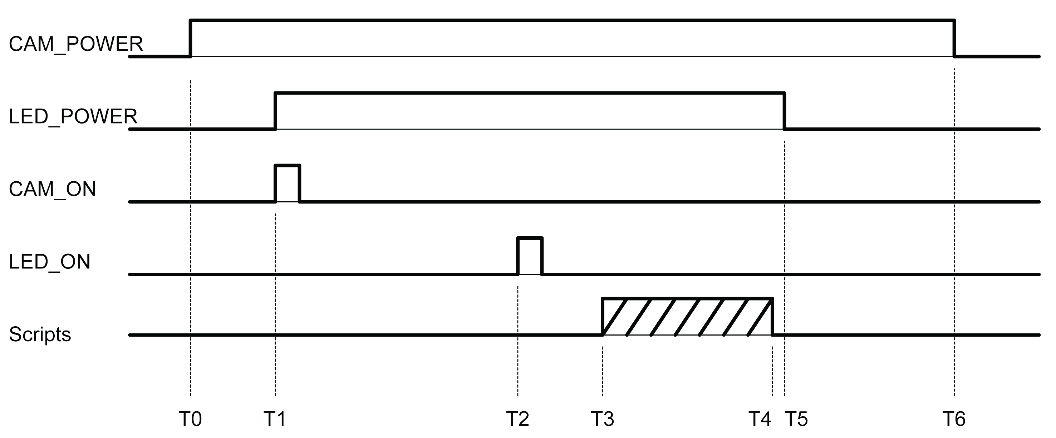

T0: Battery voltage is applied to the GoPro camera.
T0-T1 Delay: An approximate 5 second delay.
T1: Battery voltage is applied to the LED module and the GoPro is turned on.
T1-T2 Delay: An approximate 10 second delay in order for the GoPro to boot up.
T2: The LED is now turned on.
T3: Once the GoPro has booted up, the script file is automatically initiated.
T3-T4: The script file runs. The length is determined by the specific script function.
T5: The battery voltage is removed from the LED module (thus turning off the LED).
T5-T6 Delay: An approximate 6 second delay to ensure the SD card has finished closing files.
T6: The battery voltage is removed from the camera module (thus turning off the GoPro).

Configuring the GoPro Camera

The GoPro Hero needs to be placed in the desired mode of operation prior to installation into the camera module. This can be either a video or camera mode, with multiple resolutions and viewing angles available. Refer to the programming guide or the GoPro user’s manual for specific information on those modes. The default mode, video or stills, should also be set; this causes the camera to enter that mode upon boot up (and should match the script functionality).

Script Writing
The script is a simple batch file that is initiated every time the GoPro is powered up. Simple script functions such as button presses allow software control of the GoPro. More detail is provided in the programming guide, but a sample script would look like the following:

//################################################
//# Hero3+: wait 5, PhotoMode, wait 5, Take one image, wait 5 seconds and power down #
//################################################
//
//sleep 5
//t app appmode photo
//sleep 5
//t app button shutter PR
//sleep 5
//poweroff yes
//reboot yes

The script files need to be saved in Unix format, meaning they only have a line feed (\n). (no carriage return \r). The filename of the script must be autoexec.ash and it must reside in the root folder of the SD card (Figure 4).

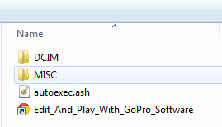

Arduino Programming
[codebender and/or Arduino environment]

External Serial Port Communication

Appendices

