LingsFire® Super Bright 7000LM 7 X CREE XM-L T6 3 Modes Waterproof LED Flashlight Torch Power Source 1 2 3 4 x 18650 Battery For Indoor/Outdoor Activities Like Cmaping, Hiking, Hunting etc.. (Black 7xT6)
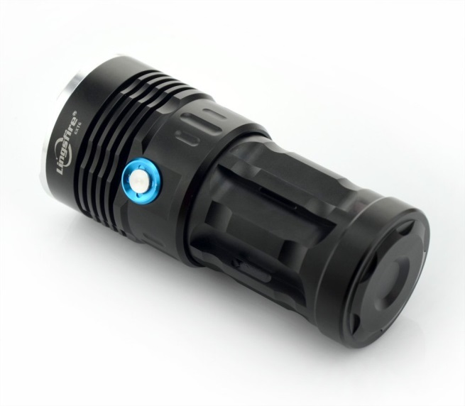

Product Description
Color: Black 7xT6
Features:
1.Brand New
2.This torch uses 7 X CREE XM-L T6 LEDs, producing very bright beam of light.
3.Output brightness can come to above 7000 lumens. Water-Resistant, you can use it in a rainy day
4.Applies efficient booster circuit to internal wiring, and utilize batteries to the largest extent
5.Wide usage such as biking, camping, backpacking, hunting, fishing and home repairing
Specifications:
1.Led bulb: CREE XM-L T6 LED bulb
2.Lifespan:100,000 hours
3.Led bulb Total: 7 x CREE XM-L T6
4.Light: Color: White
5.Brightness: Max output 7000 lumens
6.Power Source: 1x 18650 battery or 2x 18650 or 3x 18650 or4 x 18650 3.7v battery (Not Included)
7.3 mode: High, Low, Strobe (Long press the button for at least 3 seconds)
8.Material: Aluminum
9.Lens: Coated Glass Lens
10.Reflector: Aluminum smooth reflector
11.Casing Color: Black
12.Net Weight: 330g
13.Flashlight Dimension: 130mm x 59mm x 50mm(LxHxD)
NOTE: After-sale Service: The products can be returned and exchanged within 90 days

Package Content:
1 x LingsFire® 7000LM 7 X CREE XM-L T6 Waterproof LED Flashlight

Technical Details
Item Weight | 10.4 ounces
Product Dimensions | 5.1 x 2.3 x 2.3 inches
Color | Black 7xT6
Shape | Round
Power Source | battery-powered
Type of Bulb | led
Special Features | Portable
Batteries Required? | Yes
Battery Cell Type | Lithium Ion
Description Pile | 1x 18650 battery or 2x 18650 or 3x 18650 or4 x 18650 3.7v battery

