SeeStar Battery Charge and Discharge Tests
A random battery was chosen from our initial order of twelve and was put through a series of charge and discharge cycles at various rates. The data presented below represents the nominal charge and discharge rates that the battery should experience in a deployment situation.

Battery Information
The battery is a 12-cell NiMH pack made by Battery Specialties (Part Number 11021184) with an internal thermal fuse. It has a nominal voltage of 14.4Vdc and is rated for 4500mAH. Refer to the manufacturer’s datasheets and the SeeStar Battery Module Technical Manual for more detailed information regarding the battery.

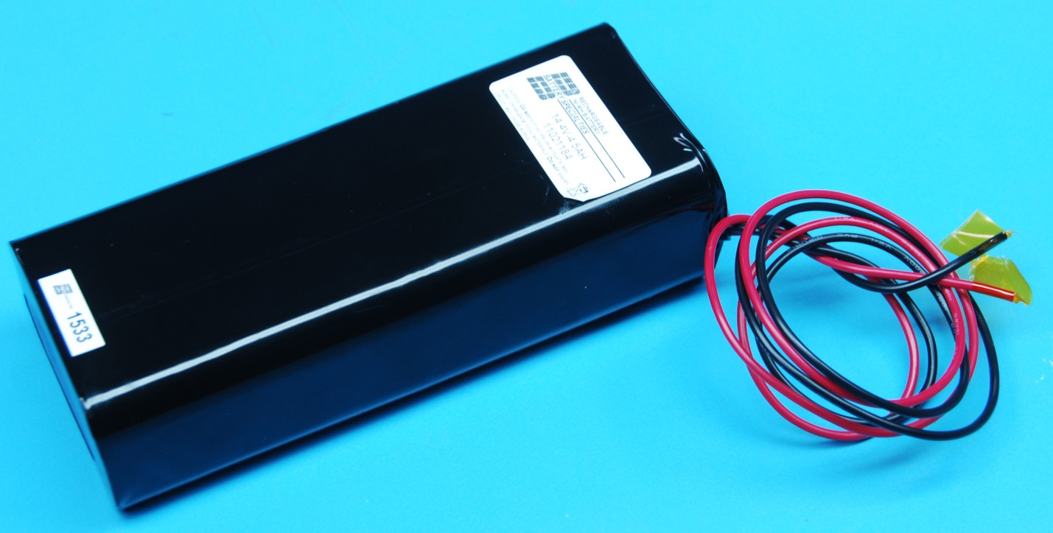
Figure 1: 12-cell NiMH battery

Equipment Used
For the charge cycles, an Extech 80W Switching DC Power Supply was used (Part Number 382260).
For the discharge cycles, a BK Precision 300W Programmable DC Electronic Load was used (Part Number 8500).
A Fluke 87 V multi-meter was used to measure all voltages.
The leads going to and from the power supply and electronic load were cut to length to simulate a deployment scenario.

Battery Charge Cycle
A fully discharged battery was charged at a 0.33C rate using a DC power supply. The charge voltage was 20.0Vdc and the current limit on the supply was set to 1.5 amps. The battery voltage was measured at set intervals and this data can be seen in Table 1. Figure 2 displays the resultant charge curve, which matches the expected curve.

Figure 2: Plot of 0.33C charge cycle

Minutes | Volts | Current | 1 cell eqv
1 | 14.85 | 1.503 | 1.24
2 | 15.28 | 1.503 | 1.27
3 | 15.52 | 1.503 | 1.29
4 | 15.69 | 1.503 | 1.31
5 | 15.84 | 1.503 | 1.32
6 | 15.96 | 1.503 | 1.33
7 | 16.06 | 1.503 | 1.34
8 | 16.12 | 1.503 | 1.34
9 | 16.18 | 1.503 | 1.35
10 | 16.25 | 1.503 | 1.35
25 | 16.30 | 1.503 | 1.36
40 | 16.77 | 1.503 | 1.40
55 | 16.97 | 1.503 | 1.41
70 | 17.07 | 1.503 | 1.42
85 | 17.15 | 1.503 | 1.43
100 | 17.20 | 1.503 | 1.43
115 | 17.25 | 1.503 | 1.44
130 | 17.34 | 1.503 | 1.45
145 | 17.42 | 1.503 | 1.45
160 | 17.47 | 1.503 | 1.46
175 | 17.52 | 1.503 | 1.46
190 | 17.76 | 1.503 | 1.48
205 | 18.14 | 1.503 | 1.51
220 | 18.48 | 1.503 | 1.54
235 | 18.23 | 1.503 | 1.52
250 | 17.66 | 1.503 | 1.47
255 | 17.41 | 1.503 | 1.45
260 | 17.40 | 1.503 | 1.45
Table 1: Data from 0.33C charge cycle

Battery Discharge Cycle
A fully charged battery was discharged at a 0.2C rate using a programmable DC load. The DC load was set in a constant current discharge mode at 0.9 amps. The battery voltage was measured at set intervals and this data can be seen in Table 2. Figure 3 displays the resultant discharge curve, which matches the expected curve.

Figure 3: Plot of 0.2C discharge cycle

Minutes | Volts | Current | 1 cell eqv
0 | 16.40 | 0.898 | 1.37
5 | 16.11 | 0.898 | 1.34
10 | 15.90 | 0.898 | 1.33
15 | 15.71 | 0.898 | 1.31
25 | 15.43 | 0.898 | 1.29
35 | 15.24 | 0.898 | 1.27
45 | 15.11 | 0.898 | 1.26
75 | 14.93 | 0.898 | 1.24
105 | 14.85 | 0.898 | 1.24
135 | 14.78 | 0.898 | 1.23
165 | 14.67 | 0.898 | 1.22
195 | 14.49 | 0.898 | 1.21
200 | 14.44 | 0.898 | 1.20
205 | 14.39 | 0.898 | 1.20
210 | 14.33 | 0.898 | 1.19
215 | 14.27 | 0.898 | 1.19
220 | 14.19 | 0.898 | 1.18
225 | 14.11 | 0.898 | 1.18
230 | 14.01 | 0.898 | 1.17
235 | 13.90 | 0.898 | 1.16
240 | 13.77 | 0.898 | 1.15
245 | 13.61 | 0.898 | 1.13
250 | 13.39 | 0.898 | 1.12
255 | 13.06 | 0.898 | 1.09
260 | 12.42 | 0.898 | 1.04
262 | 12.00 | 0.898 | 1.00
Table 2: Data from 0.2C discharge cycle

