SeeStar LED & DC-DC Converter Efficiency Test
Prior to the final selection of the components which comprise the LED module, a series of efficiency tests were performed. This document details the results of the system test which included all of the final components to be deployed.

DC-DC Converter Information
The Murata DC-DC converter chosen for the LED module is rated for 10 amps and has an adjustable output from 0.75Vdc to 5.5Vdc. It is a high efficiency part with built in over current and temperature shutdown. It has a stated input range of 8.3Vdc to 14Vdc, but our testing showed it was stable up to 15Vdc. For more detailed information, consult the manufacturer’s datasheet.

The output voltage of the converter is programmed via one external resistor. A 1% 3.09K resistor gives approximately 3.32Vdc output, which is the level the LED flashlight operates at.

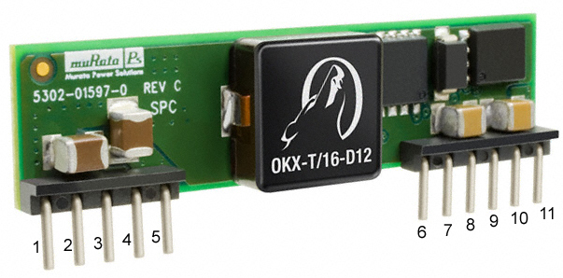
Figure 1: Murata DC-DC converter

LED Information
The LED module for SeeStar is comprised of two circuit boards from a commercially available flashlight. Detailed disassembly instructions are included in the SeeStar LED Technical Manual. The Power pcb operates from the 3.3Vdc output of the DC-DC converter and drives the seven LEDs on the LED board.

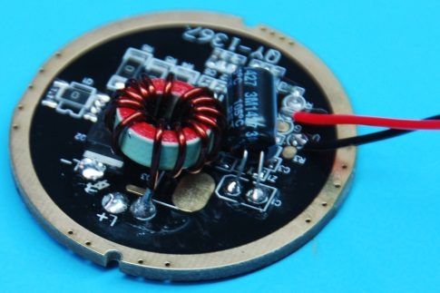
Figure 2: Front of Power PCB

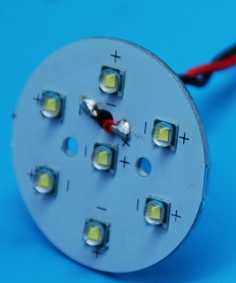
Figure 3: Front of LED PCB

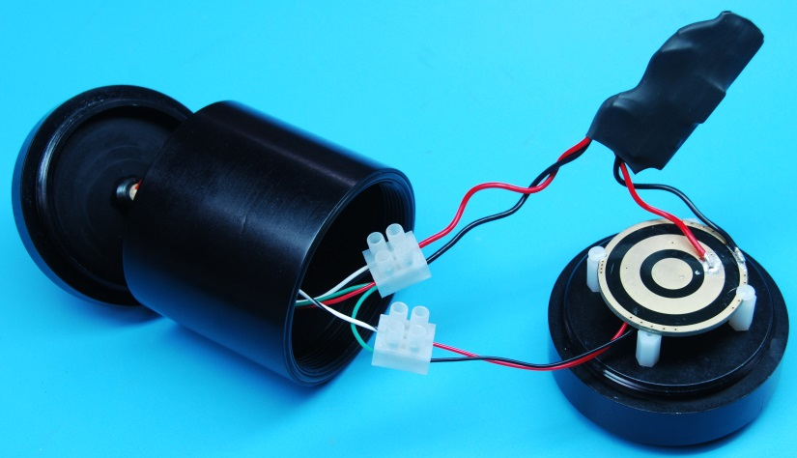
Figure 4: Wired components of the LED module (the circular board is the rear of the Power pcb).

Equipment Used
To simulate the battery, an Extech 80W Switching DC Power Supply was used (Part Number 382260).
Two Fluke 87 V multi-meters were used to measure all currents and voltages.
The wires between the DC-DC converter output and Power pcb input were cut and male-female banana pairs were added so the current could be measured.

Efficiency Test
The DC power supply output was adjusted in multiple steps from 15Vdc down to 12Vdc to simulate the range of the NiMH battery module. Input and output voltages and currents from the DC-DC converter were measured at each step and the efficiencies calculated. All of this data can be seen in Table 1 while Figure 6 displays the resultant curve. The efficiencies achieved match that of the manufacturer’s specifications as can be seen in Figure 7.

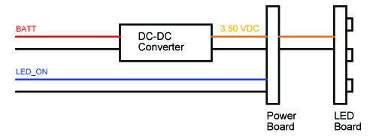
Figure 5: Block diagram of the LED module

Vin | Iin | Pin | Vout | Iout | Pout | Eff
(volts) | (amps) | (watts) | (volts) | (amps) | (watts) | (%)
15.04 | 1.196 | 17.99 | 3.312 | 4.897 | 16.22 | 90.17
14.93 | 1.209 | 18.05 | 3.312 | 4.915 | 16.28 | 90.18
14.86 | 1.215 | 18.05 | 3.312 | 4.920 | 16.30 | 90.25
14.73 | 1.226 | 18.06 | 3.312 | 4.926 | 16.31 | 90.34
14.70 | 1.229 | 18.07 | 3.312 | 4.931 | 16.33 | 90.40
14.54 | 1.243 | 18.07 | 3.312 | 4.935 | 16.34 | 90.44
14.41 | 1.253 | 18.06 | 3.312 | 4.939 | 16.36 | 90.60
14.23 | 1.269 | 18.06 | 3.312 | 4.941 | 16.36 | 90.62
14.10 | 1.281 | 18.06 | 3.312 | 4.944 | 16.37 | 90.66
13.98 | 1.292 | 18.06 | 3.312 | 4.946 | 16.38 | 90.69
13.85 | 1.303 | 18.05 | 3.312 | 4.950 | 16.39 | 90.85
13.82 | 1.307 | 18.06 | 3.312 | 4.955 | 16.41 | 90.86
13.54 | 1.334 | 18.06 | 3.312 | 4.956 | 16.41 | 90.88
13.42 | 1.346 | 18.06 | 3.312 | 4.956 | 16.41 | 90.87
13.32 | 1.355 | 18.05 | 3.312 | 4.956 | 16.41 | 90.94
13.11 | 1.376 | 18.04 | 3.312 | 4.957 | 16.42 | 91.01
13.04 | 1.384 | 18.05 | 3.312 | 4.960 | 16.43 | 91.02
12.92 | 1.396 | 18.04 | 3.312 | 4.960 | 16.43 | 91.08
12.80 | 1.409 | 18.04 | 3.312 | 4.963 | 16.44 | 91.14
12.73 | 1.415 | 18.01 | 3.312 | 4.962 | 16.43 | 91.24
12.17 | 1.476 | 17.96 | 3.312 | 4.962 | 16.43 | 91.49
12.13 | 1.480 | 17.95 | 3.312 | 4.962 | 16.43 | 91.54
12.07 | 1.488 | 17.96 | 3.312 | 4.962 | 16.43 | 91.50

Table 1: Data from efficiency test

Figure 6: Plot of efficiency test

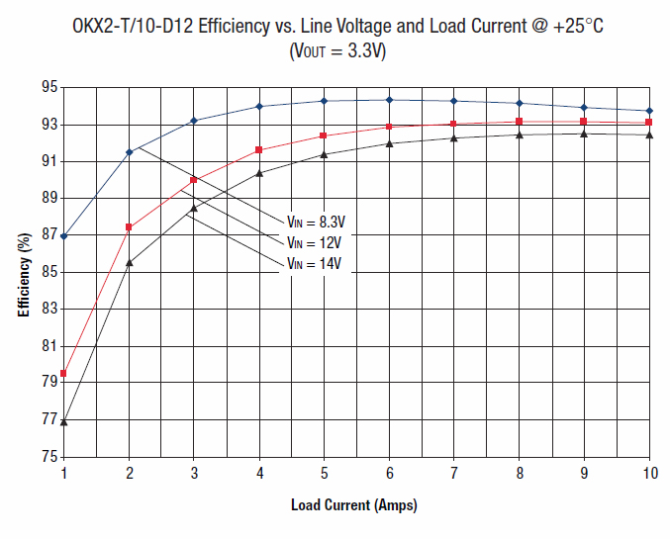
Figure 7: Murata efficiency curve for 3.3Vdc output

