SeeStar II
Programming Guide, v0.2

Monterey Bay Aquarium Research Institute

December 31, 2015



Table of Contents
Programming Overview 5
Camera Timing 5
Configuring the GoPro Camera 6
Hero 3+ Overview 6
Hero 3+ Imaging Modes 8
Hero 3+ Video Modes 8
Deployment Configuration 9
Disable Camera LEDs 9
Disable Camera Sounds 9
Choose Default Power Up Mode 9
Choose Video Resolution 9
Choose Imaging Resolution 9
Formatting the SD Card 10
Script Writing 10
Arduino Programming 11

Figure 1: Physical features of the GoPro Hero 3+ Black camera 6
Figure 2: GoPro Hero 3+ modes 7
Figure 3: GoPro Hero 3+ Settings menu 7
Figure 4: GoPro Hero 3+ Imaging modes 8
Figure 5: GoPro Hero 3+ Video modes 8
Figure 6: Location of script file on the SD card 10

Programming Overview
To program the SeeStar II Imaging System for taking videos or still images, three separate, but simple, tasks need to be performed. These are: configure the GoPro camera in the desired operating mode, install the script file onto the SD card, and set the operating parameters in the Arduino sketch (code). Prior to describing the three steps, the timing of the camera will be discussed. An understanding of the timing diagram will greatly assist with future programming.

Camera Timing
Figure 1 shows a simplified timing diagram of the SeeStar II Imaging System. Below are quick descriptions of the events displayed.

CAM_POWER: Battery voltage is applied to the GoPro (but it is not turned on yet).

LED_POWER: Battery voltage is applied to the LED module (but it is not turned on yet).

CAM_ON: The GoPro is turned on.

LED_ON: The LED is turned on.

Scripts: The script file is activated.

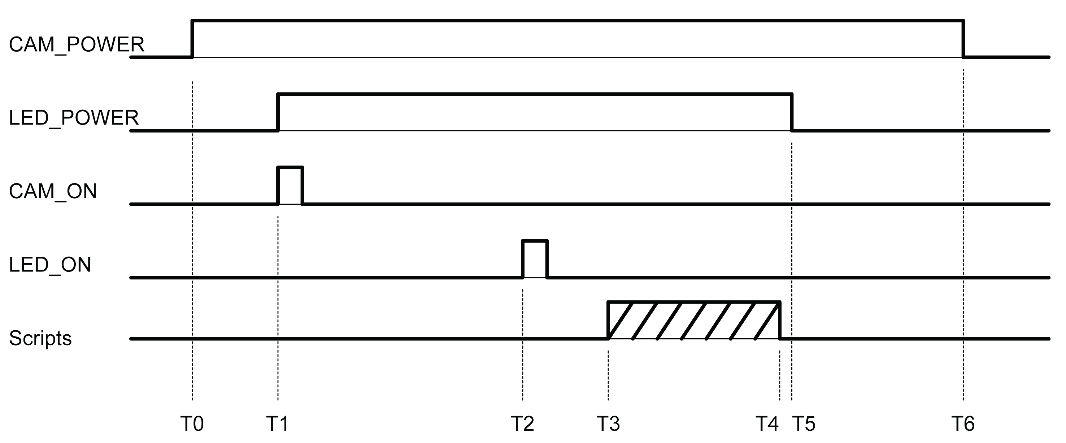

T0: Battery voltage is applied to the GoPro camera.
T0-T1 Delay: An approximate 5 second delay.
T1: Battery voltage is applied to the LED module and the GoPro is turned on.
T1-T2 Delay: An approximate 10 second delay in order for the GoPro to boot up.
T2: The LED is now turned on.
T3: Once the GoPro has booted up, the script file is automatically initiated.
T3-T4: The script file runs. The length is determined by the specific script function.
T5: The battery voltage is removed from the LED module (thus turning off the LED).
T5-T6 Delay: An approximate 6 second delay to ensure the SD card has finished closing files.
T6: The battery voltage is removed from the camera module (thus turning off the GoPro).

Configuring the GoPro Camera
There are many varieties of GoPro Hero cameras. SeeStar II was designed to work with the Hero 3 and Hero 3+. This guide will be specifically referring to the Hero 3+ Black version. Please consult the User’s Guide which came with your specific camera for any minor differences.

Hero 3+ Overview

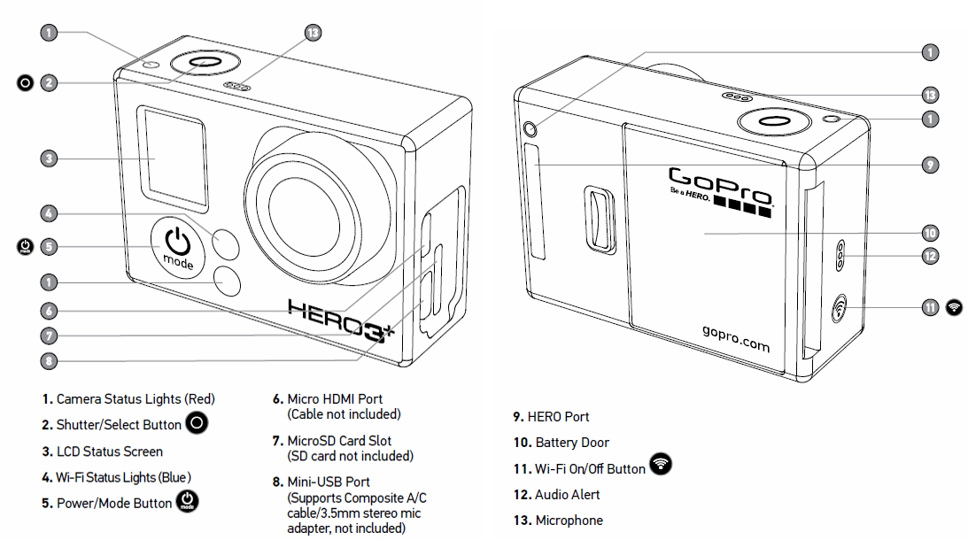
Figure 1: Physical features of the GoPro Hero 3+ Black camera

To Power ON: Press the Power/Mode button (5).
To Power OFF: Press and hold the Power/Mode button (5).

The Hero 3+ has several modes; to cycle through them, press Power/Mode button (5) once the camera is on.

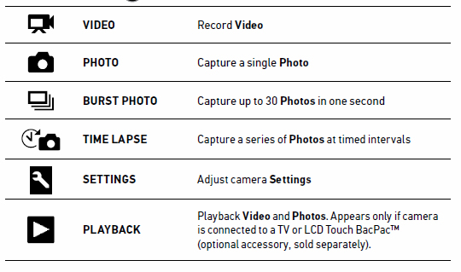
Figure 2: GoPro Hero 3+ modes

Figure 3: GoPro Hero 3+ Settings menu

Hero 3+ Imaging Modes

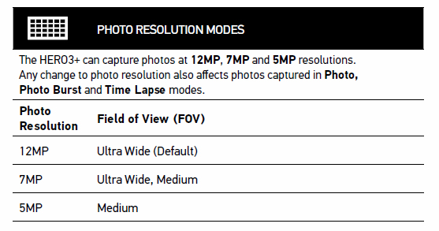
Figure 4: GoPro Hero 3+ Imaging modes

Hero 3+ Video Modes

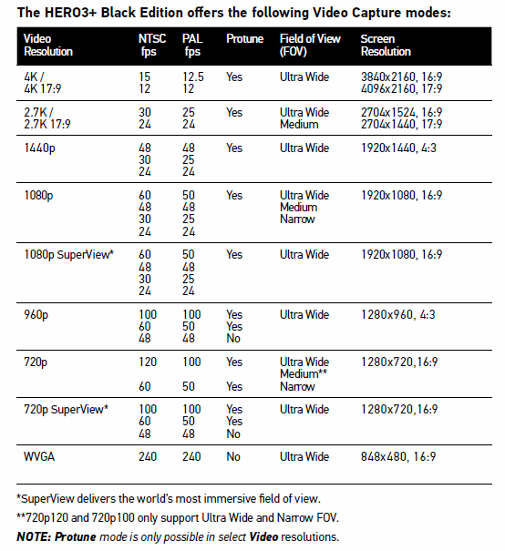
Figure 5: GoPro Hero 3+ Video modes

Deployment Configuration
Prior to deployment, the Hero 3+ camera needs to be properly configured.

Disable Camera LEDs
Enter the camera menu and select the Camera Settings icon.

Select the Setup icon 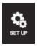 and then the LED icon.  Choose OFF.

Disable Camera Sounds
Enter the camera menu and select the Camera Settings icon.

Select the Setup icon and then the Sounds icon.  Choose OFF.

Choose Default Power Up Mode
Enter the camera menu and select the Camera Settings icon.

Select the Setup icon and then the Default Power Up icon.  Choose Video or Imaging.

Choose Video Resolution
Enter the camera menu and select the Camera Settings icon. Choose the Video Resolution icon and set desired parameters.

Choose Imaging Resolution
Enter the camera menu and select the Camera Settings icon. Choose the Image Resolution icon and set the desired imaging resolution.

Formatting the SD Card

Insert a blank MicroSD card into the Hero 3+ camera and power it on. Enter the camera menu and select the Camera Settings icon. Select the Delete icon and then choose ALL to format the SD card.

Script Writing
The script is a simple batch file that is initiated every time the GoPro is powered up. Simple script functions such as button presses allow software control of the GoPro. Below are two sample scripts. The first takes one image and then powers down. The second takes a 30 second video and then powers down. In each case, the GoPro must be setup to the correct Default Power Up Mode (Imaging vs Video)

#######################################################
# Hero3+: wait 5, Take one image, wait 5 seconds and power down #
#######################################################
sleep 5
t app button shutter PR
sleep 5
poweroff yes
reboot yes

##########################################################
# Hero3+: wait 5, Take a 30 sec video, wait 5 seconds and power down #
##########################################################
sleep 5
t app button shutter PR
sleep 30
t app button shutter PR
sleep 5
poweroff yes
reboot yes

The script files need to be saved in Unix format, meaning they only have a line feed (\n). (no carriage return \r). The filename of the script must be autoexec.ash and it must reside in the root folder of the SD card (Figure 4).

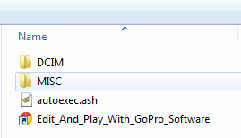
Figure 6: Location of script file on the SD card

Arduino Programming
Primary testing of the Arduino firmware has been accomplished using the codebender [www.codebender.cc], a free website which compiles, verifies, and loads the sketch onto the Arduino Pro-Mini.

- If the Arduino is plugged onto the Controller Shield, install a jumper shunt on J4.
- Hook up the FTDI cable between the computer and the Arduino.

On codebender
- Login and choose your Arduino (SeeStar) project.
- Choose the COM port associated with your FTDI cable.
- Choose the style of Arduino to be programmed.
- Press ‘Save sketch’.
- Press ‘Verify Code’.
- Press ‘Run on Arduino’. If successful, a message will be displayed confirming the sketch download.

