Project Number: | 901107

Project Start: Jan. 1, | 2011 | Project Duration (in years): | 3

Please indicate what type of project is being proposed (mark only one).

 |  |  |  | X
Feasibility/Scoping  [Less than 100 days effort] |  |  | Development |  |  | Research |  |  | Infrastructure¹ |  |  | Education
 |  |  | Time Series |  |  | Institute Initiative

Project Manager: Chad Kecy
Principal Investigator: Steve Haddock
Lead Scientist: Steve Haddock, Ken Smith
Lead Engineer: Chad Kecy, Mike Risi

Project Title:
Self-Contained Plankton Imager
- ABSTRACT (new projects only)

- PROPOSAL

  - New Projects

Statement of the problem, why it is important

How does it relate/contribute to MBARI’s mission and strategic plan?

How does it relate/contribute to the Packard Foundation’s Ocean Visions Grantmaking policies? (See http://mww.mbari.org/oed/OED_Documents3.htm#Packard for documents.)

Approach to the problem

Publications (from other projects over the last 5 years)

  - Continuing Projects

If the proposed project includes multiple individual projects, please list each of these projects as a subheading in the proposal. For each subheading, please address the following:

Current status of project and results to date

We have spent the first half of 2012 performing trade studies of potential imagers, lighting systems, and overall system design. Results of this process included a detailed power budget, calculations for the required amount of light for proper imaging, and an overall modular approach. A preliminary design review was held mid year. The chosen design meets the scientific needs of at least two MBARI PIs (Haddock and Smith) and could potentially meet the needs of a third (Bellingham).

The remainder of 2012 will be spent building a prototype unit based on our engineering trade studies. The prototype unit will use the GoPro Hero2 camera as the imager. Operation of the Hero2 will be accomplished using a customized control board. In order to avoid any intellectual property issues, we will be using the standard interface utilized by the GoPro WiFi and LCD bacpacs.

Completed as of July 2012:
1. Purchased multiple consumer grade cameras and performed comparative evaluation
2. Calculated amount of light required to capture image
3. Made a system level power budget
4. Held a preliminary design review
5. Began build of prototype system that meets all functional requirements

To be completed by end of 2012:
1. Finalize design of modular 300m rated housings
2. Finalize electrical interconnection bus and specify connectors
3. Build camera module, battery module, and light module
4. Perform integration and system level testing

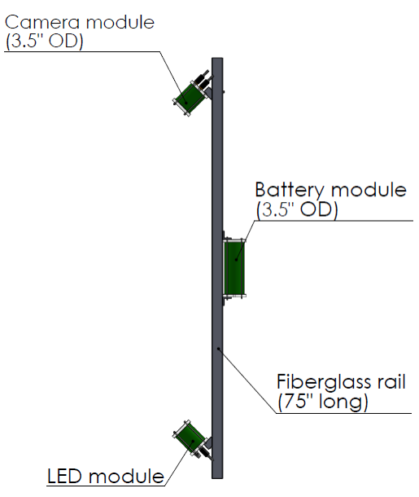

Significant changes from previous project proposal

We are on schedule based on the 2012 project proposal. No significant changes have occurred.

Publications based on the results of this project only

None.
- New and Continuing Projects: Plans for 2013

Research Activities

As detailed in the original proposal, the motivation is to have a method of quantifying zooplankton that works without human intervention, and which can be deployed for many scientific purposes. Several research groups at MBARI have expressed a strong interest in camera-based instruments that can be deployed across a variety of platforms. Specific imaging goals include zooplankton (Haddock Lab, CANON PIs, AUV groups, Vrijenhoek Lab), and particle flux dynamics (Ken Smith).With an optional deep-rated housing, the camera could even be deployed from the MARS observatory. SCPI development is driven by meeting these goals, with a priority on macrozooplankton identification, since that is the technological capability that is currently most lacking in marine research.

The technical imaging requirements for this system were set by target size that will be quantified. It is difficult to evaluate whether an image is of sufficient quality without resorting to subjective terms. To quantify differences between camera options, and to evaluate prototypes and subsequent iterations of SCPI, one of the metrics we will use is how many species we can effectively count. This will be a function of the lighting and sensor capabilities, as already demonstrated in our laboratory tests under realistic conditions. As shown in the figure, the prototype system built during 2012 should be able to resolve Moon Jellies (A) and Sea Nettles (B) well enough to allow for species quantification. As development proceeds, we will be able to target more difficult species. Future versions of SCPI will aim to resolve other common species such as Aegina (small circles in C and D) and Nanomia (large circle in D).

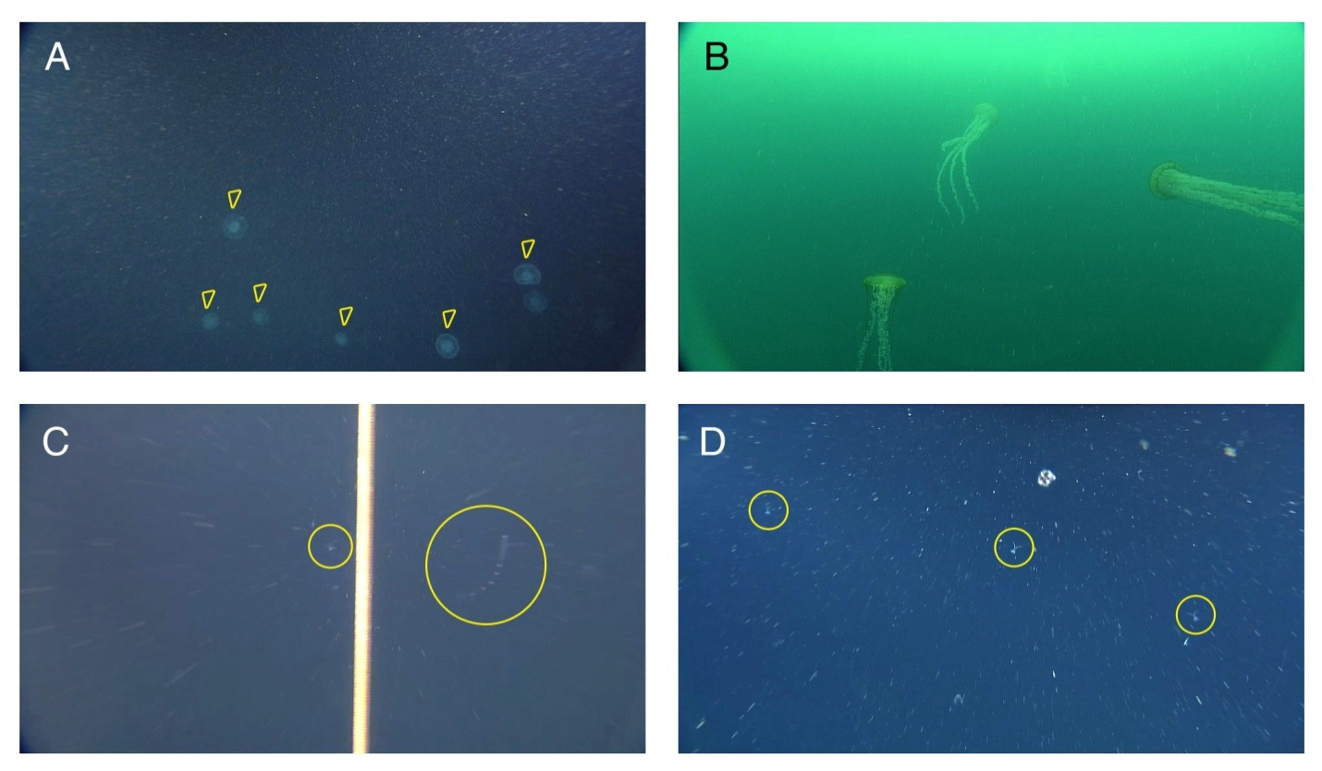

The second near-term requirement will be to image particles for several sediment trap systems. These will be evaluated based on particle size that can be counted, since the lighting and lens settings will be adapted to those goals rather than visualizing larger zooplankton.

Engineering/technology development

We intend to take a staged, iterative development approach to SCPI. We will begin with basic system functionality in order to concentrate on proper imaging and lighting. However, software and hardware hooks are being designed in to allow for future upgrades. These include improved imagers with more sensitivity and resolution, metadata logging, external event triggering, remote serial communication, and networking capability.

2013 Tasks:
1. Field testing of prototype unit
2. Enter field test pictures into VARS system
3. Evaluate test results and reassess camera selection
4. Bench test system upgrades
5. Hold design review of Gen2 SCPI system
6. Build two Gen2 SCPI systems
7. Integration of testing of Gen2 systems
8. Deliver Gen2 systems to Haddock and Smith labs

Data analysis plans.

Using MBARI’s existing software and pipelines, images generated by SCPI deployments can immediately be incorporated into the VARS database (Brian Schlining, pers. comm.). This is already being done with images from Ken Smith's cameras and the Coolpix still cameras on the ROVs. In the future, we will investigate the free fuzzy logic identification systems that other groups have developed (e.g., ZooScan). With an eye to the future, in the longer term we will also investigate other methods for processing images, including crowdsourcing and an AVEDAC-type pre-classifier, which sorts out photos and regions of interest from long time series.

Field programs (detail ship requirements/deployments/diver requirements)

We intend to perform a series of field tests of the prototype SCPI in early 2013. The testing will be performed at a range of depths, from diver serviceable down to the maximum rating of 300 meters. Potential testing sites include the Santa Cruz pier, Capitola Pier, Cal Poly SLO, the Kelp Forest Array at Hopkins Marine Station, the moorings and CTD rosettes from either the Western Flyer or Rachel Carson. Any ship time required can be piggybacked onto existing deployments from the Haddock or Smith labs.

Specific deliverables

We will build two operational SCPI units by the end of 2013. One will be used by Ken Smith's lab and the other by Steve Haddock.
Milestones (see last page for personnel classification list)

 | Milestone 1 | Milestone 2 | Milestone 3 | Milestone 4 | Milestone 5 | Milestone 6 | Total Resources for each resource category for all milestones listed here
Milestone Date | 3/13 | 5/13 | 6/13 | 9/13 | 10/13 | 11/13
Milestone Description | Field Testing | Bench Test Upgrades | Design Review | Build Gen2 Units | Integration & Testing | Deliver Gen2 Units
EE | 100: CK | 40: CK  60: MC | 20: CK  20: MC | 50: CK | 40: CK  20: MC | 50: CK | 300: CK  100: MC
SE |  | 100 | 40 | 60 | 100 | 50 | 350: MR
ME | 25: AH  25: FC | 25: AH  25: FC | 20: AH  20: FC | 50: AH  50: FC | 30: AH  30: FC | 25: AH  25: FC | 175: AH  175: FC
EE Tech |  | 50 |  | 125 |  |  | 175
SE Tech
ME Tech |  |  |  | 125 |  |  | 125
Machine Shop |  |  |  | 50 |  |  | 50
Divers

Budget justification

Our budget for 2013 is broken down into three main tasks: completion of the field tests, purchasing and testing of system upgrades, and the build of the two Gen2 SCPI units.

 | Cost
Field Testing | $1,300
Portable HD | $300
Misc Hardware | $1,000
Upgrades | $6,000
Cameras | $2,100
Housing | $300
Cables | $1,000
Connectors | $300
Networking Gear | $300
Ckt Board Fab/Parts | $1,000
Misc Hardware | $1,000
Operational Units | $10,950
Cameras | $1,400
Control Boards | $1,000
Relay Boards | $450
LEDs | $200
LED Drive Bds/Parts | $2,000
Batteries | $300
Depth Sensor | $200
Housings | $1,000
Connectors | $1,400
Cables | $2,000
Mountings | $1,000
Misc Hardware | $1,000
Total | $19,250

Project team

Chad Kecy, Mike Risi, Mark Chaffey, Andrew Hamilton, Francois Cazenave, Steve Haddock, Ken Smith

Project lab space

The project will use existing lab space and will not require additional space.

Data availability outside project team, uniqueness

We intend to utilize the VARS system as the primary means of image and metadata handling and processing.

Export Regulation Does the project team anticipate any foreign collaborations or international travel? If so, please identify collaborators by name, institution, and country.

We do not foresee any foreign collaborations or travel.

Does the project team plan or anticipate export controlled purchases, shipments, or transfers of items (e.g., research instruments, proprietary data, hand-carried tools or samples) outside the U.S. temporarily or permanently? If yes, please identify country or countries and indicate whether these items will remain under MBARI control while abroad or controlled by others. Will the items be exported to more than one country? Please include foreign collaborator information as described above.

We do not expect any export control issues.

Risk matrix (development and infrastructure projects only)

 | Technical Risk | Organizational Risk | Tech Transfer Risk | Labor Estimate Risk
High
Medium | X | X | X | X
Low

Personnel Classifications

Engineer -  Mechanical Engineer | Engineer -  Electrical Engineer | Engineer -  Software Engineer | Engineer -  Mechanical Tech | Engineer -  Electrical Tech | Engineer -  Software Tech | Observ Support Technician | Science –  Software Engineer
(Reg) | (Reg) | (Reg) | (Reg) | (Reg) | (Reg) | (Reg) | (Reg)
Jim Birch (2/3) | Mark Chaffey | Dave Caress | John Ferreira | Paul Coenen | Karen S | Mike Kelley | Mike Godin
Larry Bird | Scott Jensen | Danelle Cline | Frank Flores | Tom Marion |  | Jared Figurski | Frederic Py
Francois Cazenave | Chad Kecy | Duane Edgington(2/3) | Mike Parker | Jim Montgomery
Jon Erickson | Denis Klimov | Kevin Gomes (2/3) | Jim Schofield | Jose Rosal
Dale Graves (2/3) | Paul McGill | Kent Headley (2/3)
Andy Hamilton (2/3) | Ed Mellinger | Rich Henthorn |  |  |  |  | Science –  Mechanical Engineer
Brett Hobson | Craig Okuda | Bob Herlien |  |  |  |  | (Reg)
Bill Kirkwood | Alana Sherman | Brian Kieft |  |  |  |  | Gene Massion
Doug Pargett |  | Thom Maughan
Farley Shane |  | Mike McCann
 |  | Rob McEwen
 |  | Tom O’Reilly
 |  | Wayne Radochonski
 |  | Mike Risi
 |  | Brent Roman
 |  | Carlos Rueda-Velasquez
 |  | Brian Schlining
 |  | Rich Schramm

