SeeStar Antarctic tripod camera test.
Francois Cazenave, May 7 2014.
Test 1, May 1 2014
The camera, light and battery were mounted to the tripod (see images below). A checkered target was attached in the field of view, about 110cm from the camera. The camera was setup to take a picture every 30 seconds and lowered in the test tank.
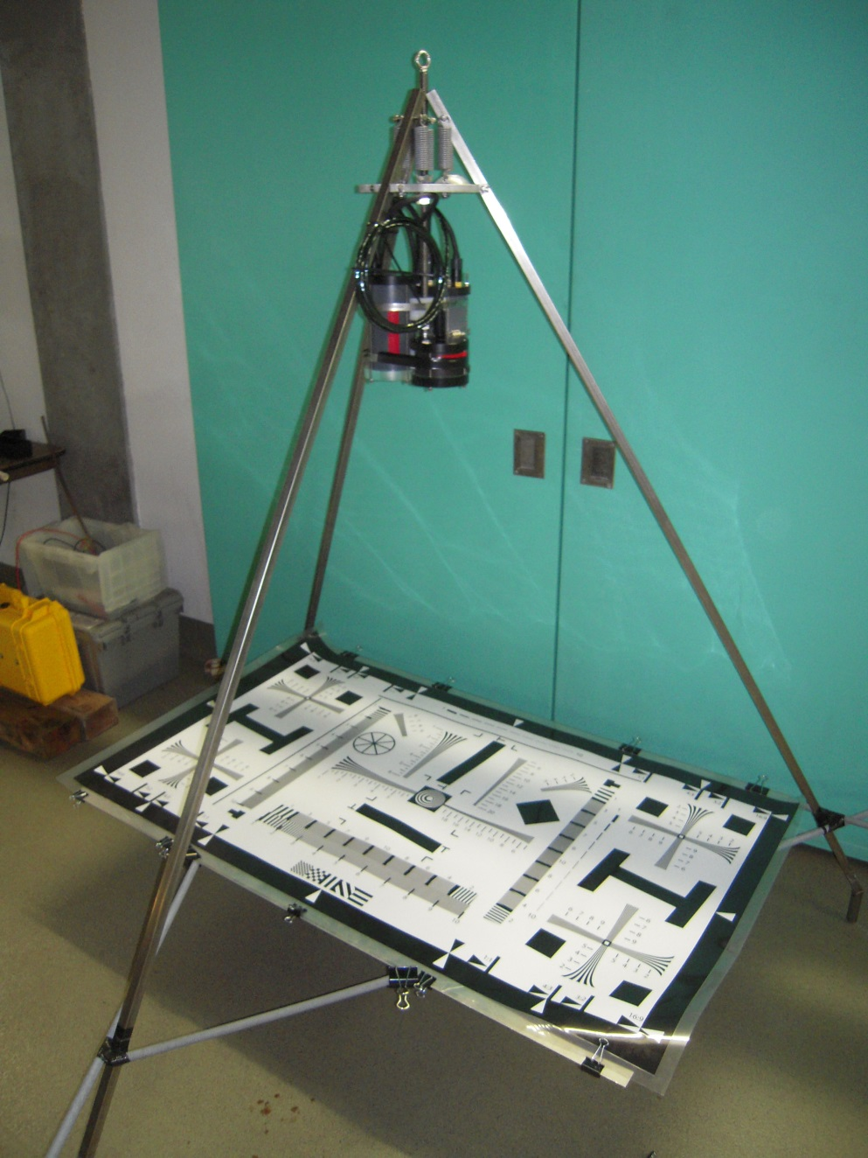
In water, the size covered by the image was approximately 103cmx138cm. There was very little distortion and the resolution was good. There was chromatic aberration on the edges of the image. 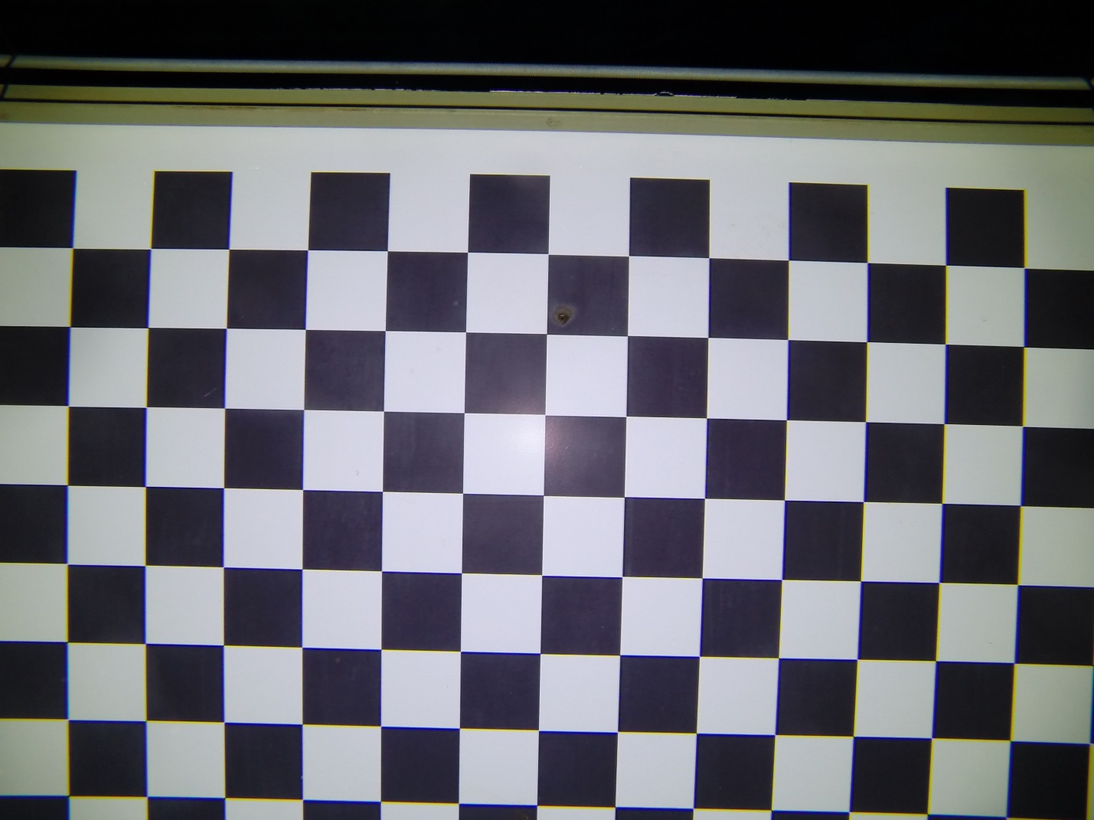
See more images:
\\atlas\ProjectLibrary\901107.SCPI\Images\Test Tank 05-01-2014

Test2, May 7 2014
The camera, light and battery were mounted to the tripod (see images below). A calibration target was attached in the field on view, about 90 cm from the camera. The camera was setup to take a picture every 30 seconds and lowered in the test tank.
Results: In water, the size covered by the image was approximately 114cmx85.5cm. There was very little distortion and the resolution was good. There was chromatic aberration and poor sharpness on the edges of the image.
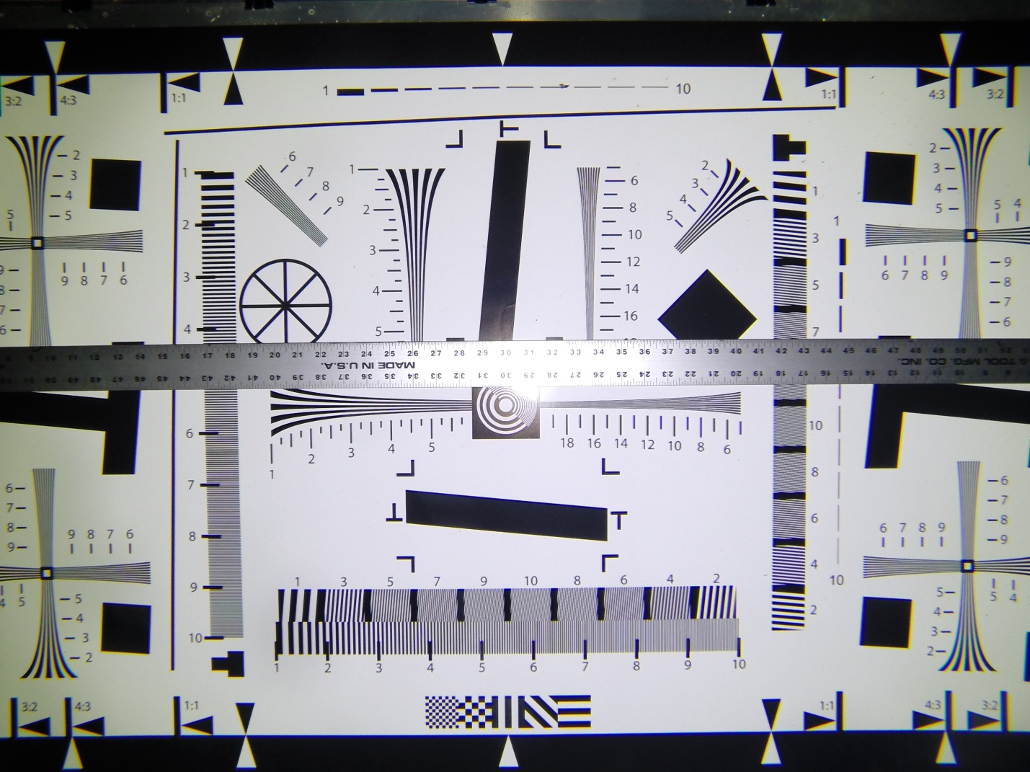
More images:
\\atlas\ProjectLibrary\901107.SCPI\Images\Test Tank\Test Tank 05-07-2014
Conclusion:
With the gopro set at the medium angle format, and a distance of approximately 90cm from the camera to the sea floor, the image covers approximately 1m², with an aspect ratio of 4:3. This setup should be appropriate for Stacy’s experiment in Antarctica.

