Serial Interface

The serial interface for the user console is a simple three-wire interface with only transmit, receive and ground lines. The serial interface configuration for the user console is 9600 8N1 with no hardware handshake.

Command Summary

PARAM - display current user parameters
DEFAULT - set user parameters to default
SAVE - save user parameters to flash
TIME - display the RTC time
HELP - display this help menu
RESET - reset the PIC microcontroller
LED ON - toggle the LED relay on
LED OFF - toggle the LED relay off
SAMPLE NOW - take a sample now

GET LED - get the LED relay state
GET POWER - get the power consumption

SET TIME - set the RTC time
SET AUTO RUN MODE - set the auto run mode [ON|OFF]
SET AUTO RUN DELAY - set the auto run delay (SEC)
SET AUTO RUN DURATION - set the auto run duration (SEC)
SET SAMPLE MODE - set the controller sample mode [OFF|PIC|VID|HR3]
SET SAMPLE INTERVAL - set the camera sample interval (SEC)
SET SAMPLE DURATION - set the duration of the sample (SEC)
SET LED ON DELAY - set the LED relay delay (HR3 only)
SET LED ON DURATION - set the LED relay duration (HR3 only)

Command Descriptions

PARAM

Description

Display the user configuration parameters. See GoProto Configuration and Operation below for details of the configuration parameters.

DEFAULT

Description

Restore the user configuration parameters to their default settings. A SAVE command must be issued after the DEFAULT command to permanently store the parameters to non-volatile memory. See GoProto Configuration and Operation below for details of the configuration parameters.

SAVE

Description
Store the user configuration parameters to non-volatile memory. See GoProto Configuration and Operation below for details of the configuration parameters.

TIME

Description

Display the RTC current time and date to the user console.

HELP

Description

Display a command summary and brief description of each command to the user console.

RESET

Description

Perform a software reset of the controller.

LED ON

Description

This command toggles the LED relay on. This can be useful to verify the configuration of the LED lighting.

LED OFF

Description

This command toggles the LED relay off. This can be useful to verify the configuration of the LED lighting.

SAMPLE NOW

Description

This command interactively takes a sample (image, video, or Hero 3 script) when it is issued. The user configuration parameters must be setup up correctly for the sample to be properly captured.

GET LED

Description

This command returns the state of the LED relay. This can be useful for debugging issues with the LED lighting. See LED ON and LED OFF above.

GET POWER

Description

Returns the voltage, current, and power consumption of the GoProto power bus.

SET TIME

Description

Set the time of the RTC.

Usage: SET TIME MM/DD/YY HH:MM:SS DAY (DAY = 1->Sun, 2->Mon, ... , 7->Sat)

Example: To set the time and date to, “2:00:00 PM, Tuesday, July 19th, 2013” the following command would be entered.

SET TIME 7/19/13 14:00:00 3

SET AUTO RUN MODE [ON|OFF]

Description

This command enables the auto run mode. If set to ON the GoProto controller will start sampling automatically after AUTO RUN DELAY seconds.

SET AUTO RUN DELAY

Description

This command sets amount of time in seconds that the GoProto will wait before sampling if AUTO RUN MODE is set to ON.

SET AUTO RUN DURATION

Description

This command sets the number of seconds the GoProto controller will sample if AUTO RUN MODE is set to ON. This duration starts after the AUTO RUN DELAY has elapsed.

SET SAMPLE MODE [PIC|VID|HR3|OFF]

Description

This command sets the sample mode of the GoProto controller. The PIC and VID mode are compatible with the Hero 2 Camera. The HR3 is used for the Hero 3 camera and must be used in conjunction with an autoexec.ash script.

SET SAMPLE INTERVAL

Description

Set the amount of time in seconds between samples. See GoProto Configuration and Operation below for details of the configuration parameters.

SET SAMPLE DURATION

Description

This sets duration in seconds that GoProto controller samples. This parameter is applicable to the VID and HR3 modes and has no affect on PIC mode.

SET LED DELAY

Description

This sets the delay in seconds after the camera is powered on after which the LED lighting will be turned on. This parameter is only applicable to HR3 mode. This parameter has no affect on PIC and VID modes.

SET LED DURATION

Description

This sets the duration in seconds that the LED will stay on in HR3 mode. If this is set to zero, the LED will not come on. This parameter has no affect on PIC and VID modes.

GoProto Configuration and Operation

The GoProto controller can be configured to take still images or short video clips at a set interval. After power up or reset the controller will enter sample mode after the AUTO RUN DELAY has elapsed. The parameters to configure the GoProto controller are described below.

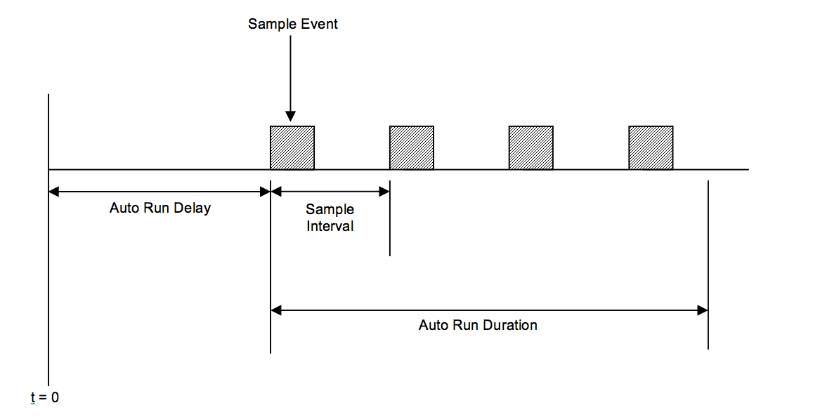

AUTO RUN MODE – This parameter can be set to ON or OFF. This must be set to ON in order for the GoProto controller to start capturing samples.

AUTO RUN DELAY – This is the amount of time the controller will wait before starting to capture samples.

AUTO RUN DURATION – This is the amount of time the controller will capture samples.

SAMPLE MODE – The GoProto controller supports three capture modes. For the Hero 2 camera there is a PIC mode for capturing still images and VID mode for capturing video clips. For the Hero 3 camera there is an HR3 mode that powers the camera up at which point an, “autoexec.ash” file takes control of the camera sampling.

SAMPLE INTERVAL – This is the amount of time between start samples.

SAMPLE DURATION – This parameter only applies only to the VID and HR3 mode. In the VID mode this defines the length in seconds of the captured video clip. In the HR3 mode this defines the amount of time the GoProto will keep the Hero 3 powered up. It is up the user to make sure that the autoexec.ash script completes execution in this time.

LED ON DELAY – The delay in seconds that LED light relay will wait to turn on after the Hero 3 is powered up. It is up to the user to determine the correct LED ON DELAY. This parameter is only used in HR3 mode.

LED ON DURATION – This defines the duration in seconds that the LED light is powered on. This duration will vary depending on the contents of the autoexec.ash script. It is up to user to determine the correct LED ON DURATION. This parameter is only used in HR3 mode.

GoProto Configuration Examples

Hero 2 PIC mode example

The following is an example of a configuration that will start capturing still images five minutes after the GoProto controller is reset or power is applied. It will capture an image every two minutes for one hour. This should result in thirty images total.

AUTO RUN MODE : ON
AUTO RUN DELAY : 300 SEC
AUTO RUN DURATION [DFLT] : 3600 SEC
SAMPLE MODE : PIC
SAMPLE INTERVAL : 120 SEC
SAMPLE DURATION [DFLT] : 0 SEC
LED ON DELAY [DFLT] : 0 SEC
LED ON DURATION [DFLT] : 0 SEC

Hero 2 VID mode example

The following is an example of a configuration that will start capturing video clips five minutes after the GoProto controller is reset or power is applied. The video clips will be thirty seconds in length and be captured every two minutes for one hour. This should result in thirty video clips total.

AUTO RUN MODE : ON
AUTO RUN DELAY : 300 SEC
AUTO RUN DURATION [DFLT] : 3600 SEC
SAMPLE MODE : VID
SAMPLE INTERVAL : 120 SEC
SAMPLE DURATION : 30 SEC
LED ON DELAY [DFLT] : 0 SEC
LED ON DURATION [DFLT] : 0 SEC

Hero 3 HR3 mode example

The following is an example of a configuration that will execute a Hero 3 autoexec.ash script five minutes after reset or power is applied. The autoexec.ash script will have thirty seconds to execute and power down the camera. The LED will come on five seconds after the camera is powered on and will stay illuminated for a total of five seconds. The following configuration repeats this sequence every two minutes for a total of two hours. It is up to the user to verify that their autoexec.ash script can meet all the timing requirements defined by the configuration parameters. This should result in sixty samples of whatever the autoexec.ash script is programmed to capture.

AUTO RUN MODE : ON
AUTO RUN DELAY : 300 SEC
AUTO RUN DURATION : 7200 SEC
SAMPLE MODE : HERO3
SAMPLE INTERVAL : 120 SEC
SAMPLE DURATION : 30 SEC
LED ON DELAY : 5 SEC
LED ON DURATION : 5 SEC

