How To Guide
Owner’s Manual:
Housings for GoPro/ Sony :
This housing is machined out of a solid block of aluminum. A third party lab has tested this case at different depth, in a vacuum chamber. The housing did not implode until it reached 6,500 psi or about 14,000ft deep. While these figures represent the ultimate fail-point, we recommend using this case at a maximum depth of 9,000ft or 2,750m. The case is made up of these parts:
1) The housing (ScoutPro/ Abyss Pro)
2) The lid
3) Glass lens
4) Glass lens holder
5) Set of foam pads
6) Set of O-rings
7) Set of screws.
The O rings, glass lens and glass lens holder are already pre-installed. DO NOT remove the lens unless you absolutely must. If you have to remove the lens holder/lens, please be extremely careful when inserting the lens back into the lid. DO NOT OVERTIGHTEN ANY OF THE SCREWS. This can lead to O-ring failure or breaking the glass lens!!!!
The ScoutPro/Abyss Pro are compatible with the GoPro J-hook mount, the handlebar mount and the VideoFins mount.
YOU MUST TEST THE HOUSING AS SOON AS YOU RECEIVE IT. WHILE WE SHALLOW WATER TEST ALL HOUSINGS PRIOR TO SHIPPING,TAKE THE EMPTY HOUSING WITHOUT THE CAMERA AND PLACE IT IN A BUCKET OF WATER. LEAVE THE HOUSING IN THE WATER FOR SEVERAL HOURS. RETRIEVE THE HOUSING AND INSPECT IT FOR WATER INTRUSION. IF THERE IS ANY WATER IN THE HOUSING, PLEASE CONTACT US IMMEDIATELY.
Maintenance
After each use, rinse the outside of the housing with warm fresh water. Avoid getting water in the case. The glass lens can also be cleaned with fresh water. Do not use any chemical cleaner as it could ruin the O-ring. Verify that the o-rings are clean, in good shape (no tear, no twist, etc.) and no sand, dust or other particles are in the O-ring groove. If you must take the lens and lens cover apart, make sure the o-ring is not torn or twisted. The O-ring groove should be clear of any particles and water. When re-assembling the lens and lens cover,DO NOT OVERTIGHTEN THE SCREWS OR THE GLASS WILL BREAK. DO NOT LUBRICATE THE O-RINGS. MAKE SURE THE O-RINGS AND THE O-RING GROOVES ARE CLEAN AND DRY.
It is critical that the inside of the ScoutPro / Abyss Pro housing is absolutely dry prior to using it otherwise condensation may develop and it will cloud your camera lens. Adding a small silica bag in the ScoutPro / Abyss Prowill prevent the fogging of the GoPro lens.
A note about the ScoutPro /Abyss Pro Housing :
The ScoutPro is specifically for GoPro Hero / GoPro Hero2 or GoPro Hero3. To use it, simply turn the GoPro on, put it in the housing and place the lid cover on the case. Insert the screws and tighten down with an allen wrench. DO NOT OVERTIGHTEN THESE SCREWS.
The housing is extra deep so that the GoPro Hero 1/2/3 camera can be fitted with an extra battery or an LCD display or a Wifi Back. The extra battery will let you shoot almost twice as much footage (as long as your SD card has the capacity). The LCD pack is nice if you want to review the footage as soon as you have retrieved the camera (such as when you want to check the visibility) . The Wifi allows you to turn the camera on or off and control several GoPros at once. The Wifi pack will operate the GoPro even if the GoPro is enclosed in the ScoutPro case! This is a great feature because you don’t have to take the ScoutPro case apart to turn the GoPro off. The Wifi range once the GoPro is in the housing is 30ft (10m)
The ScoutPro comes with a set of 4 foam pads. Depending on how your GoPro is set-up, use a combination of the pads to ensure that the GoPro lens is right against SoutPro lens. The thickest foam pad has a hole in it so that a small silica bag can placed in it.
On the ScoutPro H3 (made for the GoPro Hero3), you can take the lid and place the camera lens directly into the port. The tolerance are tight enough that the GoPro Hero3 will be held in place. This will also minimize cropping.
The Abyss Pro is made for the Sony HDR-AS10 and HDR-AS15. The same rules that are applicable to the ScoutPro apply to the Abyss Pro.
Using the kit.
If you have also purchased the VideoFins and some of the optional accessories, you will need to decide how you want to deploy it. This kit can be used for stationary observation, drifting or trolling.
Stationary Observation.
As the name implies, this method is used for passive observation. The two ways this can be achieved:
On the seafloor/riverbed:
The camera housings are used with the optional tripod. The tripod is mounted on the bottom eyebolt, between the embedded bolt and the screw hole. The rudder piece of the kit CAN be omitted if desired. The diver can place the kit with the camera housing on the seafloor, pointing the camera system in the desired direction. Ideally, the housing either faces or follows the prevailing current. The current should not hit the camera system broadside without additional anchoring points.
If there is any chance of the housing being swept away, we recommend using a parachute cord (500lb test) and a spike. Tie the parachute cord with the spike to the bottom eyebolt of the VideoFins. Bury/drive the spike in the seafloor/river bed.
Above the seafloor/riverbed:
When stationary observation within the mid-or upper water column is desired, a buoy is used. There are three options:
1) In stronger current, an anchor is deployed to hold the buoy in the current. From the buoy, the VideoFins and housings are hung at the desired depth. If the current is consistent, such as in a river, the buoy and camera system may sway laterally to a certain extent. In a tidal situation, the movement of the buoy is dictated by the scope of the anchor line. The longer the anchor line, the greater the buoy’s movement.
2) If there is little or no current, an anchor is not used. Instead, the buoy remains stationary with the help of a heavy weight. (weight lifting/scuba diving weights/fishing weights. Fishing tackle stores usually have very large weights up to 50 oz ) This weight is directly attached to the eyebolt with a 40/50lb leader . The bottom weight should not exceed 25lbs.
3) In very heavy current (or tide) or when the movement of the camera must be restricted as much as possible, the combination of the two methods above is suggested.
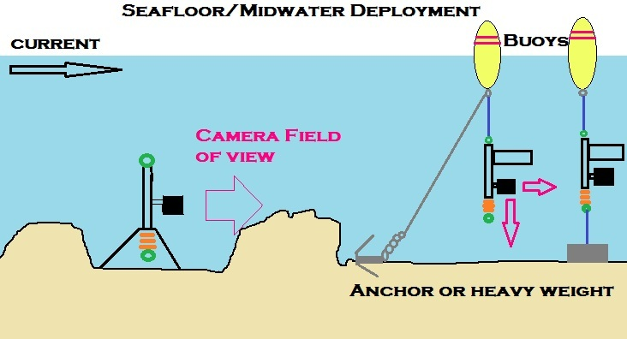
Drifting Observation.
Drifting aboard a kayak, or boat remains a very inexpensive to cover a very large area. Regardless of which method you decide to use while drifting, there are several common factors to consider:
1) The line used to deploy the camera system under water is critical. We recommend at least 200lb test. The best line we have found so far is Kevlar and/or spectra fishing line. This line is extremely thin and very strong. Some of these fishing lines are hollow which prevents the line from “digging in” in the reel and is splice able. The thin diameter also creates less drag. While drag is not important when in shallow water, it becomes a real factor in deeper water. Ultimately, especially when trying to shot a video of a very specific location such as a shipwreck, you want the camera system to be as directly below you as possible, regardless of depth.
2) Situational awareness is the term used to describe the understanding of where in the water the camera is, in relation to the boat, the seafloor ,and whatever it is you are trying to video. Since there is no “live feed’ from the camera, you must develop this awareness. While it may seem difficult in theory, it is not. It does take a bit of practice, that’s all. To expedite the learning curve, here are a few tips:
a. Use additional weight. In addition to the provided weight, get a 3-5 pound weight from the tackle shop. A round ball or cylindrical is preferable. Tie a 2-3 foot section of 40-50lb mono fishing line to the bottom eyebolt of the camera system. Tie the additional weight on the end of that section. (The reasoning behind a lower strength mono line is that in the event your camera gets caught in a structure, you want that section with the heavy weight to break first, hopefully freeing your camera system in the process.) This additional weight will help you “feel” when the camera system has hit the seafloor. Practice in shallower water first (ie 100-200ft). The deeper you get, the more subtle it will be, especially in heavy current. The main visual clues that the camera system is on the seafloor is slack line and no line is getting pulled from your reel. Additional weights also ensure that the camera system is as vertical as possible (in relation to your boat). If your line is completely vertical, you will know what the camera is pointing at. (More on that later). Also, if the camera system is directly below the boat, it is often picked up by the sounder (fishfinder). This helps you confirm the system’s position within the water column. Once you get in deeper water, you will need additional weight. The weight required depends on two factors: depth and speed of the current. Here in the Floridian gulfstream, I cannot hold bottom with 10 LB weight at 600ft. I need at least 15lb. The deeper you go, the stronger the effect of the current, the more weights will be required.
Finally, once you have develop the feel, you will be able to tell when the weight has hit the bottom so precisely that you will quickly stop the line and lift the rod tip up as to prevent the camera system from hitting the seafloor. This will lessen the number of scratches the ScoutPro and VideoFins. If you are using an additional weight (highly recommended) that is dangling down from the bottom of the camera system, it will be your early warning system. Think of it as a probe.
b. Use a fishing rod/reel. The rod enables to have a greater reach such as when you need to get around the boat motor, or a lobster buoy, etc. The fishing rod itself amplifies subtle hints felt by your hand. When the camera system hits a soft, sandy bottom, it will feel a bit mushy but not overly. When the camera system is dragging through weeds, your hand will feel a pull and release sensation. When you are on gravel/small rock bed, it will feel like going through weeds but without the mushiness. It will feel more like a tic-tic-tic; very distinct and sharp. When the line itself (not the camera system) is going over something such as a cable above a shipwreck, you feel the line rubbing against the cable. Knowing the type of bottom you have encounter may help you decide how far up you want to bring the camera system. On a sandy bottom, you may want to bring the camera up 3-4 feet from the seafloor; in weeds, maybe 4-10 ft; same for jagged rocks…
c. Despite using the thinnest line available to deploy the camera system under water, the system may end up 50-150 yards behind the boat when you are trying to record videos 600+ feet deep. In such instance, you may have to retrieve the camera system to slightly change the camera’s angle to capture the video you want.
d. Camera’s angle. Unless you want to capture videos of the seafloor only, there is a bit of a learning curve as far as angling the ScoutPro / GoPro correctly on the VideoFins. Always keep in mind that if you set the angle of the camera based upon having the VideoFins absolutely vertical, once in the water; the system may be slightly tilted upwards, hence the camera’s field of view will not be what you anticipated.
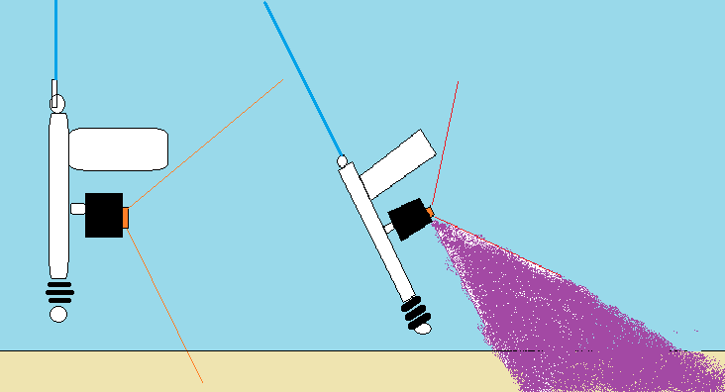
The orange line represents the camera’s field of view. The purple area represents what the camera will not capture on video. Placing an additional weight tied to the bottom eyebolt prevents the tilting of the camera to some extent. If I am deploying in very heavy current such as when in the gulfstream, I will let the camera system go down about 25 ft and stop it there. I then watch how far back it is being pulled, taking note of the angle at which the line is entering the water. If the line is entering the water at a 20 degree angle, I retrieve the camera system and readjust the camera’s angle by half of the line’s angle or 10 degree DOWN in this case. This has served me well. This is a trial and error process. You will learn this faster just by shooting lots of 5-10 minutes clips while changing the angle of the camera. This allows you to understand the relationship of the video camera’s angle vis-à-vis VideoFins and the video you are actually shooting.
e. Understanding how to establish and change the depth of camera system is critical. Your first point of reference is when the camera system hits the seafloor and the line becomes slack. From there, you can adjust the depth by reeling in some line. On all reels, the manufacturers list the amount of line being retrieve each time the reel handle makes a full circle. For example, a reel may retrieve 24”(2ft) of line per turn. So if you want to place the camera 8ft above the sea floor, the reel’s handle must be turned 4 full revolutions. If you have an additional weight dangling 2 feet from the bottom eyebolt of the camera system, factor that in ( In this case, you would do only 3 full revolutions. )
When the seafloor is jagged, you will need to reconfirm your depth several times during a drift. You do that by engaging the reel in free spool and letting the camera system hit the seafloor. Once again, turn the reel’s handle 3 full revolutions. The object is to follow the seafloor contour.
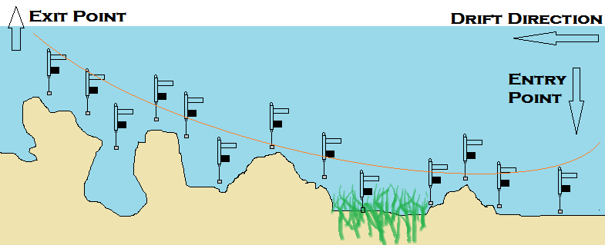
A fish finder provides so much visual data in deciphering the seafloor topography that I would consider it as a “Must have”. The cost of a fish finder ranges from under $75 to several thousands of dollars. Even the most basic one will display the contour of the seafloor (or river,lake.etc) at least in shallower depth. The lower cost fish finders will not work at greater depth (500+ feet). By looking at the seafloor’s contour on the fish finder, you will know when to let the camera system sink deeper or raise it .
Since most fish finders come with a GPS function, you will be able to record the long/lat coordinates when the camera system was dropped overboard and it was retrieved. So for example, on drift number 546, the camera system was dropped in at 57 15 31.66N /4 30 0.02W and retrieved at 57 16 07.06N/4 30 9.11W. If you also note the time at the entry and retrieve point, you will have enough data to be able to revisit something interesting that you may have captured on video.
Deploying the camera system
1) The easiest way to deploying this system is to attach parachute cord to the swivel on top of the camera system. Military grade parachute cord is very strong (500lb test). This method is feasible for shallower water (5-30ft). At deeper depth, be mindful that the diameter of the parachute cord is fairly thick and will create quite a bit of drag. This in turn tilts the camera up. I used what is called a Cuban YoYo reel to store the parachute cord. This reel is nothing more than a plastic spool. I use the camera system with a yoyo reel to record fish movement in the inlet from a bridge. The camera system, camera and yoyo reel easily fit in a small backpack.
2) Using a fishing rod and reel is the most convenient way of deploying the system. The rod should be stiff, 60-80lb class. Sometimes referred to as “Tuna sticks”, these rods can be picked up on Craiglist/Ebay for under $50 or so, especially the older fiberglass rods. New graphite rods range from $200-500 on average. If buying used, make sure that the inside of the guides (little metal hoops on the rod) are smooth and have no nicks or jagged edges. (Jagged edges may cut your line). The reel should be a conventional reel (looks like a small pop can on its side), not spinning. The main concern on reel is capacity. The reel capacity will depend on the diameter of the fishing braided line you will put on the spool. Since we recommend at least 250lb braid, the choice of reel is going to be limited to “big game” reels. The capacity of the reel should be at least 50% greater than the depth at which you plan on shooting your videos. Some if you plan on shooting at 200ft, the reel capacity should be at least 300ft. Keep in mind that there is no liability in having more line than you need. You can use what is commonly known by fisherman as 30 wide, 50 wide and 80 wide. I use the 30W for 400ft depth and less, 80w for 800ft depth.
If you are using a rod and reel combo to lower the camera system in the water, you should hold the rod all times. If you are drifting and the camera system is above any obstruction, you can leave the rod in the rodholder.
3) For over 800ft, I use a commercial reel known as a “Bandit Reel” . These are commercial grade large fishing spools mounted on a stand. I’ve pick one up used on Ebay for $125 and they are available new on the web for $350-800. A rod is not needed if using a Bandit reel. Bandit reels were designed for Deep-drop fishing (bottom fishing at extreme depth) so they are ideally suited for this. They are very durable, have plenty of capacity and a high retrieve speed (3-4ft retrieve per handle turn). An electric motor can be added to these reels. However, due to the exposed belts etc, they are dangerous pieces of equipment and should be treated with the outmost respect. If you are going to shoot videos in 2000ft+ on a regular base, an electric bandit is probably the best way to go.
4) Self-Contained Electric reels are the nec plus ultra. Connected to the boat’s 12 volt system via a plug, these high capacity reels retrieve the camera system and weights by the push of a button. Something anyone will appreciate after manually reeling in 2000ft of line (with the camera system and 15-20lb of weights). Electric reels are expensive, about $2000 used and $3000-5000 new. While they do not have the capacity of a Bandit reel, they are good for about 2500ft.
5) Drifting with buoy. Feeding frenzy on the surface such as when tuna feed on mackerel /sardines/anchovies is an incredible sight to witness. This type of action can be difficult to video since these both bait and predators sound when a boat get to close. One way to capture such amazing footage is to tow a buoy far behind the boat (200-300 yards) behind the boat. If two camera kits are used, let’s say one 10 feet deep and the other 40 feet deep, it will allow you to capture other predators that may lurk below. More on this technique later.
6)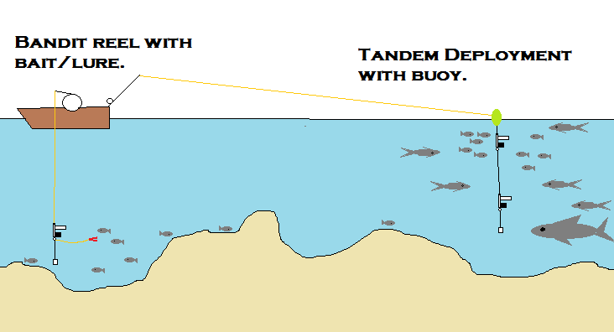
Trolling
This set up can be trolled with an optional trolling weight. You can get the weight at a fishing tackle shop. These weights are called “In line trolling weights”. You are looking for weights that are at least 24oz. Attach the trolling weight swivel on the bottom of the eyebolt and the screw hole right next to the bolts holding the rudder on the VideoFins.
Trolling speed is restricted to 5 knots.
How can you tell how deep the system is?
Let’s say that in you are in 800ft of water, but you want to put the camera system only 100ft deep. There are two ways you can achieve that. The first one (and the easiest) is to buy a fishing line counter. This is a little gizmo that you can buy for $15 online. This gadget is attached to the rod and the fishing line is guided through it. As the fishing line is pulled out of the reel, the counter display how many feet have gone out. The second way (and the cheapest) is to simply mark the fishing line with a marker. Every 10 feet has a small black marking. Every 50ft is marked with a long black spot. Every 100ft is marked with a small red spot; every 500ft is marked with a long red spot. Every 1000ft has a small green spot. See table below. However, remember that sun and water fades the spots over time. Also, should you have to cut the line (because it is frayed, etc) , all the markings will be off. This works best for shallower water.
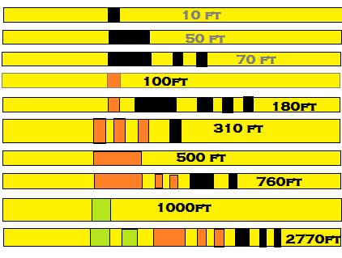
LINE COUNTER PERMANENT INK MARKINGS
Got stuck …now what?
Sooner or later, you will get the camera system stuck on a structure. Many time you will be able to retrieve the camera system back just by reversing course and pulling the camera from the opposite angle. If you decide to reverse course, DO NOT STOP AND BACK THE BOAT UP! You may risk getting the line caught in the propeller, losing the camera system and damaging the motor at the same time… Instead, make a large loop and take a 180 degree heading from your original course. For example, on the picture below, the camera got stuck on the red dot. (boat position 1). The boat makes a large loop AWAY from the stuck camera system. (boat position 2,3 and 4). Keep a close eye on the line, making sure that it is away from the prop. When performing this maneuver, I usually do not keep the camera system line taut; I give it a lot of slack instead. However, I have not been able to confirm if keeping the line slack give you a better chance at retrieving the camera system. Once you can pull the camera system from the opposite angle (boat position 5) , give it a slow but firm tug. Remember that the line you put on the reel should be at least 200lb test. That should give you plenty of pulling strength. ***WARNING: DO NOT PULL ON THE FISHING ROD SO HARD THAT IT MAY CAUSE THE ROD TO BREAK. THIS COULD RESULT IN SERIOUS INJURY TO THE OPERATOR!!****
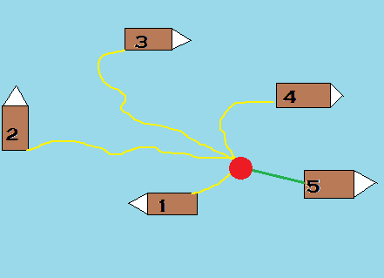
If it doesn’t work on the first try, keep on pulling from different angles. Sometimes it takes me a dozen of tries before I get the camera system back. If you are in shallower water (under 200ft), instead of breaking the camera system off, you may want to cut the line, and tie on a buoy. You can then return with a qualified diver to retrieve the system. I’ve done just that once (200ft deep) and it cost me $50 and lunch. Don’t forget to mark the buoy’s location on your gps or fish finder.
Avoiding getting stuck
Exploring a shipwreck is by far the most technical situation. If you can get in and out of a shipwreck on a fairly consistent basis, you should be able to handle natural formations on the seafloor well. The method described below works well with an unfamiliar seafloor, lakes, rivers,etc
The safest technique involves making a series of passes over the shipwreck (or area). Since you will be drifting, it is key that you lower the camera system at the exact same spot at the beginning of each drift. You want the boat (hence the camera system) to take the same exact path each time.
(The location of shipwrecks in your area is usually listed in fishing charts as well as scuba diving charts. Maritime authorities also do keep an update list of shipwrecks.)
If the shipwreck is located in 200ft, keep in mind that the ship’s structure may be 40-50ft above the seafloor. So the first pass will be made at 200-50- the first safety buffer or 50 feet (yours may vary). So the first pass is set at 100ft. Once the drift completed, review the footage (look for masts, cables, etc) . If there is no unforeseen upright structure, return to the exact same starting point of your first drift. On the second drift, lower the camera a bit deeper, let’s say 125ft. Again, review the footage to make sure that you will be able to safely lower the camera system even lower on the third drift. On the third drift, lower the camera to 150ft.
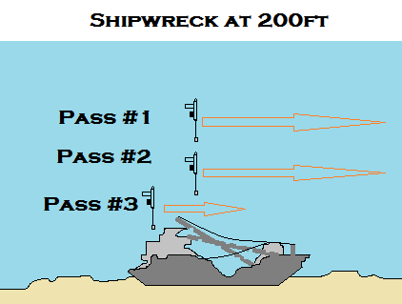
The point being that you incrementally change the depth of the camera system once you are reasonably assured that you will not get hung on the structure. You can also make several passes at a safe distance from the wreck (100ft in this case) from different starting points. This will give you different perspectives of the wreck and a better understanding of it lays on the seafloor. Once you are comfortable with how the shipwreck is laid out, you can go deeper, right into the shipwreck. Obviously, there is always the possibility that you may lose the camera system for ever, especially if the wreck is beyond the reach of recreational/tech divers. (about 250ft). On the reward side, you will get some incredible footage. I have shot videos where the whole camera system goes right into a ship’s stack… Many of these shipwrecks are out of the divers’ range yet easily accessible with this set-up.
Of Visibility
Visibility will always be a key factor. Sometimes the visibility is absolutely perfect, at other time it is so bad that it is not worth shooting videos. While it may look crystal clear on top, it may be a veritable sediments/plankton soup 20 ft below. Just send the camera down, stopping the descent at 20 or 30 ft intervals. This will allow you to know how much visibility there is at different depth when you review the video. Sometimes the visibility improves as you get closer to the bottom, sometimes it does not.
The key here is to have back up plans for each outing. If the visibility is too bad in shallow water, I will head in 200-300 feet of water, if it also bad there, then I’ll go in 600+ feet.
Of Current,Winds and Tides
Fish move with the tides. When shooting video in an inlet or other tidal water, it is usually best on the incoming tide. The incoming tide brings in clearer water along with baitfish and predatory fish. The outgoing tide flushes out all type of debris/silt from the tidal water to the ocean. This usually creates bad visibility. On the incoming tide, I usually set up inside the inlet, while I typically set up outside the inlet on the outgoing. Keep in mind that this is what I do here (Port Saint Lucie Inlet) because the tannic /fertilizer-laden water coming out of the Okeechobee Lake and into the inlet. The slack tide after the high tide is generally good for shooting videos. However, it seems that marine wildlife is more dispersed during a slack tide. When the tide is moving (in either direction) fish/ marine wildlife seem to follow certain patterns. Usually, they follow the path of least resistance (or current in this case). In an inlet, the tidal surface current is much faster in the middle than on either side of it.
While the effect of tides further out in the ocean has a less drastic impact, it should be taking into consideration if you want to shoot videos of a very precise area of the seafloor. If I want to shoot a video of a shipwreck and intend on bouncing the camera right on it, I wait for a slack tide.
Certain sea current such as the Gulfstream are constant in the direction they move. The speed of the current itself can change daily. Since you will drop the video system overboard to check for visibility, take note of what the current is also doing. The current at the surface is generally faster than on the bottom.
Wind direction and speed will also play a great factor when drifting. The speed of the wind seems to be less early in the morning and when the sun goes down. Sometimes, I’ll use a sea-anchor to slow down the drift speed. A sea anchor is nothing more than a small underwater parachute. Sea anchors are available online for less than $40.
Shooting in the dark
Shooting video in 250+ feet deep will require additional light. There are quite a few compact scuba diving flashlights available that will go 500-600ft deep and a few that will go 1000ft deep. There are no self-contained lights that go beyond 1000ft to my knowledge. (We are building a prototype that will go 10,000ft+).
If you are going to use a scuba diving light, we have found that LED flashlight to be better. Since your POV camera has a wide angle, you want to have a flashlight that throws a wide light beam (80+ degree). Avoid pencil beam lights. Some scuba diving lights are tubular so they can be attached on the VideoFins with a clamp. While not the most elegant solution, I’ve also used waterproof duct tape to tape the flashlight directly to the ScoutPro case. (Make sure you wrap it well!)
Attracting marine wildlife to your camera
The easiest way to attract fish is to chum. Chum is usually made up of fish part or whole bait fish such as menhaden. Tackle shop usually carry frozen chum bags. If they don’t have chum bags, you can make your own by grinding frozen sardine, butterfish, mackerel, squid or whatever bait the tackle shop has for bait. If you are going to chum a lot, get a chicken wire chum basket. These are also available online for under $20. These wire chum basket are great if they are going to be deployed on the seafloor. Another alternative is to buy pre-made dry chum available on line. They are available for both fresh and salt water.
You can also tie a series of hooks baited with squid, shrimp, baitfish, etc. If you do not plan on keeping the fish, and using the hooks only to hold the bait, you can cut the hook’s point and barb off as to minimize the damage to the fish. If you want to keep the fish, use the appropriate size circle hooks.
You can also use live bait such as mullet, blue runner, greenies, etc. Shooting a video with a live bait is difficult as the baitfish will swim in and out of the camera’s field of view. You minimize this by using a longer leader (6-8 feet, I know, it sounds counter intuitive).
You can also think out of the box to attract fish or other marine life. For example I’ve always been fascinated by how squid and cuttlefish seem to communicate by changing colors. It would be interesting to deploy a waterproof LED board and program a light pattern . (Update: This has already been done! Dr Edith Widder, the famed marine biologist, designed an LED attractant based on the groundbreaking studies she has done of bioluminescence. It is with her invention that she was the first to get footage of a live giant squid.)
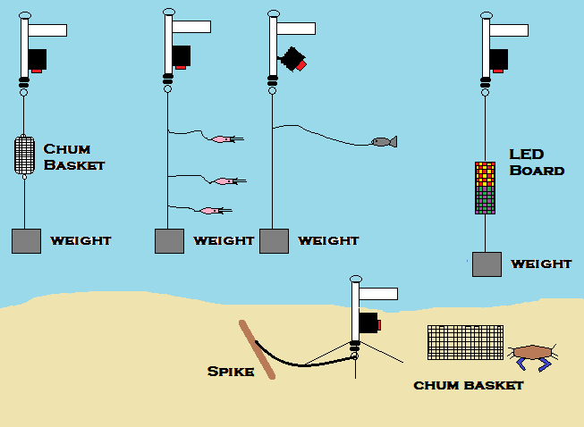
Natural set ups
If you do not want to create an artificial situation by using chum, you still can shoot great videos. The more you understand fish (or marine life) behavior, the better you will be at finding fish. I’ll quickly share what I’ve learned as an avid fisherman. Fish are driven by 3 factors: 1) Food 2) Survival 3) Reproduction. That’s it. So, a fish’s sole purpose in life is to eat and reproduce before it get eaten. Since reproduction occurs during certain time of the year, we’ll leave that one alone for now.
A mullet for example will go far up in tidal water to eat microorganism and algae. You can see them at high tide on the flats. Jack Crevalle, snook, tarpon, etc will follow the mullets. These predators however do not stay on the flats. Instead, they cruise in slightly deeper water, which offer them protection (osprey,etc) . They dart in and out of the flats only when there is a reasonable chance that they can catch mullet. Meanwhile, a bull shark will cruise the deeper channel, looking for the jack, snook or tarpon. Keep in mind that “deep channel” is relative. I’ve seen 8+foot bull shark cruise in less than 6 feet of water….
The scenario is the same in the deep sea. As soon as the sun goes down, trillions of copepods rise towards the surface. The copepods are preyed upon by squid, which in turn get eaten by swordfish and other pelagic fish.
In freshwater, even during the winter time, midge flies start to hatch during the warmest part of the day. Once the hatch begins, the trout start to feed.
Nature can also be cyclical and predictable. Each year, mass migrations of baitfish such as mullet or sardines move up and down the coast. Predatory fish follow in tow.
While these are oversimplifications, it illustrates how everything is interrelated. Find the food source and you will find fish.
During the reproduction cycle, marine life congregates in specific areas. Sometimes it takes places in spring. For example, spinner sharks assemble each spring on the SE Floridian coast . They invade the shallow shores in massive schools (1000+). In the fall, steelheads stage right outside the Great Lakes tributaries. Once the water level reaches a certain level, these steelheads go up their native streams and creeks to reproduce. Either scenario represents a great opportunity to shoot great videos.
This is not an end-all, be-all guide. Instead, it will be a continual work in progress. If you have any pointers and tips, please feel free to share it with us and we will add it to this guide.

We are looking for distributors and affiliates. Please contact Frank Betoulaud email:frank at Groupbinc.com Tel: +1 772 631 0411

