Species that Henry Ruhl has length vs biomass data for:

Amperima:

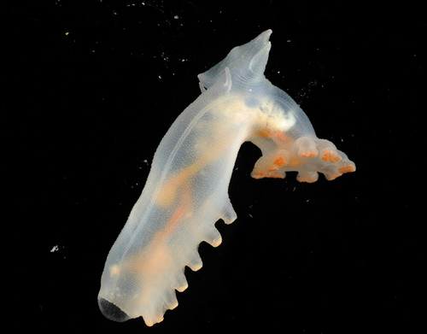
Amperima sp. (http://ecomar2010.wordpress.com/)

Deima:

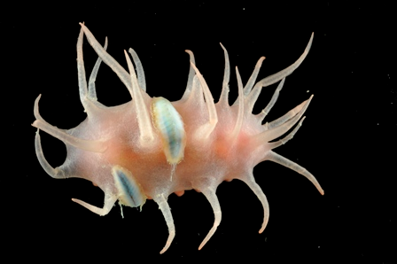
Deima validium validium (http://ecomar2010.wordpress.com/)

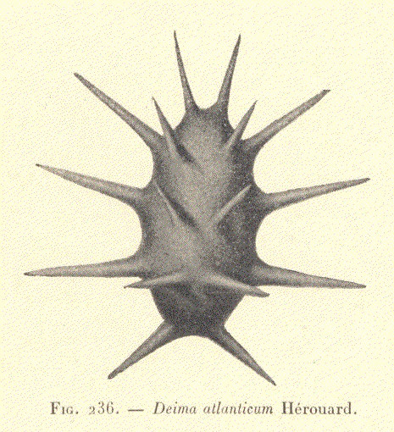

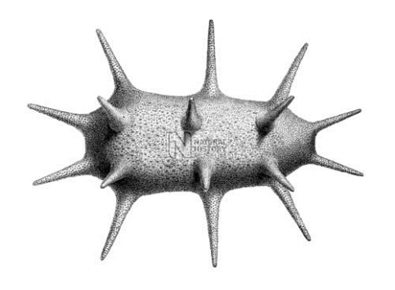

http://piclib.nhm.ac.uk/results.asp?image=035456&itemw=4&itemf=0001&itemstep=1&itemx=2

Ellipinion or Kolga (Genus level):

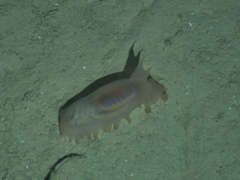
Ellipinion new species (http://ecomar2010.wordpress.com/)

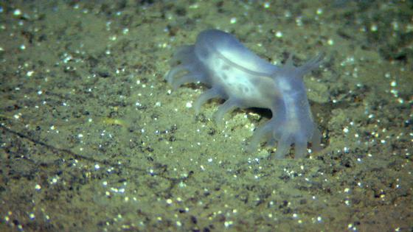
Kolga hyalina (http://www.imr.no/nyhetsarkiv/2009/november/2700_meter_under_havets_overflate/en)

