Research Collaboration in South-Central California Federal Waters

This document describes the research goals of the existing Bureau of Ocean Energy Management (BOEM) and United States Geological Survey (USGS) Department of Interior Intra-agency agreement and proposed areas of collaboration with Monterrey Bay Aquarium Research Institute (MBARI). The overarching goal is to establish a geologic and ecologic framework around an area of interest for the development of a floating windfarm in Federal waters off Morro Bay, California. Multiple floating wind devices generating electricity is of interest to the State of California and though operational in Scotland and Japan, this technology is unproven in the United States. Emerging companies pushing this development forward lack the deep financial support as compared with oil and gas development offshore. To ensure that this new technology is implemented in an environmentally sound way, MBARI, USGS, and BOEM are proposing to further our existing partnership to characterize regional geohazard and baseline biological communities. We feel this project will ensure that siting of these facilities incorporates surficial and subbottom geological processes as well as a regional baseline understanding of the seafloor-related habitats and fish and invertebrate communities.

This document explains the planned cruises for 2018 and is a proposal for the continued collaboration of MBARI, USGS, and BOEM staff time, equipment, vessels to collect sediment cores and visual survey data of the surficial geology and benthic biological communities. We hope to begin surveys and analyses in the first half of calendar year 2019.

BACKGROUND

The potential direct, indirect and cumulative impacts on the human, coastal and marine environments must be evaluated in order for BOEM to make environmentally sound decisions about managing energy activities and developing mitigation measures to avoid or minimize impacts. The BOEM Environmental Studies Program provides funding for numerous studies to provide up-to-date information necessary for agency analysts to adequately address potential impacts in environmental impact statements and environmental assessments under National Environmental Policy Act. The State of California is actively engaged with BOEM in planning of siting of offshore energy projects within Outer Continental Shelf (OCS) regions. These projects will need to interact with the seafloor over many kilometers and thus BOEM has a critical need for identifying active seismic faults, seafloor mapping and site characterization data to then evaluate the structural integrity of proposed energy projects and also the environmental impacts to seafloor habitats. Geophysical and geological data acquisition and interpretation methods provide baseline maps of the physiography of the region needed to assess geology and habitat, and model processes. Previous high-resolution mapping has been conducted using these systems in other Pacific OCS areas however there is a lack of high-resolution sub-bottom and seafloor data in the south-central OCS offshore of California. Potential developers indicated interest in areas further offshore, due to higher wind resource potential, reduced visual impacts, and also to minimize fishing conflicts.

The geographic scope of this research, is focused on the south-central portion of California at depths of 500 to 1100 meters, approximately 2000 km², lying in Federal waters on the outer continental shelf offshore. The latitude and longitude boundaries of the area of highest interest are shown in Figure 1. The seabed in this area is likely composed areas of fault uplifted bedrock outcrop and mud on the shelf, with rocky outcrops on the shelf break and upper slope. Nearby data suggest the potential for hydrocarbon seep-related carbonates or tar.

MBARI, USGS, and BOEM have already begun to collect data for this region. Our partnership highlights USGS’s ability to conduct regional site surveys using conventional multibeam echo sounders (MBES), and MBARI’s capacity to follow up with higher-resolution AUV and ROV technology. All three groups selected a location for a one day of MBES 20 m collection in November 2017. This enabled a follow up cruise planned by Charlie Paull in April 2018 to utilize an AUV for high-resolution subbottom imaging. USGS and BOEM are also planning to collect 20 m grid resolution MBES data and high-resolution multichannel seismic (MCS) survey using a USGS sparker seismic source and multichannel streamer system for this entire region by October of 2018. Guy Cochrane at USGS is the lead principle investigator for this cruise and supported by Maureen Walton focusing on the subbottom imaging collection. The BOEM contact is Lisa Gilbane.
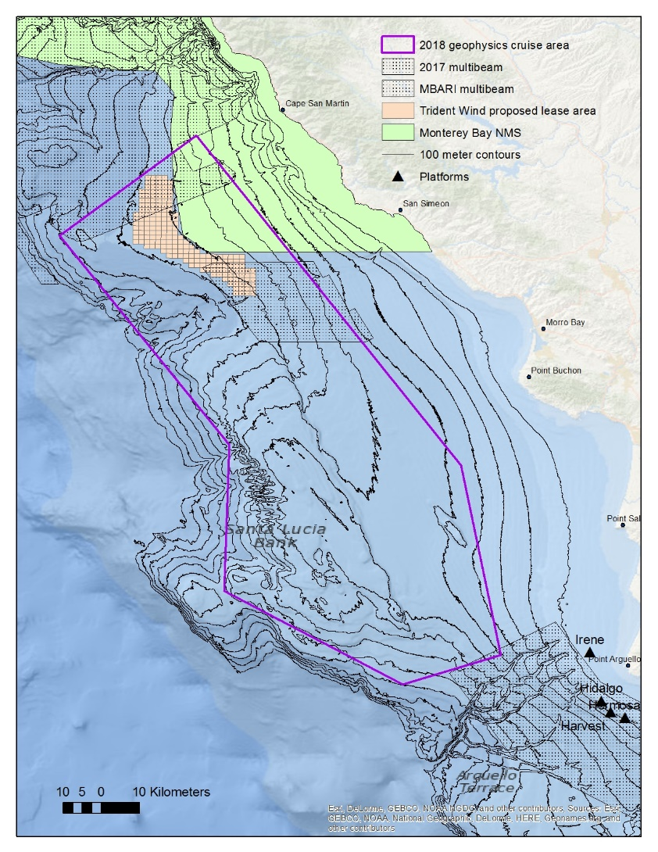

Figure 1. Study area. Multibeam echo sounder data and high-resolution subbottom imaging surveys in this area are expected to be completed by October 2018.

2018 PLANNED CRUISES

April 2018 AUV surveys of selected regions – Charlie Paull, MBARI

MBARI is schedule to conduct up to six AUV surveys over a period of three days in April 2018. These surveys, each covering a region approximately ~8 km², will image small areas of the seafloor with ultra-high-resolution (1 m grid resolution) bathymetric data. The surveys have been designed to target small areas of high scientific interest, including areas with potentially active channel systems, faults, and pockmarks. Determining the long term impact of the existing telecommunicaitons cables within this area is also of interest. The AUV surveys will be used for future survey planning (e.g., ROV, coring, and sampling to be conducted in 2019 and later).

September 2018 regional geophysical characterization (MBES and sub-bottom seismic data) – Guy Cochrane, USGS

The planned September 2018 geophysical survey will collect baseline seafloor data that will be used to identify surficial geology, benthic habitats, fault structures, and other geologic features. The USGS will coordinate data acquisition using a multibeam echo-sounder (MBES) survey to collect bathymetry and backscatter data. The same survey effort will also collect high-resolution multichannel seismic (MCS) survey using a USGS sparker seismic source and multichannel streamer system. The NOAA Ship Rainier will utilize its own MBES survey equipment and operation is sub-contracted by USGS for 23 total days at sea in September 2018. MBES bathymetry and backscatter-intensity data will be collected relative to the WGS84 ellipsoid and post processed to the NAD83 horizontal datum and the NAVD88 vertical datum using the Geoid 2003 model. MBES data will be processed at approximately 10-meter resolution (dependent on final survey depths). MCS reflection data will be collected in conjunction with the multibeam survey, and USGS personnel will perform first-pass MCS processing at sea. Chirp data will also be collected along several contour-perpendicular transects, concurrently with MCS and MBES, to tie contour-parallel MCS lines together and to image structures at optimal orientations.

Data will be initially processed during the survey for the purpose of quality control and to aid in operational decision making. Final MBES data processing and analysis will be conducted by NOAA COS and archived at NCEI. Raw data will immediately available to all collaborators. Prior to the survey, the USGS will obtain any permits necessary from State and Federal agencies in order to legally operate sonar equipment in these waters. Marine mammal observers will be onboard during data acquisition if this is required by permit. The survey team will follow the procedures required by permitting agencies when marine mammals are in the survey area. A cruise plan detailing the specific survey area and data types to be collected will be submitted and agreed upon among all partners two months prior to field operations.

GOALS AND OBJECTIVES FOR 2019 GROUND-TRUTHING SURVEY

These studies start by conducting a reconnaissance of the outer continental shelf of south central California which is necessary for improving understanding of seafloor (benthic) habitats, geologic hazards, and sedimentary processes. Geophysical and geological data acquisition and interpretation methods provide baseline maps of the physiography of the region needed to assess geology and habitat, and model processes. The ultimate goal of the survey is to provide a regional scientific synthesis of the area using multiple data sources to develop comprehensive digital elevation models, habitat maps, and geologic maps, and process studies which are needed to address important issues associated with marine spatial planning, ecosystem assessments, geohazards, and offshore infrastructure.

Here, we propose a joint USGS-MBARI survey to collect ROV and piston coring data simultaneously during a 2019 survey in order to complete objectives of habitat maps, species observations, and geologic characterizations. Specific objectives of this study are:

- To improve the classifications for geologic and biologically-based habitat maps: Following the geophysical surveys in 2018, ROV video observations will be conducted. ROV transects will be planned at selected prominent habitats along depth stratums between 500 m and 1100 m to understand fish and invertebrate associate with prominent habitat types and surficial seafloor features in the region.
- To estimate the age of structures and understand the patterns of sediment transport and structural deformation: Sediment sampling with up to piston coring systems capable of collecting up to 10 m long cores will be undertaken.
- To analyze data and create joint publications, integrative mapping and modeling products: New and existing survey results will be used to update seafloor maps and to improve the resolution of near surface structure.

DESCRIPTION OF WORK FOR 2019 GROUND-TRUTH SURVEY

Goal 1. To improve the classifications for geologic and biologically-based habitat maps.

Obtaining visual imagery of the seafloor is important for accurately interpreting (i.e. ground-truth) the geological features generated from remote sensing data. A visual ROV survey is also needed to identify structure forming invertebrates and distinct species groups associated with the seafloor. Distinct benthic fish and invertebrate species are known to be associated with particular depths and geo-habitats. We propose a stratified ROV survey design that identifies species at two major depth classes; Shallow being 500 to 800 meters and a Deep component at 800 to 1100m. This ‘shallow and deep’ paired design will be repeated at up to five distinct known geologic surficial habitats including pockmark structures, channels, telecommunication cables, unconsolidated muds, low-relief hard bottom, and high-relief rock features. Species groupings, abundances, and possibly size classes can then be compared while factoring depth and geology. Other depths and transition areas identified from the sensor data will be acquired when transiting among the focus habitat and depth sites. This design ensures adequate visual sampling to ground-truth sensor data and maps of the surficial geology, invertebrate forming habitats, and distinct benthic species groupings. The additional stratified design ensures that depth and feature type can be factored and correlated with species presence and abundance. Understanding how species compositions change with the depth and key features, such as the presence of cables or rock, will enable preliminary predictions of changes associated with proposed development in this region.

ROV exploration and ground truth sampling will be conducted using two different ROVs. A cruise or cruise(s) utilizing the Doc Ricketts is being proposed within Charlie Paull’s internal MBARI project for 2019 in this area. The concept is that the data on for this effort will be jointly used to satisfy both goals. The Doc Ricketts dives will focus in the 800-1100 m range, where the miniROV is capable but less efficient.

We propose one cruise aboard a commercial vessel utilizing MBARI’s miniROV at depths ranging from 500 to 1100 m during the first half of 2019. The ROV will capture still imagery and high-definition video. Taxonomic experts at MBARI will than identify, count and size species found at these habitats onboard and later onshore. The cruise utilizing the MBARI’s miniROV to focus on approximately ten 12-hour ROV days (daytime operations) to focus on ten sites within 500 to 1100 m areas with pre-identified surficial geologic features repeated at a shallow and deeper depths at a similar latitude. This breaks down to one site per 12hr day. There will be multiple transects planned within a site. We anticipate fewer hours are needed at some sites and that time will be used to collect imagery where the sensor data show a likely transition between two surficial geologies. This design and estimate is based on 3500 m of linear bottom coverage per 12 hours at 500 m depth, and 3000 m per 12 hours for 1000 m depth and needs verification from MBARI staff with experience aboard the mini-ROV. Final design is dependent on confirming the operation specifications and linear distance of the ROVs from MBARI staff, with final survey regions to be defined following preliminary processing of geophysical data collected in 2018. The final design will be agreed upon by all partners and all roles must be clearly established two months before the cruise date.

We propose MBARI lead the biological data collection effort utilizing their equipment in the field and their state of the art video lab to identify, enumerate, and size as possible biological species. BOEM will commit two biologists to assist in field data collection and post-lab classifications. MBARI and BOEM will describe the analyses and identify leads. BOEM will ensure data analysis is complete and in the correct format for USGS to create biotic groups and biotope maps for the area.

Goal 2: To estimate the age of structures and understand recency of sediment transport events and structural deformation.

Piston core data can be used to acquire valuable age, sedimentary, substrate, and fluid information. Piston cores, which can penetrate >5 m of the subsurface, can be used for a variety of valuable scientific analysis, including dating recent earthquake events, characterizing active fluid expulsion, and modeling active sediment transport. Specifically, MBARI could lead analysis on regional sediment transport science, seep and pockmark studies, and issues related to cable routes over transport features. Following the 2018 regional geophysical survey, BOEM and USGS – in collaboration with MBARI – will use the new 2018 geophysical datasets (including seafloor and subsurface data) to identify coring targets. Most coring sites would be dependent on analysis of regional geophysical data, but we would absolutely look to target the pockmark field, potentially active channels, and the Santa Lucia Bank Fault, and collect other cores appropriate for regional sedimentary and substrate analysis throughout the study area.
We estimate that we will be able to collect ~3 piston cores per 12-hour shift. Ideally, this work could occur during the 12 hours night watch while ROV operations are conducted during the 12 hour day shift. This of course is dependent on confirming that both operations can be conducted on the vessel (e.g., R/V Bold Horizon). Alternatively, a second sampling cruise could be contracted. Assuming we conduct 12-hour long coring operations at night, we estimate we could collect as many as 30 piston cores in the study area during a 10-day survey. USGS equipment, staff, and resources will be used to collect, log, and store cores. Following core acquisition, the USGS, in collaboration with MBARI, will provide initial core data and analysis, including scans, sampling, sediment characterization, and geochemistry analysis. BOEM and USGS may also choose to pay for radiocarbon dates assuming viable samples are collected ($300/sample) and savings on ROV costs have created adequate funds.

Goal 3: To analyze data and create joint publications, integrative mapping and modeling products.

Regional MBES, seismic, video, and core data will be analyzed by USGS to provide a digital elevation model, surficial habitat and geologic maps, geologic structure, and analysis of hazards and sedimentary processes needed to address important issues associated with marine spatial planning, ecosystem assessment, and offshore infrastructure. New data will be integrated with existing survey results to update seafloor maps and to improve the resolution of near-surface structures. MBES map products will be compatible with classifications and maps to the north and south of the study area and integrated with larger maps as much as practicable. CMECs classification will be completed, visual data will create data for biotope maps, and a report will be released describing the associations of fish and invertebrate species groups to surficial geology classifications and other available physical factors. USGS will collaborate with MBARI in age dating and other core analysis in support of earthquake hazards and regional sediment transport models. BOEM will collaborate with MBARI biologists to analyze biological data. The USGS will release all datasets to the public via peer-reviewed publications and in internally-reviewed publications such as open-file reports and data releases.

Costs and Logistics: Commercial Vessel miniROV/Piston Coring Cruise – Spring 2019
- 10 days of 500 to 1100 m operations within the study area, not including mobilization, demobilization, and transits, which will likely account for two days on both ends of the survey for a total of 14 days of operations. 24-hour operations would include 12-hour daytime operations, which would utilize MBARI’s miniROV and team, and 12-hour nighttime operations, which would utilize the USGS piston coring gear and technicians. The proposed 10 days of active surveying includes 1 day of contingency time for weather. BOEM/USGS propose using a contract vessel such as the R/V Bold Horizon, which has a day rate of $15,500 plus $2,700 per day for fuel, and a $12,500 mobilization day rate. (Total cost for a 10-day cruise with 4 mobilization days: $232,000 paid by BOEM/USGS to the vessel contractor.)
- 14 days total use of MBARI’s miniROV, including mobilization and demobilization. The MBARI ROV team will be responsible for generating a Hypack survey project with planned line file, associated sensor data log files, and background bathymetry maps, navigation survey maps, data logs, still photo database, and HD video archive. The MBARI personnel will give BOEM a copy of HD video before end of project. Costs assume 12-hour operations for the miniROV while underway, shipping, and travel costs for the 3-person miniROV team. (Total cost: $60,214 paid by BOEM/USGS to MBARI.)
- Use of USGS piston coring equipment and technicians. These will consist of USGS in-kind contributions, with the exception of the cost of technician overtime while on board the cruise (paid for by BOEM/USGS).
- Radiocarbon dating for core samples. BOEM/USGS may pay to have radiocarbon analysis performed on valuable piston cores, at a rate of $300/sample (typically $1000-$2000/core). (Total estimated cost for 4 samples*15 cores*$300/sample: $18,000 paid by USGS/BOEM to contractor.)
- BOEM, USGS, and MBARI will each have representatives on the cruise to participate and oversee data collection efforts.
- All other costs are agreed to as per prior agreements.

Costs and Logistics: MBARI-led Doc Ricketts Cruise – Summer 2019
- Four days of 12-hour ROV time at depths of 900 to 1200m, led completely by MBARI.
- The Doc Ricketts may also provide ROV collected vibracores, push-core and other samples to supplement piston cores.
- MBARI will include BOEM and USGS in the survey design to maximize the usefulness of the data for all the planned outcomes.

PROJECT TIMELINE (Note: may be modified based on availability of contracted ships and equipment)

Specific Task | Spring 2018 | Fall 2018 | Winter 2018 | Spring 2019 | Summer 2019 | Fall 2019
Geophysics |  | Rainier
ROV/Sampling |  |  |  | x | x | x
Analysis |  |  |  |  | x | x

PROJECT ADMINISTRATION

A. BOEM Contracting Officer’s Representative (COR)

Lisa Gilbane, Pacific Region Biologist, 760 Paseo Camarillo, 2nd Floor, Camarillo, CA
Telephone: (805) 384-6387; Cellphone: (562)400-9168; Email: lisa.gilbane@boem.gov

B. USGS Principal Investigator

Dr. Guy R. Cochrane, U.S. Geological Survey, Pacific Coastal and Marine Science Center, 2885 Mission Street, Santa Cruz CA 95060; Telephone: (831) 460-7554; Fax 301-713-4384; Email: gcochrane@usgs.gov

C. MBARI Principal Investigator

Charlie Paull, Monterey Bay Aquarium Research Institue, 7700 Sandholdt Road, Moss Landing, CA, 95039-9644; Telephone (831 775-1886; Fax 831-775-1620; Email: paull@mbari.org

REFERENCES

Cochrane, G.R., Dartnell, P., Hemery, L.G., and Hatcher, G., 2017, Data release for USGS field activity 2014-607-A, Oregon OCS seafloor mapping: selected lease blocks relevant to renewable energy (ver. 2.0, July 2017), U.S. Geological Survey data release, https://doi.org/10.5066/F7V40S8V.

Cochrane, G.R., Hemery, L.G., and Henkel, S.K., 2017, Oregon OCS seafloor mapping: Selected lease blocks relevant to renewable energy: U.S. Geological Survey Open-File Report 2017-1045 and Bureau of Ocean Energy Management OCS Study BOEM 2017-018, 51 p., https://doi.org/10.3133/ofr20171045.

Cochrane, G.R., 2017, Data release for interpretive products, Oregon OCS Seafloor Mapping: Selected Lease Blocks Relevant to renewable Energy: U.S. Geological Survey Data Release, accessed February 24, 2017, at http://dx.doi.org/10.5066/F7000069

