- System power up:
  - The power distribution system is shown below. There are two switches on Plugstrip 1 that control all the video equipment. The video equipment gets very hot and should be turned off every night. In general all other components can remain on:
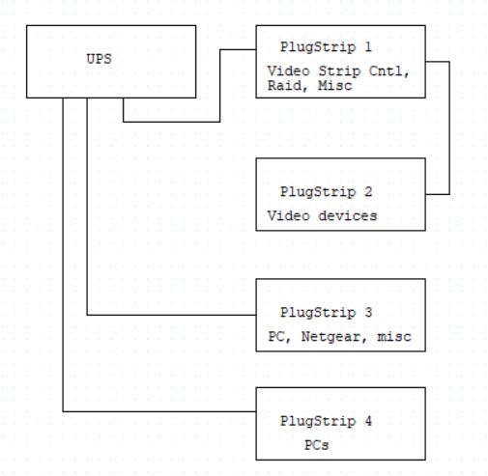
- Computers and logins:
  - These are the computers that are part of the MiniROV Fulmar rack:
    - Main PC
      - Should boot up without login needed but if needed
        - Login: MINIROV
        - Pwrd: MINIROV
      - IP address: 192.168.1.11
    - Co-pilot PC
      - Should boot up without login needed but if needed
        - Login: MINIROV-PC-3
        - Pwrd: MINIROV
      - IP address: 192.168.1.12
    - Overlay PC
      - Should boot up without login needed but if needed
        - Login: minirov
        - Pwrd: minirov
      - IP address: 192.168.1.13
    - M3RS Mac
      - Should boot up without login needed but if needed
        - Login: DIGITALADMIN
        - Pwrd: USEOSX
      - IP address: 192.168.1.3
    - VARS Mac
      - Should boot up without login needed but if needed
        - Login:DIGITALADMIN
        - Pwrd: USEOSX
      - IP address: 192.168.1.109
    - Sonar PC
      - Should boot up without login needed but if needed
        - Login:MINIROV
        - Pwrd: MINIROV
      - IP address: 192.168.1.109
    - Sonardyne PC
      - Should boot up without login needed but if needed
        - Login: MiniROV
        - Pwrd: MINIROV
      - IP address: 192.168.179.29 – this machine just connects to the Sonardyne ESH via Ethernet
    - Winfrog PC
      - Should boot up without login needed but if needed
        - Login: MINIROV
        - Pwrd: MINIROV
      - IP address: 192.168.1.90
- Starting up system
  - Make sure all plugstrips are turned on, at the back of the rack you can turn the video on using switch 2 & 3 on Plugstrip 1.
  - Turn on the large monitor. The switch us on the lip below the lower right hand corner of the screen
  - To shift between computers via the KVM use the hotkeys : press scroll lock two time then press the number of the computer you wish to talk to. The computers numbers are listed on top of the keyboard
  - Start up Main PC
    - Use KVM switch to navigate to Main PC, should be selection 1
    - Login to PC with details above
  - Start up Vehicle Control GUI
    - Open up NI LabVIEW 2019 SP1 (32 bit)
    - Open up main GUI software:
      - \\MINIROV-RAID1\Project-Library\Software\LabVIEW code\Working Directories\MINI WD\MiniROV_Main.git\trunk\MiniROV.lvproj
      - Once project is open in the “Main Loop” folder open Main_MiniROV.vi. This is the main software that runs the vehicle. Once that is open press the white arrow on the upper left hand corner to start the software.
  - Turn on Co-pilot machine and start up Clump software
    - Use login details above to login to co-pilot
    - Open up NI LabVIEW 2019 SP1 (32 bit)
    - Open up main GUI software:
      - \\MINIROV-RAID1\Project-Library\Software\LabVIEW code\Working Directories\SMARECLUMP WD\trunk\CO_Pilot_project.lvproj
      - Once the project is open go to the folder “FP” which stands for front panel and open that folder
      - In this folder open CO_Pilot_Main.vi
        - If nay messages as to use a new path with a file, select the option and choose “load with selected”
    - Turn on Co-pilot software by clicking the white arrow on the upper left hand corner to start the software.
    - In t
  - Turn on Overlay
    - Turn on computer and login
    - Open NI LabVIEW 2019 SP1 (32 bit) this machine has 2018 version installed so look carefully at which version you open.
    - From local directory open C:\Users\MINIROV\Documents\LabVIEW Projects\Overlay WD\trunk\MINI_OVERLAY WD
    - In the project open OVERLAY MAIN.vi
    - You should see it appear in the lower left hand screen quadrant. You will need to start the program by using the mouse to click on the arrow in the upper left corner

  - Turn On ROV
    - Return to the Main PC and MiniROV main GUI
    - Turn on ROV using the green start button in the lower right hand corner. Be aware that high voltage power is not present in the vehicle and umbilical. Use protective gloves when working on the system.
    - If joysticks are not present the software will not be able to connect to the vehicle.
    - You should see that the vehicle is drawing less than 0.5 Amps in upper left hand corner. The bus voltage at the vehicle should be around 400-415 volts
  - Check video
    - Looking on the main monitor you should see:
      - Main camera with Picture-in-Picture in lower left square
      - Aux HD cameras in upper left and upper right square
      - In lower left corner the screen should display 4 aux cameras – some may not be showing such as the winch camera or cameras that you need to turn on with the GUI
  - Turn on VARS
    - Make sure machine is powered up and you should not have to log in but credentials are above.
    - There are currently three steps to start up VARS, open the VARS README on the desktop and follow the steps
      - Double click “start_vars_service.sh”
      - and “start_frame_capture.sh” DO NOT CLOSE WINDOW
      - start VARS Annotation.app
    - Once VARS is open select ship by clicking on the upper left icon with an arrow. You should see a ship icon, click on that
    - Under the pull down menu next to ROV choose MiniROV
    - Under dive no enter the dive number or 9999 for a test
    - Finally in the upper tool bar select a user
    - You should not be able to take frame grabs and annotate
  - Turn on M3RS
    - Turn on computer, you should not need to login, but if so use credentials above
    - M3RS should come up and record to the Video Raid drive.
    - When the machine turns on it beeps a couple times.
    - It seems to take a minute or so to be able to be ready to record even though the M3RS screen appears right away.
  - Set up Sonar machine
    - Turn PC on and use login credentials above
    - Sonar is displayed on a separate small monitor but the mouse and keyboard are still controlled by the KVM switch
    - To turn on monitor the switch is under the lower right hand lip
    - Open the software on the desktop Win881AL, the icon looks like a gray and red sonar beacon.
    - Make sure you turn the Sonar button to “ON” (indicated by light gray color) in the main GUI.
  - Set up Winfrog
    - Turn on machine and use login credentials above
    - Open Winfrog 3.10 software on desktop
    - You will see the MiniROV and Clump
    - If the winfrog is receiving data from the Sonardyne ESH via serial the nav data will appear in black
  - Setting up Sonardyne
    - Open up MiniRanger 2 software on the Sonardyne page
    - Note: to test the connection you can use the “ Simulate” command that appears under the Tools menu under Advanced. If you do not see it there you need to manually add the option
      - Go to the Tools menu
      - Select the Options pull down
      - Select Menu
      - In this dialog window select Tools
      - Select Advanced then click on the “Simulate” check box
    - The MiniRanger software should be able to communicate with the clump and the ROV once the transducer is in the water
- Controlling Vehicle
  - Return to the Main GUI to control the vehicle
  - The main vehicle GUI can be used to control:
    - Lights
    - Cameras
    - Sonar
    - Main Camera Tilt
    - GF monitoring
    - Thruster mods and enabling
    - CT, Depth, Heading
For each one of these, buttons on the GUI can toggle power and/or comms
  - The Co-pilot GUI can be used to control:
    - Clump Camera, camera tilt, lights, heading
    - For midwater sled: suction sampler and indexing motor and sampler light
    - Thruster enable
    - Note vicor temp not working currently

