Project Number: | 901813

Project Start: Jan. 1, | 2018 | Project Duration (in years): | 1

Please indicate if proposal includes requests for any of the following (mark all that apply).

Ship Time |  |  | ROV |  |  | AUV |  |  | Wave Glider |  |  | Mini ROV

Please indicate what type of project is being proposed (mark only one).

 |  |  |  | X
Feasibility/Scoping  [Less than 100 days effort] |  |  | Development |  |  | Research |  |  | Infrastructure² |  |  | Education |  |  | Time Series |  |  | Institute Initiative

Project Manager: Dale Graves
Principal Investigator: [Enter name here]
Lead Scientist: Katija, Benoit Bird, Kemp, Rock
Lead Engineer: Dale Graves

Project Title: Test Tank Development Platform

Please indicate percentage of effort on this project anticipated for 2018 toward these three highest institutional goals (percentage total should equal 100%).

Goal | Developing/adapting innovative technologies | Utilizing developments to explore and understand ocean systems | Technology/knowledge transfer
Percentage | 80 | 0 | 20

- ABSTRACT (new projects only)

Project Description: The miniROV was designed to be a multi-user, multi-purpose mobile platform for conducting a wide array of scientific missions around the world. One of the unanticipated benefits of the miniROV is that it's an excellent tool for developing instrumentation and control algorithms that are destined for MBARI’s large ROVs.
In the past few years, there has been increasing demand for the miniROV to perform science missions in the field, and as a result the vehicle spends a large part of the year away from MBARI. Thus, there are often projects and users who could benefit from a test platform, but it is unavailable. The Test Tank Development Platform (TTDP) seeks to address the need for a test tank capable vehicle to facilitate development of instruments, algorithms, and methods prior to ROV deployment. We propose to design and build a platform that leverages our existing miniROV design but is only test tank capable. This platform will have HD video, MBARI standard science ports, and a configurable toolsled. The vehicle will be capable of integrating different payloads to meet the needs of various PIs. The vehicle will be an engineering asset that will be operable by scientists/engineers and will not require a pilot.
There are a number of MBARI investigators whose programs could directly benefit from such an asset. Kelly Benoit Bird would use the TTDP as a development platform for new acoustic sensors, allowing her to experiment with placement of sensors, integration with imaging systems, coordinated movement, lighting, calibration and intercomparison. Kakani Katija proposes to use the TTDP to develop instrumentation that will (1) allow for fluid visualizations of reflective surfaces, (2) expand the utility of DeepPIV to measure three-dimensional fluid interactions, and/or (3) quantify temporally varying, shape-shifting surfaces for bio-inspired design applications. Matt Kemp could make use of TTDP for testing the docking capability of his “sea hive”, which would require thousands of test docks to ensure reliability. Steve Rock would use the TTDP to aid the development of vision-based control algorithms required in the Precision Control Project. The test tank platform would enable a much more time-efficient and much less costly means of performing the preliminary tests for all of these applications.
The TTDP would have immediate application in the area of Ocean Visualization as highlighted in the Strategic Plan. This platform can also contribute to the more efficient development of instruments and algorithms related to cooperative robotic systems, sampling systems, persistent robotics, and biogeochemical sensors. This list represents an example of just some of the efforts highlighted in the Tech Roadmap that would benefit from such a test platform.
In summary, the proposed platform would be an institutional asset that would expedite development, increase the value of sea days, and be used across a wide range of research programs.

- PROPOSAL

  - New Projects

Statement of the problem, why it is important

One of the challenges of developing instrumentation or algorithms for underwater vehicles is that it is very hard to recreate the conditions that exist during deployments in the lab. Inevitably, many issues only reveal themselves during an ROV dive causing precious ship time to be used towards troubleshooting rather than data collection. While we can’t completely recreate the conditions at sea, the goal of this project is to create a platform with identical interfaces to MBARI’s ROVs that can be used in the test tank enabling developers of software and instrumentation to more thoroughly test their components. The importance of this is we will save our most precious resources (ship and ROV time) for the most valuable efforts (deployment and data collection), and use a low cost platform to facilitate more rigorous predive testing and check out.
Furthermore, this platform could also be used for algorithm development for applications such as vision based navigation (for example jelly tracking) and docking. The development of these algorithms requires many iterative cycles, which is expensive and not always feasible with the constraints on ship time.
Ultimately, the TTDP should improve the value of our dive time by allowing project team to go to sea with a more thoroughly tested and qualified system.

How does it relate/contribute to MBARI’s mission and strategic plan?

The TTDP is a flexible enabling technology that can contribute to all the themes in the strategic plan, just as our ROVs and AUVs do. The TTDP will have immediate application in the area of Ocean Visualization as highlighted in the Strategic Plan. Two of the interested users (Katija and Benoit Bird) will each be using the platform to develop visual and acoustic systems, which relate directly to Ocean Visualization.

How does it relate/contribute to the Packard Foundation’s Ocean Visions Grantmaking policies? (See http://mww.mbari.org/oed/OED_Documents.htm#Packard for documents.)

The TTDP is a technology that cleary aligns with the Packard Foundation Ocean Visions Grantmaking strategy of supporting basic research to understand the function of ocean ecosystems. The TTDP is a tool that enables researchers to develop their instruments and measurement techniques more efficiently, and we expect many of these developments will relate to ocean ecosystems. Furthermore, it is easy to envision that systems developed on the TTDP could also have an impact on fisheries and conservation related projects.

Does it relate to the Technology Roadmap? If so, please describe how.
(See http://mww.mbari.org/oed/TechnologyRoadmap.pdf.)

The TTDP can contribute to the more efficient development of instruments and algorithms related to cooperative robotic systems, sampling systems, persistent robotics, and biogeochemical sensors, all of which are mentioned in our tech roadmap.

Approach to the problem

In general, our approach to the problem of developing a multi-function test tank capable platform is to leverage off of our previous developments and to build a robust and flexible instrument.
Specifically our approach to this development is to:
- Replicate all the relevant technology from the MiniROV, to reduce design and build time
- Build a system with interfaces that are identical to MBARI’s ROVs
- Use low cost floatation and framework appropriate for a tank-only vehicle
- Build a system that is highly flexible and easily reconfigurable
- Design a platform on which different toolsleds and payloads can be mounted
- Develop a platform that can be easily operated by scientists and engineers

Publications (from other projects over the last 5 years)

[Click here to enter text]

  - Continuing Projects

  - New and Continuing Projects: Plans for 2018

Research Activities

None.

Engineering/technology development

The following are the steps for the development:
- Come up with a complete set of requirements through discussions with potential users
- Develop concept and present it at concept design review
- Do detailed design leading to Preliminary and/or Critical Design Reviews
- Order components and submit drawings for parts
- Integration and testing of system
- Test dives and training of operators

The development of this project can happen over one or two years. We have indicated below which tasks could be shifted to year two if need be. 1st year build up epod and frame wait till second year for thrusters (defer a lot of the cost and labor (machine shop)
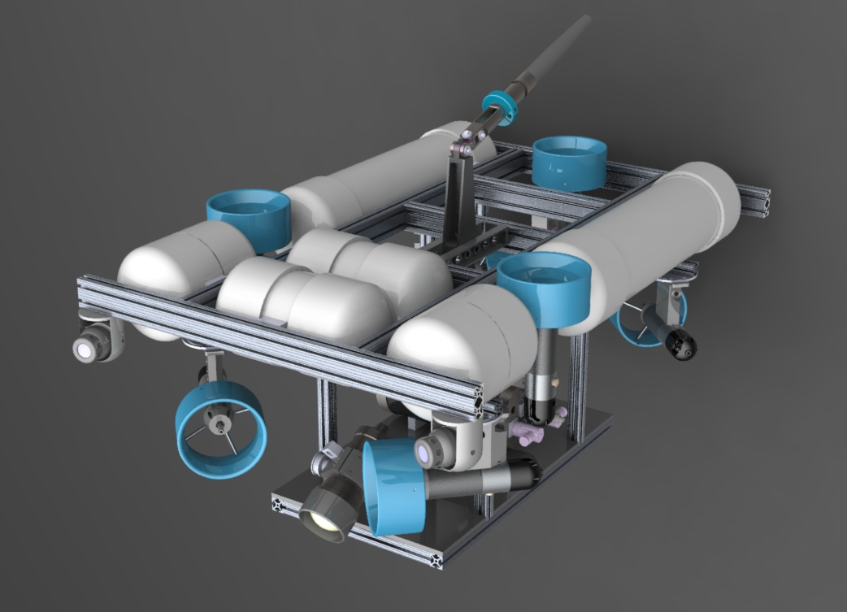
Figure 1: Concept model of the TTDP vehicle utilizing the suite of MiniROV components and reconfigurable frame and buoyancy modules.

Field programs (detail ship requirements/deployments/diver requirements)

None

Isotope Usage
Project teams must provide details regarding any planned isotope use on shore, on ships, in the Sanctuary, etc. Please review the guidance on isotope usage at http://www.mbari.org/at-sea/cruise-planning/hazardous-materials/ and policy at http://mww.mbari.org/safety/SafetyManual/Isotope_Use_Policy.pdf, and then provide details on plans below.

None

Specific deliverables

The test tank vehicle will have the following key components:

MBARI ROV standard science ports. (MINK-10 w/RS-232 serial port and 24 & 12vdc power)
MBARI ROV standard GIGE port (MINK-10L w/GIGE and 110ac power)
Fiber-optic video/data multiplexor (compatible with all MBARI ROV’s)
Subsea connector for access to spare single mode fiber-optic cable.
HD camera w/ tilt.
(3) Analog video channels.
Common bus voltages (400vdc, 110vac, 48vdc, 24vdc, 12vdc, 5 vdc) for instruments & payloads.
Depth, heading and altitude sensors.
(2) LED lights (18,000 lumens)
MiniROV brushless DC thrusters w/integrated drive electronics
MiniROV subsea thruster power can (3600 watts @48vdc)
MiniROV Electronics pod (1 atm housing with mux., power converters and I/O)
MiniROV video overlay system & tiler
MiniROV lift frame to support up to 1000 lb. loads (vehicle + payload)
MiniROV pilot console & topside interface module
MiniROV control system software with hooks for external control of vehicle with 3rd party code.
Reconfigurable frame & buoyancy modules.

Milestones (see personnel classification list for staff classifications)

[Click here to enter text]

2018 Project Start Date:  MM/DD/2018 | Milestone 1 | Milestone 2 | Milestone 3 | Milestone 4 | Milestone 5 | Total Resources for each resource category for all milestones listed here
Milestone Date | 2/18 | 3/18 | 7/18 | 8/18 | 11/18
Milestone Description | Preliminary design review | Submit drawings to shop/E-lab | Complete fabrication | Mech/elect. Assembly & component testing | Comp. of integration & testing
Electrical Engineer | 80-Sherman | 100-Sherman |  | 80-Sherman | 40-Sherman | 300
Software Eng-Embedded | 40-Risi |  |  | 120-Risi | 120-Risi | 280
Software Eng-Info Eng
Mechanical Engineer
Mechanical Eng-Division
Mechanical Eng-Mfg | 80-Graves | 120-Graves | 80-Graves | 80-Graves | 120-Graves | 480
Associate Engineer |  | 40-Parker | 40-Parker | 40-Parker |  | 120
Electrical Tech |  |  | 80-Marion | 160-Marion | 40-Marion | 280
Software Tech
Mechanical Tech |  |  | 100-Flores | 200-Flores | 180-Flores | 480
Machinist |  | 500 | 500 |  |  | 1000
Divers

Budget justification

The TTDP will require annual maintenance and we are estimating 120 hours/year for Dale Graves and a budget of $5,500 dollars for repairs, tools and consumables.

Project team

Mike Risi – Development of Multi drop (CANopen) network and 3rd party interfaces.
Alana Sherman - Electrical engineering
Dale Graves – Mechanical/Software design
Frank Flores - Fabrication
Mike Parker – Mechanical design and fabrication
Tom Marion – Electrical assembly

Project lab and office space requirements
In addition to any changes to current space usage, please also include anticipated office and lab needs for students, postdocs, collaborators, etc.

We wish to continue to use bench space in the Mechanical Engineering Lab where the MiniROV has been located for the last couple of years. This area is ideally located for the TTDP testing with its proximity near the test tank. We would also like space where the nitrogen tanks were previously located next to the roll up door to store the vehicle.

Data storage requirements (see Todd Ruston for assistance)

None

Data availability outside project team, uniqueness

[Click here to enter text]

R/V Paragon Requests
If the project team will be requesting time for the R/V Paragon, please specify the operators in the group and provide estimates of their availability to operate the vessel.

None

Export Regulation
Does the project team anticipate any foreign collaborations or international travel? If so, please identify collaborators by name, institution, and country.

None

Does the project team plan or anticipate export controlled purchases, shipments, or transfers of items (e.g., research instruments, proprietary data, hand-carried tools or samples) outside the U.S. temporarily or permanently? If yes, please identify country or countries and indicate whether these items will remain under MBARI control while abroad or controlled by others. Will the items be exported to more than one country? Please include foreign collaborator information as described above.

None

Monterey Bay National Marine Sanctuary (MBNMS)

General Permit
Projects teams need to indicate if any work will be performed that is either: (1) currently authorized under our general permit; or (2) will require that we obtain authorization. The current permit can be viewed at http://mww.mbari.org/pco/permits/mbnms-2015-002_feb2015.pdf. Please see Mandy Allen for questions.

Is a permit with MBNMS required for your work?

No

SESAs (General map)
Projects will need to indicate whether or not work will be conducted within one of the Monterey Bay National Marine Sanctuary's Ecologically Significant Areas (SESAs). An interactive map can be found on the Sanctuary's SIMoN webpages at http://sanctuarysimon.org/maps/sesa/. (Note: It may take a moment for the page to load, so please be patient. Also, if prompted for a login, hit “Cancel” and then you will be able to access page.) To determine if your work will occur in a SESA, specific coordinates can be entered using the locator function (click on the red "target" button in the toolbar at the top of the map). If your work will be conducted in one of these areas, please indicate which area, by number.

Not required

California Department of Fish & Wildlife
A Scientific Collecting Permit will be required for biological and geological sample collections offshore California (even in Federal waters and beyond), and for many activities in State Marine Protected Areas. Please see Mandy Allen for questions.

Will you be collecting samples that require a permit?

No

Will you be working in a State Marine Protected Area?

No

Authorizations/Permits from other Agencies or Organizations
Is the project team aware of any other permits or authorizations that will be necessary to perform the proposed work? If so, please list below along with status of authorizations (obtained, pending, need to apply, etc.). Please see Mandy Allen if you have questions.

None

Active Acoustics
We are keeping an inventory of acoustic instrumentation. The current list is posted here: https://mww.mbari.org/resources/2018_Proposal_Process/documents/mbari_acoustic_instruments_2016-08-08_ver_10.pdf. If you have or plan to use equipment that is not already on this list, please be sure to include that information here.

None

Risk matrix (development and infrastructure projects only)

 | Technical Risk | Organizational Risk | Tech Transfer Risk | Labor Estimate Risk
High
Medium |  |  |  | X
Low | X | X | X

Development and infrastructure projects must complete the risk matrix (see end of the proposal form).
Not all projects will require all four titles to be filled in. Please indicate individuals only for those titles that are appropriate for your project.
This category includes transfer of hardware, know-how, publications, presentations, etc.
This number should be the same number you entered on the resource requests for this particular resource.

