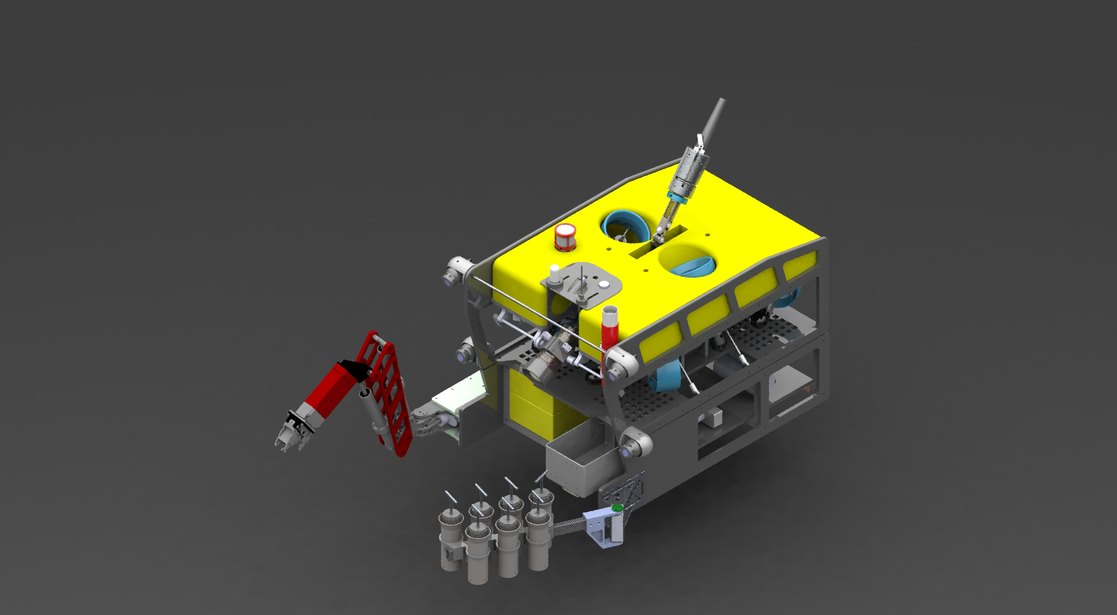
MiniROV
Specifications & Deployment Procedure
Monterey Bay Aquarium Research Institute
2026

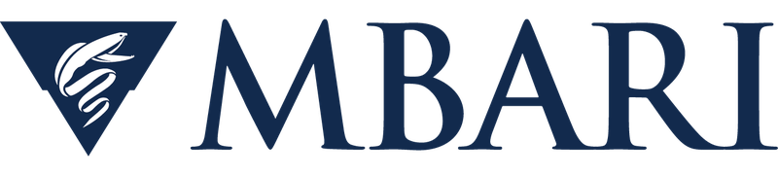
This document does not include and controlled information

Table of Contents

MiniROV 4
Overview 4
Core Specifications 4
Autonomous Functions 4
Core Sensors & Instruments 5
Payload Sleds 5
Benthic Sled 5
Midwater Sled 5
Smart Clump 6
Specifications 6
Role in System 7
Winch 8
Winch Specifications 8
Winch Base Plate 8
Sheave Block 10
Sheave Block Specifications 10
Control Vans & Transport 11
Control Van — Option 1 (10 ft) 11
Control Van — Option 2 (20 ft) 11
Transport Container 11
System Layout on Deck 13
Key Components Identified 13
MiniROV Deployment Procedure 14
7.1 Responsibilities 14
Captain 14
Bosun 14
ROV Chief Pilot 14
ROV Pilot (Control Van) 14
Remote Pilot Operator (Belly Pack) 14
Winch Operator 14
Chief Scientists 14
7.2 Personnel Requirements 14
7.3 Personnel Safety 14
7.4 Communication Protocols 15
7.5 Safety Equipment & PPE 15
7.6 ROV Rigging 15
Rigging Procedure 15
7.7 Pre-Dive Procedure 15
System Power-Up Sequence 15
Unpowered ROV Checklist (ROV Pilot responsible) 15
Powered ROV Checklist (ROV Pilot responsible) 15
Smart Clump Checklist (ROV Chief Pilot responsible) 15
7.8 Launch Procedure 16
Step 1 — Pick Up MiniROV 16
Step 2 — Extend A-Frame and Lower MiniROV 16
Step 3 — Unlatch MiniROV 17
Step 4 — MiniROV Begins Flying Away 17
Step 5a — Pull in Slack from Smart Clump 18
Step 5b — Lift Smart Clump Over Rail 18
Step 6 — Extend A-Frame and Lower Clump into Water 19
Step 7 — Lower Clump and MiniROV Simultaneously 19
Step 8 — System Fully Deployed 19
7.8.1 Vehicle Tracking 19
7.9 Dive Procedure 19
Managing Delta (Vertical Separation) 20
7.10 Recovery Procedure 20
Recovery Step 1 — Notify Captain and Prepare Deck Crew 20
Recovery Step 2 — Begin Ascent with Flying Tether Stretched 20
Recovery Step 3 — 50 m Hold and Belly Pack Operator Prepares 20
Recovery Step 4 — Final Ascent 20
Recovery Step 5 — Recover Smart Clump 20
Recovery Step 6 — MiniROV Backs Toward Ship While Deck Crew Retrieve Flying Tether 20
Recovery Step 7 — Hold Position Below A-Frame and Install Latch 20
Recovery Step 8 — Optional: Attach Tag Line via Boat Hook 20
Recovery Step 9 — Lift MiniROV Aboard 20
7.11 Post-Dive Procedure 20
Power Down and Initial Secure 20
Vehicle Inspection 21
Scientific Sample Recovery 21
Remove and Charge Beacons 21
Fresh Water Rinse 21
Prepare Vehicle for Next Dive 21
7.12 Emergency and Abort Procedures 21
Loss of ROV Communications 21
Tether Entanglement 22
Power Failure 22
Man Overboard / Person in Water 22
Electrical Shock / GFI Trip 22
Vessel Movement / Loss of Station-Keeping 22

Section 1: MiniROV

Overview
The MiniROV is MBARI's next-generation fly-away remotely operated vehicle, designed and built entirely in-house. It provides a portable, low-cost, 1,500-metre inspection-class ROV operable by a crew of just one to two people on ships of opportunity around the world.
The vehicle supports light-duty work including limited sampling, video transects, and instrument deployment and recovery. Mission-specific payloads are accommodated via bolt-on tool skids.
MiniROV — 3D render showing vehicle with manipulator arm and push-core sled

Core Specifications
Mass | 900 lb (408 kg)
Propulsion | Electric — 400 VDC, ~5 kW
Thrusters | 6 × ~0.75 hp electric DC brushless
Dimensions | 48" L × 35" W × 24" H (122 × 89 × 61 cm)
Depth Rating | 1,500 m
Degrees of Freedom | 4 DOF
Max Instrument Payload | 120 lb (54 kg)
Aux. Instrument Power | ~1 kW; voltages: 240, 48, 24, 12, and 5 VDC
Aux. Data | 1× spare single-mode fiber, RS-232 serial ports

Autonomous Functions
The MiniROV supports the following autonomous control modes:
  - Auto Depth — maintains a set depth automatically
  - Auto Heading — holds a specified compass heading
  - Observation Mode (MBARI Mode) — halts forward thrusters to reduce forward thruster wash
- Advanced Navigation Mode — enables sophisticated navigation behaviors including:
- Autonomous lawnmower survey patterns for systematic horizontal seafloor mapping
- Vertical wall survey patterns for mapping seamount faces, shipwrecks, or structures
- Autonomous path following and waypoint navigation
- Autonomous jellyfish tracking
- Dynamic Station Keeping — holds position against currents using all thrusters

Core Sensors & Instruments
Main Camera | Insite Pacific Mini Zeus III HD — 1080p/60fps, 30× optical zoom, manual/auto iris and focus (±75° tilt)
HD Cameras | 2× DSPL HD Multi SeaCam
Analog Cameras | 3× DSPL Analog Camera
Lights | 6× DSPL Sealite (0–5 V dimmable)
CTD | Integrated CTD sensor
Scaling Lasers | Paired laser scaling system
Depth Sensor | Valeport UltraP pressure sensor
Compass / HPR | PNI TCM-XB 3-axis heading, pitch and roll sensor (VN100 upgrade pending)
USBL | Sonardyne WMT USBL transponder with remote head
Sonar | Imagenex 881-A scanning sonar with gyro compass
Strobe & RF | Activated by swiping a magnet up the side of each unit

Payload Sleds
The MiniROV carries mission-specific tool skids fastened with ¼-20 bolts. Two operational skids are available:

Benthic Sled
Designed for seafloor survey and sampling:
- Stereo Camera ×2
- Laser Lines ×3
- VN100 IMU (pending upgrade)
- Norbit WBMS Bathy (downward facing)
- Oculus forward-looking MBES
- WaterLinked A125 DVL (downward and forward-facing)
- 4× DSPL Lights
- Sample collection drawer (~8.5 x 15 x 7 in / 22 × 38 × 18 cm)
- Swing arm
- 7× Push Cores
- Gas sampler
- Valeport VA500 Altimeter/Depth Sensor
- 5 DOF manipulator arm with continuously rotating wrist
- Temperature probe and CT sensor on probe motor

Midwater Sled
- 8-bucket suction sampler
- Stereo VR camera
- Autonomous animal tracking system
- Deep PIV (Particle Image Velocimetry)

Section 2: Smart Clump
The Smart Clump's primary function is to act as a depressor weight for the main umbilical, keeping the umbilical vertical in the water column and preventing the ROV from having to drag the vertical portion of the tether through the water. Its mass and depth also serve to decouple the heave motion of the ship from the ROV, so that wave-induced movement is not transmitted through the tether to the ROV. It is also instrumented with cameras and sensors to assist with umbilical management, navigation, and providing a bird's-eye overview of the ROV.
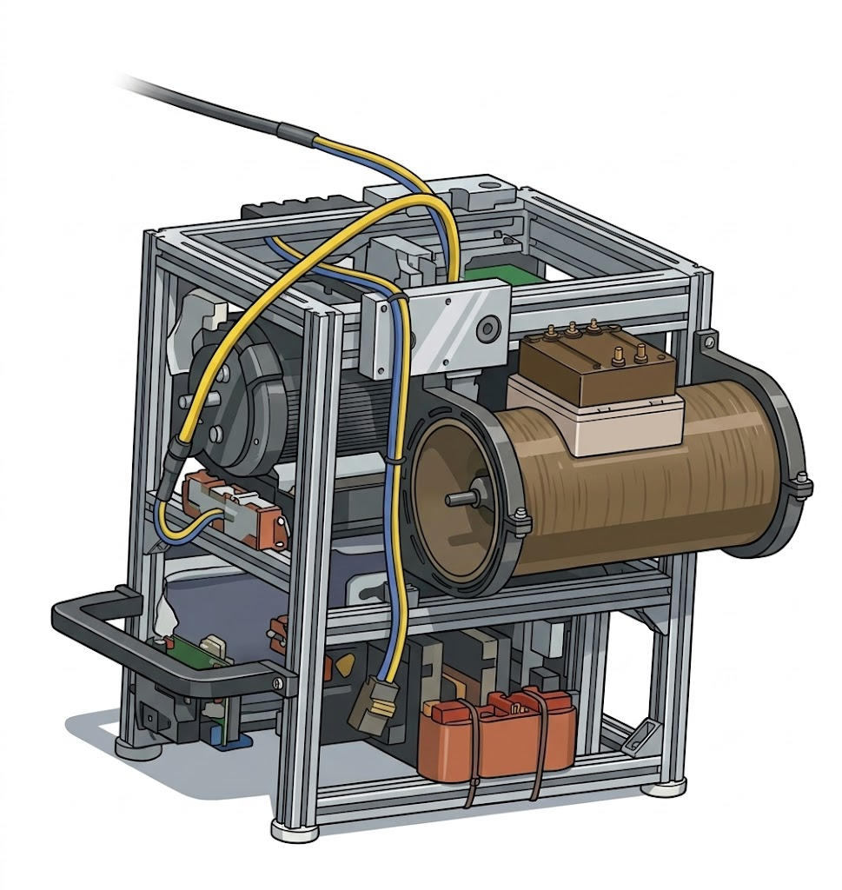
Smart Clump

Specifications
Mass | 350 lb (159 kg)
Camera | DSPL HD Wide Angle Multi SeaCam (±90° tilt)
Analog Camera | 1× DSPL Analog Camera (downward facing, redundancy)
Lights | 1× DSPL Dimmable Light
Thrusters | Auto-heading and limited maneuvering
Depth Sensor | Valeport VA500 Altimeter / Depth Sensor
USBL | Sonardyne WMT 6G USBL transponder
Water Sampler | Triggerable 5 L Niskin bottle
Sonar (optional) | Imagenex 881-A Scanning Sonar
DO Sensor | Pumped Seabird SBE 43 dissolved oxygen sensor
Compass / HPR | PNI TCM-XB heading, pitch and roll sensor (VN100 upgrade pending)
Tether to MiniROV | 50 m flying tether with buoyancy floats
Power | 400 VDC tapped from main umbilical
Connection | Connects directly to winch via main umbilical via a Yale grip

Role in System
During operations, the Smart Clump acts as a stable depressor maintaining near-vertical tether geometry between the ship and the MiniROV. The Smart Clump carries two thrusters that operate in an auto-heading mode, automatically maintaining a set compass heading to counteract currents and reduce lateral tether offset. The auto-heading mode is enabled from the control van; the ROV Pilot can also command heading adjustments via the control interface. The thruster response is verified during the pre-dive Smart Clump checklist. USBL positioning allows the bridge to monitor both the Clump and ROV positions relative to the vessel at all times.
The 50 m flying tether — fitted with buoyancy floats — allows the ROV freedom to maneuver at depth while the clump remains relatively stable above it.

Section 3: Winch
The winch is an electrically driven spool for the 1,700-metre umbilical. It is equipped with a level wind system and can be operated locally at the winch or remotely from the Co-Pilot station in the Control Van.
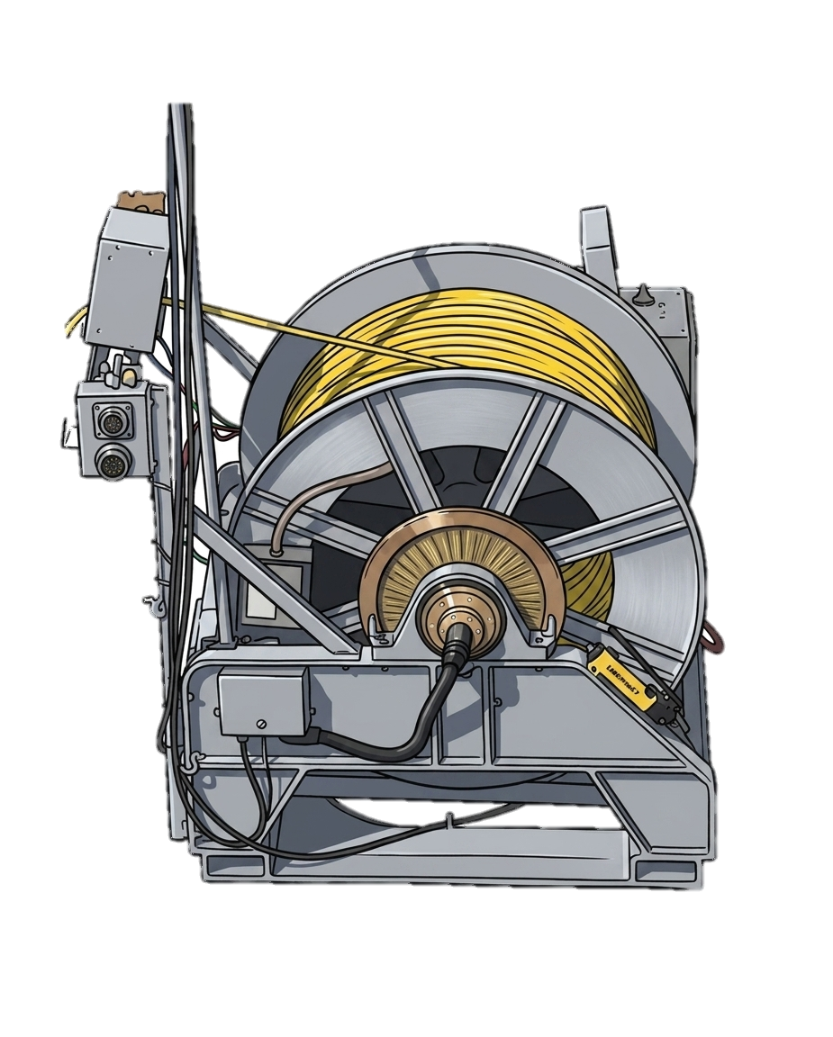
Winch assembly

Winch Specifications
Tether Capacity | 1,700 m of 0.625" OD tether
Safe Working Load | 3,500 lb (1,600 kg)
Dimensions | ~60" × 60" × 60" (152 × 152 × 152 cm)
Mount Pattern | 4 ft × 4 ft, 1.25" threaded bolt pattern
Angle Increments | Mountable at various angles in 22° increments
Drive | Variable-speed electric motor
Level Wind | Motorized level wind for even tether spooling
Power | 240 VAC single-phase, 4 kW
Power Cable | 21 m long — plugs directly into control van
Operation | Local joystick OR remote from Co-Pilot station
Braking | Emergency hydraulic brake
Mounting Options | Bolt-on base plate or welded directly to deck

Winch Base Plate
Mass | Approximately 1,000 lb (454 kg)
Lifting | 4× threaded lifting eyes installed in threaded corner holes. Used to lift and move the base plate into position with a crane or forklift.

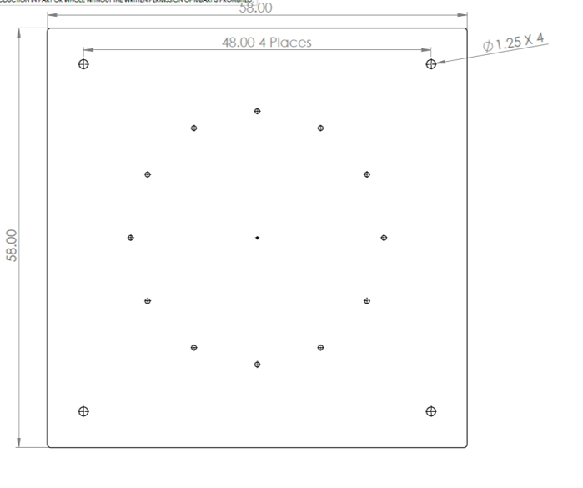
Winch base plate (Dimensions in Inches)
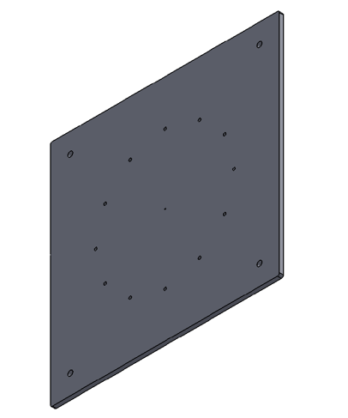
Winch base plate (Isometric Render)

Section 4: Sheave Block
The 28-inch sheave block guides the umbilical over the ship's rail during deployment and recovery, providing a low-friction turning point that protects the tether from chafing against the hull.
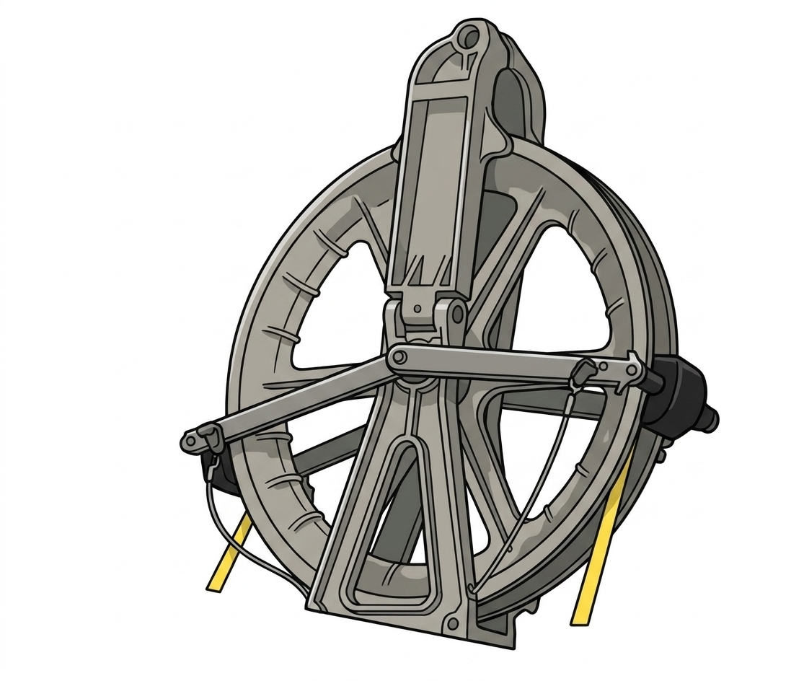
28-inch sheave block

Sheave Block Specifications
Size | 28 inches
Sheave OD | 28 in (711 mm)
Rim Width | 3¼ in (83 mm)
Groove Bottom Distance | 24 in (610 mm)
Connection Point to Groove Bottom | 10¼ in (260 mm)
Throat Dimensions | 5 13/16 in (148 mm)
Width | 3¼ in (83 mm)
Overall Height | 38½ in (978 mm)
Overall Width | 7¼ in (184 mm)
Groove Radius | 1 in (25 mm)
Flare Angle | 15°
Max Working Load Limit | 12,000 lb (5,443 kg)
Block Weight | 62 lb (28 kg)

Section 5: Control Vans & Transport
The topside control system is typically contained in an 8'×10' converted ISO shipping container. If the ship does not have sufficient deck space, the control system can be housed in portable shipping instrument racks.

Control Van — Option 1 (10 ft)
Mass | 9,000 lb (4,082 kg)
Power Input | 480 VAC 3-phase; 30 m power cable
Personnel Capacity | 4–6 persons
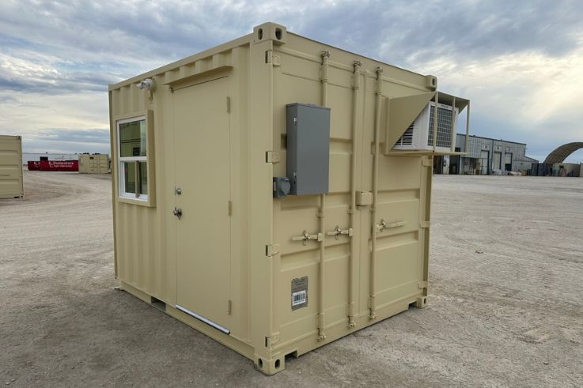
10 ft control van

Control Van — Option 2 (20 ft)
Mass | TBD
Power Input | 200–500 VAC 3-phase; 30 m power cable; >50 A circuit required
Personnel Capacity | ~10 persons

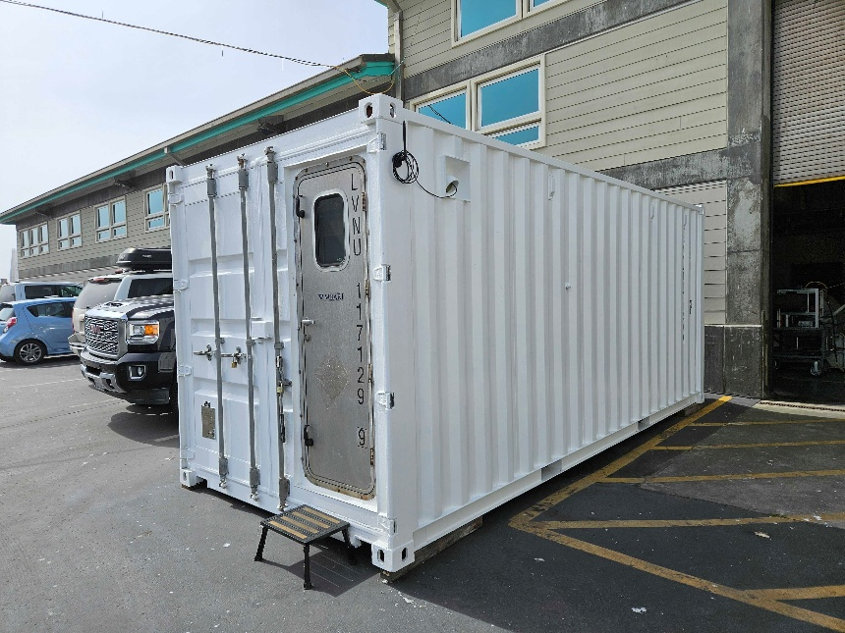
20 ft control van exterior
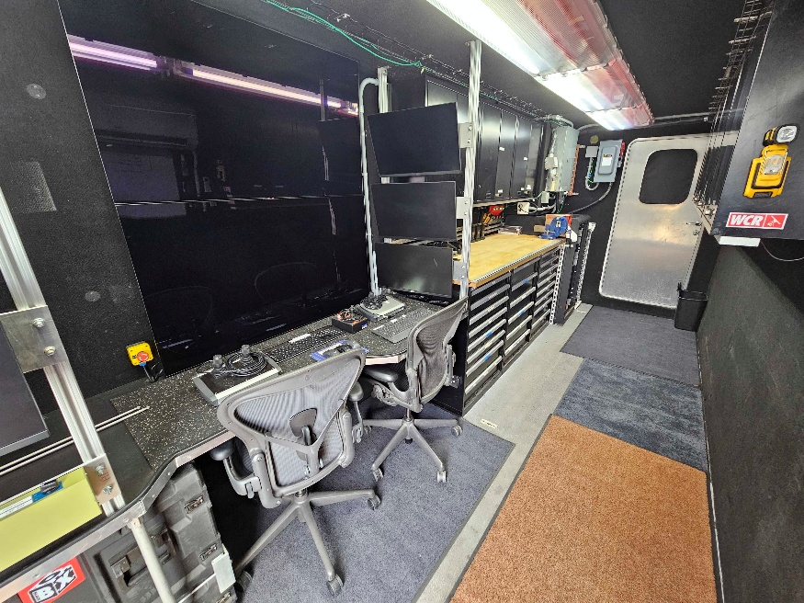
20 ft control van interior

Transport Container
An additional container transports all major system components between deployments:
- MiniROV vehicle
- Winch assembly
- Spare power supply
- Spare transformer
- 4× Rowe packs (spares)
- Smart Clump
- Zarges crates (spares)
- MiniROV stand
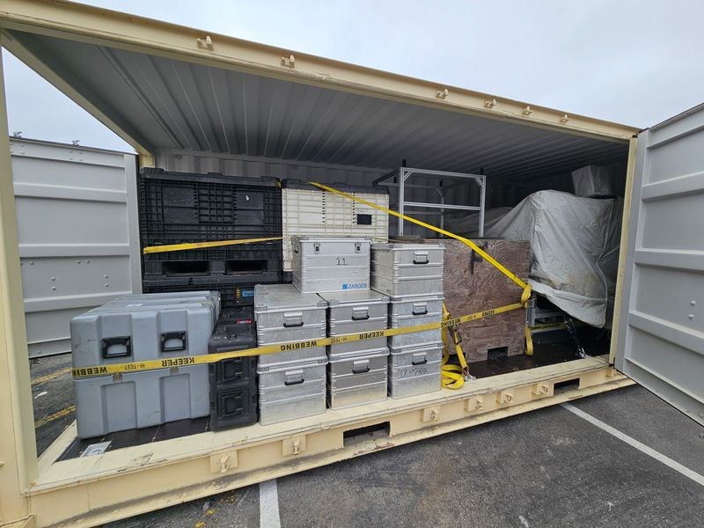
Transport container with system components

Section 6: System Layout on Deck
The diagram below shows the arrangement of all major system components on deck prior to deployment.
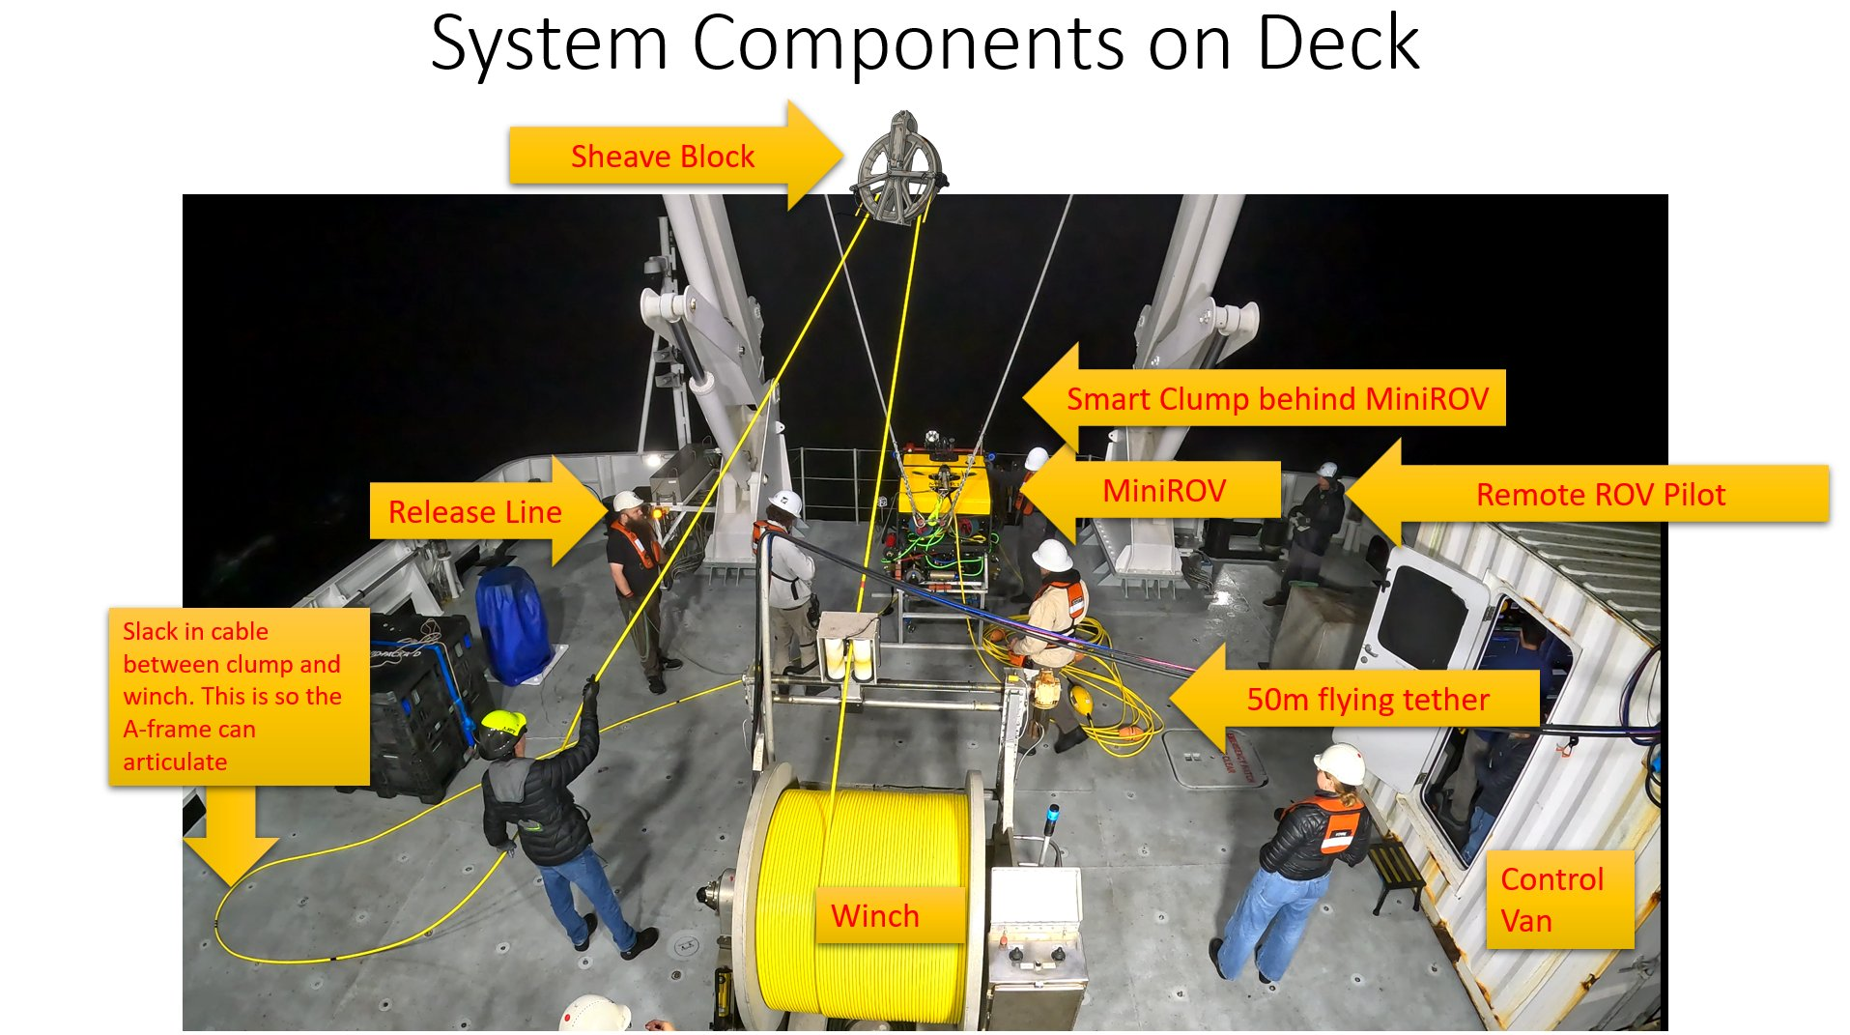
Annotated deck layout — system component positions prior to launch

Key Components Identified
Sheave Block | Mounted high on the A-frame; guides umbilical over the rail
MiniROV | Vehicle positioned at A-frame ready for deployment
Smart Clump | Positioned behind MiniROV on deck
Winch | Stores the main umbilical (1,700 m); level wind for even spooling
50 m Flying Tether | Coiled figure-8 on deck between MiniROV and Smart Clump
Release Line | Tag line that releases MiniROV from the crane when in water
Control Van | Operators manage telemetry from here
Remote ROV Pilot | On deck with belly pack for visual control of ROV
Umbilical Slack | Slack kept between clump and winch to allow A-frame articulation

Section 7: Deployment Procedure
The following sections describe all responsibilities, personnel requirements, safety protocols, and step-by-step procedures for deployment, dive operations, and recovery of the MiniROV system.

7.1 Responsibilities

Captain
Retains overriding authority and ultimate responsibility for the safe execution of operations and the safety of all personnel and the vessel. Has authority to cancel a dive due to adverse weather.

Bosun
Responsible for all deployment and recovery deck operations, including crane operation, lifting, and deck crew coordination, ensuring the safety of all personnel involved.

ROV Chief Pilot
Coordinates all launch, inspection, sampling, and recovery operations. Ensures effective coordination and communication. Has authority to cancel a dive due to adverse weather or any other reason.

ROV Pilot (Control Van)
Stationed in the control van and is responsible for monitoring all vehicle telemetry. Can give control of the vehicle to the Remote Pilot Operator (belly pack) or take control back at any time. Responsible for conducting the vehicle checkout and all pre-dive checklists. Must communicate all relevant vehicle information — including depth, heading, thruster status, sensor readings, and any anomalies — to the deck deployment team throughout the operation.

Remote Pilot Operator (Belly Pack)
Stationed on deck and is responsible for remotely piloting the MiniROV via line of sight during launch and recovery. Directs deck crew through all deployment and recovery steps, coordinating the sequence of operations. Communicates directly with the Winch Operator on when to pay out or haul in tether, and with deck crew on all rigging and handling tasks. Transfers control to/from the ROV Pilot as required.

Winch Operator
Stationed on deck at the winch controls. Operates the winch locally, taking direction from the Remote Pilot Operator on when to pay out or haul in the umbilical at each stage of deployment and recovery. When not required on the winch, assists with deck crew tasks as directed.

Chief Scientists
Chief science officer is responsible for all scientific equipment aboard the ROV and Smart Clump, including the collection, handling, and processing of samples

7.2 Personnel Requirements
A minimum of four personnel is required during all launch and recovery operations:
- ROV Chief Pilot — overall in charge of operations
- ROV Pilot — in control van managing vehicle telemetry and systems
- Remote Pilot Operator — on deck with belly pack for line-of-sight vehicle control
- Winch Operator — on deck operating the winch
- Science Party Representative — responsible for scientific tooling (when applicable)

7.3 Personnel Safety
Before any operation begins, a toolbox meeting must be held. A risk assessment must be completed prior to every operation, covering:
- Environmental conditions (wind, sea state, currents, visibility, precipitation)
- Vessel motion and station-keeping capability
- Working area — free from slip and trip hazards
- Equipment status and condition
- Personnel competency and PPE availability
The following minimum conditions are required for operations to proceed. The ROV Chief Pilot and Captain must jointly confirm conditions are acceptable before any launch:
- Sea state and wave height must be suitable for safe launch and recovery operations, assessed by the Captain and the ROV Chief Pilot. Sea state will be monitored throughout the dive, and the dive will be aborted if required
- Wind speed must be within acceptable limits for deck operations.
- Vessel station-keeping or slow-speed maneuvering must be maintained throughout the dive
- Night operations are permitted provided deck lighting is sufficient for visual control of the ROV and deck crew safety
Operations must be postponed if any concerns arise until all hazards are resolved.

7.4 Communication Protocols
- Establish communication links between deck, control room, science party, and bridge before operations begin.
- Handheld radios are the primary means of communication for all personnel involved in ROV launch, recovery, and dive operations.
- Hand signals complement verbal commands — all personnel must understand the fundamentals.
- Anyone on the vessel has authority to call an all-stop for any reason.

7.5 Safety Equipment & PPE
All personnel must wear appropriate PPE:
- Life jacket (while on deck)
- High-voltage gloves (mandatory when handling the 400 VDC tether)
- Steel-toed safety shoes
- Hard hat
- Foul-weather gear (when required)
- High-visibility vest
ℹ The MiniROV operates at 400 VDC with an active GFI for personnel protection. High-voltage gloves are mandatory for all crew handling the tether.
⚠ EMERGENCY WINCH KILL: An emergency shut-off switch is located inside the control van. Activating this switch immediately cuts power to the winch. To de-energise the ROV tether, the ROV must be powered down separately from the control van.

7.6 ROV Rigging
Prior to deployment, inspect all equipment:
- All sheaves, wires, shackles, lifting hardware, and connections — confirm fit for purpose
- Umbilical and connectors — check for visible damage
- Underwater connections — confirm properly tightened; cables secured to vehicle frame
⚠ IMPORTANT: Should the ROV Supervisor have any concerns regarding the vessel’s ability to maintain position, operations will be postponed until conditions improve.

Rigging Procedure
Once inspection is complete and equipment is confirmed serviceable, rig the system in the following order:
- Confirm the sheave block is correctly mounted and secured on the A-frame. Verify the umbilical is correctly seated in the sheave groove.
- Attach the crane lifting block to the MiniROV frame lifting point. Confirm the shackle is rated for the vehicle weight (minimum 900 lb / 408 kg) and that the pin is moused or secured with a locking wire.
- Connect the umbilical wet-end connector to the MiniROV. Confirm the connector is fully seated, locked, and any locking collar is tightened. Secure the umbilical to the vehicle frame strain-relief points.
- Connect the 50 m flying tether between the MiniROV and the Smart Clump. Confirm both end connectors are fully tightened and secure. Lay the flying tether out in a figure-8 pattern on deck between the two vehicles.
- Confirm the Smart Clump lifting arrangement is rigged: attach the crane sling or shackle to the Clump’s dedicated lift point. Confirm the Clump umbilical connection to the main umbilical is made and locked.
- Attach the tag line to the MiniROV frame. Confirm the release line is properly rigged and will release cleanly when pulled from the deck. The release line must remain slack at all times until deliberately activated.
- ROV Chief Pilot conducts a final walk-around to confirm all rigging is complete, all personnel are clear of the lift zone, and the system is ready for the pre-dive checklist.

⚠ All rigging hardware must be rated to a minimum of 3× the Safe Working Load of the item being lifted. Any hardware that is corroded, cracked, or showing visible deformation must be replaced before use.

7.7 Pre-Dive Procedure

System Power-Up Sequence
The system must be powered up in the correct sequence to prevent damage to electronics and ensure safe operation. The ROV Pilot (Control Van) is responsible for this sequence:
- Confirm ship’s power supply is available and at the correct voltage (480 VAC 3-phase for the 10 ft van; 200–500 VAC 3-phase for the 20 ft van). Connect the van power cable to the vessel supply.
- Power up the control van systems: monitors, computers, telemetry rack, and communications equipment.
- Connect the winch power cable (21 m, 240 VAC single-phase, 4 kW) to the control van outlet. Confirm the winch is in local control mode before proceeding.
- Energize the 400 VDC tether supply from the control van. Confirm the GFI circuit is active and no fault are showing before proceeding.
- Power up the MiniROV from the control van. Confirm ROV communications, camera feeds, and telemetry are all active before proceeding to the powered checklist.
- Confirm the emergency winch kill switch in the control van is accessible and untampered. Confirm all deck personnel know its location and understand that it cuts winch power only — the ROV must be powered down separately to de-energize the tether.

Unpowered ROV Checklist (ROV Pilot responsible)
- Visually inspect all thrusters — no damage; confirm free and smooth hand rotation
- Inspect power-source connector
- Vehicle and umbilical inspection for visible damage
- Confirm umbilical is not twisted and is free for vehicle lift
- All underwater connectors tightened; cables secured to vehicle frame

Powered ROV Checklist (ROV Pilot responsible)
- Power up the system
- Verify ROV communications
- Check all cameras and overlay data
- Verify tilt function and full range
- Check compass heading against ship's heading
- Test all lights
- Verify thruster response to HCU commands
- Check all auxiliary instruments
- Activate USBL tracking beacon
- Activate strobe and RF beacons (swipe magnet up the side of each unit)
- Confirm all science sled tools are functional
- Verify belly-pack is functional

Smart Clump Checklist (ROV Chief Pilot responsible)
- Visually inspect all thrusters — no damage; confirm free and smooth hand rotation
- Inspect umbilical and flying tether connectors for visible damage
- Verify camera and light functionality
- Verify USBL transponder is powered and responding in Ranger 2 software
- Confirm auto-heading thruster response — command a heading change and verify thrusters fire correctly
- Check Valeport depth sensor is reading correctly
- Confirm DO sensor (SBE 43) status — do not leave sensor powered out of water for extended periods; recalibrate approximately annually
- Confirm Niskin bottle trigger is functional (if water sampling is planned)
- Confirm flying tether is correctly attached and laid in figure-8 on deck; buoyancy floats are fitted and in good condition

7.8 Launch Procedure
The Chief ROV Pilot verifies vessel position with Navigation and confirms readiness, then requests permission from the bridge to begin.
Deck layout — component positions at start of launch

Step 1 — Pick Up MiniROV
The ROV is lifted by crane using a lifting block attached directly to the vehicle frame. Tag-line release is kept slack until the ROV is in the water.
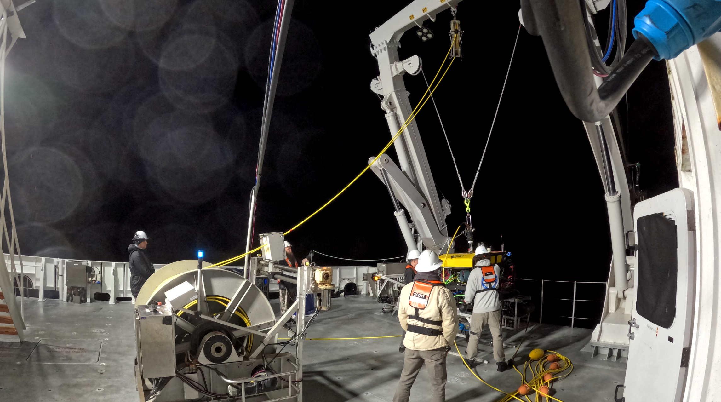
Step 1 — Pick Up MiniROV

Step 2 — Extend A-Frame and Lower MiniROV
The A-frame is extended over the side and the MiniROV is lowered towards the water surface.
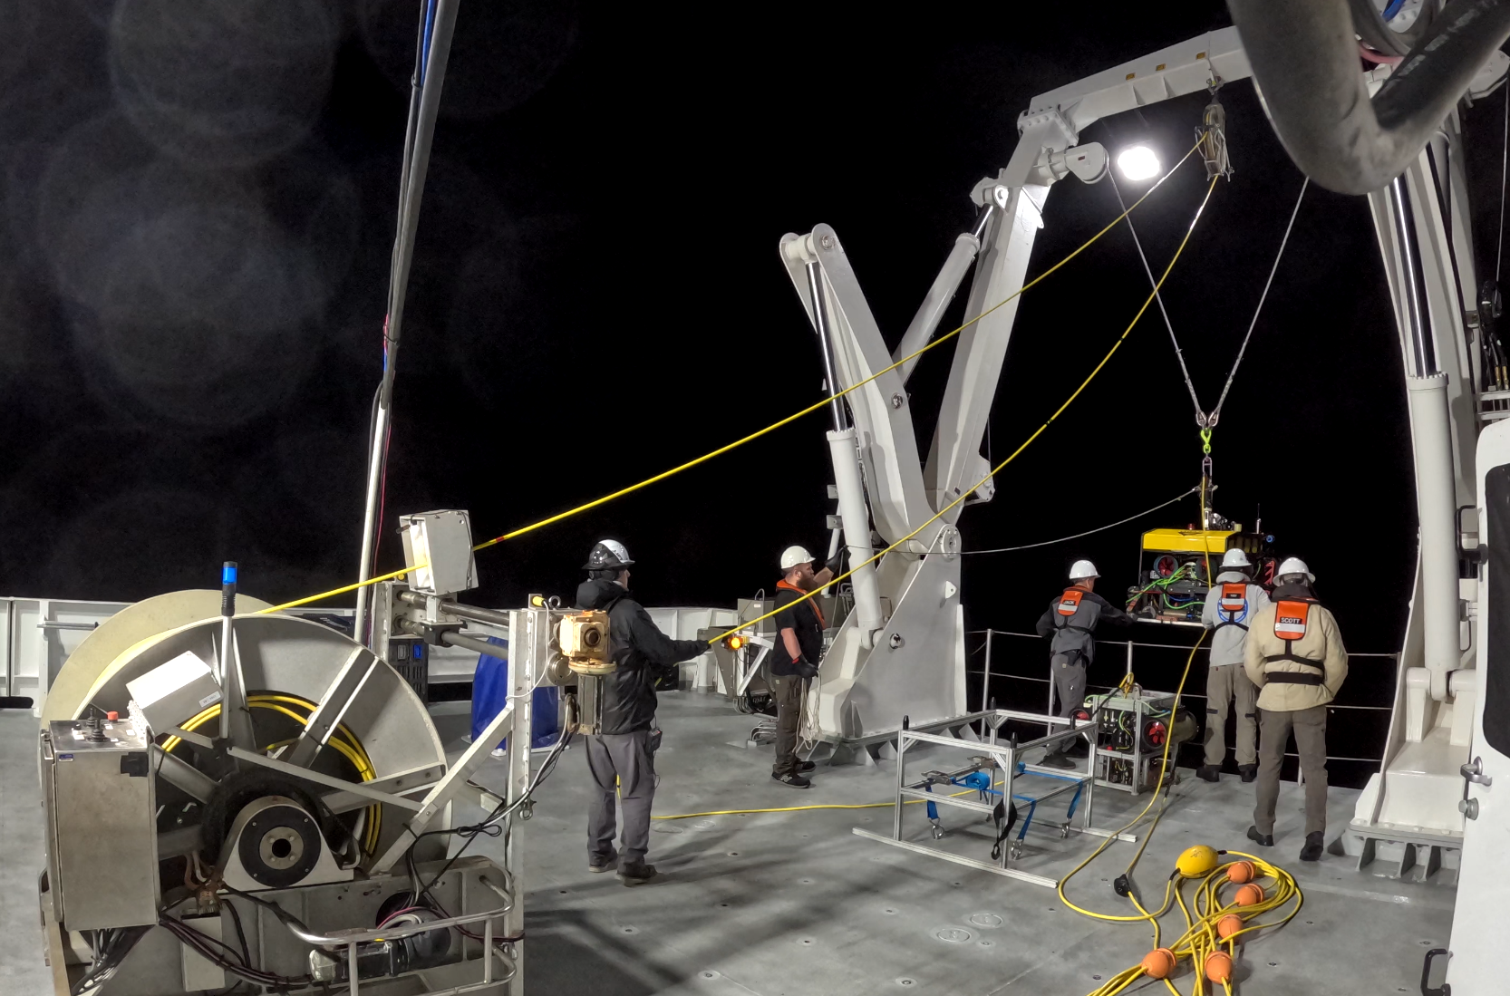
Step 2 — Extend A-Frame and Lower MiniROV

Step 3 — Unlatch MiniROV
Once the ROV is in the water, the belly pack pilot signals to the deck crew and the release line is pulled to unlatch the vehicle from the crane. The release line is a dedicated lightweight line rigged to the crane latch; it is pulled by a deck crew member standing clear of the lift zone. Confirm visually that the vehicle has unlatched and is free-swimming before signaling the crane operator to recover the latch. If the vehicle does not unlatch on the first pull, do not attempt to re-engage the crane — the belly pack pilot should hold the ROV stationary in the water while the deck crew attempts a second pull. If the latch cannot be released remotely, haul the ROV back alongside the vessel using the tag line and resolve the issue before attempting launch again.
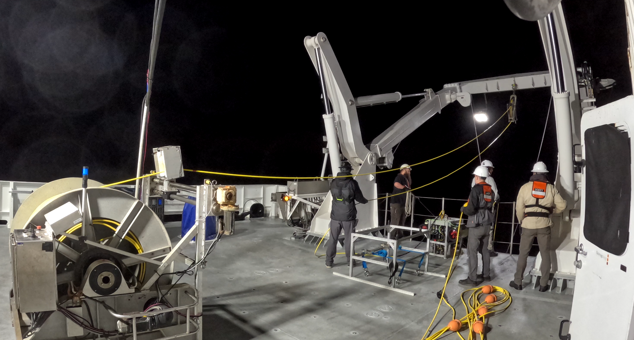
Step 3 — Unlatch MiniROV

Step 4 — MiniROV Begins Flying Away
The Remote Pilot Operator flies the vehicle away from the ship while maintaining a visual. Deck crew pay out the 50 m flying tether. ROV lights must be ON at night.
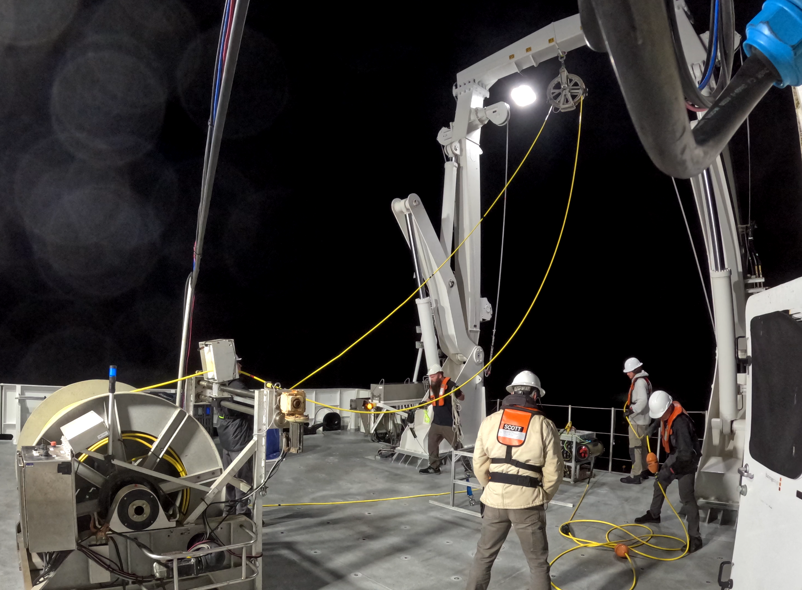
Step 4 — MiniROV Begins Flying Away

Step 5a — Pull in Slack from Smart Clump
With the MiniROV clear, the Winch Operator pulls in any slack between the Smart Clump and the winch.
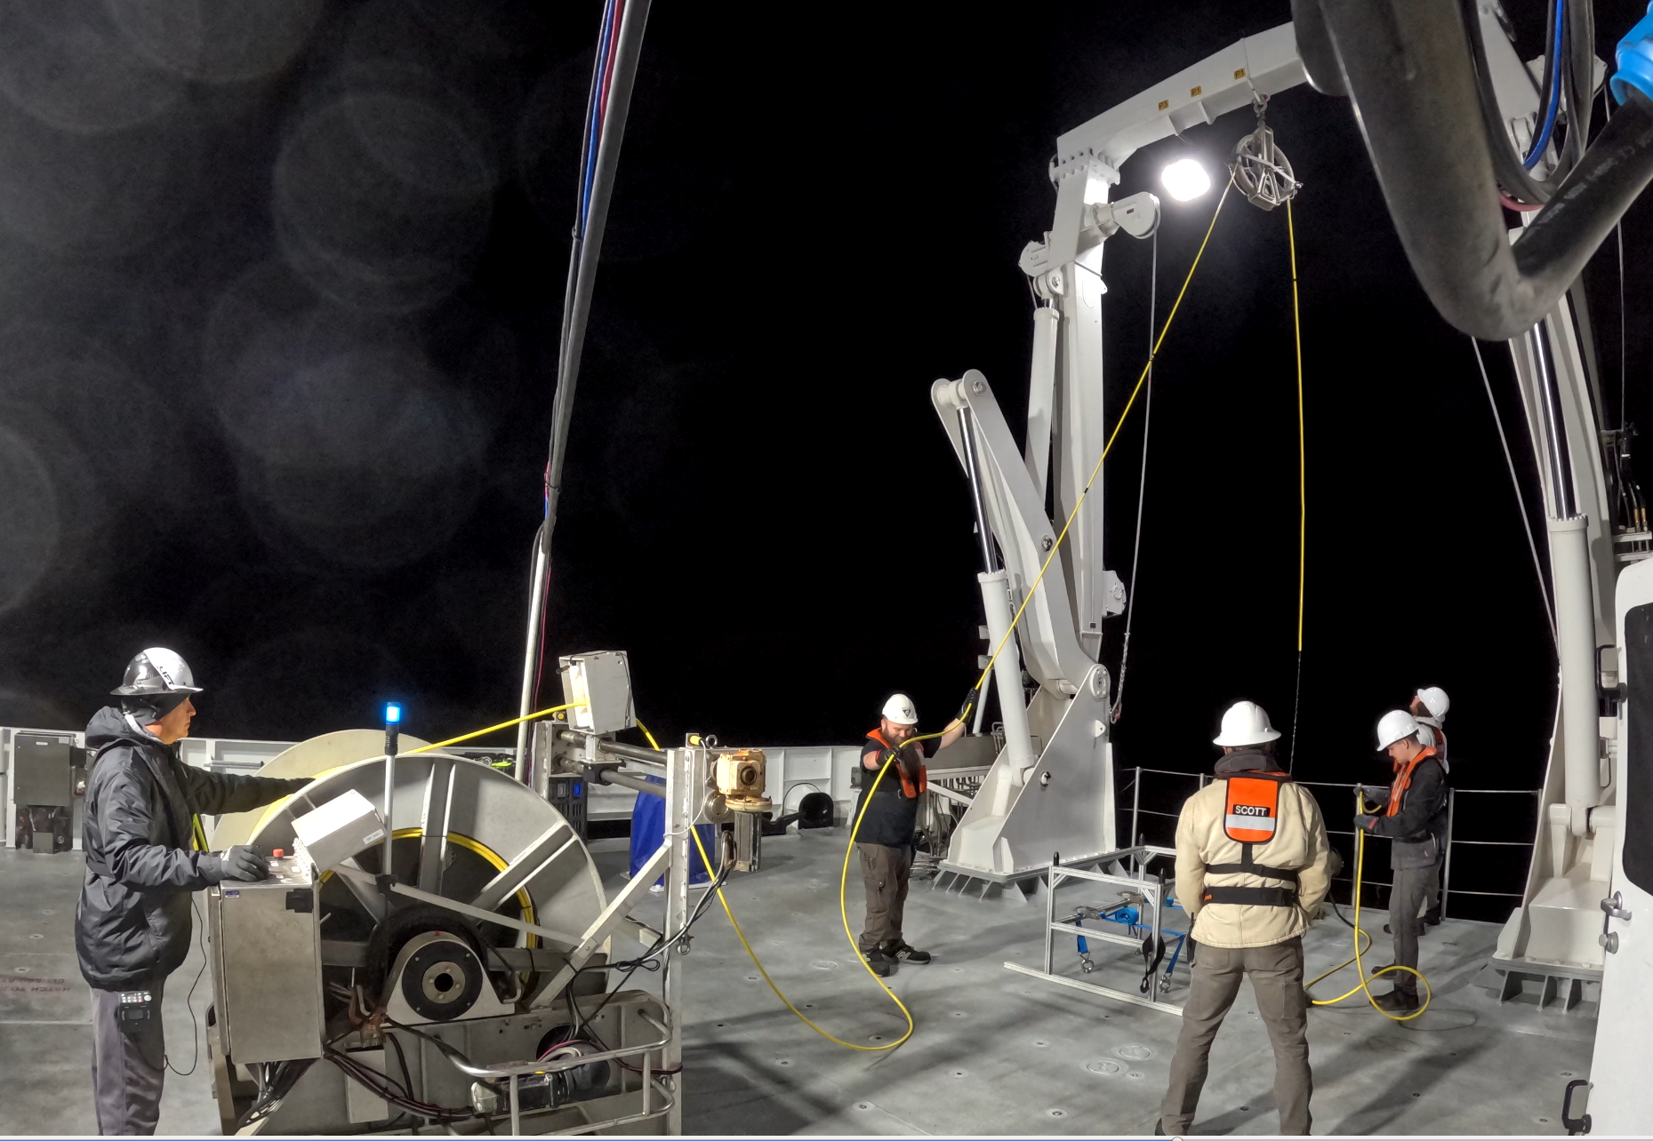
Step 5a — Pull in Slack from Smart Clump

Step 5b — Lift Smart Clump Over Rail
The Smart Clump is lifted and positioned over the ship's rail in preparation for deployment.
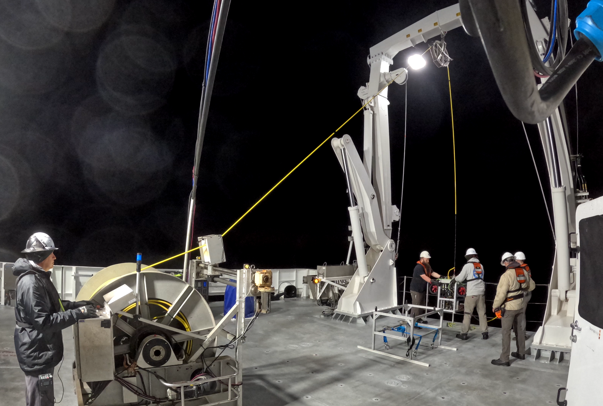
Step 5b — Lift Smart Clump Over Rail

Step 6 — Extend A-Frame and Lower Clump into Water
The A-frame is extended again and the Smart Clump is lowered into the water.
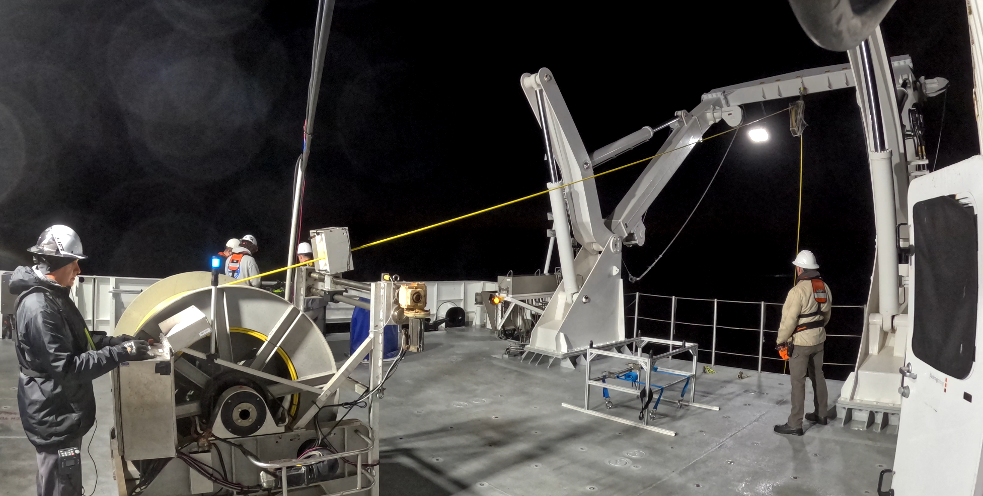
Step 6 — Lower Clump into Water

Step 7 — Lower Clump and MiniROV Simultaneously
Both vehicles are lowered together. Buoyancy floats on the flying tether keep the cable near-neutral, reducing propeller entanglement risk.
ℹ Once USBL positioning has acquired tracking and the ROV reaches 40 m depth, the Winch Operator may continue paying out cable to allow further descent.

Step 8 — System Fully Deployed
Maximum depth is 1,500 m. The MiniROV is flown to maintain position directly below the Smart Clump. The Smart Clump's thrusters counteract currents to maintain a near-vertical tether.

7.8.1 Vehicle Tracking
Vehicle positioning is monitored throughout the dive using a Sonardyne Ranger 2 USBL tracking system. The Ranger 2 displays the real-time position of both the MiniROV and the Smart Clump relative to the ship, allowing the bridge team and ROV pilots to maintain situational awareness of the underwater system at all times.
The Ranger 2 interface provides a plan-view display centered on the vessel, showing the horizontal offset and range of each tracked transponder. Both the ROV and Clump are equipped with Sonardyne WMT 6G USBL transponders, and their positions update continuously as the system descends. This display is used to confirm that the system is deploying correctly, to monitor the separation between the ROV and Clump, and to ensure the ROV remains within safe operating range beneath the vessel. The ROV Pilot (Control Van) is responsible for monitoring the Ranger 2 display throughout the dive and communicating position updates to the deck team and bridge as required. If USBL tracking is lost for either the ROV or Clump, the Chief ROV Pilot will evaluate the situation and determine whether to continue the dive or recover the vehicle.
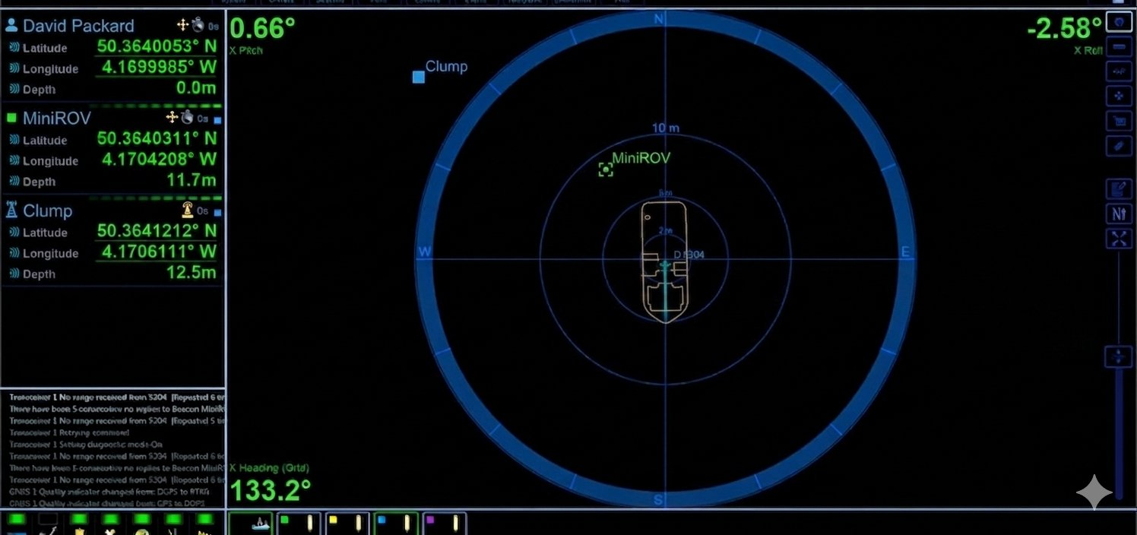
Sonardyne Ranger 2 display showing MiniROV and Clump positions relative to the ship

7.9 Dive Procedure
The ROV Pilot in the control van monitors all vehicle telemetry and communicates relevant information to the deck team. The Remote Pilot Operator directs vehicle movement while the ROV Pilot manages depth, heading, and thruster modes.
The Chief ROV Pilot may request the bridge to maintain a specific heading to keep the umbilical clear of the hull and propellers.
Only the minimum umbilical necessary for free ROV movement should be paid out, minimizing the risk of the tether snagging on the seabed.

Managing Delta (Vertical Separation)
'Delta' refers to the vertical distance between the MiniROV and the Smart Clump. Maintaining correct delta is critical to tether management and safe operation:
- Delta should be maximized whenever possible — a greater vertical separation keeps the flying tether taut and prevents it from forming loops or slack sections.
- A minimum delta of approximately 20–40 m should be maintained during normal operations to keep the flying tether stretched and clear.
- If delta decreases (i.e. the clump descends towards the ROV), the Winch Operator should haul in on the main umbilical to restore separation.
- ROV Pilots will monitor delta continuously throughout the dive and pay in or out on the winch remotely.

7.10 Recovery Procedure
Recovery is conducted in the reverse sequence of deployment. The following steps provide detailed instructions for safely recovering the MiniROV and Smart Clump from depth.

Recovery Step 1 — Notify Captain and Prepare Deck Crew
Before initiating ascent, the ROV Pilot radios the Captain to inform them the vehicle is ready to begin recovery. The Captain acknowledges and instructs the deck crew to take their positions and prepare for recovery operations. All personnel must confirm readiness before the ascent begins.

Recovery Step 2 — Begin Ascent with Flying Tether Stretched
The ROV Pilot initiates ascent. The Winch Operator hauls in the main umbilical at a controlled rate, bringing both the Smart Clump and MiniROV up together. Throughout the ascent, the MiniROV must be flown to keep the flying tether fully stretched out downwind or down-current of the vessel. Maintaining a stretched flying tether prevents loops from forming and keeps the tether clear of the hull and propellers. Monitor delta continuously and adjust as needed.

Recovery Step 3 — 50 m Hold and Belly Pack Operator Prepares
When the Smart Clump reaches approximately 50 m below the vessel, the Winch Operator pauses haul-in. The Remote Pilot Operator (belly pack) moves to the deck and prepares their equipment. Continue flying the MiniROV to maintain the flying tether in a stretched position during this hold. The belly pack operator does not take active control of the vehicle until it surfaces, and they have a clear visual on it. Confirm that all deck crew are in position and ready before proceeding to final ascent.

Recovery Step 4 — Final Ascent
With all personnel in position, the Winch Operator resumes hauling in the main umbilical, bringing the Smart Clump to the surface. Continue to maintain the flying tether in a stretched position throughout. As the Smart Clump approaches the surface, the belly pack operator acquires a visual on the MiniROV and takes over active control of the vehicle from the control van.

Recovery Step 5 — Recover Smart Clump
As the Smart Clump surfaces alongside the vessel, the A-frame swings the clump inboard over the rail. The Smart Clump is lowered onto the deck and secured.

Recovery Step 6 — MiniROV Backs Toward Ship While Deck Crew Retrieve Flying Tether
The Remote Pilot Operator pilots the MiniROV back towards the vessel at the surface from downwind/down-current, while deck crew manually retrieve the 50 m flying tether as it goes slack, flaking it in a figure-8 pattern on deck to prevent tangling. These two actions happen at the same time — coordinate carefully between the belly pack operator and deck crew.

Recovery Step 7 — Hold Position Below A-Frame and Install Latch
Once the MiniROV is alongside the vessel and directly below the A-frame, the Remote Pilot Operator holds the vehicle in position at the surface. A deck crew member installs the crane’s latching mechanism over the umbilical above the vehicle and slides it down the tether until it latches securely into the lifting attachment on the MiniROV frame. Confirm the latch is fully engaged before proceeding. Do not begin lifting until the latch is confirmed.

Recovery Step 8 — Optional: Attach Tag Line via Boat Hook
If sea conditions require additional control during the lift, a tag line can optionally be attached to the MiniROV using a long boat hook while the vehicle is still in the water, and the latch is confirmed. This allows deck crew to stabilize the vehicle and prevent it from swinging as it is lifted clear of the water. Recommended in swell or when conditions make the lift unpredictable.

Recovery Step 9 — Lift MiniROV Aboard
The crane lifts the MiniROV clear of the water. The A-frame swings the vehicle inboard. Deck crew guide the vehicle using tag lines to prevent it from swinging. The MiniROV is lowered carefully onto its stand on deck.

7.11 Post-Dive Procedure
Once the MiniROV and Smart Clump are safely on deck, the post-dive procedure ensures the vehicle is properly inspected, scientific samples are secured, equipment is readied for the next dive, and all personnel complete their close-out tasks.

Power Down and Initial Secure
Once the MiniROV is confirmed stable on its stand, the ROV Pilot powers down the vehicle from the control van. Secure all umbilical connectors and cable assemblies. Do not leave high-voltage connections live after the vehicle is on deck.

Vehicle Inspection
The ROV team conducts a thorough visual and physical inspection of the MiniROV and Smart Clump. Checking for any damage sustained during the dive, including thruster condition, connector integrity, camera housing condition, and frame integrity. Note any concerns and report to the ROV Chief Pilot. Inspect the umbilical and flying tether for cuts, kinks, or chafing damage along their full length.

Scientific Sample Recovery
The science party takes responsibility for recovering all scientific samples from the vehicle. This includes removing and processing any push cores, retrieving samples from the suction sampler buckets or collection drawer, and recovering any Niskin bottle water samples from the Smart Clump. All samples must be labelled, handled according to scientific protocols, and transferred to the science team immediately. The ROV team assists with physical access to the vehicle as required.

Remove and Charge Beacons
Remove the strobe and RF beacons from the MiniROV and place them on charge immediately. These beacons have limited battery life and must be fully charged before the next deployment. Verify charging is active and confirm the estimated charge time against the planned next dive window.

Fresh Water Rinse
Rinse the MiniROV, Smart Clump, and flying tether thoroughly with fresh water to remove salt and debris.

Prepare Vehicle for Next Dive
Once inspection, sample recovery, and rinsing are complete, prepare the vehicle for the next dive. This includes re-configuring any science skid payload, replacing spent consumables (push cores, gas sampler, Niskin bottle), checking thruster condition, and confirming all connectors are secured. Re-attach beacons once fully charged. Confirm with the science party that the tool skid is configured correctly for the next dive objective. The ROV Pilot updates the pre-dive checklist and confirms readiness with the ROV Chief Pilot before the next deployment.

7.12 Emergency and Abort Procedures
The following procedures apply in the event of an emergency or unplanned abort. All personnel must be familiar with these procedures before operations begin. In all cases, the safety of personnel takes absolute precedence over equipment.

Loss of ROV Communications
If telemetry or vehicle control is lost during a dive, the team should immediately attempt to re-establish communication links. Vehicle tracking should be checked to confirm the ROV's position, and the Captain and bridge notified. If telemetry cannot be re-established, begin hauling in the main umbilical at a controlled rate while monitoring tension throughout.

Tether Entanglement
If a tether loop or entanglement is detected: immediately stop all ROV thrusters and cease winch pay-out. Use camera feeds to assess before acting. Attempt to reverse the ROV slowly. If the tether cannot be cleared by gentle maneuvering, haul in at minimum speed while monitoring tension. If the tether snags on the seabed, maneuver the ROV to free it before applying winch load.

Power Failure
In the event of complete power failure to the ROV: do not attempt to restore power until the cause is identified. Use the winch (separate power circuit) to begin a controlled emergency haul-in. If the winch also loses power, engage the hydraulic emergency brake immediately to prevent free-spooling. Notify the Captain. A GFI trip indicates a ground fault — do not reset it until the fault is found. Water ingress or conductor damage must be suspected until ruled out.

Man Overboard / Person in Water
If a person falls overboard: shout “Man Overboard” and alert the bridge immediately. Power down the ROV from the control van to de-energize the tether. Throw a lifebuoy. All ROV operations cease until the person is recovered. Follow the vessel’s man overboard procedure as per the ship’s Safety Management System.

Electrical Shock / GFI Trip
If a person receives an electrical shock: The GFI will active automatically, powering down the ROV and hazardous voltage. Do not touch the person until you are certain they are clear of any live conductor. Call for medical assistance via the bridge. Do not restore power until the fault source is identified and made safe. Record all details in the dive log.

Vessel Movement / Loss of Station-Keeping
If the vessel loses station-keeping ability, operations should be halted immediately and the Chief Pilot notified. The Chief Pilot will assess the situation and determine the best course of action. If the vessel can maintain position under manual control, the dive may continue at the Chief Pilot's discretion. If not, the deck crew will be notified, and recovery of the vehicle will begin.
⚠ In all emergencies: safety of personnel takes absolute priority over equipment. When in doubt, stop the winch using the emergency kill switch, power down the ROV from the control van, and alert the bridge. No piece of equipment is worth a life.

