Maxon driver motor tuning with resolver:
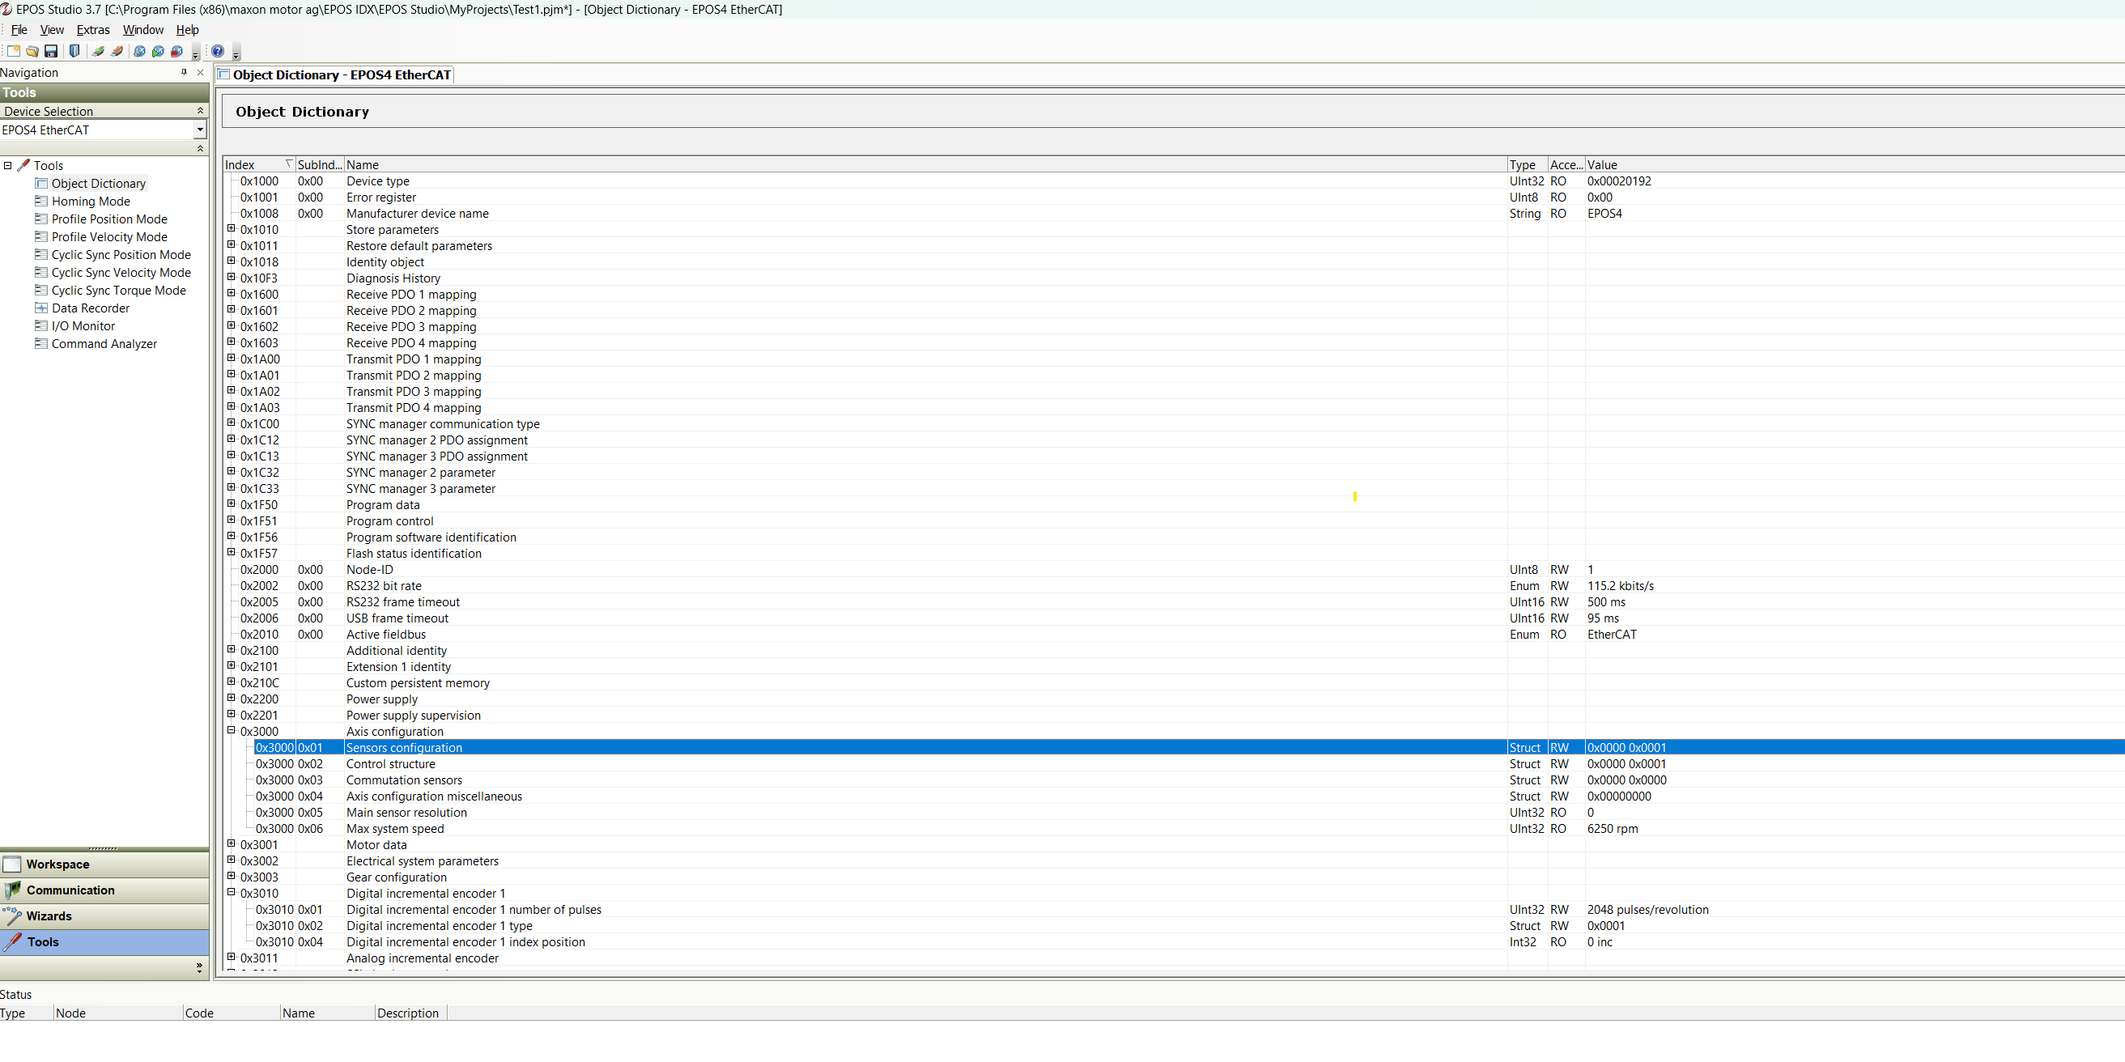
I had to change “Sensors configuration” manually to 0x0000 0x0001 – this disables the requirement for a hall sensor.

Commutation sensors: 0x000 0x0031 = X4 – none & X5 Digital incremental encoder 1
Defaults:
