South Bay Cable diagram:
Part number: SB48323
Here are some relevant notes for power/voltage loss calculations for the cable:
- From conversation with Gary Brown, 12/12/13, 13 AWG conductor current limit is 7 A
- As of October 2013 the maximum power draw of the vehicle was 8A @ 400 VDC, the calculations for those values with Ventana Falmat cable are:

Thus the most power we have seen used at the vehicle is <2700W
- The minimum voltage for the Vicors is 250V
- The Vicor maximum input voltage is 425V, this is what limits the maximum voltage on the topside.
  - The only transient voltage suppression diodes are rated for working voltage of 420V with a minimum breakdown voltage of 470V

- The Vicor minimum input voltage is 250V
  - The only concern this creates is the current rating of the traces on the carrier boards, but the 3A rated traces are sufficient, as even at 250V and 600W the maximum input current is 2.5A
- The South Bay cable has 6 13 AWG conductors, with a resistance of 2.44 Ohms/1000ft or 8.01 Ohms/km for each conductor. Three conductors in parallel would have 8.01/3 Ohms/km = 2.67 Ohms/km. The total resistance is then the length of the cable (1.7 km) multiplied by 2 (to include the return trip) multiplied by the equivalent resistance:
2.67 ohms/km * 1.7 km*2 = 9.07 Ohms
Note: this does not account for extra copper which results from helical winding.
- The table below calculates the high end of power that could reach the vehicle- actually the maximum is higher but with a current of 15 A (max is probably 21 A):
This results in 4200 Watts at the vehicle, and is still in the bounds of what the topside power supply can source and what the Vicors can operate from. This is 1.5 kW more than our current maximum.
- A more reasonable estimate of the losses and vehicle voltage is given in the following table:
This provides a little safety on the high side of the Vicor input, and still provides about 500 W more than we are using at our maximum now.
- Notes: what is left to add to these calculations:
  - Confirmation in writing of max current for each conductor
  - What is lay angle of cable
- From Paul McGill
“Here's how much power you can deliver at 425 V topside, minimum of 275 V at the vehicle, 20 degree lay angle, 1.7 km cable length.

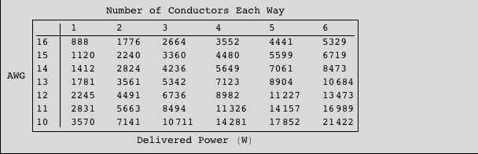

Your South Bay cable can deliver 5342 W with the assumptions stated above. A good way to compare one cable to another is to calculate the wattacity of the cables, as I describe in the paper.”

