I2MAP Camera System Design and Programming Notes

10021117DOC-1-F
Rev. E – 15JAN16 mrc Updated I/O and log list and minor revisions.
Rev. F – 21JUL16 mrc Added recorder and camera configuration.

Introduction.
This document describes the electrical design and is a programming reference for the i2MAP controller and electrical switching printed circuit board. The function of the board is to provide local control of the camera and light system while interfacing with the Dorado AUV using a 10/100 Base-T Ethernet connection. A commercial module based on a PIC processor provides the communications and processor input/output functions for the board. The LOCA board is installed in the camera housing and provides the following functions:
  - Electrical switching and dimming control for four DeepSea Power & Light LED lights.
  - Electrical power control for the camera system, which includes the camera, the video recorder and the camera lens iris drive circuit.
  - Electrical power control for the SBE 25 CTD and the associated sensors.
  - Serial communications (EIA 232) to the SBE 25.
  - Serial communications (EIA 485) to the iris motor controller.
  - Logic power control for the AJA KiProQuad video recorder.
  - Local environmental monitoring for water alarms, internal housing temperature and humidity.
  - Camera video signal mean and peak signal levels (for iris control algorithim).
  - Power conversion from the AUV 18-36 Volt bus to local 12 and 5 VDC.

Detailed Circuit Description.
  - Embedded processor: Communications and input output functions (I/O) are provided by a commercial processor module from the Modtronix Corporation, PN SBC65EC (MODULE). This module has the advantage of having a TCP/IP stack and embedded firmware that allows configuration and control through a simple HTML interface available at IP address: 134.89.32.55, user: admin, password: pw. (this may change in the future). The functions of the host micro-processor, the PIC18F6627 CPU are all accessible through this interface, including 32 channels of analog and digital I/O. The details of setting up the Modtronix embedded processor are in section 3 below.
  - Electrical power switching: THIS NEEDS TO BE UPDATED! The electrical switches for each of the individual lights, the camera system and the CTD loads are on digital output Ports B0-B5. These ports should be configured as outputs. Check the port list table below to see if the switch active (ON) state for each output is high or low. A low level active signal /FAULT from each switch is routed to the analog input ports T0-T2. If an over-current or over-temperature is detected by the individual switch, it will set the /FAULT line low. The analog input reading for that port will drop from 4.5-5V to 0.1-0.4V and the switch will shut off the load. To restore the switch, the cause of the fault must be removed, and the power switch cycled through the off state.
  - AJA KiProQuad video recorder power control (RECORDER): The video recorder is on the AUV Ethernet network and can be reached with an HTML GUI interface at IP address: 134.89.32.54 (this may change in the future). The electrical power for the RECORDER is switched ON or OFF using the circuit described in section B above. The RECORDER also requires a logic signal to mimic the action of the user pressed “power” button on the front panel. A 3.3V logic level circuit using MODULE Port B6 has been hacked into the recorder to provide this function. Control of the RECORDER logic power switch on/off function with Port B6 has the following properties:
    - Turn on with momentary pulse (~1 sec.).
    - Turn off with pulse > 2 seconds.
    - All override off and restore factory default with pulse > 6 seconds.

  - Dimming control: The dimming function uses pulse width modulation and an integrating circuit to provide a 0-5V output from the RC2 output pin which provides dimming control to all 4 lights simultaneously. This pin must be configured as a PWM output with a base frequency of 9.766 kHz and 8 bits (important for proper calibration of light output vs PWM setting). Full scale (100% brightness) is a PWM setting of 255.

Figure 1. Plot showing relationship between PWM value and lamp current. Note that the lamp output in LUX was a very coarse measurement. It is safe to assume that the light output tracks the lamp input current.

  - SBE 25 CTD serial communications: The communications with the SBE 25 use the processor MODULE internal USART, channel 1. The on-MODULE 232 transceiver is also used.
  - Camera lens iris position control: The i2MAP system camera does not have any method of providing an internal auto-iris function. To allow for camera system operation under variable lighting conditions a lens iris drive system is implemented using a small stepper motor to drive the lens and an EZ Stepper model EZ17 motor controller. The communications between the MODULE and the EZ17 controller are EIA 485 serial protocol and the LOCA board provides a 485 transceiver and the required line turn-around circuit to arbitrate between the full duplex MODULE TTL communications and the half-duplex EIA 485 standard.
If the lens drive is disassembled, the intermediate gear and lens iris gear ring must be re-aligned using the index marks on the gears to provide the proper home position for the lens driver.
Under conditions of little ambient lighting, the iris is driven to and held in the f5.6 (note this value may change depending on testing results) position based on a lookup table of motor-steps to desired position from the mechanical stop at the minimum iris position . Under conditions of high ambient light levels (near the surface in daylight), two signals are provided to assist in setting the appropriate iris position. The first is the peak video signal level on the A/D converter input, Port A0. The peak video signal level should be about 0.9V. The second signal is the mean video signal level on the A/D converter input, Port A1. Depending on the type of scene, the mean level should be less than 0.5V. Using these two inputs, an adjustable algorithm weights each appropriately and compares the results to a set variable. Using the difference between the actual values and the set point, a look-up table is used to adjust the iris position before each recording when in environments of high ambient lighting.
  - Temperature sensing and over-temperature shutdown: The housing ambient temperature is sensed with an analog module connected to the A/D converter input Port A3. The sensor outputs 500mV + (10mV per degree Celsius), for example, 20° C = 0.7V. There is an over-temperature protection circuit in the electrical hardware that shuts down the 15 Volt power supply to the camera and recorder if the housing internal temperature reaches 40 degrees C. The circuit has 5 degrees of hysteresis and will not re-enable 15 Volt power until the temperature drops to 35 degrees C. The port map shows the /OVERTEMP FAULT signal routed to digital input port T6, but this has not been done in the current hardware revision. With the current revision, the only indications of an over-temperature fault would be a temperature above 40 degrees C in the system log file. If the system goes into over-temperature the camera and recorder will shut down immediately and if the system is recording then data may be lost. For this reason the software application should perform an orderly camera and recorder shutdown when the housing temperature reaches 35 degrees C.

  - Humidity sensing: To sense humidity, an analog sensor is connected to A/D converter input Port A2. The output of 0.5 to 2.5V corresponds to 0-100% humidity.

  - Water alarms: A water alarm contact is installed in the fore and aft ends of the camera pressure housing. The fore sensor is connected to A/D converter input Port A5 and the aft sensor connected to Port A4. A voltage of greater than 0.5V on these inputs signifies a water alarm.

Programming Notes.
  - A Modtronix Engineering single board PIC computer model SBC65EC is used for network communications and all input and output functions. The i2MAP I/O board J1 & J2 connector pin description and Modtronix module configuration is shown below. Note that the configuration of the ports to digital or analog input only allows for sequential analog assignments. The incorrectly mapped digital inputs shown on RF0, 1, 2, and 6 below will be re-assigned on the next hardware revision.

  - Data logging. The state of the following Modtronix/PIC register values shall be included in the log file for post-mission camera system performance analysis:

  - Modtronix configuration. The following port and system configurations are set through the Modtronix web interface. Make sure that you are on the same subnet as the camera system (AUV subnet), and point your browser to the IP address 134.89.32.55.
    - System settings. 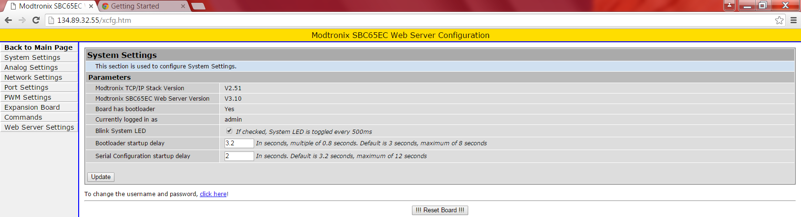
    - Network interface. 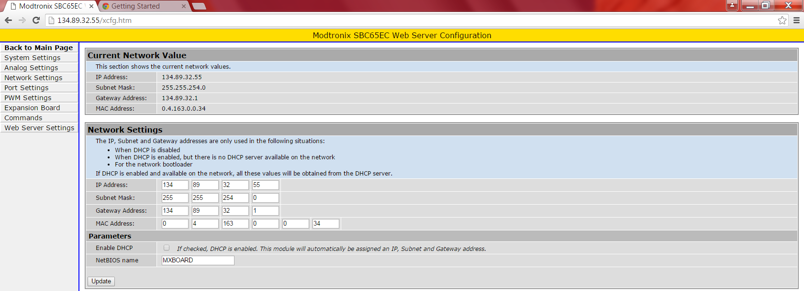
    - Web server configuration.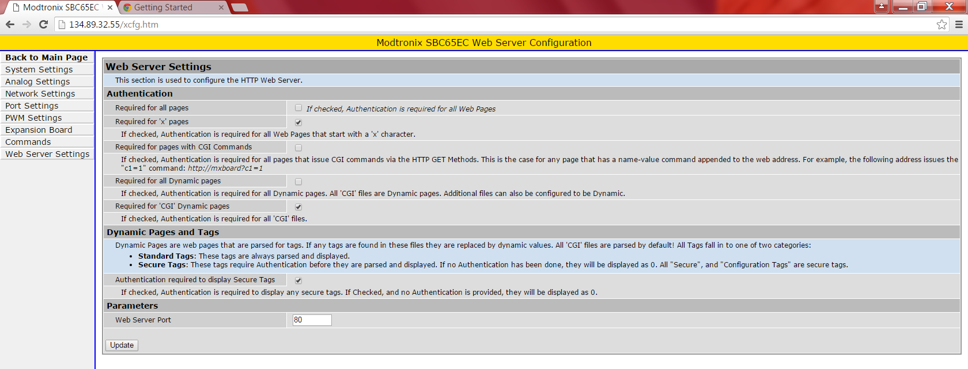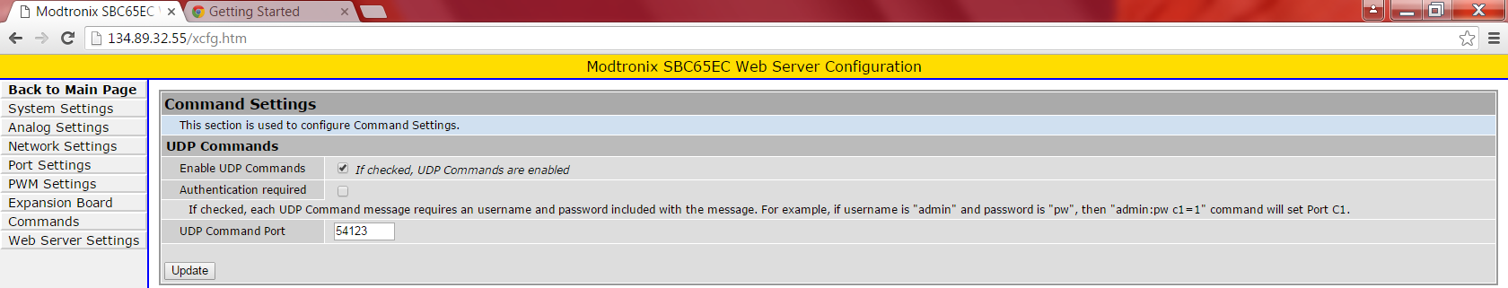
    - Serial buses.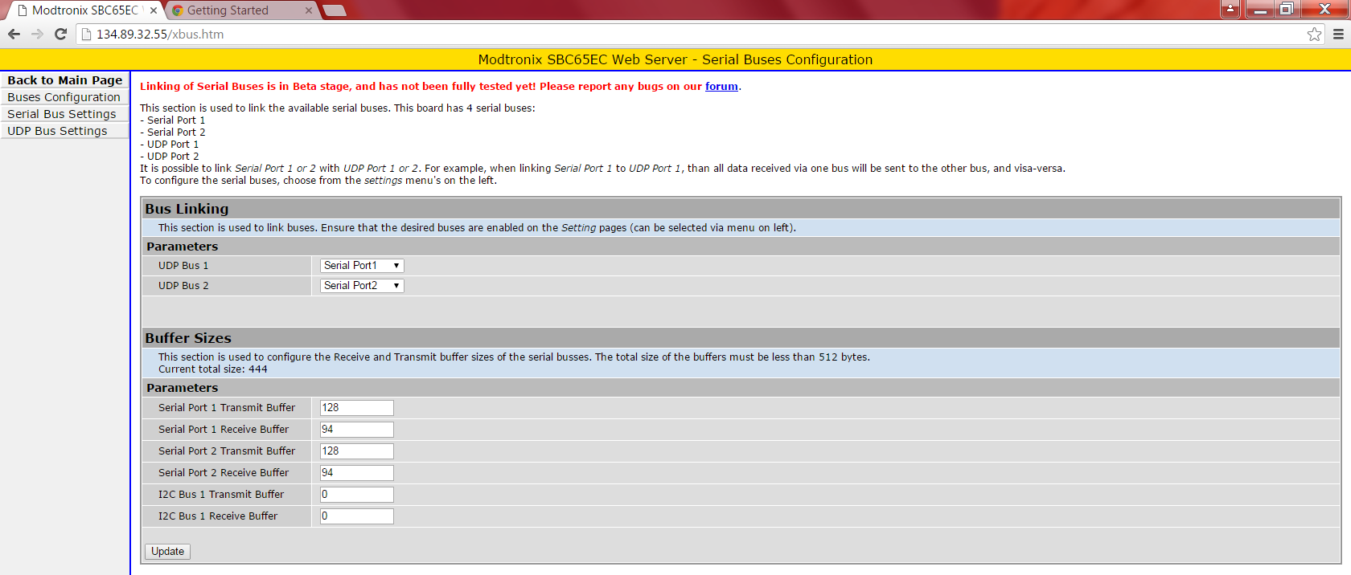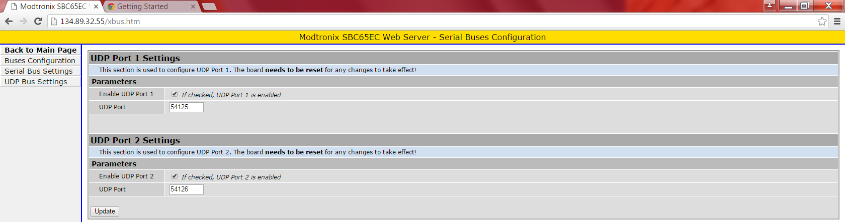
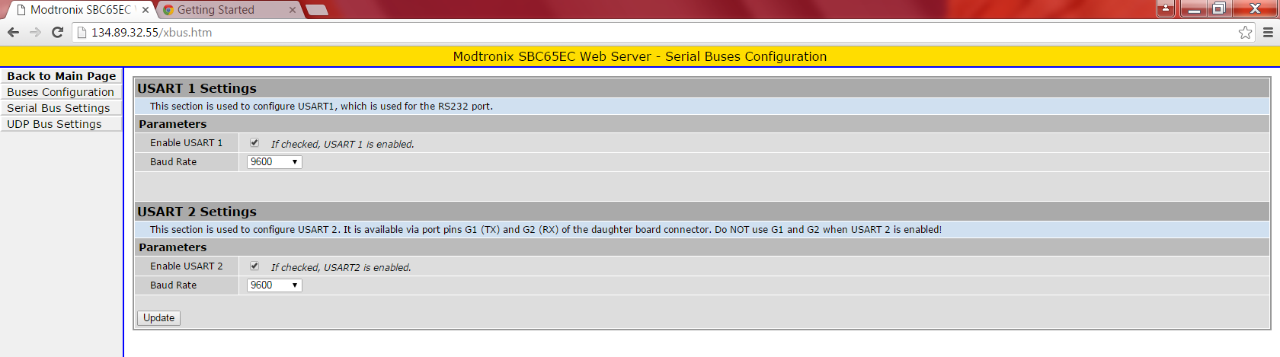
    - Analog input settings.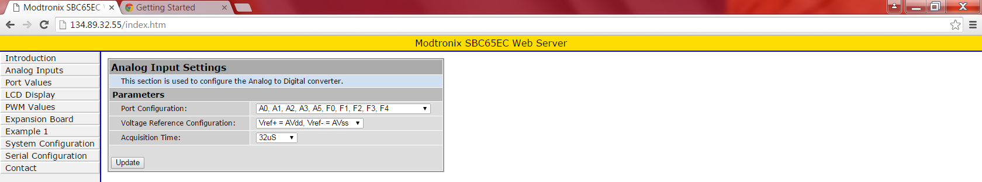

    - Port settings. 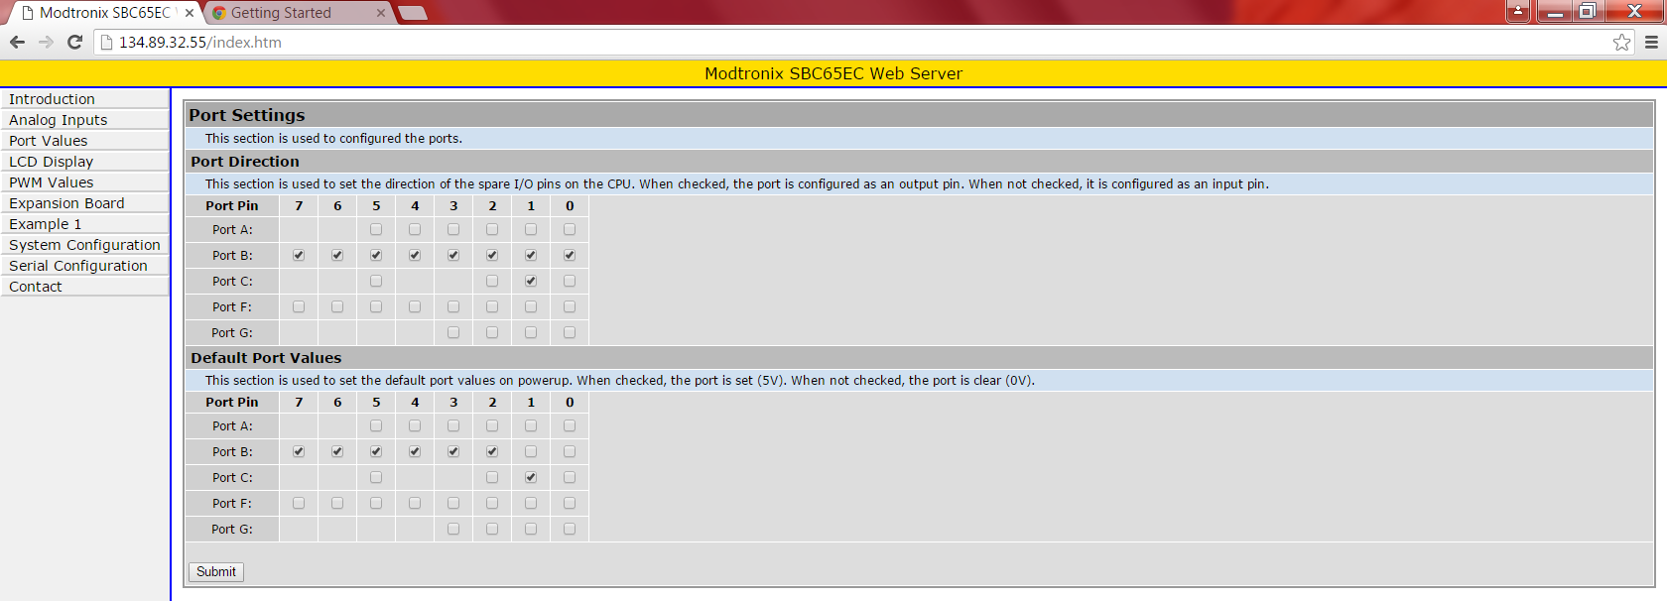

    - PWM settings. Important for proper calibration of light output vs PWM setting.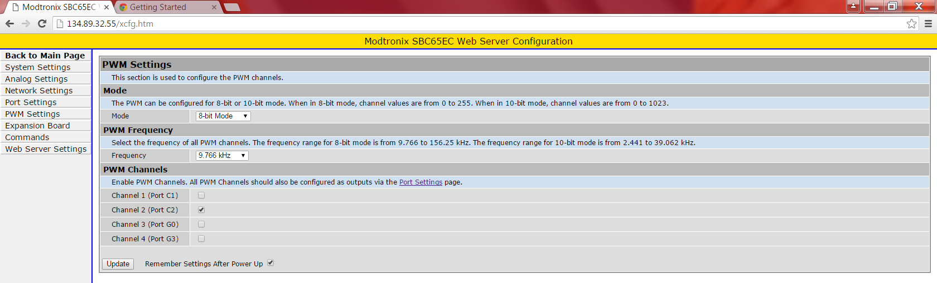

- AJA KiPro Quad Recorder Configuration.
See: EngineeringDesignDocs\ReleasedPDFs\AJAConfigurationSettings_RevA.pdf

Sony PMW F5 Camera Configuration.
See: EngineeringDesignDocs\ReleasedPDFs\ SonyCameraConfigurationSettings_RevA.pdf

