Notes from i2MAP
Mark Chaffey
An emerging interface, commonly known in the industry as dual link HD-SDI and consisting essentially of a pair of SMPTE 292M links, is standardized in SMPTE 372M; this provides a nominal 2.970 Gbit/s interface used in applications (such as digital cinema or HDTV 1080P) that require greater fidelity and resolution than standard HDTV can provide. A more recent interface, 3G-SDI, consisting of a single 2.970 Gbit/s serial link, is standardized in SMPTE 424M that will replace the dual link HD-SDI.
3G-SDI (SMPTE424M) effectively doubles the bandwidth to 2.97 Gbit/s. Video data that previously needed two SDI connections can now use "only one cable" and images which couldn't be handled in realtime at all can now use dual-link 3G-SDI.
Best light meter:

Sekonic Litemaster Pro L-478D Light Meter and X-Rite ColorChecker Passport with Sekonic Gray Balance Card

Standard | Name | Bitrates | Example video formats
SMPTE 259M | SD-SDI | 270 Mbit/s, 360 Mbit/s, 143 Mbit/s, and 177 Mbit/s | 480i, 576i
SMPTE 344M | ED-SDI | 540 Mbit/s | 480p, 576p
SMPTE 292M | HD-SDI | 1.485 Gbit/s, and 1.485/1.001 Gbit/s | 720p, 1080i
SMPTE 372M | Dual Link HD-SDI | 2.970 Gbit/s, and 2.970/1.001 Gbit/s | 1080p
SMPTE 424M | 3G-SDI | 2.970 Gbit/s, and 2.970/1.001 Gbit/s | 1080p
TBA | 6G UHD-SDI | 6 Gbit/s | 4K
TBA | 12G UHD-SDI | 12 Gbit/s | 4K

Circle of confusion. For 35mm format or large format lenses, the value of 0.020mm seems to be commonly used. Fujinon uses 0.009mm for the 2/3” lenses! Approximately matches the CCD pixel size.
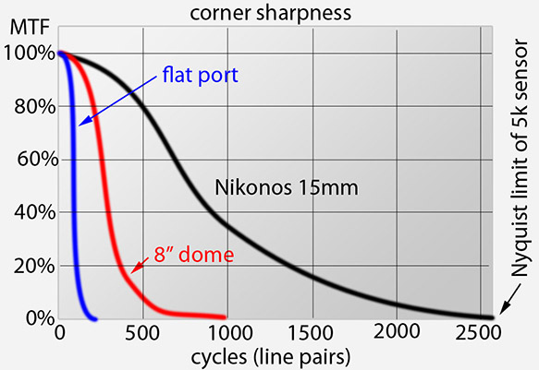

Lens dealer: http://cinematechnic.com/products/sales_lenses.html
Lens dealer with Tokina lenses: http://www.fjsinternational.com/lenses.html
3CCD Prism Cameras: The introduction of the B4 interface was a milestone - it was the first time in history that a common lens mount and specifications were adopted for all 2/3" HD cameras. (this was the Broadcast Technology Association global standard BTA S-1005-A adopted in 1994, followed by the EBU Tech Spec in 2002). Before this standard, every camera manufacturer had their own mounts and specifications.
In establishing the B4 standard, a specific 48mm flange back dimension was dictated - this is where the green image "in air" plane is that you see reference marked on the side of the camera - and what you "back focused" to.
If you are only looking at one part of the light spectrum, that would be easy - and the end of the story. Chances are that you are not shooting black & white - where the green channel would be enough for luminance. Color adds a degree of complexity.
In the case of 2/3" HD cameras, the light is split by a prism to land on 3 sensors. The prism assemblies are designed to mitigate both types of abberations by offsetting the sensors - Red is offset by 10 micrometers and Blue is offset by 4 micrometers from the Green image plane. This is a compromise - but take away those modifications and you end up with real problems ( aka inferior results).
Optical fabrication
http://www.melleroptics.com/index.asp
Fathom Imaging (joint effort of Micro Optech (Dr. Paul Remijan) and JBV Optics)
JBV Optical Products
Optical consultants
Fathom Imaging
Micro Optech
Dr. Paul Remijan
Milt Lakin
Richard Buchroeder

“All the codecs supplied for test by the 2 major broadcast equipment manufacturers are based on the newer H.264/AVC standard which can be extended to Ultra HD frame sizes. However, as Andrew Cotton mentioned in a recent blog post, Ultra HD is more than just the oft-publicised “4k” resolution. The codecs used for Ultra HD production will need to handle high frame rates, larger colour spaces, higher bit depths and a higher dynamic range than we are currently used to.
Further work will be required as broadcast manufacturers bring more open and proprietary Ultra HD-compatible codecs to market (e.g. Apple ProRes and SMPTE VC-3 (DNxHD)). Additional work will be required to ensure that Digital Cinema formats such as OpenEXR and DCP can be successfully imported into a broadcast environment”

Many of you will already be aware that ultra-high definition (UHD) displays will start to appear in shops later this year, and some of you may already have seen them. These new screens have a resolution of 3840x2160 pixels - four times higher than today’s “Full HD” displays. But it’s not all about resolution – many of the UHDTV screens will be big so they’ll fill more of your field of view. Because of that, just like the IMAX cinema, they’ll bring with them a greater sense of reality.
For those who’re not familiar with UHDTV its basic parameter set is defined by theITU BT.2020 standard. The standard defines two UHDTV profiles – what’s commonly called UHD-1 at 3840x2160 pixels and UHD-2 at 7680x4320 pixels. The UHD-2 format was used for last year’s joint NHK/BBC public demonstrations of Super Hi-Vision during the London 2012 Olympics. However, based on research we conducted back in 2004, current thinking is that the lower resolution UHD-1 format is better suited to domestic screens. That research, published in BBC R&D White Paper 092, shows how the current 1920x1080 HD format is sufficient for the vast majority of viewers with screens of up to around a 60” diagonal. The UHD-1 format really comes into its own on larger screens, or where the viewer is particularly close to the screen.

For HDTV operation, XAVC can be considered as the mezzanine level format that fills the gap between the mastering quality format (MPEG4 SStP, or HDCAM-SR), and MPEG2 as illustrated in Figure 6).
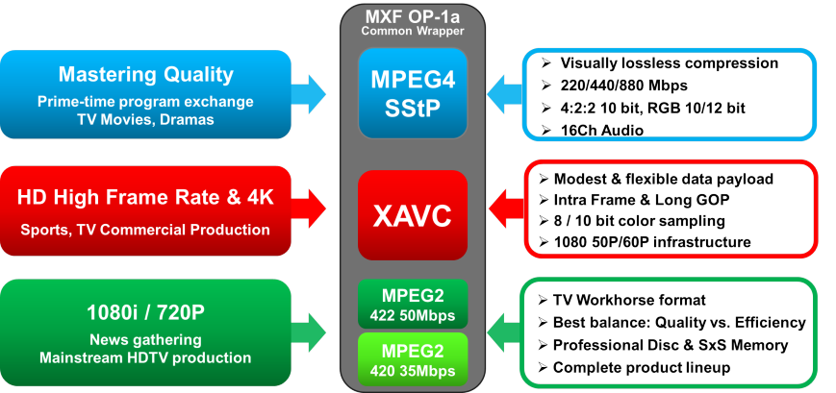
In order to productize portable camcorders with modest power consumption, Sony has developed a custom hardware chipset that handles the XAVC encoding & decoding process. Moreover, the chipset has the ability to encode/decode MPEG2 as well. The multi codec capability is expected to significantly increase the product life value. It will allow facility/equipment owners to create a service infrastructure that can easily convert between MPEG2 and XAVC. The first product to make full use of this multi codec capability is the PMW-F5/F55 production camcorder, which handles MPEG4 SStP and RAW in addition to XAVC and MPEG2.
XAVC also plays a critical role in enabling a portable camcorder with extreme high-frame rate capability in HDTV resolution. The PMW-F55 records full resolution 1920x1080 10bit 4:2:2 images up to 180 Frames-per-second onto the internal SxS Pro+ memory cards. By filling the two memory card slots with 128GB cards, continuous recoding time is extended to approx. 40 minutes at 180Fps. WHAT ABOUT THE F5?
The F-55 sensors are different. The space given over on each photosite to the additional electronics that makes the global shutter a global shutter is the reason that the F55 is ISO1250 and the F5 ISO2000. In addition it uses different dyes in the bayer colour filters to produce a wider potiential colour gamut.
Lens notes from Alan Albert at Claremont Camera: Lens drive rings have two different gear pitches; metric, “ .8 modulo”, which is 0.8mm pitch, and “14 ½, 32 degree pressure angle”, the “old” gear pitch. They are close to interchangeable, but for the least backlash and the smoothest operation you need to make sure your drive matches the lens gear pitch.

