Pressure testing of the dome port

François Cazenave, May 20 2016.
This document summarizes the pressure testing performed on the i2mpa domes. Description of the design, of the test procedure, and analysis of the results are included.
Test logs and data are included in the project folder.

April 4 2015 test at Maripro facility
The first test was performed at the Maripro pressure test facility. The test chamber was chilled to 4ºC. The pressure was raised to 2750 PSI and cycled 9 times over a few hours. The dome was inspected and looked intact. The dome was then pressurized to 2750 PSI over 3 days, unattended. After three day it was found to have failed. Analysis of the glass has shown that the crack originated at the seat, near the ID. The seat was not polished and the ID was not beveled, which might have contributed to the failure.

May 8, 2015 test at Maripro facility
This test was performed at Maripro. The design was not modified except for the paint which was removed from the seat. The pressure was raised to 1850PSI and cycled 15 time over several hours. Then, it was held for over 48 hours. Then it was cycled 5 times again. The test was successful.

February 4, 2016 test at Navy facility.
This test was performed at the Navy’s pressure test facility in Port Hueneme. The small pressure vessel was used. The temperature was 2.6ºC.
The design was significantly modified for this test. The 0.005” kapton gasket was replaced with a 0.020” Cirlex (laminated kapton) gasket. The seat of the glass dome was polished and the ID was beveled. A groove was cut in the titanium seat to help relieve compressive stress near the ID of the glass. The pressure was increased at a rate of 100PSI/min until the dome failed unexpectedly at 1563PSI.
During this test, the axial displacement of the dome was measured by a LVDT (linear displacement sensor) placed inside the housing. The pressure was also recorded. Figure 1 shows the displacement and the pressure versus time. The maximum axial displacement before failure was 0.011”.
Figure 2 shows the pressure versus the displacement. The slope of a linear fitting of the data is included on the plot.
It was expected that the seat of the glass would not slide radially on the kapton ring, due to high friction. With that assumption, the FEA had predicted an axial displacement of 0.007” at 1563 PSI. The displacement turned out to be greater. The FEA was performed again, with a lower coefficient of friction allowing sliding at the dome seat. Using that model the predicted displacement matched the measured value of 0.011”. This led us to believe the failure was due to tensile hoop stress that developed near the OD of the dome. Later analysis of the broken glass by a glass scientist confirmed this explanation.

Figure 1: Plot showing the failure of the dome. The blue line shows the hydrostatic pressure and the green line shows the axial displacement of the dome

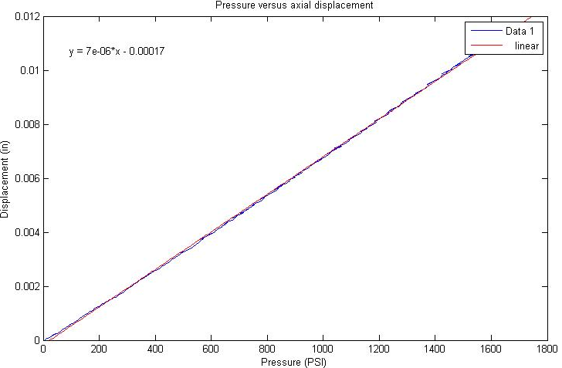
Figure 2: Pressure versus axial displacement and linear fit.

May 5, 2016 test at Navy facility.
This test was performed at the Navy’s pressure test facility in Port Hueneme. The large (6’ diameter) pressure vessel was used. At the beginning of the test, the temperature was 10ºC and it slowly decreased during the day. At the end of the test, the following morning, the temperature was 1.8ºC.
The design was significantly modified for this test. A 0.020” Cirlex gasket was used. The seat of the glass dome was polished and the ID was beveled. The OD of the dome was bonded to a titanium ring to prevent tensile hoop stress from developing.
The pressure was increased at a rate of 100PSI/min and cycled to 200PSI, 500PSI, 1000PSI, 1500 PSI, 2000PSI, and 2400PSI. It was then cycled at 1500 PSI 6 times and held under pressure overnight (18 hours). The test was successful.
During this test, the axial displacement of the dome was measured by a LVDT (linear displacement sensor) placed inside the housing. The pressure was also recorded. Figure 1 shows the displacement and the pressure versus time. The axial displacement at 1500 PSI was 0.007”.
Figure 3 shows the pressure and the displacement during the displacement. Note that during the overnight pressure hold, the displacement decreased slightly due to temperature change.
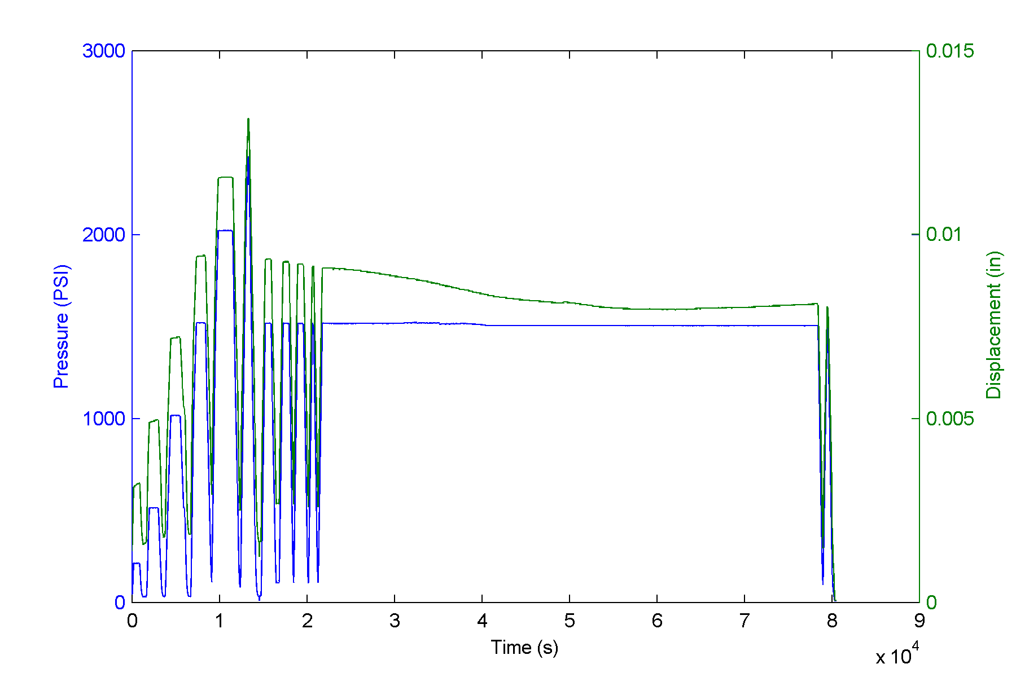
Figure 3: Pressure and axial displacement during pressure test

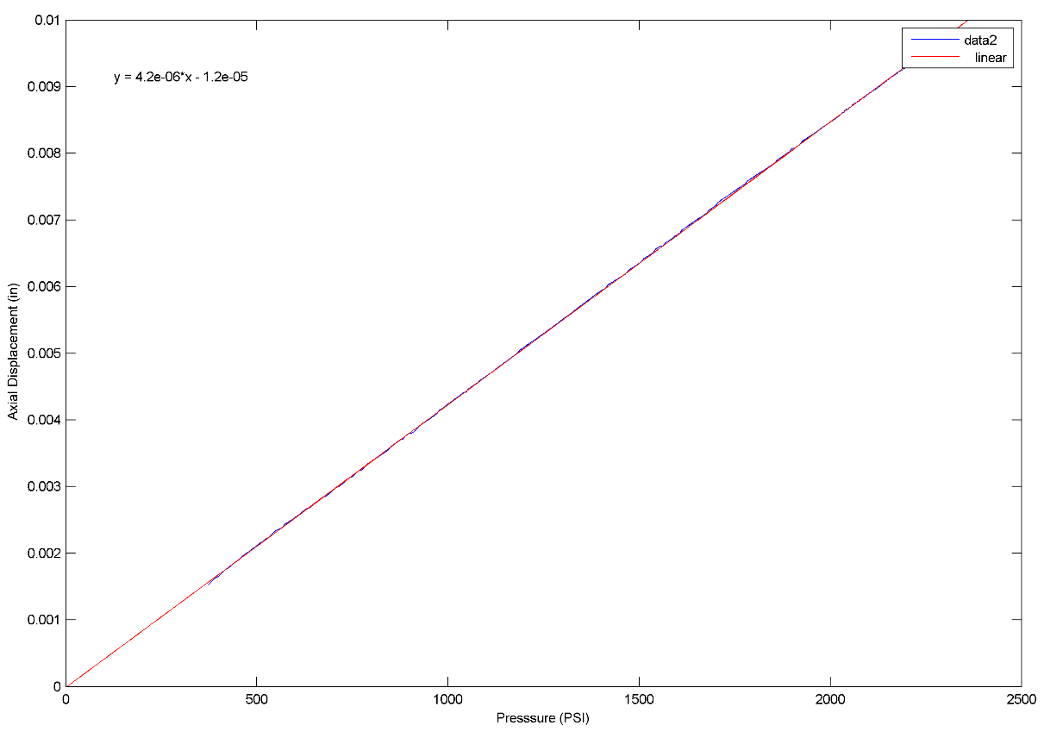
Figure 4: Pressure vs Displacement during the highest pressure cycle. Only the linear portion of curve is shown. A linear fit has been added.

The displacement observed during this test closely matches the FEA prediction.

Conclusion

The axial displacement of the glass during the last test was 40% less than during the previous test. This shows that the new design is effective in preventing radial sliding of the glass on the titanium seat. Also, both tests validate the FEA.

