Mechanical design of a glass dome for the I2map camera housing
By François Cazenave, created 09/10/2014. Updated 10/14/14.

Determining an acceptable maximum stress value
The strength of the glass to be used is unknown to us. It depends on many factors (type of glass used, micro structure of surface of the glass, area of surface exposed, rate of stress increase, environmental media) and can only be calculated if these factors are known. Typically the strength of glass is determined experimentally.
Testing the glass would be too expensive and time consuming so we must err on the conservative side and use values from proven designs.
The dome of the Sony HDTV housing is a proven design. By modeling the dome in Solidworks Simulation, we find that at 4000m depth (its rated depth), the stress in the glass is about 18000 PSI (displacement was about 0.1mm). The 6000m rated DSPL camera housing is another proven design. The stresses were modeled for that depth; they are near 22KSI.
So it can be assumed that 18000PSI is a safe value (we have to assume that a reasonable the safety factor was used and that the glass we are using has similar mechanical properties).

Simulations of dome design provided by Paul Remijan on October 7, 2014

Based on the drawing provided by Paul Remijan (the optical engineer) two 3d models of the dome were made (one with 9mm CT, or thickness on the axis, and one with 15mm CT). First, simple simulations (FEA) of these domes were performed. Then, more advanced and realistic simulations of the domes assembled with an aluminum mounting ring were performed. The results are summarized below. Plots of these simulations are included at the end of this document.

Analysis of Dome only
Stresses are in KSI and displacements in mm
Type of Fixtures used | Max stress on axis | Max stress on outside face | Axial displacement on axis of dome | Radial displacement on edge of dome
Dome with 9mm CT, fixed edge faces | 22.5 | 22 | 0.38 | 0
Dome with 9mm CT, radial point support only | 26 | 42 | 0.85 | 0.5
Dome with 9mm CT, radial and axial point supports | 23 | 24 | 0.5 | 0
Dome with 15mm CT, fixed edge faces | 15.7 | 15.7 | 0.27 | 0
Dome with 15mm CT, radial point support only | 20 | 22 | 0.64 | 0.28
Dome with 15mm CT, radial and axial point supports | 18 | 18 | 0.37 | 0
Dome 2 with 22 CT  Fixed edge faces | 8.74 | 8.75 | 0.15 | 0
Dome 2 with 22 CT  Radial point support  only | 9.93 | 10.0 | 0.23 | 0.05

Analysis of Dome and Aluminum ring assembly
Stresses are in KSI and displacements in mm
Type of Fixtures used | Max stress on axis | Max stress on outside face | Axial displacement on axis of dome | Radial displacement on edge of dome
Dome with 9mm CT, No OD Support | 26.7 | 29.6 | 0.77 | 0.34
Dome with 9mm CT, with OD Support | 22.5 | 22.6 | 0.42 | 0.03
Dome with 15mm CT, No OD Support | 18.3 | 19.7 | 0.53 | 0.19
Dome with 15mm CT, with OD Support | 15.6 | 15.6 | 0.29 | 0.02

Notes on results

From the results above we can conclude that:
- Stress in the dome with 9CT is higher than the acceptable value of 18000PSI. Stress in the dome with 15CT is around 15000PSI, which is acceptable.
- When the dome is not supported on the OD, an area of higher stress appears on the outside face. This effect is more noticeable with the 9mm CT dome.
- Supporting the dome on the OD reduces axial displacement by about 50%. It reduces stress on the axis by about 15%.
- Without outside support, the radius of the dome increases under stress (the center of the dome moves in and the edge moves away from the axis). With outside support, the radius of the dome decrease much less (edge does not move away radially and axis displacement is smaller).

Other considerations:
- Stress must be distributed as evenly as possible at the mounting surface to avoid stress risers. Very little space will be available for the O-ring sealing surface. The mating faces of the dome and metal will have to be shaped such that there is no edge loading under pressure. The edges of the dome will need to be beveled. Two kapton rings (or similar) will have to be inserted between the mating faces. An epoxy coating, as suggest by Paul Remijan, might be another option. Certainly, a coating would make sealing easier.
- Glass and aluminum have similar elastic moduli (7.92E10 MPa and 6.9E10 MPa) so aluminum is a good choice for the dome ring. Titanium and steel are much stiffer (11E10 MPa and 19.5 MPa) and should be avoided.
- Thermal effects will have to be considered but are likely to be small compared to pressure induced displacements.
- If the displacements listed above are not within the tolerances determined by Paul Remijan, the dome CT will have to be increased (or OD decreased, or both)

I suggest that the dome CT be no less than 15mm. Also, I suggest that the OD of the dome be reduced, if it can be done without reducing the optical quality. Reducing the dome size decreases the stress in the glass, it reduces the displacements, it simplifies the design of the mounting hardware and it reduces the cost and the weight. Also it reduces the chances of damaging the dome during operation. It will likely reduce the cost of the dome also (allowing us to buy more spares for testing and operation).

Cross sectional area of 250mm OD dome: 76.08 in²
Area of glass in contact with metal:
OD = 25cm= 9.84” , ID = 220mm= 8.66” Area = 17.16 in²
Total Axial force on dome = Pressure x area = 2200 x (9.84/2)² x pi = 167300 lb
Pressure applied on contact area = 167300 /16.47 = 9750 PSI

Dome Ring analysis:
See FEA results. Dome retainer moves in 0.002” on radius, while dome moves out 0.002”.

Simulation plots

9mm CT, No OD support
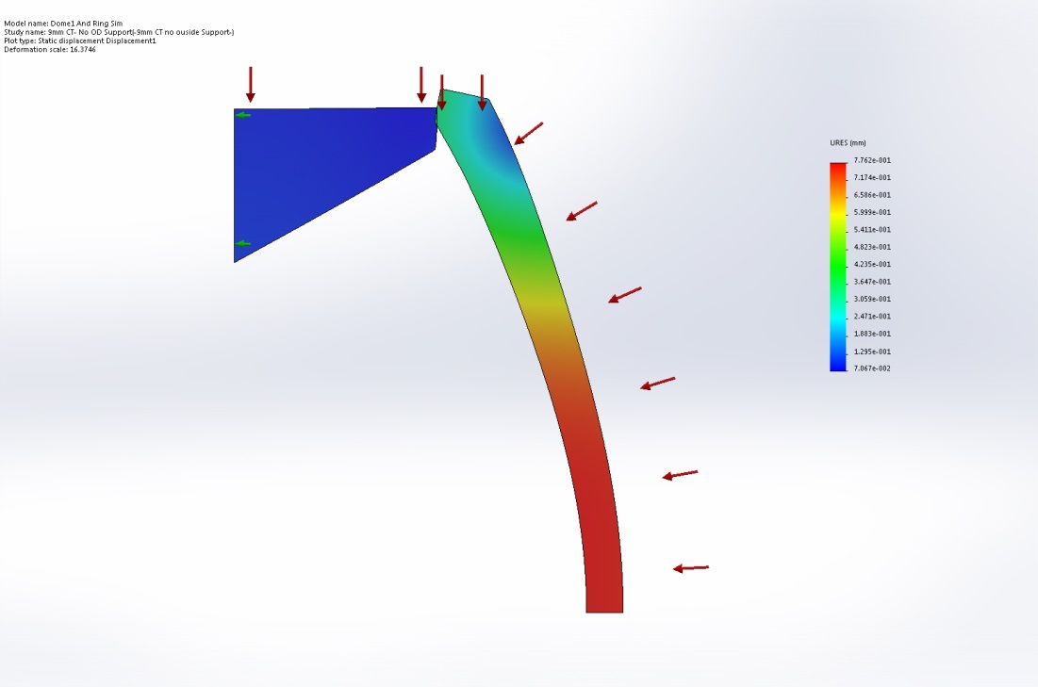
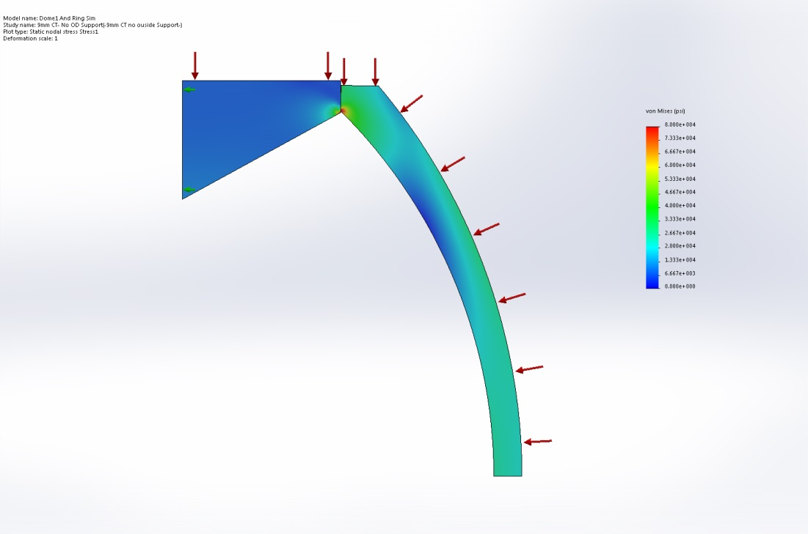

9mm OD with OD support
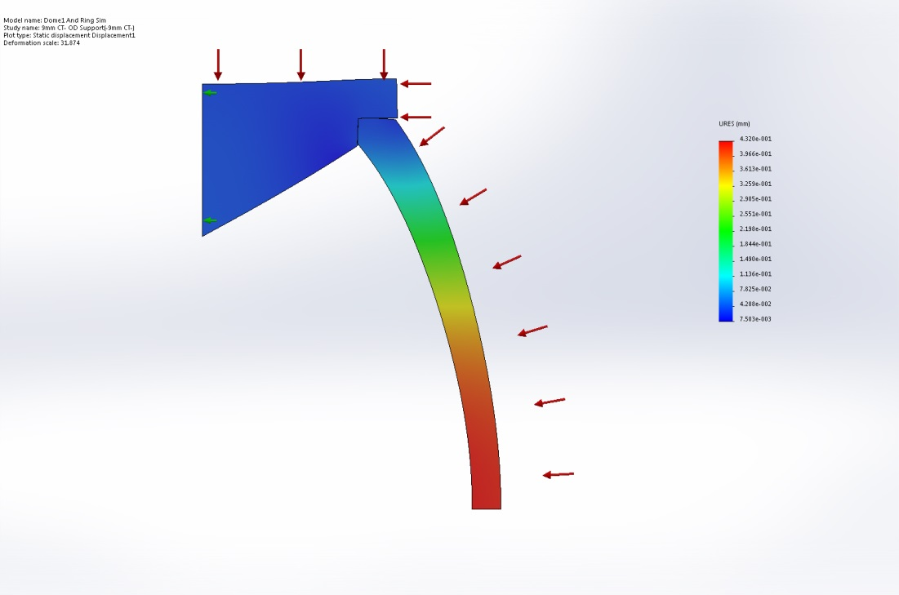

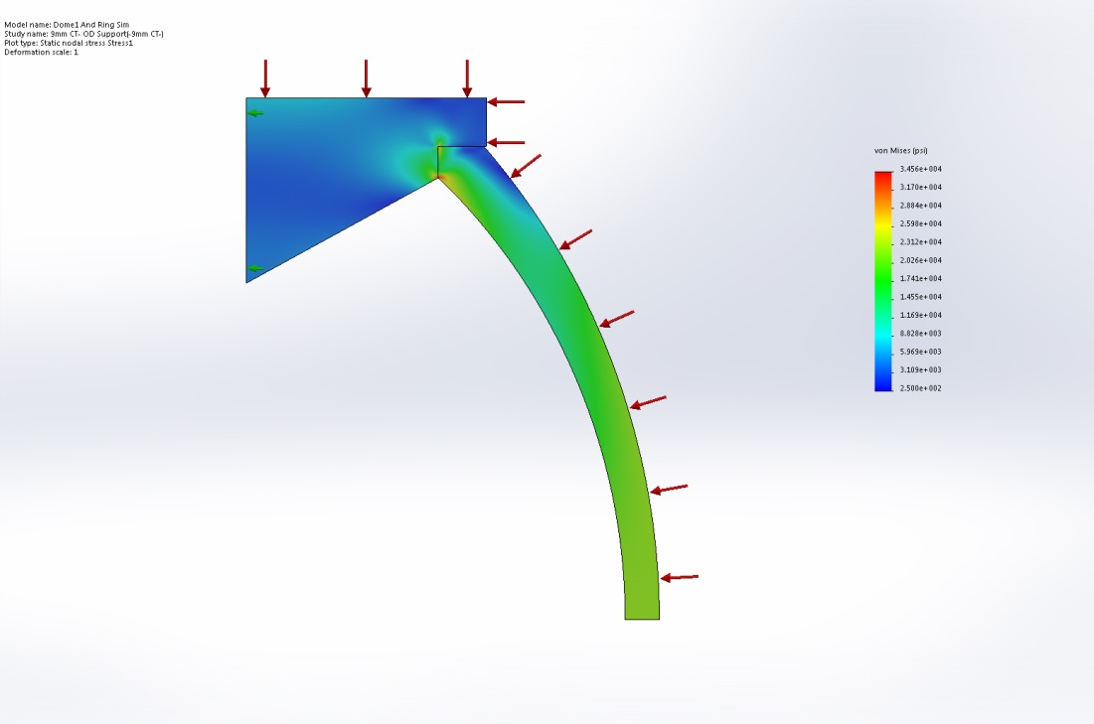

15mm CT without OD support
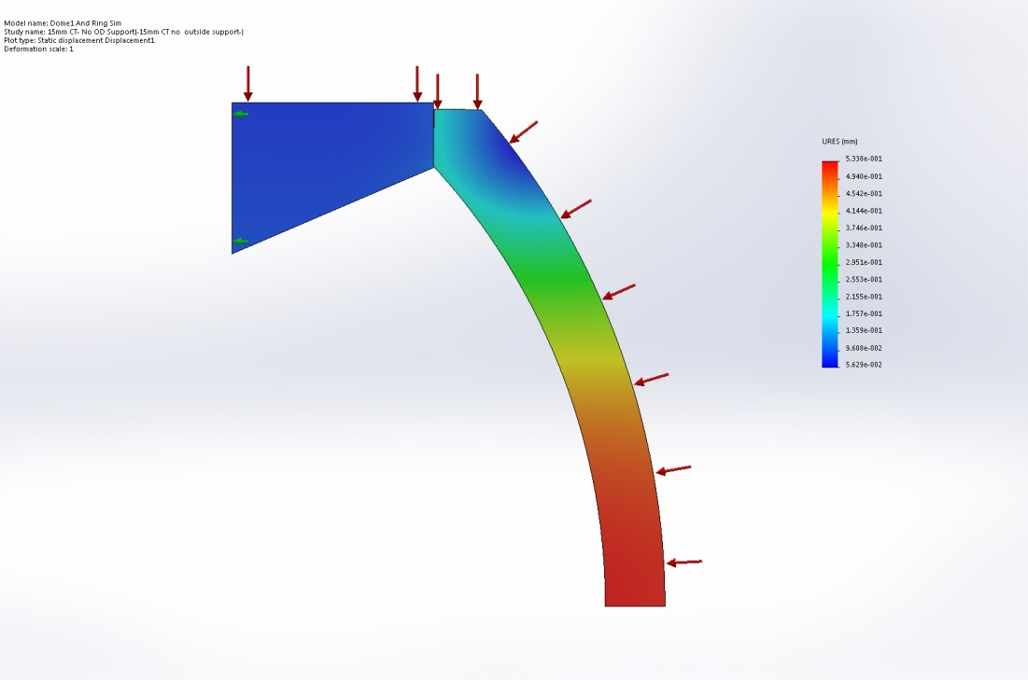
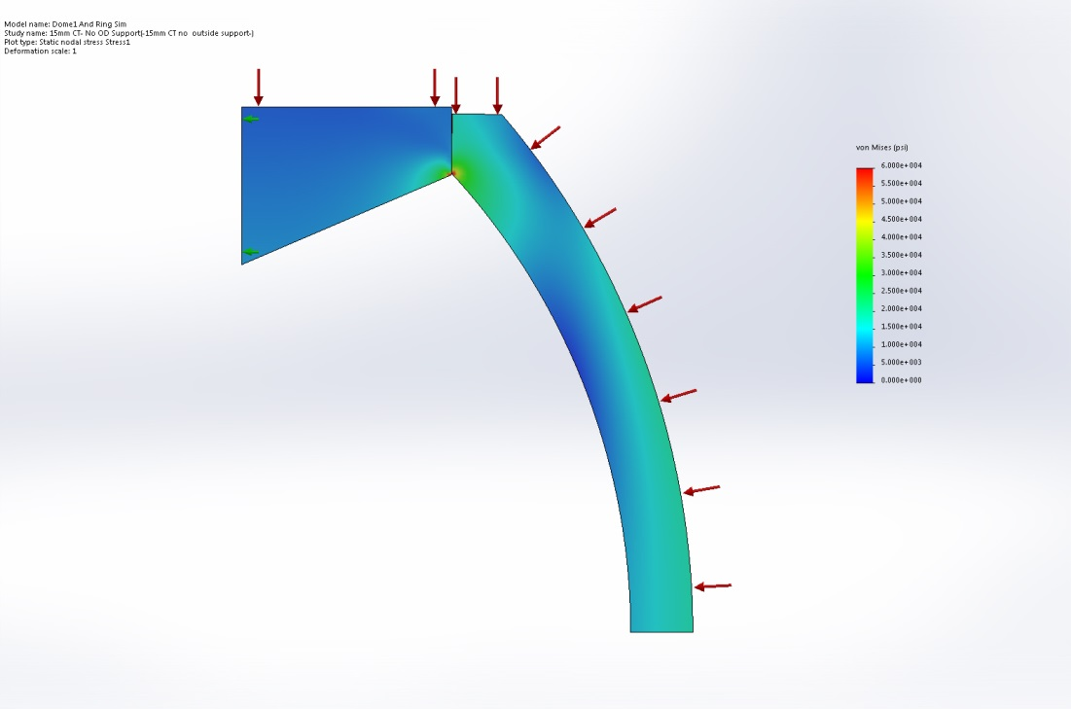

15mm CT with OD support
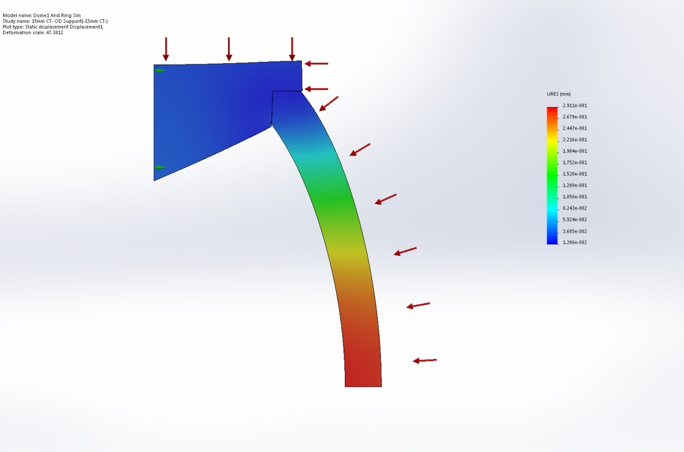
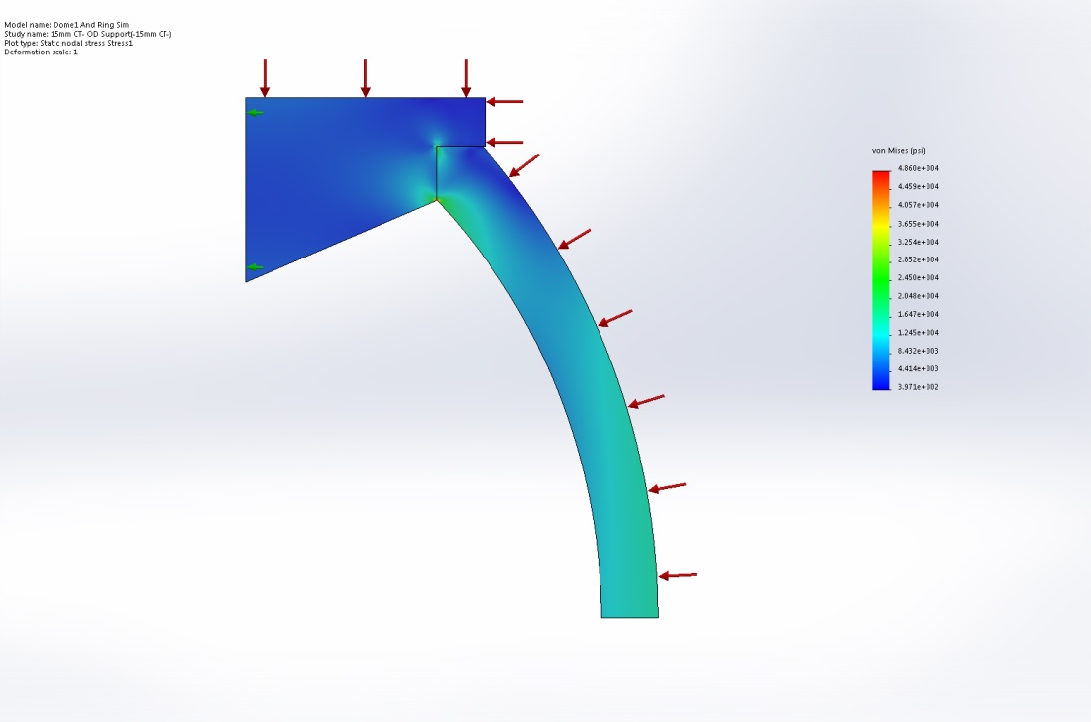

22 mm CT, lens only, no OD support
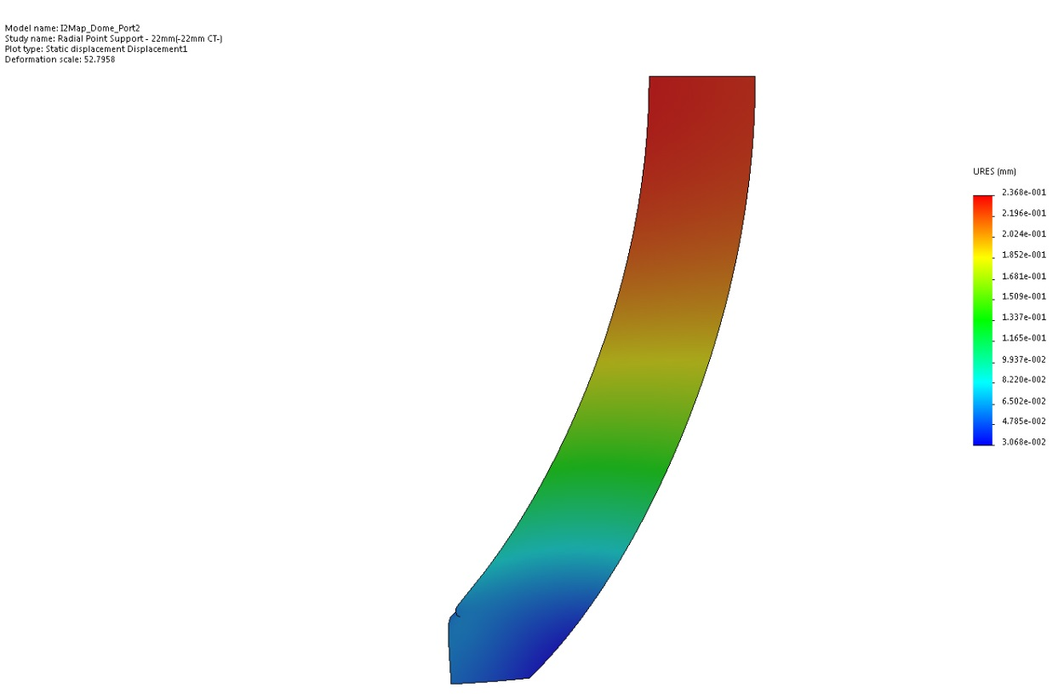
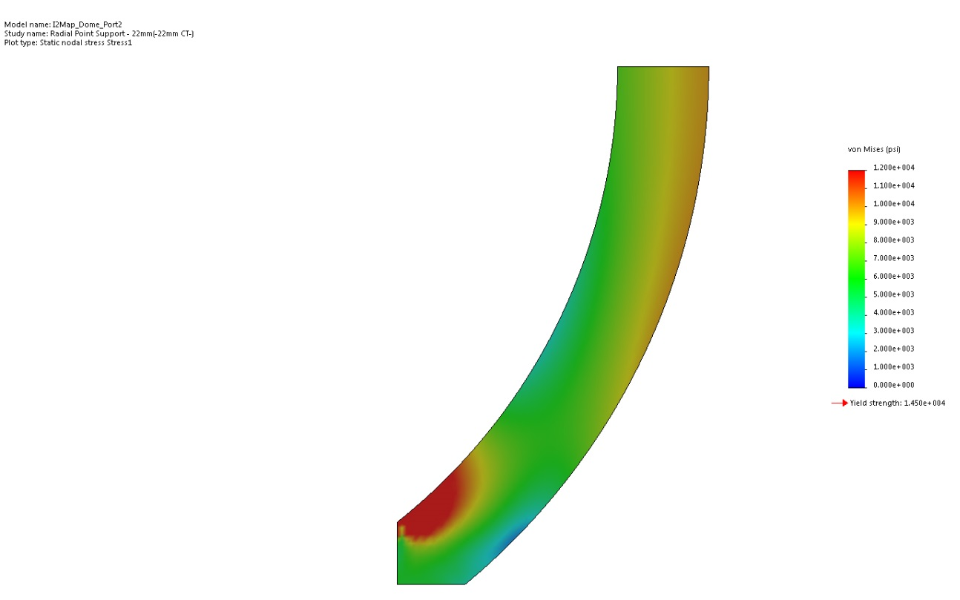

22 mm CT, support ring

